**FRANCHISE DISCLOSURE DOCUMENT**

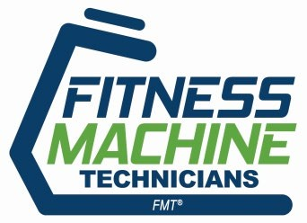

**Main Line Brands LLC**

a Delaware limited liability company 2359 Perimeter Pointe Parkway, Suite 250 Charlotte, North Carolina 28208

1-800-709-1190

fitnessmachinetechnicians.com [contact@mainlinebrands.com](mailto:contact@mainlinebrands.com)

The franchise offered is for the right to own and operate a “Fitness Machine Technicians FMT” business which provides maintenance and repair products and services for exercise equipment.

The total investment necessary to begin operation of an “Fitness Machine Technicians FMT” franchise is from $65,950 to $127,990. This includes $37,000 to $59,000 that must be paid to the franchisor and/or its affiliate.

This disclosure document summarizes certain provisions of your franchise agreement and other information in plain English. Read this disclosure document and all accompanying agreements carefully. You must receive the disclosure document at least 14 calendar days before you sign a binding agreement with, or make any payment to the franchisor or an affiliate in connection with the proposed franchise sale. **Note, however, that no government agency has verified the information contained in this document.**

You may wish to receive your disclosure document in another format that is more convenient for you. To discuss the availability of disclosures in different formats, contact Jason Pritchard at 2359 Perimeter Pointe Parkway, Suite 250, Charlotte, North Carolina 28208 and 1-800-709-1190.

The terms of your contract will govern your franchise relationship. Don’t rely on the disclosure document alone to understand your contract. Read your entire contract carefully. Show your contract and this disclosure document to an advisor, like a lawyer or an accountant.

Buying a franchise is a complex investment. The information in this disclosure document can help you make up your mind. More information on franchising, such as “*A Consumer’s Guide to Buying a Franchise*,” which can help you understand how to use this disclosure document, is available from the Federal Trade Commission. You can contact the FTC at 1-877-FTC-HELP or by writing to the FTC at 600 Pennsylvania Avenue, NW, Washington, DC 20580. You can also visit the FTC’s home page at [*www.ftc.gov*](http://www.ftc.gov/)for additional information. Call your state agency or visit your public library for other sources of information on franchising.

There may also be laws on franchising in your state. Ask your state agencies about them.

**Issuance Date:** May 2, 2025

**How to Use This Franchise Disclosure Document**

Here are some questions you may be asking about buying a franchise and tips on how to find more information:

|  |  |
| --- | --- |
| **QUESTION** | **WHERE TO FIND INFORMATION** |
| **How much can I earn?** | Item 19 may give you information about outlet sales, costs, profits or losses. You should also try to obtain this information from others, like current and former franchisees. You can find their names and contact  information in Item 20 or Exhibit D. |
| **How much will I need to invest?** | Items 5 and 6 list fees you will be paying to the franchisor or at the franchisor’s direction. Item 7 lists the initial investment to open. Item 8 describes the suppliers you must use. |
| **Does the franchisor have the financial ability to provide support to my business?** | Item 21 or Exhibit F includes financial statements. Review these statements carefully. |
| **Is the franchise system stable, growing, or shrinking?** | Item 20 summarizes the recent history of the number of company-owned and franchised outlets. |
| **Will my business be the only Fitness Machine Technicians**  **FMT business in my area?** | Item 12 and the “territory” provisions in the franchise agreement describe whether the franchisor and other  franchisees can compete with you. |
| **Does the franchisor have a troubled legal history?** | Items 3 and 4 tell you whether the franchisor or its management have been involved in material litigation or bankruptcy proceedings. |
| **What’s it like to be a Fitness**  **Machine Technicians FMT franchisee?** | Item 20 or Exhibit D lists current and former franchisees. You can contact them to ask about their experiences. |
| **What else should I know?** | These questions are only a few things you should look for. Review all 23 Items and all Exhibits in this disclosure  document to better understand this franchise opportunity. See the table of contents. |

**What You Need To Know About Franchising *Generally***

**Continuing responsibility to pay fees**. You may have to pay royalties and other fees even if you are losing money.

**Business model can change**. The franchise agreement may allow the franchisor to change its manuals and business model without your consent. These changes may require you to make additional investments in your franchise business or may harm your franchise business.

**Supplier restrictions**. You may have to buy or lease items from the franchisor or a limited group of suppliers the franchisor designates. These items may be more expensive than similar items you could buy on your own.

**Operating restrictions**. The franchise agreement may prohibit you from operating a similar business during the term of the franchise. There are usually other restrictions. Some examples may include controlling your location, your access to customers, what you sell, how you market, and your hours of operation.

**Competition from franchisor**. Even if the franchise agreement grants you a territory, the franchisor may have the right to compete with you in your territory.

**Renewal**. Your franchise agreement may not permit you to renew. Even if it does, you may have to sign a new agreement with different terms and conditions in order to continue to operate your franchise business.

**When your franchise ends.** The franchise agreement may prohibit you from operating a similar business after your franchise ends even if you still have obligations to your landlord or other creditors.

**Some States Require Registration**

Your state may have a franchise law, or other law, that requires franchisors to register before offering or selling franchises in the state. Registration does not mean that the state recommends the franchise or has verified the information in this document. To find out if your state has a registration requirement, or to contact your state, use the agency information in Exhibit A.

Your state also may have laws that require special disclosures or amendments be made to your franchise agreement. If so, you should check the State Specific Addenda. See the Table of Contents for the location of the State Specific Addenda.

**Special Risks to Consider About *This* Franchise**

Certain states require that the following risk(s) be highlighted:

1. **Out-of-State Dispute Resolution.** The franchise agreement requires you to resolve disputes with the franchisor by mediation, and/or litigation only in Pennsylvania. Out-of- state mediation, arbitration, or litigation may force you to accept a less favorable settlement for disputes. It may also cost more to mediate, arbitrate, or litigate with the franchisor in Pennsylvania than in your own state.
2. **Spousal Liability.** Your spouse must sign a document that makes your spouse liable for all financial obligations under the franchise agreement even though your spouse has no ownership interest in the franchise. This guarantee will place both your and your spouse’s marital and personal assets, perhaps including your house, at risk if your franchise fails.
3. **Mandatory Minimum Payments.** You must make minimum royalty or advertising fund payments, regardless of your sales levels. Your inability to make the payments may result in termination of your franchise and loss of your investment.

Certain states may require other risks to be highlighted. Check the “State Specific Addenda” (if any) to see whether your state requires other risks to be highlighted.

REMAINDER OF PAGE LEFT BLANK INTENTIONALLY

**MICHIGAN**

**NOTICE REQUIRED BY THE MICHIGAN FRANCHISE INVESTMENT LAW**

### The following statement is required to be provided to you under the Michigan Franchise Investment Law. By providing this statement, we do not represent or warrant that any of the following provisions of the law are enforceable. We reserve the right to contest the enforceability of any of the following provisions.

### The State of Michigan prohibits certain unfair provisions that are sometimes in franchise documents. If any of the following provisions are in these franchise documents, the provisions are void and cannot be enforced against you.

### Each of the following provisions is void and unenforceable if contained in any documents relating to a franchise:

### A prohibition on the right of a franchisee to join an association of franchisees.

### A requirement that a franchisee assent to a release, assignment, novation, waiver, or estoppel which deprives a franchisee of rights and protections provided in this act. This shall not preclude a franchisee, after entering into a franchise agreement, from settling any and all claims.

### A provision that permits a franchisor to terminate a franchise prior to the expiration of its term except for good cause. Good cause shall include the failure of the franchisee to comply with any lawful provision of the franchise agreement and to cure such failure after being given written notice thereof and a reasonable opportunity, which in no event need be more than 30 days, to cure such failure.

### A provision that permits a franchisor to refuse to renew a franchise without fairly compensating the franchisee by repurchase or other means for the fair market value at the time of expiration of the franchisee's inventory, supplies, equipment, fixtures, and furnishings. Personalized materials which have no value to the franchisor and inventory, supplies, equipment, fixtures, and furnishings not reasonably required in the conduct of the franchise business are not subject to compensation. This subsection applies only if: (i) The term of the franchise is less than 5 years and (ii) the franchisee is prohibited by the franchise or other agreement from continuing to conduct substantially the same business under another trademark, service mark, trade name, logotype, advertising, or other commercial symbol in the same area subsequent to the expiration of the franchise or the franchisee does not receive at least 6 months advance notice of franchisor's intent not to renew the franchise.

### A provision that permits the franchisor to refuse to renew a franchise on terms generally available to other franchisees of the same class or type under similar circumstances. This section does not require a renewal provision.

### A provision requiring that arbitration or litigation be conducted outside this state. This shall not preclude the franchisee from entering into an agreement, at the time of arbitration, to conduct arbitration at a location outside this state.

### A provision which permits a franchisor to refuse to permit a transfer of ownership of a franchise, except for good cause. This subdivision does not prevent a franchisor from exercising a right of first refusal to purchase the franchise. Good cause shall include, but is not limited to:

### The failure of the proposed transferee to meet the franchisor's then current reasonable qualifications or standards.

### The fact that the proposed transferee is a competitor of the franchisor or subfranchisor.

### The unwillingness of the proposed transferee to agree in writing to comply with all lawful obligations.

### The failure of the franchisee or proposed transferee to pay any sums owing to the franchisor or to cure any default in the franchise agreement existing at the time of the proposed transfer.

### A provision that requires the franchisee to resell to the franchisor items that are not uniquely identified with the franchisor. This subdivision does not prohibit a provision that grants to a franchisor a right of first refusal to purchase the assets of a franchise on the same terms and conditions as a bona fide third party willing and able to purchase those assets, nor does this subdivision prohibit a provision that grants the franchisor the right to acquire the assets of a franchise for the market or appraised value of such assets if the franchisee has breached the lawful provisions of the franchise agreement and has failed to cure the breach in the manner provided in subdivision (c).

### A provision which permits the franchisor to directly or indirectly convey, assign, or otherwise transfer its obligations to fulfill contractual obligations to the franchisee unless provision has been made for providing the required contractual services.

### The fact that there is a notice of this offering on file with the attorney general does not constitute approval, recommendation or endorsement by the attorney general.

### Any questions regarding this notice should be directed to: Michigan Department of Attorney General

### Consumer Protection Division Attn: Franchise

### 525 W. Ottawa Street, 1st Floor Lansing, Michigan 48909

### (517) 373-7117

REMAINDER OF PAGE LEFT BLANK INTENTIONALLY

**TABLE OF CONTENTS**

ITEM 1: THE FRANCHISOR, AND ANY PARENTS, PREDECESSORS AND AFFILIATES 1

ITEM 2: BUSINESS EXPERIENCE 4

ITEM 3: LITIGATION 5

ITEM 4: BANKRUPTCY 6

ITEM 5: INITIAL FEES 6

ITEM 6: OTHER FEES 8

ITEM 7: ESTIMATED INITIAL INVESTMENT 13

ITEM 8: RESTRICTIONS ON SOURCES OF PRODUCTS AND SERVICES 16

ITEM 9: FRANCHISEE’S OBLIGATIONS 18

ITEM 10: FINANCING 20

ITEM 11: FRANCHISOR’S ASSISTANCE, ADVERTISING, COMPUTER SYSTEMS AND TRAINING 20 ITEM 12: TERRITORY 28

ITEM 13: TRADEMARKS 30

ITEM 14: PATENTS, COPYRIGHTS AND PROPRIETARY INFORMATION 31

ITEM 15: OBLIGATIONS TO PARTICIPATE IN THE ACTUAL OPERATION OF THE FRANCHISE BUSINESS 32

ITEM 16: RESTRICTIONS ON WHAT THE FRANCHISEE MAY SELL 32

ITEM 17: RENEWAL, TERMINATION, TRANSFER AND DISPUTE RESOLUTION 33

ITEM 18: PUBLIC FIGURES 37

ITEM 19: FINANCIAL PERFORMANCE REPRESENTATIONS 37

ITEM 20: OUTLETS AND FRANCHISEE INFORMATION 43

ITEM 21: FINANCIAL STATEMENTS 49

ITEM 22: CONTRACTS 49

ITEM 23: RECEIPTS 49

EXHIBITS

1. Agents for Service of Process/State Administrators
2. Franchise Agreement
3. Table of Contents of Brand Standards Manuals
4. List of Franchisees
5. Franchisees Who Have Left the System
6. Financial Statements
7. Form of General Release
8. State Specific Addenda RECEIPT

## ITEM 1: THE FRANCHISOR, AND ANY PARENTS, PREDECESSORS AND AFFILIATES

### The Franchisor

The Franchisor is Main Line Brands LLC. For ease of reference, Main Line Brands LLC will be referred to as “we,” “us,” or “Fitness Machine Technicians FMT,” which is the name under which you will operate. We will refer to the person or entity who buys the franchise as “you” throughout the Disclosure Document. If you are a corporation, limited liability company, partnership or other corporate entity, certain provisions of the agreement also apply to your owners and will be noted.

Our agents for service of process are disclosed in Exhibit A.

We are a Delaware limited liability company, originally formed as Authority Franchising, LLC on September 10, 2020, and we changed our name to Main Line Brands LLC effective on March 18, 2021.

We conduct business under the names “Fitness Machine Technicians FMT”, “Mosquito Authority” and “Pest Authority.” We do not do business under any other name. Our principal business address is 2359 Perimeter Pointe Parkway, Suite 250, Charlotte, North Carolina 28208.

We began offering franchises for Fitness Machine Technicians FMT in May 2023. As of December 31, 2024, there were 140 franchised Fitness Machine Technicians FMT businesses in the United States. We acquired in 2023 and currently operate 1 business of the type being franchised, which business is located in Nebraska.

### Our Parents, Predecessors and Affiliates

Our predecessor is Proexco, LLC, a Pennsylvania limited liability company established on October 14, 2011 (“Proexco”). Proexco began offering franchises for Fitness Machine Technicians FMT in 2012 under the name “Exertech”, before rebranding in 2015 as “Fitness Machine Technicians FMT”, and offered and sold franchises through May 2023. Proexco’s last known principal address is 134 Pennsylvania Avenue, Malvern, Pennsylvania 19355.

We acquired all of the outstanding ownership interests in Proexco by a transaction in May 2022 (“Transaction”). Proexco continued to offer franchises “Fitness Machine Technicians FMT after the Transaction until we transitioned the franchisor role in the United States to us in May 2023.

After acquiring all of its outstanding ownership interests in the Transaction, we also became the direct parent and sole member of our affiliated company, DP and Partners, LLC, a Pennsylvania limited liability company formed on April 28, 2020 (“DP”). DP offered franchises for Fitness Machine Technicians FMT businesses in Canada from late 2020 to September 2023 when we transitioned the franchisor role in Canada to us in September 2023. DP’s last known principal business address was 134 Pennsylvania Avenue, Malvern, Pennsylvania 19355.

After acquiring all of its outstanding ownership interests in the Transaction, we are also the direct parent and sole member of our affiliated company, Powersmith, LLC, a Pennsylvania limited liability company originally formed as Powersmith, Inc. on October 17, 2002, and which was converted to a limited liability company effective on May 3, 2022 (“Powersmith”). Powersmith owns and operates 1 business of the type being franchised (in Pennsylvania beginning in 2002), and licenses to us the right to use and sublicense the sue of certain trademarks, including the principal mark “Fitness Machine Technicians FMT”. Powersmith has not offered franchises in this or any other lines of business previously. Powersmith’s principal business address is 559 W. Uwchlan Ave, Suite 150., Exton, PA 19341.

We currently operate 1 business of the type being franchised in Nebraska, which we acquired from a franchisee in 2023. We do not currently have any affiliates that offer franchises in any line of business or provide products or services to our franchisees.

However, we separately offer franchises for mosquito, tick, fly and spotted lantern fly control specialty businesses under the name and mark “Mosquito Authority,” and also separately offer franchises for outdoor and indoor pest control and moisture control services and equipment under the name and mark “Pest Authority”. We have offered Mosquito Authority and Pest Authority franchises since October 2020. As of December 31, 2024, there were 546 franchised Mosquito Authority businesses in the United States and 346 franchised Pest Authority businesses in the United States.

Our direct parent is Main Line Brands Holdings, LLC, a Delaware limited liability company originally formed as Authority Franchising Holdings, LLC on September 10, 2020, and which changed its name to Main Line Brands Holdings, LLC effective on March 18, 2021 (“Holdings”). The current principal business address for Holdings is 2359 Perimeter Pointe Parkway, Suite 250, Charlotte, North Carolina 28208. Holdings is majority owned and controlled by Authority Franchising Partners, LLC, a Delaware limited liability company formed on September 10, 2020 (“Partners”). Partners is ultimately controlled by Susquehanna Private Capital Fund II, LLP, a Delaware limited liability partnership formed on December 27, 2019 (“Susquehanna”). The current principal business address for Partners and Susquehanna is 401 E. City Avenue, Bala Cynwyd, Pennsylvania 19004. None of Holdings, Partners nor Susquehanna have offered franchises in this or any other lines of business previously.

Susquehanna became the indirect parent of Soccer Shots Franchising, LLC, a Pennsylvania limited liability company formed on January 15, 2005, effective December 31, 2021. Soccer Shots Franchising, LLC has offered franchises for the “Soccer Shots” brand since February 1, 2005. The current principal business address of Soccer Shots Franchising, LLC is 401 E. City Avenue #220, Bala Cynwyd, Pennsylvania 19004.

Susquehanna became the indirect parent of Little Kickers Canada Management ULC, a British Columbia unlimited liability company, on October 21, 2022. Little Kickers Canada Management ULC and its affiliates, including Little Kickers International Holdings ULC and Little Kickers Franchising Ltd and Little Kickers Canada Operations ULC, own, operate and franchise the Little Kickers system in the United Kingdom, Canada and certain other countries in the world. The current principal business address of Little Kickers Canada Management ULC is 401 City Ave., Bala Cynwyd, PA 19004.

### The Franchise Offered

We franchise a system for businesses that provide maintenance and repair services for exercise equipment under the name and mark “FMT” or “Fitness Machine Technicians FMT” (the “Marks” or “Proprietary Marks”).

The franchise grants you the right to own and operate a single “Fitness Machine Technicians FMT” business (the “Business” or “Franchised Business”) and offer all of the products and services which comprise the System in a single designated territory. In addition, you are granted an exclusive right to use and display the Proprietary Marks and trade names and to use the Fitness Machine Technicians FMT copyrighted materials and trade secrets in a defined geographical location called a “Territory.” You must sign our Franchise Agreement, which is attached to this Disclosure Document as Exhibit B. If you wish to own and operate your Franchised Business in more than one designated territory, you must sign a separate Franchise Agreement for each designated territory.

We offer a Full-Size Franchise or a Hometown Franchise to those who meet our then current standards and qualifications, in our determination. The only difference between a Full-Size Franchise and a Hometown Franchise is that a Hometown Franchise territory contains fewer people in the Territory and therefore pays a reduced Initial Franchise Fee. The initial investment and other fees and costs are the same. The specific type of Franchise you will purchase and the specific Initial Franchise Fee you pay will be described in your Franchise Agreement.

For Full-Size Franchises, we will use commercially reasonable efforts to grant only one license to a franchisee for every 800,000 people in a designated geographical area.

For Hometown Franchises, we take into account the number of combined population but we do not have any specific minimum level of total population in a specific geographic area for a Hometown Franchise since this type of Hometown Franchise is meant to serve a smaller community. We will use commercial reasonable efforts, including the use of the most recent information available in the U.S. Census Data, or other statistical sources of our choosing, to determine these demographics. We reserve the right to change, modify, or delete the Population Limits in our sole discretion.

As a Full-Size Franchise or Hometown Franchise operator, you may operate one Franchised Business for each Franchise Agreement you sign with us.

If permitted by your local ordinances, you may operate the Franchised Business from your home, or you may choose to lease a garage or light industrial space for your Franchised Business.

We strongly recommend that you be certified by each exercise equipment manufacturer to provide maintenance and repair services for their equipment. Not having the manufacturer’s certification does not stop you from offering repair and maintenance services for that manufacturer’s equipment. However, as a certified technician, the manufacturer is more likely to forward service requests to you than if you have not achieved certification. The manufacturer may require you to periodically be recertified.

### Competition and Market

The market for exercise equipment repair services is developing, but is not seasonal in nature.

You will offer maintenance and repair services to companies owning exercise equipment, including colleges, universities, hotels and apartment buildings, as well as individuals owning exercise equipment. You will compete with companies offering similar services, including local, regional or national companies, some of which may be franchise systems. Fitness Machine Technicians FMT Businesses offer maintenance and repair services for a variety of manufacturers and are not exclusive to a specific manufacturer.

### Industry Specific Laws

You must comply with any state or local licensing or regulatory requirements that may apply to the Franchised Business, which may require you to obtain a special permit to operate a business from your home. You must meet all local, state, or federal contracting laws that may apply to offering this Franchised Business. You should seek counsel or contact your state and local agencies for detailed information about applicable laws and regulations. There may be other laws of general applicability that could impact your operation.

## ITEM 2: BUSINESS EXPERIENCE

### President – Jason Pritchard

Mr. Pritchard has served as our President of Fitness Machine Technicians since February 2024. He served as Vice President of Fitness Machine Technicians from January 2023 to February 2024. From February 2020 until January 2023, Mr. Pritchard independently operated multiple Mosquito Authority and Pest Authority franchises based in Dallas, Texas. From January 2012 until February 2020, Mr. Pritchard served as Director of Operations for TMAFS, LLC.

The following persons hold positions with our parent Holdings:

### Manager - Kyle Squillario

Mr. Squillario has been the Manager of Holdings since October 2020. He has also served as Manager of Proexco, DP and Powersmith since May 2022. Mr. Squillario has been Vice President of Soccer Shots Franchising LLC since January 2022. Mr. Squillario has also served as Vice President of SS Acquisition LLC and Stronger Youth Brands Holding, LLC and Vice President of COUS, LLC and Soccer Shots IP, LLC since January 2022, and as Director and Vice President of Little Kickers Canada Management and ULC Little Kickers Franchising Ltd. since October 2022. Since January 2020, Mr. Squillario has also been a Partner at Susquehanna Private Capital in Bala Cynwyd, Pennsylvania. From March 2017 to December 2019, Mr. Squillario was a Director at Susquehanna Private Capital in Bala Cynwyd, Pennsylvania. From September 2013 to March 2017, Mr. Squillario was Vice President, Private Equity for TZP Group in New York, New York.

### Manager – John McGinley

Mr. McGinley has been a Manager of Holdings since October 2020. He has also served as Manager of Proexco, DP and Powersmith since May 2022. Since January 2020, Mr. McGinley has also been a Vice President, Private Equity at Susquehanna Private Capital in Bala Cynwyd, Pennsylvania. From August 2017 to December 2019, Mr. McGinley was Senior Associate, Private Equity at Susquehanna Private Capital in Bala Cynwyd, Pennsylvania. From June 2015 to July 2017, Mr. McGinley was Associate, Private Equity for Quad-C Management in Charlottesville, Virginia.

### Manager – Joseph Osborne

Mr. Osborne has been a Manager of Holdings since October 2020. From January 2018 to September 2020, Mr. Osborne served as PALLC’s Chairman. He also served as President of Authority Franchise System International, LLC (“AFSI”) from October 2016 to September 2020, President of TMA Franchise Systems, Inc. (“TMA”) from January 2011 to September 2020 and of TMA’s predecessor (“Original TMA”) from October 2009 to September 2020. All of AFSI, TMA and Original TMA were located in Hickory, North Carolina, and were predecessors to Main Line Brands.

### Founder and Consultant – Don Powers

Mr. Powers founded the Fitness Machine Technicians FMT franchise system in October 2011. Since the Transaction, Mr. Powers has served as a consultant to us. Prior to the Transaction, Mr. Powers also served as our President and Chief Executive Officer of Proexco since its inception in October 2011. Mr. Powers also founded our affiliates, DP and Powersmith, in April 2020 and October 2002, respectively. Prior to the Transaction, Mr. Powers served as the President and Chief Executive Officer of our affiliates, DP and Powersmith, since each of their inceptions in April 2002 and October 2002, respectively.

## ITEM 3: LITIGATION

Pending

None. Concluded

We are not party to any litigation required to be disclosed in this Franchise Disclosure Document, but our predecessor with respect to the Mosquito Authority brand (TMA Franchise Systems, Inc.) was party to the following matters:

*In the Matter of TMA Franchise Systems, Inc*., Case No. 2013-0198. On August 21, 2013, TMA entered into a Consent Order with the Securities Division of the Office of the Attorney General of Maryland to resolve alleged violations of the Maryland Franchise Registration and Disclosure Law. Specifically, the Maryland Securities Division alleged that TMA sold two franchises in Maryland without being registered to sell franchises there, and in addition, that TMA did not provide the two franchisees with franchise disclosure documents prepared in accordance with the Maryland Franchise law. We cooperated fully with the state’s investigation of this matter. By the terms of the Consent Order, TMA agreed to i) permanently cease and desist from the offer and sale of franchises in violation of the Maryland Franchise Law; ii) submit an initial franchise application in accordance with the Maryland Franchise law and diligently pursue the application’s registration; and, iii) offer rescission to our Maryland franchisees in accordance with the terms of the Consent Order**.**

*In the Matter of TMA Franchising, Inc*. On October 9, 2013, TMA entered into a Consent Agreement with the Rhode Island Department of Business Regulation to resolve alleged violations of the Rhode Island Franchise Investment Act. Specifically, the Rhode Island Department of Business Regulation alleged that TMA sold two franchises in Rhode Island without being registered to sell franchises there, and in addition, that TMA did not provide the two franchisees with franchise disclosure documents prepared in accordance with the Rhode Island franchise law. We cooperated fully with the state’s investigation of this matter. By the terms of the Consent Agreement, TMA agreed to submit an initial franchise application in accordance with Rhode Island franchise law, provide an offer of rescission to the two Rhode Island franchisees, and pay an administrative fee of $5,000 to the Rhode Island Department of Business Regulation**.**

*In the Matter of TMA Franchise Systems, Inc. d/b/a The Mosquito Authority and Joseph D. Osborne*, Case No. SEC-2015-00002*.* On June 18, 2015, TMA entered into a Settlement Order with the Virginia State Corporation Commission Division of Securities and Retail Franchising to resolve alleged violations of the Virginia Retail Franchising Act. Specifically, the Division of Securities and Retail Franchising alleged that TMA sold eleven franchises in Virginia without being registered to sell franchises there, and in addition, that TMA did not provide the franchisees with franchise disclosure documents prepared in accordance with the Virginia Franchise Act. We cooperated fully with the state’s investigation of this matter. By the terms of the Settlement Order, TMA agreed to pay a monetary penalty of $20,000 and administrative costs of $2,500 to the Division, provide a copy of the Order to each Virginia franchisee, and refrain from violating the Virginia Franchise Act in the future.

*In the Matter of TMA Franchise Systems, Inc. d/b/a The Mosquito Authority*, Case No. File No. 47341*.* On August 11, 2017, TMA entered into a Consent Order with the Minnesota Department of Commerce to resolve allegations that TMA offered and sold an unregistered franchise in Minnesota in

violation of Minn. Stat. § 80C.02 (2016). We cooperated fully with the state’s investigation in this matter. By the terms of the Consent Order, TMA agreed to pay a monetary penalty of $1,000 to the Department of Commerce, disclose this Consent Order in this Franchise Disclosure Document for a period of one year, and cease and desist from further sales in Minnesota until registered.

Disclosures Regarding an Affiliated Franchise Program

Our affiliate, Soccer Shots Franchising, LLC, resolved a single action brought against it with settlements that involved their becoming subject to a currently effective injunctive or restrictive order or decree. This action does not have any impact on us or our brand, nor alleged any unlawful conduct by us.

*In Re: Franchise No Poaching Provisions* (Soccer Shots Franchising, LLC), Case No. 19-2-28301- 7 SEA. On or about October 28, 2019, Soccer Shots Franchising, LLC entered into an Assurance of Discontinuance (“AOD”) with the State of Washington in which Soccer Shots Franchising, LLC agreed it

(1) will no longer include no-poaching provisions in any future U.S. franchise agreements; (2) will continue not enforcing no-poaching provisions in any existing franchise agreements, and will not seek to intervene or defend in any way the legality of any no-poaching provision in any litigation in which a franchisee may claim third-party beneficiary status rights to enforce an existing no-poaching provision; (3) Soccer Shots Franchising, LLC will notify all of its U.S. franchisees of the entry into the AOD with state and provide them a copy of the AOD upon request; (4) notify the Attorney General’s Office of any effort by a franchisee in Washington to enforce any existing no-poaching provision; and (5) exercise all reasonable commercial efforts to amend all existing franchise agreements with entities in Washington to remove any no-poaching provisions in its existing franchise agreements. On January 2, 2020, Soccer Shots Franchising, LLC confirmed in writing its compliance with the AOD to the State of Washington.

Other than the above 5 actions, no litigation is required to be disclosed in this Item.

## ITEM 4: BANKRUPTCY

No bankruptcy information is required to be disclosed in this Item.

## ITEM 5: INITIAL FEES

### Initial Franchise Fee for Full-Size Franchise and Hometown Franchise

When you sign the Franchise Agreement, you must pay us an Initial Franchise Fee (“Initial Franchise Fee”) in full. The Initial Franchise Fee will differ if you are purchasing a Full-Size Franchise or a Hometown Franchise, which is based on the number of people in your proposed territory and identified and added to the Franchise Agreement before you sign.

The Initial Franchise Fee for a Full-Size Franchise is $45,000, which is based on a proposed territory of approximately 800,000 persons.

The Initial Franchise Fee for a Hometown Franchise is $25,000.

The initial franchise fee is imposed uniformly on all franchisees. The initial franchise fee is fully earned upon receipt and is not refundable.

During 2024, we sold franchises to existing franchisees for a reduced Initial Franchise Fee of

$31,500.

If you sign two or more Franchise Agreements at the same time for multiple territories when you are signing your first Franchise Agreement with us, we will discount your initial franchise fee by 30% for the second and each additional Franchise Agreement you concurrently sign with us.

From time to time, we may offer special incentive programs as part of our franchise development activities. We reserve the right to offer, modify or withdraw any incentive program without notice to you. We offer a 15% discount of the Initial franchise fee to Veterans of the U.S and Canadian armed forces via the VetFran program.

We will not hold any area in reserve for you, and you are not granted a right of first refusal to any territory, including those territories that are adjacent to yours.

There are no other payments to or purchases from us or our Affiliate that you must make before your Franchised Business begins operating.

During the initial term of the Franchise Agreement, you will maintain rights to your Territory even though the demographics in your Territory may increase or decrease. However, on renewal, we will have the right to reconfigure the Territory (including, for example, changing from a Hometown Territory to a Full-Size if the demographics increase and puts it over the population threshold for a Hometown Territory or vice versa.)

### Pre-Opening and First Year Marketing Package

If you are opening your first Franchised Business, you must also pay us or our designated vendor a Pre- Opening and First Year Marketing Package fee of between $12,000 and $14,000 for an initial package of branded items, branded marketing materials and other pre-opening marketing materials and continuing assistance before you open and during the first year of your operations (the “Pre-Opening and First Year Marketing Package Fee”). We may reduce the amount of the Pre-Opening and First Year Marketing Package Fee in our discretion if there are existing franchises near the market. The Pre-Opening and First Year Marketing Package is payable to us or our designated vendor when you sign the Franchise Agreement and is non-refundable once paid.

### Additional Territories

We do not offer an area development or multi-territory franchise rights, but at our option you may be offered the opportunity to purchase additional Territories. Each Territory must be purchased by paying the then-current Initial Franchise Fee and by signing the then-current Franchise Agreement. However, if you sign two or more Franchise Agreements at the same time for multiple territories when you are signing your first Franchise Agreement with us, we will discount your initial franchise fee by 30% for the second and each additional Franchise Agreement you concurrently sign with us.

#### Remainder of Page Intentionally Left Blank

## ITEM 6: OTHER FEES

|  |  |  |  |
| --- | --- | --- | --- |
| **Type of Fee** | **Amount** | **When Due** | **Remarks** |
| Royalty Fee | Royalties are a percentage of Gross Sales:  6% of the first $499,999 of Gross Sales each calendar year;  5% of Gross Sales in excess of $500,000 each calendar year.  Royalties are subject to a monthly minimum beginning in your 13th month, through the term of the contract.  The minimum monthly royalty for each territory is  $500. See note 2. | By the 8th business day of the month based on Gross Sales for the immediately preceding month | The term “Gross Sales” means all money received by you in the operation of the Franchised Business, less sales taxes actually paid by you and any customer refunds or adjustments you make. All royalty payments are made by electronic funds transfer. See note 3. |
| Brand Development Fee | The Brand Development Fee is 1% of Gross Sales. | Payable at the same time and in the same manner as the Royalty | The Brand Development Fund is administered by us for the purpose of regional and national advertising of the System. We reserve the right to increase the Brand Development Fee up to 2% of Gross Sales. See Item 11 for a discussion of the Brand Development Fund. |
| Software Fee | Estimated at $100 to $250 per month. | Payable to us at the same time and in the same manner as the Royalty or to a 3rd party vendor that we designate at the time and manner required by such third party | This fee includes required software and/or subscription service and vender fee for online access to our POS forms. |
| Local Advertising | $1,000 per month or 1% of your Gross Sales, whichever is greater. | Beginning in month 4 | You will make payments directly to approved advertising suppliers. All advertising you propose to use must be pre-approved by us |

|  |  |  |  |
| --- | --- | --- | --- |
| **Type of Fee** | **Amount** | **When Due** | **Remarks** |
| Franchisee Cooperative Fees | The members of a Cooperative will determine the amount and frequency of contributions to the Cooperative. | The members of a Cooperative will determine the amount and frequency of contributions to the Cooperative. | Fitness Machine Technicians FMT Businesses owned by us or our Affiliate are entitled to vote on the same basis as you and other franchisees in the Cooperative. If we do not own a unit, we do not vote. No franchisee or commonly controlled group of Fitness Machine Technicians FMT Businesses will have greater than 25% of the total vote. |
| Local Website pages, social media reputation management, local search web form, for organic leads, review generation tools, and SEO | Currently $250 per month, but we may increase the monthly fee upon notice based on our then current costs | Payable to us or an outside vendor on a monthly basis, as applicable | You must pay a monthly fee to us or our selected vendor partners to create custom local website pages on our Internet website inclusive of a digital marketing offer generator for organic inbound sales leads, review generator and search engine optimization (SEO). You must have a separate local website for each Territory you own and operate.  This obligation will begin the same month your local website pages go active. |
| Social media pages and management; posts and review response for Google, Facebook and Yelp. | Currently none, but we may implement and later increase the monthly fee upon notice based on our then current costs | Payable by ACH or EFT debit on the 1st day of the month | If implemented, this obligation will begin the same month your local website pages and/or social media presence goes active. |

|  |  |  |  |
| --- | --- | --- | --- |
| **Type of Fee** | **Amount** | **When Due** | **Remarks** |
| On-site assistance or Training Fee, including Seminars, Conventions or Programs | $500 to $5,000 Our then- current per diem fee per trainer, plus expenses (currently $500)  If you fail to attend the annual conference, you will be charged the greater of $699 or that year’s cost to attend. | Deposit paid before training then balance due 7 days after billing | If you request that we provide on-site assistance or training at your Franchised Business location. The expenses you must reimburse include travel, lodging, meals and local transportation |
| Refresher Training | $200 to $700 | Before attending training | We may designate that certain refresher training courses are mandatory, unless we excuse your absence |
| Manufacturer’s Certification | $100 to $600, as charged for Original Equipment Manufacturer training by the manufacturer to obtain Manufacturer Certification | As incurred | Once you are certified by the exercise equipment manufacturers to maintain and repair their equipment, you must maintain your certification according to the manufacturer’s requirements. Paid to any approved OEM that requires certification and/or ongoing recertification. |
| Transfer Fee | $7,500 U.S. if the transferee does not have any existing relationship with us (for Mosquito Authority, Pest Authority or Fitness Machine Technicians) or $2,500  U.S. if the transferee has an existing relationship with us (for Mosquito Authority, Pest Authority or Fitness Machine Technicians) | Upon signing the then-current successor Franchise Agreement | Payable in lump sum. We will waive the transfer fee, one time only, for a transfer from individuals to a corporate entity that has been formed for convenience of ownership |
| Successor Agreement Fee | $3,500 | Upon signing of the successor Franchise Agreement | Payable in lump sum, at the time of signing the successor Franchise Agreement. Successor Agreement Fee is based on the then current territory population at the time of the successor term. |

|  |  |  |  |
| --- | --- | --- | --- |
| **Type of Fee** | **Amount** | **When Due** | **Remarks** |
| Product or Supplier Evaluation | $500 | With request for approval | If you request to use a product or supplier that we have not previously approved for the System |
| Insurance | Reimbursement of our costs | On demand | We may, but are not obligated to, obtain insurance coverage for you if you fail to do so |
| Management Fee | 25% of Gross Sales, plus expenses | On demand, if incurred | We have the right to step in and manage your Franchised Business in certain circumstances, including your death, disability, inability to operate the business according to our standards or prolonged absence |
| Mystery Shopper Service | Up to $500 | As incurred | We reserve the right to engage a mystery shopper service. If you do not achieve a required minimum score, then you must pay the cost of the mystery shop and we may require you to receive additional training from us. If you achieve the minimum score, we will pay the cost of the mystery shop |
| Computer System Maintenance | $0 | Annually | We do not currently require you to have a maintenance contract for your computer, but we may do so in the future with a cost up to  $1,000 per year. Payable to approved supplier |
| Credit Card Processing Fee | Then current fees set by third party vendor | As incurred | You will have to pay any fees assessed by the credit card processing vendor |
| Late Fee | $100 | As Incurred | Payable to us via ACH payment if Profit & Loss Statements are not delivered to us by the 15th of each month. |

|  |  |  |  |
| --- | --- | --- | --- |
| **Type of Fee** | **Amount** | **When Due** | **Remarks** |
| Interest | 18% per annum or the highest legal rate we can charge, whichever is less | Due with overdue amount | Payable on all overdue amounts. Interest will be calculated from the original due date until payment is received in full |
| Audit | Will vary under the circumstances, but not less than $1,000 | After audit | If an audit of your books and records shows any understatement in amounts reported or paid to us, you must pay the understated amount plus interest. If the audit shows any understatement of 2% or more, you must reimburse all costs related to the audit, including fees, travel, lodging and other related expenses in addition to paying any understated amount plus interest |
| Costs and Attorneys’ Fees | Will vary under circumstances | As incurred | Payable upon your failure to comply with your Agreement. See Washington Addendum. |
| Indemnification | Will vary under circumstances | As incurred | You must reimburse us if we are held liable for claims arising from your operations |

* 1. All fees described in this Item 6 are non-refundable and are uniformly imposed. Except as otherwise indicated in the preceding chart, we impose all fees and expenses listed and you must pay them to us.
  2. Upon reaching your 13th month of operation you will be required to pay a monthly minimum Royalty payment of Five Hundred Dollars ($500.00) per territory. This monthly minimum increases with every territory your franchised business operates within. For example: If your franchised business operates within two territories, as of the 13th month of your operation, you will pay a minimum royalty payment of One Thousand Dollars ($1,000.00).
  3. “Gross Sales” means all revenues and income from any source derived or received by Franchisee from, through, by or on account of the operation of the Franchised Business or made pursuant to the rights granted hereunder, including but not limited, any and all other revenues received using Franchisor’s methods, operations and/or trade secrets whether received in cash, in services, in kind, from barter and/or exchange, on credit (whether or not payment is actually received) or otherwise. “Gross Sales” also includes commissions on the sale of equipment and referrals. It does not include

(i) any sales tax or similar taxes collected from customers and turned over to the governmental authority imposing the tax, (ii) properly documented refunds to customers, (iii) properly documented promotional discounts (i.e. coupons) or (iv) properly documented employee discounts

(limited to 3% of Gross Sales). Gross Sales does not include gift card purchases, at the time of purchase, but Gross Sales does include the redemption amount of purchases made by gift card.

If you do not report your Gross Sales, we may debit your account for 120% of the last Royalty and Brand Development Fee that we debited. If the Royalty and Brand Development Fee we debit are less than the Royalty and Brand Development Fee you actually owe us, we will debit your account for the balance on a day we specify. If the Royalty and Brand Development Fee we debit are greater than the Royalty and Brand Development Fee you actually owe us, we will credit the excess against the amount we otherwise would debit from your account for the next payment.

* 1. All fees are imposed uniformly, except that the Franchisor contributes to the local advertising of the first three franchisees. Other than modifications to the Initial Franchise Fee (as detailed in Item 5) and the Grand Opening Advertising (as detailed above), there are no additional fees that a multi- unit franchisee is subject to that a single territory franchisee does not pay.

## ITEM 7: ESTIMATED INITIAL INVESTMENT

|  |  |  |  |  |  |
| --- | --- | --- | --- | --- | --- |
| **YOUR ESTIMATED INITIAL INVESTMENT**  **\*For a Hometown Franchise and Full-Size Franchise** | | | | | |
| **Type of Expenditure** | **Amount** | | **Method of Payment** | **When Due** | **To Whom Payment is to be Made** |
| Low | High |
| Initial Franchise Fee (1) | *$25,000 | *$45,000 | Lump Sum or Installments | On signing Franchise Agreement | Us |
| Rent (3 months)  (2) | $0 | $3,600 | As Arranged | As Arranged | Landlord |
| Leasehold Improvements (2) | $0 | $5,000 | As Arranged | As Agreed | Contractor |
| Equipment,  Furnishings and Fixtures (3) | $500 | $2,000 | As Arranged | As Agreed | Suppliers |
| Signage (4) | $1,800 | $3,500 | As Arranged | As Incurred | Suppliers |
| Initial Inventory and Operating Supplies (5) | $0 | $3,000 | As Arranged | As Arranged | Suppliers |
| Security Deposits (6) | $0 | $2,400 | As Arranged | As Arranged | Landlord, Utility Companies |
| Insurance (3  months) (7) | $2,500 | $5,000 | As Arranged | As Arranged | Insurance Companies |

|  |  |  |  |  |  |
| --- | --- | --- | --- | --- | --- |
| **YOUR ESTIMATED INITIAL INVESTMENT**  **\*For a Hometown Franchise and Full-Size Franchise** | | | | | |
| **Type of Expenditure** | **Amount** | | **Method of Payment** | **When Due** | **To Whom Payment is to be Made** |
| Low | High |
| Training Expenses (8) | $1,100 | $3,600 | As Arranged | As Incurred | Suppliers |
| Computer System/ Software  (9) | $1,200 | $2,500 | As Arranged | As Incurred | Suppliers |
| Permits/Licenses (10) | $100 | $200 | As Arranged | As Required | State or Local Government |
| Service Vehicle (3 Months) (11) | $1,350 | $1,950 | As Arranged | As Arranged | Leasing Company |
| Professional Fees (12) | $1,500 | $5,000 | As Arranged | As Arranged | Attorney, Accountant |
| Pre-Opening and First Year  Marketing Package (13) | $12,000 | $14,000 | As Arranged | As Arranged | Approved Suppliers |
| Service Technician (14) | $3,900 | $6,240 | As Arranged | As Arranged | Employee/Contractor |
| Additional Funds (15) | $15,000 | $25,000 | As Arranged | As Required |  |
| **Total** | **$65,950** | **$127,990** |  | | |

*\*The only difference between a Full-Size Franchise and a Hometown Franchise for purposes of your initial investment is that a Hometown Franchise territory contains fewer single-family dwellings and therefore pays a reduced Initial Franchise Fee. See Note 1 below.*

In general, none of the expenses listed in the above chart are refundable, except any security deposits you must make may be refundable.

1. ***Initial Franchise Fee*** – The Initial Franchisee Fee is $25,000 for a Hometown Franchise and is

$45,000 for a Full-Size Franchise. We do not offer a multi-territory agreement, but if you sign two or more Franchise Agreements at the same time for multiple territories when you are signing your first Franchise Agreement with us, we will discount your initial franchise fee by 30% for the second and each additional Franchise Agreement you concurrently sign with us.

1. ***Rent; Leasehold Improvements*** – The low end of our estimates assume that you will operate the Franchised Business from a home-based office and you will not incur costs for rent or leasehold improvements. If you will operate from a leased space, you will need approximately 2,000 square feet of space in a garage or light industrial location. We anticipate that any space you choose to lease will not need extensive renovation or leasehold improvements.
2. ***Equipment, Furnishings and Fixtures*** – You will need basic office furnishings, such as a desk, chair, filing cabinet and shelving.
3. ***Signage*** – The estimate includes the cost of wrapping your service vehicle. If you choose to lease space you may purchase additional signage, but these costs are not included in our estimate.
4. ***Initial Inventory and Operating Supplies*** – You will need to purchase assorted hand tools and testing equipment. If you currently own some of the hand tools we require, you may use these tools if they meet our specifications.
5. ***Security Deposits*** – If you lease space from which to operate your Franchised Business, you may have to pay security deposits to your landlord and your local utility companies.
6. ***Insurance*** – The estimate reflects average quarterly premiums for the insurance you must have for your Franchised Business. Some insurance companies may require you to pay your premiums quarterly, semi-annually, or annually. See Item 8 for a more detailed description of the insurance you must have.
7. ***Training Expenses*** – We will provide our initial training program to three people, one of whom must be you. You must pay for the travel, lodging, meals and applicable wages for you and your trainees. The low end of the estimate assumes that you are the sole trainee and are within driving distance of our training facility and will not incur additional costs. The high end of the estimate assumes that you will need to travel and arrange accommodations to attend initial training. Your actual costs will depend on how far you and your trainees must travel and the accommodations you choose. You must also pay directly to QuickBooks a training fee for small business accounting training.
8. ***Computer System/Software*** – You must have a computer system for your Franchised Business, including hardware and software components (such as FranConnect Software from FranConnect [(sales@franconnect.com,](mailto:(sales@franconnect.com) 800-280-8305)) and a printer. You must also have a tablet computer. See Item 11 for a further discussion of the computer system. The low end of our estimate assumes that you own a computer that we have approved for use in your Franchised Business, and includes the cost of buying the printers. The high end of our estimate assumes you will purchase a new computer system. You will also spend about $50/month on CRM software as a service.
9. ***Permits/Licenses*** – You must obtain the business permits required by the state or town in which your Franchised Business is located. You may have to obtain a special permit to allow you to operate the Franchised Business from your home. We strongly encourage you to determine which permits and licenses you will need to obtain and the cost of these permits and licenses before you sign the Franchise Agreement.
10. ***Service Vehicle*** – You must purchase or lease the make & model of service vehicle that we specify for your Franchised Business. Each vehicle you obtain for your Franchised Business must be wrapped according to our specifications and must be in excellent condition (including no visible rust or body damage). If you have more than one service vehicle, you are permitted to have branded

magnets on the body of the vehicle in lieu of wrapping for a period of 6 months. All additional vehicles operated for the benefit of your Franchised business must be wrapped to our specifications no later than 6 months after obtaining the vehicle. Our estimate assumes three months of vehicle lease payments and $100 to $300 per month in fuel. If you choose to purchase a vehicle rather lease, your initial costs will likely be higher.

1. ***Professional Fees*** – You may wish to hire an attorney and/or an accountant to assist you in reviewing this franchise offering. You may also wish to form a corporate entity to own the franchise.
2. ***Pre-Opening and First Year Marketing Package*** – The Pre-Opening and First Year Marketing Package is payable to us or our designated vendor when you sign the Franchise Agreement and is non-refundable once paid.
3. ***Service Technician*** – It is anticipated that you will hire or contract with a service technician, initially on a part-time basis. Estimate assumes an average of 20 to 32 hours per week, at $18/hr, for 13 weeks
4. ***Additional Funds – 3 Months*** – You will need additional capital to support on-going expenses, such as payroll and continuing fees payable to us, if these costs are not covered by sales revenue. We estimate that the amount given will be sufficient to cover on-going expenses for the start-up phase of the business, which we calculate to be three months, but does not include any revenue that you may earn during this period. We have relied on our personnel (including those that previously worked with our predecessor Proexco) and on Founder and Consultant Don Powers in formulating the amount of additional funds described in this Item. We do not finance your initial investment.

## ITEM 8: RESTRICTIONS ON SOURCES OF PRODUCTS AND SERVICES

All equipment, fixtures, furnishings, computer hardware and software, supplies and materials required for the operation of your Franchised Business must be purchased by you only from suppliers designated or approved in writing by us (which may include us or our affiliates), or from suppliers selected by you and whom we approve. Currently neither we nor our Affiliate are an approved supplier for any products or services you must purchase or lease, but we reserve the right to designate ourselves or our Affiliate as an approved supplier in the future. None of our officers has an ownership interest in any approved supplier.

The estimated proportion of required purchases and leases to all purchases and leases by you of goods and services in establishing the Franchised Business is approximately 25% to 40% and in operating your Franchised Business ranges approximately from 10% to 20%.

We will give you specifications for the minimum standards of any products, equipment (including your vehicles) and supplies. We reserve the right to require you to purchase certain equipment, tools and supplies for the operation of the Franchised Business, and we reserve the right to specify the make and model for your vehicle. Our specifications, minimum standards and approved suppliers lists will be included in our confidential brand standards manuals (“Brand Standards Manuals”), which is loaned to you for the term of your Franchise Agreement. We may also establish an intranet website for our franchisees to access this and other information. Any changes to our specifications, minimum standards, approved suppliers or the Brand Standards Manuals will be provided to you in writing, including e-mail and/or newsletters.

You must have a reliable vehicle for your Franchised Business. We reserve the right to specify the make of a service vehicle you must purchase or lease, but in any event we must approve of the service vehicle you use. Each vehicle obtained for your Franchised Business must be lettered or painted according to our specifications and must be in excellent condition (including no visible rust or body damage). Each vehicle you obtain for your Franchised Business must be wrapped according to our specifications. You may operate additional vehicles for each technician and these vehicles may operate with branded magnets for a period of 6 months. All additional vehicles utilized for the operation of your franchised business must be wrapped to our specifications no later than 6 months after purchasing them. We prefer that your vehicle be not more than four years old.

You must purchase all replacement parts for repair of exercise equipment from the equipment manufacturers as long as the part is still being manufactured. You may only purchase replacement parts from another source, such as an “after market” seller, if a part has been discontinued or if we have given our prior written approval for you to do so.

You must acquire and use all our then current operational software platform, which currently includes the required ServiceMinder software that stores the data from all customer service activity of the Franchised Business. You must obtain the ServiceMinder software thorough us, and pay us the Software Fee. Your Software Fee payments may include technical support. ServiceMinder software is currently mandatory and the only approved software for your Franchised Business, but you do not sign any separate license agreement to use the ServiceMinder software.

We currently require you to obtain and use FranConnect Software from FranConnect [(sales@franconnect.com,](mailto:(sales@franconnect.com) 800-280-8305) as your sole financial reporting software for your Franchised Business.

In processing customer payments for your Franchised Business, we have contracted with a credit card service management company that will be responsible for processing credit card payments made to your Franchised Business. The credit card processing company we designate will be the only approved supplier of credit card processing services for the franchise system. We may at our discretion change service providers for these services at any time, in our sole discretion. We will not grant our approval of any request by you to use any alternative suppliers of credit card processing services. You will pay monthly account and transaction fees directly to the credit card processing company as incurred.

We may permit you to contract with alternative suppliers who meet our criteria. If you wish to use a supplier or product that has not previously been approved by us, you must make a request to us in writing for our approval of the supplier or product, including any pertinent information we require and payment of our then-current fee (see Item 6). We will notify you in writing within 30 days if and when a supplier or product is approved. We reserve the right to re-inspect any supplier or product to ensure that the supplier continues to conform to our specifications and standards. If a supplier or product fails to conform to our specifications and standards, we may revoke our approval of the supplier or product, and you must discontinue using the unapproved supplier or product after notice from us. We do not generally make available the criteria for evaluating suppliers and/or products that we deem confidential. If we notify you that a particular product or supplier’s approval has been revoked by us, you must immediately stop using that product and/or stop purchasing from that supplier.

Neither we nor our affiliate collect or retain any and all allowances, rebates, credits, incentives, or benefits (collectively, “Allowances”) offered by manufacturers, suppliers, and distributors to you, to us, or to our affiliates, based upon your purchases of products and services from manufacturers, suppliers, and distributors; however we retain the right to do so in the future. If we do collect and retain such Allowances, any net benefit will be contributed by us, to the Brand Development Fund. Such contributions will be in

gross, and will not be allocated to or offset required fund contributions by any particular franchisee(s). In 2024, we or our affiliates collected $931.44 in rebates from suppliers for purchases of approved products by FMT franchisees.

There are no purchasing or distribution cooperatives established by us, nor have we negotiated any terms of any purchases that you will make. We reserve the right to establish purchasing or distribution cooperatives in the future, in our discretion. We may negotiate purchase arrangements, such as price terms, for the benefit of all Businesses in the System. We do not give you any benefits, like successor terms or the granting of additional franchises, based on your buying any items from our approved suppliers.

In addition to the purchases described above, you must obtain and maintain, at your own expense, insurance coverage. Our System may regulate the types, amounts, terms and conditions of insurance coverage required for your franchise and standards for underwriters of policies providing required insurance coverage; our protection and rights under the policies as an additional named insured; required or impermissible insurance contract provisions; assignment of policy rights to us; periodic verification of insurance coverage that must be furnished to us; our right to obtain insurance coverage at your expense if you fail to obtain required coverage; our right to defend claims; and similar matters relating to insured and uninsured claims. Our standards and requirements for insurance coverages will be included in our Brand Standards Manuals and will periodically be updated.

The following are the current insurance requirements: (1) commercial liability insurance with coverage of not less than $2,000,000 per occurrence, $4,000,000 aggregate; (2) automobile insurance, including hired and non-hired vehicle coverage and uninsured/underinsured motorist coverage, in amounts not less than $1,000,000 combined single limit; (3) workers’ compensation, employer liability and any other insurance required by law or statute for the state in which the Franchised Business is located, but not less than $500,000 per accident; and (4) any insurance required by the terms of your lease, if you choose to lease space for your Franchised Business, or that may be required by us in the future.

You must purchase your insurance policies from insurers that are qualified to sell insurance in the state in which your Franchised Business is located and that are rated at least A- by A.M. Best Company. Each insurance policy must name us, our officers, directors, parent, subsidiaries and affiliates as additional insureds, and must provide us with 30 days prior written notice of any change to or cancellation of any insurance policy. Before you complete our initial training program, and then upon renewal of each policy, you must provide us with a Certificate of Insurance showing that you have obtained the required insurance coverage.

Currently, we do not derive any revenue, rebates or other material consideration based on required purchases or leases by the franchisee.

## ITEM 9: FRANCHISEE’S OBLIGATIONS

### This table lists your principal obligations under the franchise and other agreements. It will help you find more detailed information about your obligations in these agreements and in other items of this Disclosure Document.

|  |  |  |
| --- | --- | --- |
| **Obligation** | **Section in Agreement** | **Disclosure Document Item** |
| (a) Site selection and acquisition/lease | Franchise Agreement – Section 9.1 | Items 7 and 11 |

|  |  |  |
| --- | --- | --- |
| **Obligation** | **Section in Agreement** | **Disclosure Document Item** |
| (b) Pre-opening purchases/lease | Franchise Agreement – Sections 5.5, 5.6, 9.5 and  9.6 | Item 7, 8 and 11 |
| (c) Site development and other pre-opening requirements | Franchise Agreement – Section 9.2 | Items 7 and 11 |
| (d) Initial and ongoing training | Franchise Agreement – Sections 5.3 and 9.11 | Items 6, 7 and 11 |
| (e) Opening | Franchise Agreement – Section 9.2 | Item 11 |
| (f) Fees | Franchise Agreement – Sections 4.2.5, 8 and 15.2, Exhibit I | Items 5, 6, 7 and  11 |
| (g) Compliance with standards and policies/ Operations Manual | Franchise Agreement – Sections 6 and 9.1 | Items 8, 11 and 16 |
| (h) Trademarks and proprietary information | Franchise Agreement – Sections 1, 7 and 13 | Items 13 and 14 |
| (i) Restrictions on products/ services offered | Franchise Agreement – Sections 3, 9.8 and 9.18 | Items 12 and 16 |
| (j) Warranty and customer service requirements | Not applicable | Not applicable |
| (k) Territorial  development and sales quotas | Franchise Agreement – Section 2.2, 3 | Item 12 |
| (l) On-going  product/service purchases | Franchise Agreement – Sections 5.5 and 9.7 | Items 8 and 11 |
| (m) Maintenance, appearance and remodeling requirements | Not Applicable | Not applicable |
| (n) Insurance | Franchise Agreement – Section 9.15 | Items 7 and 8 |
| (o) Advertising | Franchise Agreement – Sections 5.8, 9.12 and 10 | Items 6, 7 and 11 |
| (p) Indemnification | Franchise Agreement – Sections 7.7 and 12 | Item 6 |
| (q) Owner’s  participation/ management/ staffing | Franchise Agreement – Sections 9.4 and 9.9 | Items 11, 15 and  16 |

|  |  |  |
| --- | --- | --- |
| **Obligation** | **Section in Agreement** | **Disclosure Document Item** |
| (r) Records/reports | Franchise Agreement – Sections 8.6, 9.14 and 11 | Item 11 |
| (s) Inspection/audits | Franchise Agreement – Sections 9.13 and 11 | Item 6 |
| (t) Transfer | Franchise Agreement – Section 15 | Items 6 and 17 |
| (u) Renewal | Franchise Agreement – Section 4 | Items 6 and 17 |
| (v) Post-termination obligations | Franchise Agreement – Section 17 | Item 17 |
| (w) Non-competition covenants | Franchise Agreement – Section 14 | Item 17 |
| (x) Dispute resolution | Franchise Agreement – Section 20 | Item 17 |
| (y) Liquidated damages | Not Applicable | Not Applicable |
| (z) Guarantee | Franchise Agreement – Exhibit E | State Cover Page, Item 15 |

## ITEM 10: FINANCING

We do not offer direct or indirect financing. We do not guarantee your note, lease or obligation.

**ITEM 11: FRANCHISOR’S ASSISTANCE, ADVERTISING, COMPUTER SYSTEMS AND TRAINING**

### Except as listed below, we are not required to provide you with any assistance.

### Pre-Opening Obligations

#### Franchise Agreement

Before you open your Franchised Business, we will:

1. Designate your Franchised Business as a Hometown Franchise or Full-Size Franchise, and designate your Territory (See Cover Page and Section 2.1.3 of the Franchise Agreement and Attachment 1 to the Franchise Agreement). Other than designating your Territory in which you will operate your Franchised Business, we do not approve a site for your Franchised Business.
2. Lend you one copy of our Brand Standards Manuals (Franchise Agreement – Section 5.1). We will provide you specifications for the minimum standards of the products, equipment (including your vehicles) and supplies you need for the development of the Franchised Business, but we do not provide any of these items directly and only provide you names of approved suppliers, and we do not deliver or install any of these items in your Franchised Business.
3. Provide our Initial Training Program (which is described below) to up to three people at no additional charge (Franchise Agreement – Section 5.3).
4. Approve or designate the particular computer hardware and peripheral equipment which you must use for your Franchised Business (Franchise Agreement – Section 5.6).
5. Approve or designate the service vehicle you wish to use for your Franchised Business (Franchise Agreement – Section 5.11).
6. Provide certain pre-opening and first year marketing advertising assistance in exchange for the Pre-Opening and First Year Marketing Package Fee (Franchise Agreement – Section 10.3).

### Continuing Obligations

During your operation of the Franchised Business we will:

1. In addition to the training program, we may occasionally furnish you with instructions, forms or other information developed by us in connection with the operation of the System (Franchise Agreement – Section 5.2).
2. At all times during the term of the Franchise Agreement, provide information pertaining to sources of supply for products and services used in our System (Franchise Agreement – Section 5.5).
3. Maintain a Brand Development Fund for the benefit of all Fitness Machine Technicians FMT Businesses in the System (Franchise Agreement – Section 10.2).
4. Following the opening of your franchise, we will be available for consultation with you to discuss any problems in the operation of the business (Franchise Agreement – Section 5.3.3).
5. Conduct an annual meeting of franchisees, which shall be mandatory for all franchisees unless the absence is excused by us. The annual meeting will be to discuss sales techniques, instructional methods, training of personnel, performance standards, advertising, and merchandising procedures (Franchise Agreement – Section 5.10). We will not hold a franchisee meeting until we believe it is beneficial to do so.
6. Provide additional training as you may request at your Franchised Business, or as we may offer at our headquarters. Currently the per diem fee for this is $500.00. (Franchise Agreement – Section 5.12).
7. Determine the minimum and/or maximum prices you may charge, to the extent allowed by applicable law (Franchise Agreement – Section 5.7).
8. Provide periodic refresher training for you and/or your personnel. We may designate that attendance at any refresher training program is mandatory unless the absence is excused by us. Currently the fees for mandatory refresher training range from $200.00 to $700.00, based on the length and nature of the training. This fee is per course, not per diem (Franchise Agreement – Section 5.4).
9. During your first year of operation, you may submit to us for our review the preventative maintenance estimates you prepare for your customers. Our reviews will be used as a tool to teach you and refine your operation of the Business (Franchise Agreement – Section 5.13). We reserve the right to require you to provide us with copies of preventative estimates at any time for our review, including if we receive a complaint from one of your customers.

### Site Selection and Opening

Because we expect that you will operate from a home office, we will not review or approve any location you choose to lease for your Franchised Business. If you choose to operate your Franchised Business from leased space, you will need up to 2,000 square feet of space in a garage or light industrial building. We will not own or lease to you the premises for your home office or any leased office space you select. We do not have specific requirements for any site you may select and we will not assist you in locating a site.

We estimate that between 30 to 60 days will elapse from the date you sign the Franchise Agreement to the opening of your Franchised Business for business. Factors that may affect this timeframe include your ability to obtain financing or required licenses and permits, when you successfully complete our initial training program, or delayed installation of equipment, fixtures and signs. Your Franchised Business must be opened for business within 90 days after you sign the Franchise Agreement. You may not open your Franchised Business for business until: (1) the initial training program we provided has been completed to our satisfaction by all required persons; (2) the initial franchise fee and all other amounts due to us have been paid; (3) you have furnished us with all certificates of insurance required by the Franchise Agreement;

(4) you have obtained all required governmental permits, licenses and authorizations necessary for the operation of your Franchised Business; and (5) you are in full compliance with all the terms of the Franchise Agreement.

### Advertising and Promotion

#### Pre-Opening and First Year Marketing Package

As noted in Item 5, if you are opening your first Franchised Business, we will provide you an initial package of branded items, branded marketing materials and other pre-opening marketing materials and continuing assistance before you open and during the first year of your operations.

#### Brand Development Fund

We have established a brand development fund (“Fund”) to promote the System, Franchised Businesses and the products and services offered by Franchised Businesses. You must pay a non- refundable monthly Brand Development Fee in an amount up to 2% of Gross Sales. The current amount payable as a Brand Development Fee is 1% of Gross Sales, but we may modify or increase it up to 2% upon written notice to you. The Fund will be used for national and regional advertising, publicity and promotion relating to our business. We will determine, in our fully unrestricted discretion, the manner in which the Fund will be spent. Some portion of the Fund may be used for creative concept production, marketing surveys, test marketing and related purposes. We have the right to direct all advertising activities with sole discretion over creative concepts, materials and media used, as well as their placement and allocation. There is no requirement for that we or the Brand Fund to spend any amount on advertising in your area or territory

We also have the right to determine, in our sole discretion, the composition of all geographic and market areas for the implementation of these advertising and promotional activities. The Fund is intended to maximize general public recognition in all media of the Proprietary Marks and patronage of Franchised Businesses, and we have no obligation to make sure that expenditures of the Fund in or affecting any geographic area are proportionate or equivalent to payments of the Brand Development Fee by franchisees operating in that geographic area, or that any Franchised Business will benefit directly or in proportion to the Brand Development Fees paid for the development of advertising and marketing materials or the placement of advertising. No amount of the Fund will be spent for advertising that is principally a solicitation for the sale of franchises, however printed materials and/or the system website may include the

words “franchises available”, “own an Fitness Machine Technicians FMT franchise” or other words to this effect, with a link/tab or instructions for how those interested may obtain more information.

We have the right to reimburse ourselves out of the Fund for the total costs (including indirect costs) of developing, producing and distributing any advertising materials, the system website and collecting the Brand Development Fee (including attorneys’, auditors’ and accountants’ fees and other expenses incurred in connection with collecting any Brand Development Fee). The Fund and its earnings will not otherwise inure to our benefit except that any resulting technology and intellectual property will be deemed our property.

Fitness Machine Technicians FMT Businesses owned by us or our affiliates will contribute to the Fund on the same basis as you. Funds from the Brand Development Fees paid will be kept separate and distinct and will be accounted for separately from our other funds. These funds will not be used to defray any of our general operating expenses, except as described in the paragraph above. Any sums paid to the Fund that are not spent in the year they are collected will carry over to the following year. We will prepare, and furnish to you upon written request, an annual, unaudited statement of funds collected and costs incurred.

The Fund was established during the 2018 fiscal year by our predecessor Proexco. In the most recent fiscal year ending December 31, 2024, Proexco’s Fund expenditures were spent as follows: 31% Franchisee growth programs, 22% Trade show advertisement, 10% Print and Internet advertising and 2% Association memberships.

#### Local Advertising

We require, that you spend a minimum of the greater of $1,000 per month or 1% of your Gross Sales on approved local advertising and promotion to promote your Franchised Business in your Territory including a required minimum on internet advertising through our approved supplier, as further detailed in the Brand Standards Manuals. Any advertising produced by you or on your behalf may not be used until it has received our prior approval.

If you would like to use advertising that we have either not prepared or not approved within the immediately preceding 12 month period, you must submit the proposed materials to us for our review. We will have 15 days after receipt of the proposed materials to notify you whether the materials are approved. Unless we provide our specific approval of your proposed advertising materials, they are deemed not approved.

At our request, you must include certain language in your local advertising materials, such as “Franchises Available” and our website address and telephone number.

We are not required to spend any amount on local advertising in your Territory.

#### Advertising Cooperatives

We may approve the establishment of local cooperative advertising associations (“Cooperative”) consisting of all franchises and any of our company-owned units within a designated geographical area. You must participate in a Cooperative if one is formed for an area that includes all or a portion of your Territory. You will not have to participate in more than one Cooperative. Each Cooperative may adopt its own written governing documents, a copy of which must be given to us. Each Cooperative shall determine its own voting procedures. Fitness Machine Technicians FMT Businesses owned by us or our Affiliate are entitled to vote on the same basis as you and other franchisees in the Cooperative. If we do not own a unit,

we do not vote. No franchisee or commonly controlled group of Fitness Machine Technicians FMT Businesses will have greater than 25% of the total vote. We will have the power to require Cooperatives to be formed, changed, dissolved or merged.

The members of a Cooperative will determine the amount and frequency of contributions to the Cooperative. Any amounts you contribute to a Cooperative are in addition to, and do not offset, the Brand Development Fee you must pay. The Cooperative is not required to provide its members with financial statements. Any advertising developed by a Cooperative that is intended to be used by the Cooperative or by its members must first be approved by us, as described above for local advertising materials.

### Website / Intranet

We operate an Internet website that provides information about us and about Fitness Machine Technicians FMT Businesses generally, and about our franchising program. If you own multiple Territories under one or more Franchise Agreements, you will be required to maintain at least one website per Territory in which you are responsible for paying the monthly website to us or our affiliates. We have sole discretion and control over the website (including timing, design, contents and continuation). We currently require franchisees to provide us information on their Fitness Machine Technicians FMT Businesses so that we can create and maintain custom local interior website pages containing information about our franchisees’ specific Fitness Machine Technicians FMT Businesses. If implemented by us, you must also pay to us or our selected vendors a monthly social media fee to create and manage local posts on social media outlets and manage your reputation. We reserve the right to modify or increase these fees upon notice to you based on our then current costs.

We may offer and sell Products and Services through the Internet website or other websites, including in your Territory. You will have no right, license, or authority to use any of the Marks on or in connection with our website or any other website, except as we provide in the Franchise Agreement.

Unless we agree in writing, neither you nor your owners, employees or agents may use the Marks or otherwise mention your Fitness Machine Technicians FMT Business or the Fitness Machine Technicians FMT System in connection with any business or personal uses of Social Media, which we define as any and all existing or future forms of electronic communication, whether for business or personal use (including via Internet forums, weblogs, social blogs, wikis, podcasts, pictures and videos) through which users create or use online networks or communities (including but not limited through online communities such as Facebook, Twitter, Instagram, SnapChat, LinkedIn, YouTube, Yelp or Wikipedia and other similar content sharing outlets) to share information, ideas, personal messages, and other online content.

In all cases, we have sole discretion and control over any profiles using or relating to the Marks, your Fitness Machine Technicians FMT Business or the Fitness Machine Technicians FMT System, or that display the Marks that are maintained or posted on Social Media. We may (but need not) establish guidelines pursuant to which you may establish profiles or otherwise establish a presence on Social Media. In such event, you will comply with the standards, protocols and restrictions that we impose, and we can revoke any prior permissions. If implemented, we may use part of the Fund monies to pay or reimburse the costs associated with the development, maintenance and update of profiles on Social Media. You will indemnify us if we incur losses and expenses from any authorized or unauthorized use of Social Media.

### Advisory Councils

We may form one or more advisory councils to work with us to improve the System, the products and services offered, advertising conducted for the benefit of all Fitness Machine Technicians FMT Businesses, and other matters. If an advisory council is formed it will act in an advisory capacity only and

will not have decision making authority. An advisory council will include our representatives and franchisee representatives. The franchisee representatives may be chosen by us or by other franchisees in the System. If you participate on any advisory council, you must pay for the costs you incur related to your involvement, such as travel, lodging and living expenses to attend advisory council meetings. We may form, change, merge or dissolve any advisory council at any time.

### Computer System

You must purchase or lease the computer system we specify in our Brand Standards Manuals, including hardware, software and peripheral equipment.

You must acquire and use all our then current operational software platform, which currently includes the required ServiceMinder software that stores the data from all customer service activity of the Franchised Business. You must obtain the ServiceMinder software thorough us, and pay us the Software Fee. Your Software Fee payments may include technical support. ServiceMinder software is currently mandatory and the only approved software for your Franchised Business, but you do not sign any separate license agreement to use the ServiceMinder software.

You must use the QuickBooks accounting program for your Franchised Business, connected with FranConnect. FranConnect allows us to independently and remotely access your QuickBooks, and provides financial data consolidation, automated reporting, workflow management and royalty payments. Additionally, you must have a system to back up your files, which may be an on-line service such as Carbonite or IDrive. While we do not currently designate a specific type of computer you must purchase or lease, the computer must meet our minimum criteria. You may purchase the computer from the vendor of your choice. If you wish to use an existing computer system for your Franchised Business, this computer system must be approved by us first. We estimate that the cost of your computer system will be between

$1,200 and $2,500.

We do not require you to obtain a maintenance contract for your computer system, although you may find it beneficial to have this contract. We estimate that a maintenance contract for your computer system could cost up to $1,000 each year.

We may require you to purchase updates and/or upgrades for your computer system or the software you use in the Franchised Business. There is currently no contractual limitation on either the frequency or the cost for you to obtain these updates and/or upgrades. Neither we nor our Affiliate will provide you with any maintenance, updates or upgrades for your computer system or any required software.

You must at all times have a high speed internet connection for your computer system. We will have independent access to the information and data you collect at all times, as well as the right to download information related to your Franchised Business, and you must make sure that we have electronic access, at your expense. The information and data we obtain will include your revenues, the number of jobs you perform and the products and services provided, customer information, and similar data. There are no contractual limits on our access to the information and data on your computer system, and all data we download will become our property.

### Confidential Brand Standards Manuals

We will loan to you our confidential Brand Standards Manuals containing mandatory and suggested brand standards. The Table of Contents of our Brand Standards Manuals is attached as Exhibit C to this Disclosure Document. Our current Brand Standards Manuals includes approximately 179 pages.

### Training Program

Within 60 days after the Franchise Agreement is signed, we will offer to you a training program to be conducted at our headquarters in Charlotte, North Carolina or at another location we designate for approximately five days. There is no additional fee to train the first three people. If you wish to send additional people to our training program, you must pay to us our then-current training fee (see Item 6). The training program will include training regarding the operational, management and marketing pertaining to the “Fitness Machine Technicians FMT” System. If you fail to complete the training program to our satisfaction, you may re-take the training program at your expense, including payment of our then-current training fee. If you fail to complete the training program to our satisfaction a second time, we may elect to terminate the Franchise Agreement.

We will not pay compensation for any services performed by you or any other trainee in the course of training. You will pay all expenses incurred in connection with and during training, including transportation, meals, lodging, applicable wages and other expenses.

We will provide additional advisory assistance and training that we feel is advisable in the operation of the System, on the terms and conditions as we set forth in our Brand Standards Manuals. We may periodically telephone or visit you for the purposes of rendering advice and consultation with respect to the operation of the Franchised Business, assessing your overall performance and determining whether you are conducting the Franchised Business in compliance with the standards of the System.

We may train any number of individuals from any number of franchises at the same time. We may also change our training program at any time to suit the individual needs or experience of any particular trainee. The instructional materials we use in our training program include our Brand Standards Manuals, equipment manufacturer information, hand-outs and any other instructional materials that we believe will be beneficial to our franchisees. We do not currently have a set schedule for our training program. We will provide our training program on an “as-needed” basis. The following is a breakdown of the training program currently in effect:

**TRAINING PROGRAM**

|  |  |  |  |
| --- | --- | --- | --- |
| **Subject** | **Hours of Classroom Training** | **Hours of On-the- Job Training** | **Location** |
| In-Home Training via Video | 6 |  | Your location |
| 1. Introduction, History, Values, |  |  | Your location |
| 2. General Sales, Marketing, Operations, Bookkeeping |  |  | Your location |
| 3. CRM, Manufacturer Parts Web Site, |  |  | Your location |
| 4. Daily Forms, Record Keeping, |  |  | Your location |
| Service and Repair | 3-5 |  |  |
| Trouble shooting, repair, maintenance |  | 80* | Malvern, PA |
| Review Manufacturer web sites, Marketing, Operations | 6 |  | Malvern, PA |

|  |  |  |  |
| --- | --- | --- | --- |
| **Subject** | **Hours of Classroom Training** | **Hours of On-the- Job Training** | **Location** |
| Totals: | 15-17 | 80 |  |

*Approximate—We may allow you to end training early if we determine that you are ready, however you will have the option to complete the entire 80 hours.

Our training program is conducted under the supervision Pat Cahill (21 years of experience in training with us or our predecessors). The minimum experience of the instructors in the field that is relevant to the subject taught and our operations is from 6 to 10 years.

We may choose to provide you with continuing national, regional or local workshops, seminars and conferences, which we hold at our discretion. You must pay the workshop, seminar and conference fees, if any, and all travel and living expenses, incurred by you to attend such workshop, seminar, or conference. The fees to attend a workshop, seminar or conference will range from $500 to $5,000, which includes the payment by you of the conference fee ranging from $399 to $999 per conference. We recommend, and may require at our sold discretion, that you attend these workshops, seminars and conferences, which may be held at our Charlotte, North Carolina headquarters or at a location chosen by us. In the event we choose to provide such workshops, seminars or conferences, we will provide you with a minimum of 3 months’ notice regarding the date, place and cost to you of such workshop, seminar or conference. (See Section 5.10 of the Franchise Agreement).

The annual conference may be held at our corporate headquarters or at a location chosen by us (See Section 5.10 of the Franchise Agreement). If you fail to attend the annual conference, you will be charged the greater of $699 or that year’s cost to attend.

We may require you and any of your employees that we specify to attend periodic refresher training and we may designate that attendance at any refresher training session is mandatory, unless your absence is excused by us. You must pay our then-current fee for any mandatory refresher training (see Item 6, currently $200 to $700 per course), as well as any expenses you and your trainees occur while attending refresher training, including travel, lodging, meals and applicable wages.

If you request that we provide additional training or assistance on-site at your Franchised Business, or if we determine that you require additional training or assistance, you must pay our then-current per diem fee (currently, $500) for each representative we send to you to provide training or assistance, and you must reimburse each representative’s travel, lodging and meals expenses while providing the additional on-site training or assistance.

In addition to our training and refresher training requirements, we strongly recommend that you obtain and maintain certification from each exercise equipment manufacturer, according to the manufacturer’s requirements, in the maintenance and repair of that manufacturer’s exercise equipment. Any fees related to recertification must be paid to the manufacturer or another third party supplier.

**ITEM 12: TERRITORY**

### Franchise Agreement

You will not receive an exclusive territory. You may face competition from other franchisees, from outlets that we own, or from other channels of distribution or competitive brands that we control.

You have the right to operate your Franchised Business at the single location designated in the Franchise Agreement, which we anticipate will be a home-based office, and will have the right to operate your Franchised Business within a designated territory (“Territory”).

Notwithstanding, if we determine that you are unable or unwilling, or you notify us that you are unable or unwilling, to offer, sell or perform Products and Services for a prospective customer in your Territory, then we, our affiliates or other franchisees we designate may offer and sell Products and Services to the customer as we deem appropriate without any payment to you.

Our standard size Franchise is a Full-Size Franchise, and the minimum Territory we grant to you for a Full-Size Franchise is based on an area with a combined population of approximately 800,000 people based on the most recent U.S. Census data.

For Hometown Franchises, we take into account the number of combined population but we do not have any specific minimum level of total population in a specific geographic area for a Hometown Franchise since this type of Hometown Franchise is meant to serve a smaller community. We will use commercial reasonable efforts, including the use of the most recent information available in the U.S. Census Data, or other statistical sources of our choosing, to determine these demographics. You will maintain rights to your Territory even though the population in your Territory may increase or decrease. We have the exclusive right to determine the boundaries of your Territory in our sole discretion.

We will not hold any area in reserve for you, and you are not granted a right of first refusal to any territory, including those territories that are adjacent to yours, however, you may purchase additional at the same time, as further detailed in Item 5.

You may not relocate your Franchised Business without our prior approval. We will not unreasonably withhold our approval, except that the new location must be within your Territory and must not have any adverse impact on the sales of franchisees in any adjoining Territory. If you wish to relocate your Franchised Business to a location outside of your Territory, the area to which you wish to relocate your Franchised Business must be available (not sold to another franchisee in the System) and you must be in compliance with your Franchise Agreement. If you operate the Franchised Business from a home office and you choose to sell your home and move to a new area, we reserve the right to require you to lease premises within your Territory for the Franchised Business.

You may sell our products and services to customers within your Territory. You may not engage in any promotional activities or sell our proprietary products or similar products or services, whether directly or indirectly, through or on the Internet, the World Wide Web, or any other similar proprietary or common carrier electronic delivery system (collectively, the “Electronic Media”); through catalogs or other mail order devices sent or directed to customers or prospective customers located anywhere; or by telecopy or other telephonic or electronic communications, including toll-free numbers, directed to or received from customers or prospective customers located anywhere. While you may place advertisements in printed media and on television and radio that are targeted to customers and prospective customers located within your Territory, and you will not be deemed to be in violation of the Franchise Agreement if those advertisements, because of the natural circulation of the printed media or reach of television and radio, are

viewed by prospective customers outside of your Territory, you may not make any sales or deliver any products to customers located outside of your Territory, unless the customer is located in an area where there is not another Fitness Machine Technicians FMT Business in operation. You have no options, rights of first refusal, or similar rights to acquire additional franchises. You may not sell any products at wholesale.

We and our affiliates may sell products under the Proprietary Marks within and outside your Territory through any method of distribution other than a dedicated Fitness Machine Technicians FMT Business, including sales through channels of distribution such as our toll-free number, the Internet, catalog sales, telemarketing or other direct marketing sales (together, “alternative distribution channels”). You may not use alternative distribution channels to make sales outside or inside your Territory except as described in the following paragraph and you will not receive any compensation for our sales through alternative distribution channels except as described in the following paragraph.

If we engage in electronic commerce through any Internet, World Wide Web or other computer network site or sell through any other alternative distribution channel, including our toll-free number, and we receive orders for any products or services offered by a Fitness Machine Technicians FMT Business calling for delivery or performance in your Territory, then we will offer the order to you. If you choose not to fulfill the order or are unable to do so, then we, one of our affiliates or a third party we designate (including another franchisee) may fulfill the order, and you will not be entitled to any compensation in connection with this.

Except for the Fitness Machine Technicians FMT Business operated by our Affiliate, neither we nor any parent or affiliate has established, or presently intends to establish, other franchised or company- owned businesses which sell our products or services under a different trade name or trademark, but we reserve the right to do so in the future, without first obtaining your consent.

Continuation of your rights in the Territory do not depend on you achieving any certain sales volume, market penetration, or other contingency, and we do not have any right to modify or alter your Territory, but we may terminate your franchise if you breach your Franchise Agreement and you fail to timely cure the breach.

#### National Account Program

We also maintain National Account and Regional Account programs. A National Account is a customer that has multiple properties across multiple Territories and/or states. A Regional Account is a customer that has multiple properties in a single Territory and/or state. You may not negotiate any contract terms with a prospective National Account or Regional Account. We will have sole discretion to negotiate terms with the National Accounts and/or Regional Accounts. We anticipate that you will participate in the National Accounts program, which will require you to provide products and services to the National Account and/or Regional Account according to the agreement we have negotiated with them. We will collect all payments from the National Account for products and services provided by you and other franchisees in the System. If National Account has Centralized billing, you will invoice us each month for any parts and services you delivered to such National Account, less your share of the revenue after deduction of any fees owed to us (such as Royalty Fees and Brand Development Fees). You will be solely responsible for collecting all payments from the Regional Account for products and services provided by you and other franchisees in the System. Upon receipt of payment by any Regional Account, you will be required to remit payment to any Regional Account salesperson, as we may designate. If you collect monies inadvertently that belong to us or another franchisee, you must promptly alert us and comply with our instructions for routing the monies to the correct party.

If you choose not to participate in the National Account or Regional Account program, or if you are unable or unwilling to provide products and services to the National Account or Regional Account as requested, we, our affiliate or a third party (which may be another franchisee) may enter your Territory and service the National Account or Regional Account, and you are not entitled to any portion of the revenue in these circumstances. We also reserve the right to terminate your participation in the National Account or Regional Account program if you are not providing products and services according to the terms we have negotiated or your participation is not otherwise in compliance with our policies.

## ITEM 13: TRADEMARKS

You are granted the right to use the Proprietary Marks under the terms of the Franchise Agreement. We license from Powersmith the exclusive right to use or license to use the Marks, including Registration Nos. 4863883, 4863882 and 5003053 (collectively, the “Registered Marks”). The Registered Marks are registered on the Principal Register of the United States Patent and Trademark Office (USPTO) (“Principal Register”):

|  |  |  |  |
| --- | --- | --- | --- |
| **Mark** | **Registration Date** | **Registration Number** | **Register** |
| Mark Image | 07/19/2016 | 5003053 | Principal |
| Trademark image | 12/1/2015 | 4863883 | Principal |
| Trademark image | 12/1/2015 | 4863882 | Principal |

Powersmith has granted us a license to use and sublicense to use the above mentioned Marks, dated May 4, 2023. The license continues on in perpetuity, subject to termination by agreement, or upon notice and a failure to cure any material misuse of the Marks. If our license is terminated, according to the terms of the license agreement, our franchise agreements will be automatically assigned to Powersmith or to a new licensee that is acceptable to Powersmith. Except as provided in this license agreement, there are no agreements in effect that significantly limit our rights to use or to license the use of the Marks in any manner material to the Franchised Business.

There are no effective determinations of the USPTO, the Trademark Trial and Appeal Board, the Trademark Administrator of any State, or any Court; nor is there any pending infringement, opposition or cancellation proceeding or any pending material litigation involving the above-referenced service marks which is relevant to their use in this State or any state in which the Franchised Business may be located.

None of the above mentioned Registered Marks have come up for renewal. Therefore, Powersmith has not yet renewed any of the above mentioned Registered Marks. However, Powersmith intends to renew the Registered Marks when renewal(s) are due.

Powersmith has filed all required affidavits to maintain its rights in the Proprietary Marks.

We do not know of either superior prior rights or infringing uses that could materially affect your use of the Proprietary Marks in this state or the state in which the Franchised Business is to be located.

## ITEM 14: PATENTS, COPYRIGHTS AND PROPRIETARY INFORMATION

### Patents and Copyrights

There are no patents that are material to the Franchised Business. We deem all work appearing in a tangible medium of expression, whether published or unpublished, to fall within the class of our copyrights, including our Brand Standards Manuals, all advertisements, video tapes, documents and audio tapes. We have not filed any copyrights. Our right to use or license these copyrights are not materially limited by any agreement or known infringing use.

There are no current material determinations of the United States Patent and Trademark Office, the United States Copyright Office, or a court regarding any patent or copyright material to the franchise and the Franchised Business.

There are no material proceedings pending in the United States Patent and Trademark Office or any court regarding any patent or copyright material to the franchise and the Franchised Business.

There are no agreements that limit the use of any patent, patent application, or copyright material to the franchise and the Franchised Business.

We have no obligation to protect any patent, patent application, or copyright material to the franchise and the Franchised Business; or to defend you against claims arising from your use of any patented or copyrighted items material to the franchise and the Franchised Business.

We do not know of any patent or copyright infringement that could materially affect material to the franchise and the Franchised Business.

The Brand Standards Manuals is described in Item 11 and below. Although we have not filed an application for a copyright registration for the Brand Standards Manuals, we claim a copyright and the information in it is proprietary and confidential. You must also promptly tell us when you learn about unauthorized use of this proprietary and confidential information. We are not obligated to take any action, but will respond to this information as we think appropriate.

### Confidential Information

You must not, during the term of your Agreement or after the term of your Agreement, communicate, divulge or use for the benefit of any other person, partnership, association, or corporation any confidential information, knowledge or know-how concerning the methods of operation of the Franchised Business which may be communicated to you or which you may learn because of your operation under the terms of your agreement with us. You may divulge this confidential information only to those of

your employees who have access to and who operate your Franchised Business. Any and all information, knowledge, know-how, techniques and other data which we designate as confidential will be deemed confidential for purposes of your Agreement.

At our request, you must have your manager and any personnel having access to any of our confidential information sign agreements that say that they will maintain the confidentiality of information they receive in connection with their employment by you at your Franchised Business. The agreements must be in a form satisfactory to us, including specific identification of us as a third party beneficiary of the covenants with the independent right to enforce them and that they prohibit any direct or indirect ownership in a competing business.

## ITEM 15: OBLIGATIONS TO PARTICIPATE IN THE ACTUAL OPERATION OF THE FRANCHISE BUSINESS

### Franchise Agreement

You must at all times faithfully, honestly, and diligently perform your contractual obligations. System Standards may regulate the staffing levels and employee and/or independent contractor’s qualifications, training, dress, and appearance of the Franchised Business. For the first six months of operation, you are required to oversee the daily operations of the Franchised Business. Thereafter, we expect that you will participate full-time in the day-to-day operation of the Franchised Business. If you do not participate in the daily operations after the first six months of operation, you must hire a manager to oversee the Franchised Business’ daily operation with our prior consent. You and the manager must satisfactorily complete our initial training. The manager need not have an equity interest in the Franchised Business but must agree in writing to preserve confidential information to which he or she has access. We may regulate the form of agreement that you use and be a third party beneficiary of that agreement with independent enforcement rights.

For at least the first 3 months of operation, you are required to hire a trained professional to perform the administrative duties required to properly operate your business. This administrative professional’s duties will vary but he or she will handle several day-to-day operation duties outside of what the you or your general manager may handle. These duties will be determined based on the capacity and skill of your administrative professional.

If you are a corporation, limited liability company, or partnership, your owners must personally guarantee your obligations under the Franchise Agreement and must be bound personally by every contractual provision, whether containing monetary or non-monetary obligations, including the covenant not to compete. If we do not require one of your owners to sign the full Guaranty, that owner still must comply with all non-monetary obligations, including the covenant not to compete, as if he or she were the franchise owner.

## ITEM 16: RESTRICTIONS ON WHAT THE FRANCHISEE MAY SELL

Each component of the System is vital to us, to other franchisees of the System and to the operation of the Franchised Business. Therefore, you must operate your Fitness Machine Technicians FMT Business in compliance with the System.

You must operate the Franchised Business in an efficient and professional manner following the highest ethical and moral standards. You must comply with all standards of quality and service prescribed by us.

Due to changes in competitive circumstances, we may periodically change the System to better serve our interests, our franchisees and the System. We may change the components of the System, including revising the services, policies and procedures of the System, and modifying products, materials, and services which you are authorized to offer. There are no limits on our right to change the types of goods and services you must offer, and you must comply with these modifications. However, these changes will not increase your obligations under the Franchise Agreement.

We may determine the prices you may charge your customers, where permitted by applicable law. We do not guarantee that by following our pricing requirements you will earn any specific level of Gross Sales or achieve any level of profitability.

## ITEM 17: RENEWAL, TERMINATION, TRANSFER AND DISPUTE RESOLUTION

**THE FRANCHISE RELATIONSHIP**

### This table lists certain important provisions of the franchise and related agreements. You should read these provisions in the agreements attached to this Disclosure Document.

|  |  |  |
| --- | --- | --- |
| **Provision** | **Article in Franchise Agreement** | **Summary** |
| a. Term of the franchise term | Article 4 | 10 years |
| b. Renewal or extension of the term | Article 4 | If you are in good standing, and subject to contractual requirements, you may sign a successor agreement for two separate additional terms of 10 years each unless we have determined, in our sole discretion, to withdraw from the geographical area where your Franchise Business is located. |

|  |  |  |
| --- | --- | --- |
| **Provision** | **Article in Franchise Agreement** | **Summary** |
| c. Requirements for franchisee to renew or extend | Article 4 | You must provide notice that you wish to sign a successor agreement (delivered to us less than 9 months, but more than six 6 months, prior to the end of the Initial Term of the Franchise Agreement); you must be current in all payments and not in default of your Franchise Agreement; if we require, you must upgrade equipment; you must sign release, sign renewal Franchise Agreement and pay the Successor Agreement fee  You may be asked to sign a contract with materially different terms and conditions than your original contract, but the boundaries of your territory will remain the same, and the fees in the successor agreement will not be greater than the fees that we then impose on similarly situated franchisees with successor agreements |
| d. Termination by franchisee | None | You may seek termination upon any grounds available by state law |
| e. Termination by franchisor without cause | Not Applicable | The Franchise Agreement will terminate upon your death or permanent disability and the Franchised Business must be transferred with ninety days to a replacement franchisee that we approve. |
| f. Termination by franchisor with cause | Article 16 | We can terminate only if you default |
| g. “Cause” defined – curable defaults | Article 16 | Includes failure to pay fees; obtain approvals; comply with standards; use of unapproved products or services; improper use of the Marks or other confidential information; participation in a competing business; failure to maintain required insurance |

|  |  |  |
| --- | --- | --- |
| **Provision** | **Article in Franchise Agreement** | **Summary** |
| h. “Cause” defined – non-curable defaults | Article 16 | Non-curable defaults include: bankruptcy; assignment for the benefit of creditors; abandonment; conviction of a felony; material misrepresentation in obtaining the franchise; violation of law; failure to complete training; violation of confidentiality, non- competition provisions; impermissible transfers; repeated defaults; maintain false books and records; three insufficient funds fees in any 12 month period; violation of anti-terrorism laws |
| i. Franchisee’s obligations on termination/ non-renewal | Article 17 | Includes stop using Marks and System; cancel trade names; assign telephone and internet listings to us; comply with post-term covenants not to compete; return Brand Standards Manuals and other confidential information; pay amounts owed |
| j. Assignment of contract by franchisor | Article 15 | There are no restrictions. |
| k. “Transfer” by franchisee – definition | Article 15 | The actual or purported transfer of more than 50% of the Franchised Business |
| l. Franchisor approval of transfer by franchisee | Article 15 | We have the right to approve all proposed transfers, but our prior written consent will not be unreasonably withheld |
| m. Conditions for franchisor approval of transfer | Article 15 | Buyer qualifies; obligations satisfied; buyer completes training program; releases are signed; transfer fee is paid; new Franchise Agreement is signed by the buyer |
| n. Franchisor’s right of first refusal to acquire franchisee’s business | Article 15 | We can match any offer to purchase |
| o. Franchisor’s option to purchase franchisee’s business | Article 17 | We may purchase all or a portion of items containing the Marks after termination or expiration of the Franchise Agreement |

|  |  |  |
| --- | --- | --- |
| **Provision** | **Article in Franchise Agreement** | **Summary** |
| p. Death or disability of franchisee | Article 15 | Upon your death or disability, the Franchised Business must be transferred within 90 days (180 days in the State of Washington) to a replacement franchisee that we approve. If not timely transferred, we may terminate the Franchise Agreement. |
| q. Non-competition covenants during the term of the franchise | Article 14 | No involvement in a competing business |
| r. Non-competition covenants after the franchise is terminated or expires | Article 14 | No involvement in a competing business for two years within 20 miles of any “Fitness Machine Technicians FMT” Business or within 20 miles of any Fitness Machine Technicians FMT customer location |
| s. Modification of the agreement | Article 19 | Franchise Agreement may not be modified unless mutually agreed to in writing. You must comply with our Brand Standards Manuals, as it may be amended |
| t. Integration/merger clause | Section 19.4.1 | Only the terms of the Franchise Agreement and other related written agreements are binding (subject to applicable state and/or federal law). No other representations or promises will be binding. Notwithstanding the foregoing, nothing in this or any related agreement is intended to disclaim the express representations made in the Franchise Disclosure Document, its exhibits and amendments. |
| u. Dispute resolution by arbitration or mediation | Article 20 | Subject to applicable state law and except for certain claims, all disputes must be arbitrated in North Carolina |
| v. Choice of forum | Articles 19 and 20 | Subject to applicable state law, Arbitration must be in North Carolina (see state specific addenda) |
| w. Choice of law | Article 19 | Subject to applicable state law, North Carolina law applies (see state specific addenda) |

## ITEM 18: PUBLIC FIGURES

We do not use any public figures to promote our franchise.

## ITEM 19: FINANCIAL PERFORMANCE REPRESENTATIONS

The FTC’s Franchise Rule permits a franchisor to provide information about the actual or potential financial performance of its franchised and/or franchisor-owned outlets, if there is a reasonable basis for the information, and if the information is included in the disclosure document. Financial performance information that differs from that included in Item 19 may be given only if: (1) a franchisor provides the actual records of an existing outlet you are considering buying; or (2) a franchisor supplements the information provided in this Item 19, for example, by providing information about possible performance at a particular location or under particular circumstances.

This Item contains an historic performance representation of existing outlets in 2023 and/or 2024. The information generated for this Financial Performance Representation was generated by using financial reports submitted to us.

In the calendar year 2024, we had a total of 50 franchisees and a total of 140 outlets, of which 8 were affiliate-owned and 132 were franchise-owned.

[CONTINUED ON THE FOLLOWING PAGE]

**Part I**

### Powersmith Inc. ("Affiliate Operations")

In the calendar year 2024, we had a total of 50 franchisees and a total of 140 outlets, of which 8 were affiliate-owned and 132 were franchise-owned.

The table below represents the performance for the 2023 and 2024 fiscal years for our affiliate, Powersmith, Inc., which was in operation during the entire year in Malvern, Pennsylvania:

|  |  |  |  |  |  |
| --- | --- | --- | --- | --- | --- |
|  |  | **2023** |  | **2024** |  |
|  |  |  |  |  |  |
| **Gross Sales** |  | **$1,034,739** |  | **$1,085,647** |  |
| Direct Costs |  |  |  |  |  |
| Parts & Equipment |  | 231,572 |  | 216,997 |  |
| Service Technicians |  | 223,783 |  | 241,879 |  |
| Outside Services |  | 22,808 |  | 26,851 |  |
| **Total Direct Costs** |  | **$478,162** |  | **$485,727** |  |
| **Gross Profit (Margin)** |  | **$556,576** | **54%** | **$599,920** | **55%** |
| Payroll, Taxes, Benefits |  | 171,314 |  | 201,773 |  |
| Facility Costs |  | 26,202 |  | 26,793 |  |
| Auto/Truck |  | 53,948 |  | 61,790 |  |
| Utilities |  | 20,162 |  | 16,975 |  |
| Supplies |  | 10,584 |  | 12,841 |  |
| Professional Fees |  | 3,000 |  | 3,000 |  |
| Insurance |  | 10,561 |  | 11,259 |  |
| Advertising |  | 36,401 |  | 23,475 |  |
| Merchant Service Fees |  | 8,723 |  | 10,843 |  |
| All Other |  | 11,258 |  | 12,730 |  |
| Royalty/Brand Fund |  | 65,024 |  | 68,347 |  |
| **Total Indirect Costs** |  | **417,179** |  | **449,826** |  |
| **EBITDA (Margin)** |  | **$139,397** |  | **$150,094** |  |
| Usual expenses due to Company operations: |  |  |  |  |  |
| Facility costs |  | 20,000 | * | 25,304 | * |
| Administrative Overhead |  | 25,000 | ** | 25,000 | ** |
| Employee benefits |  | 20,000 | *** | 20,000 | *** |
| **Adjusted EBITDA (Margin)** |  | **$204,397** | **20%** | **$220,398** | **20%** |

1. Gross Sales include all money received in the operation of the business, less sales taxes and customer refunds/adjustments.

*Includes $25k facility rent

** Includes General Manager

** Includes full employee benefits

Notes regarding the above financial performance representation:

* 1. These results are unaudited.
  2. These results represent sales of services which will be available for franchisees to sell.
  3. Powersmith has been in business since 2002.

**Part II**

### Main Line Brands, LLC ("Franchised Business Operations")

Part II of this financial performance representation reflects franchised Business operating information for the fiscal year of January 1, 2024 through December 31, 2024.

As of December 31, 2024, there were 50 Fitness Machine Technicians franchisees owning 140 Fitness Machine Technicians franchised Businesses. Of the 50 franchisees that owned and operated 140 franchised Businesses as of December 31, 2024, 36 of these franchisees operating 116 franchised Businesses were in *continual* operation for the entire calendar years of 2023 and 2024. The figures set forth below are based upon these 36 franchisees, and the figures are taken directly from Gross Revenues reports made by these franchised businesses to us. Financial information concerning franchisees that were not Fitness Machine Technicians franchisees for the entire 2023 and 2024 calendar years is not included in this representation.

The average Gross Revenue of the 36 franchisees that operated 116 franchised Businesses during the 2024 fiscal year was $466,910.

The following information is included based on the 2024 year:

* System-Wide Gross Revenue by Year
* Gross Revenue Group Metrics
* Gross Revenue Group Metrics by Years in Operation
* Gross Revenue Metrics by Quartile
* Divisional Gross Revenue Groups

**Fitness Machine Technicians -Wide Gross Revenue**

January 1, 2021 – December 31, 2024

|  |  |
| --- | --- |
| Year | Gross Revenue |
| 2021 | $9,922,973 |
| 2022 | $13,373,592 |
| 2023 | $15,740,233 |
| 2024 | $16,808,744 |

[CONTINUED ON THE FOLLOWING PAGE]

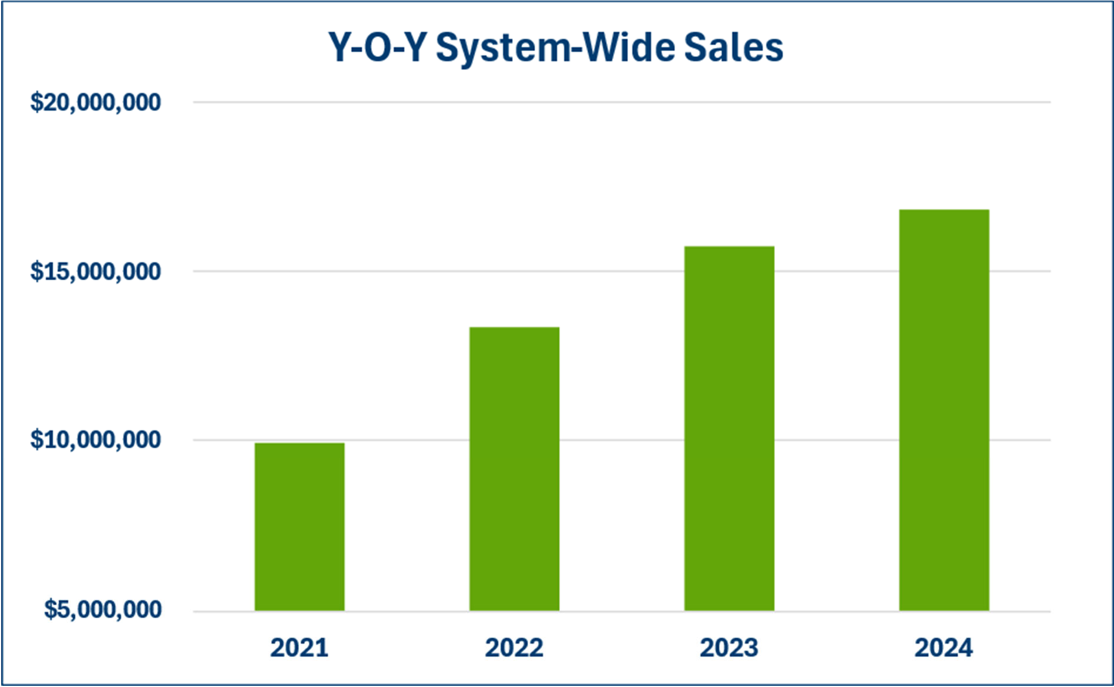

[CONTINUED ON THE FOLLOWING PAGE]

**2024 Gross Revenue Metrics**

|  |  |  |  |  |  |
| --- | --- | --- | --- | --- | --- |
| **2024 Gross Revenue** | **Number of Franchisees** | **Number of Franchisees (%)** | **Number of Franchised Units Owned & Operated by Franchisees** | **Number of Franchised Units Owned & Operated by Franchisees (%)** |  |
| **1,000,001+** | 3 | 8% | 22 | 19% |
| **$500,001-$1,000,000** | 9 | 25% | 39 | 34% |
| **$250,001-$500,000** | 14 | 39% | 35 | 30% |
| **$100,000-$250,000** | 8 | 22% | 15 | 13% |
| **Less than $100,000** | 2 | 6% | 5 | 4% |
| **Total Franchisees** | 36 |  | 116 |  |
|  |  |  |  |  |
| **2024 Gross Revenue** | **Low Number of Franchised Units Owned Per Franchise** | **Median Number of Franchised Units Owned Per Franchise** | **High Number of Franchised Units Owned Per Franchise** | **Average Number of Franchised Outlets Owned Per Franchise** | **# of Franchisees that Exceed Average** |
| **1,000,001+** | 3 | 7 | 12 | 7 | 2 |
| **$500,001-$1,000,000** | 2 | 5 | 7 | 4 | 5 |
| **$250,001-$500,000** | 1 | 2 | 5 | 2 | 5 |
| **$100,000-$250,000** | 1 | 2 | 4 | 2 | 2 |
| **Less than $100,000** | 1 | 2.5 | 4 | 3 | 1 |
|  |  |  |  |  |  |
| **2024 Gross Revenue** | **Min Length of Time Franchisee Has Owned Franchise In Years** | **Median Length of Time Franchisee Has Owned Franchise In Years** | **Max Length of Time Franchisee Has Owned**  **Franchise In Years** | **Average Length of Time Franchisee Has Owned Franchise In Years** | **# of Franchisees that Exceed Average** |
| **1,000,001+** | 5.3 | 5.6 | 9.0 | 6.7 | 1 |
| **$500,001-$1,000,000** | 2.3 | 5.7 | 6.6 | 5.4 | 6 |
| **$250,001-$500,000** | 2.3 | 5.6 | 12.7 | 5.9 | 6 |
| **$100,000-$250,000** | 3.3 | 5.0 | 6.1 | 4.4 | 5 |
| **Less than $100,000** | 3.0 | 4.7 | 6.3 | 4.7 | 1 |

**2024 Gross Revenue by Years Active**

|  |  |  |  |  |  |  |  |
| --- | --- | --- | --- | --- | --- | --- | --- |
|  | **Low Revenue** | **High Revenue** | **Average Revenue** | **Median Revenue** | **# of Franchisees** | **# of Outlets** | **# of Franchisees Who Exceed Average** |
| **At Least 2 Full Years** | $271,241.54 | $573,560.27 | $422,400.91 | $422,400.91 | 2 | 6 | 1 |
| **At Least 3 Full Years** | $94,966.06 | $384,085.32 | $175,990.45 | $112,455.21 | 4 | 8 | 1 |
| **At Least 4 Full Years** | $139,553.44 | $773,934.35 | $308,595.81 | $220,786.32 | 6 | 13 | 2 |
| **At Least 5 Full Years** | $143,587.68 | $1,484,755.83 | $606,712.32 | $495,929.99 | 13 | 56 | 6 |
| **At Least 6 Full Years** | $40,055.71 | $961,226.61 | $428,309.80 | $379,380.59 | 9 | 21 | 4 |
| **At Least 7+ Full Years** | $490,437.48 | $1,068,513.00 | $779,475.24 | $779,475.24 | 2 | 10 | 1 |

This is a historic financial performance representation. The representation only relates to the subset of franchised outlets identified above does not relate to the performance of all of the System’s existing franchisees or franchised outlets.

No franchised outlets included in this Item 19 received any services that were not generally available to other Fitness Machine Technicians franchised outlets, and each outlet offered similar products and services as would generally be offered by a typical Fitness Machine Technicians franchised outlet.

### Some outlets have sold this amount. Your individual results may differ. There is no assurance that you’ll sell as much.

Written substantiation for the financial performance representation will be made available to the prospective franchisee upon reasonable request.

Other than the preceding financial performance representation, we do not make any financial performance representations. We also do not authorize our employees or representatives to make any such representations either orally or in writing. If you are purchasing an existing outlet, however, we may provide you with the actual records of that outlet. If you receive any other financial performance information or projections of your future income, you should report it to the franchisor’s management by contacting Jason Pritchard at 2359 Perimeter Pointe Parkway, Suite 250, Charlotte, North Carolina 28208 and 800-709-1190, the Federal Trade Commission, and the appropriate state regulatory agencies**.**

# ITEM 20: OUTLETS AND FRANCHISEE INFORMATION

### Table No. 1 Systemwide Outlet Summary

### For years 2022 to 2024

|  |  |  |  |  |
| --- | --- | --- | --- | --- |
| **Outlet Type** | **Year** | **Outlets at the Start of the Year** | **Outlets at the End of the Year** | **Net Change** |
| Franchised* | 2022 | 110 | 103 | -7 |
| 2023 | 103 | 121 | +18 |
| 2024 | 121 | 132 | +11 |
| Company- Owned** | 2022 | 3 | 3 | 0 |
| 2023 | 3 | 4 | +1 |
| 2024 | 4 | 8 | +4 |
| **Total Outlets** | **2022** | **113** | **106** | **-7** |
| **2023** | **106** | **125** | **+19** |
| **2024** | **125** | **140** | **+15** |

* The Item 20 charts reflect the number of franchised territories instead of the number of specific franchisees since several franchisees have multiple franchise agreements for multiple territories.

**The Company-Owned territories in the above chart are owned and operated by us (Nebraska) and our affiliate Fitness Machine Technicians - Malvern (Pennsylvania). See Item 1.

### Table No. 2

### Transfers of Outlets from Franchisees to New Owners (other than the Franchisor) For years 2022 to 2024

|  |  |  |
| --- | --- | --- |
| **State** | **Year** | **Number of Transfers** |
| California | 2022 | 2 |
| 2023 | 0 |
| 2024 | 0 |
| Florida | 2022 | 2 |
| 2023 | 0 |
| 2024 | 0 |
| Georgia | 2022 | 1 |
| 2023 | 0 |
| 2024 | 4 |
| Kansas | 2022 | 0 |
| 2023 | 0 |
| 2024 | 2 |
| Kentucky | 2022 | 1 |

|  |  |  |
| --- | --- | --- |
| **State** | **Year** | **Number of Transfers** |
|  | 2023 | 0 |
| 2024 | 0 |
| Massachusetts | 2022 | 0 |
| 2023 | 0 |
| 2024 | 2 |
| Nebraska | 2022 | 0 |
| 2023 | 1 |
| 2024 | 0 |
| Nevada | 2022 | 0 |
| 2023 | 0 |
| 2024 | 2 |
| North Carolina | 2022 | 1 |
| 2023 | 2 |
| 2024 | 0 |
| Ohio | 2022 | 3 |
| 2023 | 0 |
| 2024 | 0 |
| Pennsylvania | 2022 | 0 |
| 2023 | 0 |
| 2024 | 4 |
| South Carolina | 2022 | 0 |
| 2023 | 0 |
| 2024 | 0 |
| Utah | 2022 | 0 |
| 2023 | 0 |
| 2024 | 0 |
| **Totals** | **2022** | **10** |
| **2023** | **3** |
| **2024** | **14** |

### Table No. 3

### Status of Franchised Outlets For years 2022 to 2024

|  |  |  |  |  |  |  |  |  |
| --- | --- | --- | --- | --- | --- | --- | --- | --- |
| **State** | **Year** | **Outlets at Start of Year** | **Outlets Opened** | **Terminations** | **Non Renewals** | **Reacquired by Franchisor** | **Ceased Operations Other Reasons** | **Outlets at End of the Year** |
| Arizona | 2022 | 0 | 0 | 0 | 0 | 0 | 0 | 0 |
| 2023 | 0 | 0 | 0 | 0 | 0 | 0 | 0 |
| 2024 | 0 | 4 | 0 | 0 | 0 | 0 | 4 |
| California | 2022 | 16 | 0 | 0 | 0 | 0 | 0 | 16 |
| 2023 | 16 | 0 | 0 | 0 | 0 | 0 | 16 |
| 2024 | 16 | 0 | 0 | 0 | 0 | 0 | 16 |
| Colorado | 2022 | 4 | 0 | 0 | 0 | 0 | 0 | 4 |
| 2023 | 4 | 0 | 0 | 0 | 0 | 0 | 4 |
| 2024 | 4 | 0 | 0 | 0 | 0 | 0 | 4 |
| Connecticut | 2022 | 0 | 0 | 0 | 0 | 0 | 0 | 0 |
| 2023 | 0 | 1 | 0 | 0 | 0 | 0 | 1 |
| 2024 | 1 | 0 | 0 | 0 | 0 | 0 | 1 |
| Delaware | 2022 | 1 | 0 | 0 | 0 | 0 | 0 | 1 |
| 2023 | 1 | 0 | 0 | 0 | 0 | 0 | 1 |
| 2024 | 1 | 0 | 0 | 0 | 0 | 0 | 1 |
| Florida | 2022 | 7 | 0 | 0 | 0 | 0 | 0 | 7 |
| 2023 | 7 | 1 | 0 | 0 | 0 | 0 | 8 |
| 2024 | 8 | 5 | 0 | 0 | 0 | 0 | 13 |
| Georgia | 2022 | 4 | 0 | 0 | 0 | 0 | 0 | 4 |
| 2023 | 4 | 0 | 0 | 0 | 0 | 0 | 4 |
| 2024 | 4 | 0 | 0 | 0 | 0 | 0 | 4 |
| Iowa | 2022 | 0 | 0 | 0 | 0 | 0 | 0 | 0 |
| 2023 | 0 | 1 | 0 | 0 | 0 | 0 | 1 |
| 2024 | 1 | 0 | 0 | 0 | 0 | 0 | 1 |
| Idaho | 2022 | 1 | 0 | 0 | 0 | 0 | 0 | 1 |
| 2023 | 1 | 0 | 0 | 0 | 0 | 0 | 1 |
| 2024 | 1 | 0 | 0 | 0 | 0 | 0 | 1 |
| Illinois | 2022 | 3 | 0 | 0 | 0 | 0 | 3 | 0 |
| 2023 | 0 | 4 | 0 | 0 | 0 | 0 | 4 |
| 2024 | 4 | 0 | 0 | 0 | 0 | 0 | 4 |
| Indiana | 2022 | 2 | 0 | 0 | 0 | 0 | 0 | 2 |
| 2023 | 2 | 2 | 0 | 0 | 0 | 0 | 4 |

|  |  |  |  |  |  |  |  |  |
| --- | --- | --- | --- | --- | --- | --- | --- | --- |
|  | 2024 | 4 | 0 | 0 | 0 | 2 | 0 | 2 |
| Kansas | 2022 | 3 | 0 | 0 | 0 | 0 | 0 | 3 |
| 2023 | 3 | 0 | 0 | 0 | 0 | 0 | 3 |
| 2024 | 3 | 0 | 0 | 0 | 0 | 0 | 3 |
| Kentucky | 2022 | 2 | 0 | 0 | 0 | 0 | 0 | 2 |
| 2023 | 2 | 0 | 0 | 0 | 0 | 0 | 2 |
| 2024 | 2 | 0 | 0 | 0 | 0 | 0 | 2 |
| Massachusetts | 2022 | 2 | 0 | 0 | 0 | 0 | 0 | 2 |
| 2023 | 2 | 0 | 0 | 0 | 0 | 0 | 2 |
| 2024 | 2 | 2 | 0 | 0 | 0 | 0 | 4 |
| Maryland | 2022 | 3 | 0 | 0 | 0 | 0 | 0 | 3 |
| 2023 | 3 | 0 | 0 | 0 | 0 | 0 | 3 |
| 2024 | 3 | 0 | 0 | 0 | 0 | 0 | 3 |
| Michigan | 2022 | 4 | 0 | 0 | 0 | 0 | 0 | 4 |
| 2023 | 4 | 0 | 0 | 0 | 0 | 0 | 4 |
| 2024 | 4 | 0 | 0 | 0 | 0 | 0 | 4 |
| Minnesota | 2022 | 2 | 0 | 0 | 0 | 0 | 0 | 2 |
| 2023 | 2 | 0 | 0 | 0 | 0 | 0 | 2 |
| 2024 | 2 | 0 | 0 | 0 | 0 | 0 | 2 |
| Missouri | 2022 | 1 | 0 | 0 | 0 | 0 | 0 | 1 |
| 2023 | 1 | 1 | 0 | 0 | 0 | 0 | 2 |
| 2024 | 2 | 0 | 0 | 0 | 0 | 0 | 2 |
| Nebraska | 2022 | 1 | 0 | 0 | 0 | 0 | 0 | 1 |
| 2023 | 1 | 0 | 0 | 0 | 1 | 0 | 0 |
| 2024 | 0 | 0 | 0 | 0 | 0 | 0 | 0 |
| Nevada | 2022 | 2 | 0 | 0 | 0 | 0 | 0 | 2 |
| 2023 | 2 | 0 | 0 | 0 | 0 | 0 | 2 |
| 2024 | 2 | 0 | 0 | 0 | 0 | 0 | 2 |
| New Jersey | 2022 | 6 | 0 | 0 | 0 | 0 | 0 | 6 |
| 2023 | 6 | 0 | 0 | 0 | 0 | 0 | 6 |
| 2024 | 6 | 0 | 0 | 0 | 0 | 0 | 6 |
| New Mexico | 2022 | 0 | 0 | 0 | 0 | 0 | 0 | 0 |
| 2023 | 0 | 1 | 0 | 0 | 0 | 0 | 1 |
| 2024 | 1 | 0 | 0 | 0 | 0 | 0 | 1 |
| New York | 2022 | 11 | 0 | 0 | 0 | 0 | 4 | 7 |
| 2023 | 7 | 0 | 0 | 0 | 0 | 0 | 7 |
| 2024 | 7 | 0 | 0 | 0 | 0 | 0 | 7 |
|  | 2022 | 4 | 0 | 0 | 0 | 0 | 0 | 4 |

|  |  |  |  |  |  |  |  |  |
| --- | --- | --- | --- | --- | --- | --- | --- | --- |
| North Carolina | 2023 | 4 | 0 | 0 | 0 | 0 | 0 | 4 |
| 2024 | 4 | 0 | 0 | 0 | 0 | 0 | 4 |
| Ohio | 2022 | 5 | 0 | 0 | 0 | 0 | 0 | 5 |
| 2023 | 5 | 2 | 0 | 0 | 0 | 0 | 7 |
| 2024 | 7 | 0 | 0 | 0 | 0 | 0 | 7 |
| Oregon | 2022 | 1 | 0 | 0 | 0 | 0 | 0 | 1 |
| 2023 | 1 | 0 | 0 | 0 | 0 | 0 | 1 |
| 2024 | 1 | 0 | 0 | 0 | 0 | 0 | 1 |
| Pennsylvania | 2022 | 5 | 0 | 0 | 0 | 0 | 0 | 5 |
| 2023 | 5 | 2 | 0 | 0 | 0 | 0 | 7 |
| 2024 | 7 | 1 | 0 | 0 | 4 | 0 | 4 |
| South Carolina | 2022 | 2 | 0 | 0 | 0 | 0 | 0 | 2 |
| 2023 | 2 | 0 | 0 | 0 | 0 | 0 | 2 |
| 2024 | 2 | 1 | 0 | 0 | 0 | 0 | 3 |
| Tennessee | 2022 | 2 | 0 | 0 | 0 | 0 | 0 | 2 |
| 2023 | 2 | 0 | 0 | 0 | 0 | 0 | 2 |
| 2024 | 2 | 0 | 0 | 0 | 0 | 0 | 2 |
| Texas | 2022 | 9 | 0 | 0 | 0 | 0 | 0 | 9 |
| 2023 | 9 | 2 | 0 | 0 | 0 | 0 | 11 |
| 2024 | 11 | 0 | 0 | 0 | 0 | 0 | 11 |
| Utah | 2022 | 2 | 0 | 0 | 0 | 0 | 0 | 2 |
| 2023 | 2 | 0 | 0 | 0 | 0 | 0 | 2 |
| 2024 | 2 | 1 | 0 | 0 | 0 | 0 | 3 |
| Virginia | 2022 | 0 | 0 | 0 | 0 | 0 | 0 | 0 |
| 2023 | 0 | 2 | 0 | 0 | 0 | 0 | 2 |
| 2024 | 2 | 3 | 0 | 0 | 0 | 0 | 5 |
| Washington | 2022 | 3 | 0 | 0 | 0 | 0 | 0 | 3 |
| 2023 | 3 | 0 | 0 | 0 | 0 | 0 | 3 |
| 2024 | 3 | 0 | 0 | 0 | 0 | 0 | 3 |
| Wisconsin | 2022 | 2 | 0 | 0 | 0 | 0 | 0 | 2 |
| 2023 | 2 | 0 | 0 | 0 | 0 | 0 | 2 |
| 2024 | 2 | 0 | 0 | 0 | 0 | 0 | 2 |
| **Totals** | **2022** | **110** | **0** | **0** | **0** | **0** | **7** | **103** |
| **2023** | **103** | **19** | **0** | **0** | **1** | **0** | **121** |
| **2024** | **121** | **17** | **0** | **0** | **6** | **0** | **132** |

*We reacquired 1 Franchised Business in Nebraska in 2023 and are operating it directly.

### Table No. 4

### Status of Company-Owned Outlets For years 2022 to 2024

|  |  |  |  |  |  |  |  |
| --- | --- | --- | --- | --- | --- | --- | --- |
| **State** | **Year** | **Outlets at Start of Year** | **Outlets Opened** | **Outlets Reacquired from Franchisee** | **Outlets Closed** | **Outlets Sold to Franchisee** | **Outlets at End of the Year** |
| Pennsylvania | 2022 | 3 | 0 | 0 | 0 | 0 | 3 |
| 2023 | 3 | 0 | 0 | 0 | 0 | 3 |
| 2024 | 3 | 0 | 4 | 0 | 0 | 7 |
| Nebraska | 2022 | 0 | 0 | 0 | 0 | 0 | 0 |
| 2023 | 0 | 0 | 1 | 0 | 0 | 1 |
| 2024 | 1 | 0 | 0 | 0 | 0 | 1 |
| **Total** | **2022** | **3** | **0** | **0** | **0** | **0** | **3** |
| **2023** | **3** | **0** | **1** | **0** | **0** | **4** |
| **2024** | **4** | **0** | **4** | **0** | **0** | **8** |

The Company-Owned territories in the above chart are owned and operated by us (Nebraska) and our affiliate Powersmith (Pennsylvania).

### Table No. 5

### Projected Openings as of December 31, 2024, for 2025

|  |  |  |  |
| --- | --- | --- | --- |
| **State** | **Franchise Agreements Signed But Outlet Not Opened** | **Projected New Franchised Outlets in the Next Fiscal Year** | **Projected New Company-Owned Outlets in the Next Fiscal Year** |
| Alabama | 0 | 1 | 0 |
| Arizona | 0 | 1 | 0 |
| Florida | 0 | 1 | 0 |
| Indiana | 0 | 3 | 0 |
| Oklahoma | 0 | 1 | 0 |
| Pennsylvania | 0 | 1 | 0 |
| Texas | 0 | 1 | 0 |
| **Totals** | **0** | **8** | **0** |

A list of the names of all franchisee and the addresses and telephones numbers of their Businesses is contained in Exhibit D to this Disclosure Document.

The name, city, state and current business telephone number (or if unknown, the last known home telephone number) of every franchisee who had a Business terminated, cancelled, not renewed or otherwise voluntarily or involuntarily ceased to do business under its agreement during the most recently completed fiscal year or who has not communicated with us within 10 weeks of the issuance date of this Disclosure

Document will be listed on Exhibit E to this Disclosure Document when applicable. **If you buy this franchise, your contact information may be disclosed to other buyers when you leave the franchise system.**

During the last three fiscal years, we have not had any franchisees sign confidentiality provisions that would restrict their ability to speak openly about their experience with the Fitness Machine Technicians FMT System.

There are no trademark-specific organizations formed by our franchisees that are associated with the Fitness Machine Technicians FMT System.

## ITEM 21: FINANCIAL STATEMENTS

Attached to this Franchise Disclosure Document as Exhibit F are the following financial statements:

1. Our interim, unaudited financial statements for the period from January 1, 2025 to March 31, 2025.
2. Our audited financial statements for the years ended December 31, 2024 and 2023.
3. Our audited financial statements for the years ended December 31, 2023 and 2022.

We changed our name from Authority Franchising, LLC to Main Line Brands LLC effective on March 18, 2021, which is not reflected in the financial statements.

Our fiscal year end is December 31st of each year.

## ITEM 22: CONTRACTS

The following agreements are attached as exhibits to this Disclosure Document: Franchise Agreement – Exhibit B

Form of General Release – Exhibit G

## ITEM 23: RECEIPTS

Attached are two copies of an acknowledgment of receipt by you, acknowledging receipt of this Disclosure Document by you, together with accompanying documents. Please sign and date both, keeping one for your files.

REMAINDER OF PAGE LEFT BLANK INTENTIONALLY

49

**EXHIBIT A TO THE DISCLOSURE DOCUMENT AGENTS FOR SERVICE OF PROCESS/STATE ADMINISTRATORS**

This list includes the names, addresses and telephone numbers of state agencies having responsibility for franchising disclosure/registration laws, and serving as our agents for service of process (to the extent that we are registered in their states). This list also includes the names, addresses and telephone numbers of other agencies, companies or entities serving as our agents for service of process.

|  |  |  |
| --- | --- | --- |
| **State** | **State Agency** | **Agent for Service of Process** |
| CALIFORNIA | Commissioner of Financial Protection and Innovation Department of Financial Protection and Innovation 320 West 4th Street, Suite 750  Los Angeles, California 90013  (213) 576-7505 or (866) 275-2677  Website: <http://www.dfpi.ca.gov/> Email: [Ask.DFPI@dfpi.ca.gov](mailto:Ask.DFPI@dfpi.ca.gov) | Commissioner of the Department of Financial Protection and Innovation |
| CONNECTICUT | State of Connecticut Department of Banking  Securities & Business Investments Division 260 Constitution Plaza  Hartford, CT 06103-1800  (860) 240-8230 | Banking Commissioner |
| HAWAII | Business Registration Division Department of Commerce and Consumer Affairs  335 Merchant Street, Room 203  Honolulu, HI 96813  (808) 586-2722 | Commissioner of Securities of the State of Hawaii |
| ILLINOIS | Office of Attorney General Franchise Division  500 South Second Street Springfield, IL 62706  (217) 782-4465 | Illinois Attorney General |
| INDIANA | Indiana Secretary of State Securities Division  302 West Washington St., Room E-111 Indianapolis, IN 46204  (317) 232-6681 | Indiana Secretary of State 201 State House  Indianapolis, IN 46204 |
| MARYLAND | Office of the Attorney General Division of Securities  200 St. Paul Place Baltimore, MD 21202-2020  (410) 576-6360 | Maryland Securities Commissioner  200 St. Paul Place Baltimore, MD 21202-2020  (410) 576-6360 |
| MICHIGAN | Michigan Department of Attorney General Consumer Protection Division  Antitrust and Franchise Unit 670 Law Building  Lansing, MI 48913  (517) 373-7117 | Michigan Department of Commerce, Corporations and Securities Bureau |
| MINNESOTA | Minnesota Department of Commerce 85 7th Place East, Suite 280  St. Paul, MN 55101-2198 (651) 539-1500 | Minnesota Commissioner of Commerce |

|  |  |  |
| --- | --- | --- |
| **State** | **State Agency** | **Agent for Service of Process** |
| NEW YORK | NYS Department of Law  Investor Protection Bureau 28 Liberty Street, 21st FL New York, NY 10005  212-416-8222 | Attention: New York Secretary of  State  New York Department of State One Commerce Plaza  99 Washington Avenue, 6th Floor Albany, NY 11231-0001  (518) 473-2492 |
| NORTH DAKOTA | North Dakota Securities Department 600 East Boulevard Avenue,  State Capitol, 14th Floor, Dept 414 Bismarck, ND 58505-0510  701-328-4712 | North Dakota Securities Commissioner  North Dakota Securities Department  600 East Boulevard Avenue,  State Capitol, 14th Floor, Dept 414 Bismarck, ND 58505-0510  701-328-4712 |
| OREGON | Department of Consumer and Business Services Division of Finance and Corporate Labor and Industries Building  Salem, Oregon 97310  (503) 378-4387 | Director of the Department of Consumer and Business Services |
| RHODE ISLAND | Department of Business Regulation Division of Securities  1511 Pontiac Avenue, Building 69-1  Cranston, RI 02920  (401) 462-9585 | Director of Rhode Island Department of Business Regulation |
| SOUTH DAKOTA | Division of Insurance Securities Regulation  124 South Euclid, Suite 104  Pierre, SD 57501  (605) 773-3563 | Director of Insurance-Securities Regulation |
| VIRGINIA | State Corporation Commission  Division of Securities and Retail Franchising 1300 East Main Street, 9th Floor  Richmond, VA 23219  (804) 371-9051 | Clerk of State Corporation Commission  1300 East Main Street, 1st Floor Richmond, VA 23219  (804) 371-9733 |
| WASHINGTON | Securities Division,  Department of Financial Institutions PO Box 41200  Olympia, WA 98504-1200  (360) 902-8760 | Director of Washington Financial Institutions  Securities Division 150 Israel Road, SW Tumwater, WA 98501  (360) 902-8760 |
| WISCONSIN | Wisconsin Securities Commissioner Securities and Franchise Registration 345 W. Washington Avenue Madison, WI 53703  (608) 266-8559 | Commissioner of Securities of Wisconsin |

**EXHIBIT B TO THE DISCLOSURE DOCUMENT FRANCHISE AGREEMENT**



**MAIN LINE BRANDS LLC FRANCHISE AGREEMENT**

### Type of Franchise:

### Full-Size Franchise Hometown Franchise

**FRANCHISEE**

**DATE OF AGREEMENT**

**TABLE OF CONTENTS**

**ARTICLE 1: DEFINITIONS 2**

**ARTICLE 2: GRANT OF FRANCHISE AND LICENSE 3**

**ARTICLE 3: TERRITORIAL SCOPE, RESTRICTIONS ON YOU AND OUR RESERVED RIGHTS 4**

**ARTICLE 4: TERM AND SUCCESSOR OPTION 5**

**ARTICLE 5: OUR DUTIES 6**

**ARTICLE 6: CONFIDENTIAL BRAND STANDARDS MANUALS 9**

**ARTICLE 7: PROPRIETARY MARKS, TRADE NAMES AND COPYRIGHTED MATERIALS 10**

**ARTICLE 8: PAYMENTS TO US 13**

**ARTICLE 9: YOUR OBLIGATIONS 16**

**ARTICLE 10: ADVERTISING 22**

**ARTICLE 11: REPORTING AND FINANCIAL MANAGEMENT REQUIREMENTS 24**

**ARTICLE 12: INDEPENDENT CONTRACTOR AND INDEMNIFICATION 25**

**ARTICLE 13: CONFIDENTIAL INFORMATION 27**

**ARTICLE 14: COVENANTS NOT TO COMPETE 28**

**ARTICLE 15: ASSIGNMENT AND RIGHT OF FIRST REFUSAL 30**

**ARTICLE 16: DEFAULT AND TERMINATION 33**

**ARTICLE 17: FURTHER OBLIGATIONS AND RIGHTS OF THE PARTIES UPON TERMINATION OR****EXPIRATION 37**

**ARTICLE 18: MODIFICATION OF SYSTEM 39**

**ARTICLE 19: GENERAL PROVISIONS 40**

**ARTICLE 20: DISPUTE RESOLUTION 44**

**ARTICLE 21: SUBMISSION OF AGREEMENT 47**

ATTACHMENTS:

1. Territory
2. Confidentiality (and Non-Competition) Agreement
3. Internet Website and Listings Agreement; Telephone Listings Agreement
4. Guaranty
5. Multi-State Addendum
6. Electronic Funds Transfer Authorization
7. Transfer of Franchise to a Corporation or Limited Liability Company
8. Accounts Program Participation Agreement

**FRANCHISE AGREEMENT**

**THIS AGREEMENT** is made and entered into this between Main Line Brands LLC, a Delaware limited liability company with its principal office at 2359 Perimeter Pointe Parkway, Suite 250, Charlotte, North Carolina 28208 (“we”, “us” or “our”), and

whose principal address is , an individual/partnership/corporation domiciled in the State of and

‘s principals , an individual residing at

, an individual residing at (“Principal(s)”).

And Principal(s) shall be collectively referred to in this Agreement as “you” or “your” or the “Franchisee”.

**W I T N E S S E T H:**

**WHEREAS**, we, our affiliate and our predecessor have developed, and we are in the process of further developing, a unique, proprietary and evolving system (“System”) relating to the establishment and operation of a business that provides maintenance and repair products and services for exercise equipment using the Proprietary Properties, Copyrights, Know How, and Proprietary Marks, all as defined in further detail below;

**WHEREAS**, you desire to enter into the business of owning and operating an “Fitness Machine Technicians FMT” Franchised Business (“FMT Business” or “Franchised Business”) in accordance with the System and wish to obtain a franchise from us for that purpose, as well as to receive the training and other assistance provided by us in connection therewith;

**WHEREAS**, you understand and acknowledge the importance of and benefits to be derived from the System, as well as our high standards of quality and service and the necessity of operating the Franchised Business in conformity with our standards and specifications;

**WHEREAS**, you desire to obtain a Franchise to use the System and the Proprietary Marks at the location described in Attachment 1 pursuant to the provisions of this Agreement, and you have had a full and adequate opportunity to be thoroughly advised of the terms and conditions of this Franchise Agreement by counsel of your own choosing, and you represent and warrant that you have the business experience and financial ability to operate an FMT Business;

**WHEREAS**, you acknowledge that you have read this Agreement and our Disclosure Document and that you understand and accept the terms, conditions and covenants contained in this Agreement as being reasonably necessary to maintain uniform high standards of quality at all locations and to protect the goodwill of the Proprietary Marks;

**WHEREAS**, you acknowledge that this Agreement places detailed and substantial obligations on you including strict adherence to our reasonable present and future requirements regarding facilities, equipment, suppliers, operating procedures, licensing requirements, management protocols and procedures, merchandising strategies, sales promotion programs and related matters. You acknowledge that future improvements, changes and developments in the System may require additional expense to be undertaken by you, but shall not be unreasonably imposed by us.

**NOW, THEREFORE**, for and in consideration of the mutual undertakings, covenants, premises and commitments contained above and below, and other good and valuable consideration , the receipt and sufficiency of which are hereby acknowledged, **IT IS AGREED**, as follows:

## ARTICLE 1: DEFINITIONS

* 1. In addition to any other terms defined in this Agreement, the following definitions shall govern this Agreement:
     1. “Agreement” means this document, including all exhibits hereto and documents referenced and incorporated herein, and any properly executed documents or agreements modifying the System.
     2. “Artificial Intelligence” means a field of science concerned with building computers and machines that can reason, learn, and act in such a way that would normally require human intelligence or that involves data whose scale exceeds what humans can analyze.
     3. “Copyrights” means all work rendered in a tangible medium of expression as defined under U.S. Copyright Law, 17 U.S.C. Sec. 101, *et seq.*, that relates to the FMT Business, whether published or unpublished, whether confidential or not, whether created by us, our affiliates or one (1) or more of our franchisees, assigned hereunder to and owned by us and licensed for use by you as part of the FMT Business under this Agreement, including without limitation, the Brand Standards Manuals.
     4. “Franchised Business” or “FMT Business” means the business that you are licensed to conduct in the Territory.
     5. “Know How” means our: (a) trade secrets and know-how, whether existing now or created during the term of this Agreement by us, our affiliates and/or one (1) or more of our franchisees (and assigned back to us), as conveyed to you, that relate to, *inter alia*, our products and/or processes, marketing practices, and business methods, affairs, tools and techniques, as well as including our client lists and trade relationships including pricing information, which tends to give us and our network of franchisees a competitive edge over others who provide the same or similar products or services in the field of exercise equipment maintenance and repair; (b) inventions that may be protected by the filing of U.S. patent applications under Title 35 of the United States Code and/or foreign statutory counterparts; and (c) all unpublished or otherwise confidential work that has been rendered and “work made for hire” protected under Title 17 of the United States Code and other applicable foreign copyright statutes. Know How need not take the form of any particular tangible medium of expression, but may also be found or contained in the form of records, magnetic media, papers, photographs, catalogs, books, cassettes, videotapes, computer files, or stored or fixed on computer hard or soft disks or diskettes.
     6. “Proprietary Marks” means all the Proprietary Marks, service marks, logos, emblems, and indicia of origin used or contemplated to be used by us and/or one (1) or more of our franchisees and other such trade names, service marks and Proprietary Marks as may be designated now or hereafter by us.
     7. “Proprietary Properties” means the Copyrights, Know How, and Proprietary

Marks.

* + 1. “Social Media” means any and all existing or future forms of electronic communication, whether for business or personal use (including via Internet forums, weblogs, social blogs, wikis, podcasts, pictures and videos) through which users create or use online networks or communities (including but not limited through online communities such as Facebook, Twitter, Instagram, SnapChat, LinkedIn, YouTube, Yelp or Wikipedia and other similar content sharing outlets) to share information, ideas, personal messages, and other online content.
    2. “System” means the conglomerate of Proprietary Properties created as a result of the expenditure of time, skill, effort, and money, for the provision of exercise equipment maintenance and repair services, consisting of all services provided and the marketing of such services.
    3. “Territory” means and constitutes the territorial limits of the exclusive license granted to you hereunder (geographically defined in Attachment 1) to use the Proprietary Marks, Know How, Copyrights, and any other Proprietary Properties as part of the System in connection with the Franchised Business, in accordance with the definitions and terms of this Agreement. A typical Territory will include an area containing a population of approximately eight hundred thousand (800,000) people.
    4. “Website” means an Internet website that we may develop and maintain to advertise and promote ourselves and FMT Businesses generally, and the Products and Services offered by FMT Businesses, and to facilitate the sale of Franchises for a FMT Business.

## ARTICLE 2: GRANT OF FRANCHISE AND LICENSE

### Grant of Franchise

Subject to the provisions of this Agreement and all documents or other agreements ancillary

thereto:

* + 1. We hereby grant to you, and you hereby accept, the exclusive franchise and license to operate an FMT Business within your Territory, in accordance with our specifications and this Agreement, and subject to our approval. This license is not sub-licensable, sub-contractable, nor assignable, except as may be set forth in this Agreement.
    2. You agree to use the Proprietary Properties solely for the Franchised Business in your Territory, and for no other purpose.
    3. The Initial Franchise Fee for a Full-Size Franchise is $45,000, which is based on an area with a combined population of up approximately 800,000 people based on the most recent U.S. Census data. The Initial Franchise Fee for a Hometown Franchise is $25,000. See the Cover Page of this Agreement.

### Relocation of the Franchised Business

You may not relocate your Franchised Business without our prior approval. We will not unreasonably withhold our approval, except that the new location must be within your Territory and must not have any adverse impact on the sales of franchisees in any adjoining Territory. If you wish to relocate your Franchised Business to a location outside of your Territory, the area to which you wish to relocate your Franchised Business must be available (not sold to another franchisee in the System) and you must be in compliance with this Agreement. If you operate the Franchised Business from a home office and you choose to sell your home and move to a new area, we reserve the right to require you to lease premises within your Territory for the Franchised Business.

## ARTICLE 3: TERRITORIAL SCOPE, RESTRICTIONS ON YOU AND OUR RESERVED RIGHTS

### Restriction on Use of Proprietary Properties

Your right to operate the Franchised Business and the right to use and display the Proprietary Marks and other Proprietary Properties is restricted to the Territory described in Attachment 1. No use of any part or all of the Proprietary Properties is permitted outside of the Territory, unless in accordance with this paragraph.

### Limitations on Your Activities

Your activities are limited to offering and selling those products and services permitted by way of this Agreement under the System from the approved location(s) in the Territory. You have been granted no right of ownership in and/or to any part or all of the Proprietary Properties.

### Rights Reserved to Us

We reserve the right: (i) of ownership in, and control over the Proprietary Properties; (ii) to grant additional franchises, whether similar or dissimilar to the franchise granted by this Agreement, outside of the Territory; (iii) to engage fully and freely and without limitation in each and every aspect of the business of selling related services, products and equipment; (iv) to offer to the public-at-large, separately, jointly or with others, all related services and/or products of every type and kind; and (v) to employ and exploit the Proprietary Marks, Copyrights, and Know How in connection therewith. Notwithstanding, if we determine that you are unable or unwilling, or you notify us that you are unable or unwilling, to offer, sell or perform products and services for a prospective customer in the Territory, then we, our Affiliates or another franchisee designated by us may offer, sell and perform such products and services to the customer as we deem appropriate without any payment to you.

### National and Regional Account Programs

We maintain National Account and Regional Account programs. A National Account is a customer that has multiple properties across multiple Territories and/or states. A Regional Account is a customer that has multiple properties in a singly Territory and/or state. You may not negotiate any contract terms with a prospective National Account or Regional Account. We will have sole discretion to negotiate terms with the National Accounts and/or Regional Accounts. We anticipate that you will participate in the National Accounts program, which will require you to provide products and services to the National Account and/or Regional Account according to the agreement we have negotiated with them. We will collect all payments from the National Account for products and services provided by you and other franchisees in the System. You will invoice us each month for any parts and services you delivered to such National Account, less your share of the revenue after deduction of any fees owed to us (such as Royalty Fees and Brand Development Fees). You will be solely responsible for collecting all payments from the Regional Account for products and services provided by you and other franchisees in the System. Upon receipt of payment by any Regional Account, you will be required to remit payment to any Regional Account salesperson, as we may designate. If you collect monies inadvertently that belong to us or another franchisee, you must promptly alert us and comply with our instructions for routing the monies to the correct party.

If you choose not to participate in the National Account or Regional Account program, or if you are unable or unwilling to provide products and services to the National Account or Regional Account as requested, we, our affiliate or a third party (which may be another franchisee) may enter your Territory and service the National Account or Regional Account, and you are not entitled to any portion of the revenue in these circumstances. We also reserve the right to terminate your participation in the National Account

or Regional Account program if you are not providing products and services according to the terms we have negotiated or your participation is not otherwise in compliance with our policies. Should you choose to participate in the National Account and Regional Account programs, you shall execute the Accounts Program Participation Agreement, annexed hereto as Attachment 10.

## ARTICLE 4: TERM AND SUCCESSOR OPTION

### Initial Term

The term of this Agreement shall be ten (10) years commencing on the date of this Agreement, unless sooner terminated in accordance with the provisions of this Agreement (the “Initial Term”).

### Successor Option

Subject to the provisions of this Section, you shall have an option (exercisable only by written notice delivered to us less than nine (9) months, but more than six (6) months, prior to the end of the Initial Term of this Agreement exercisable only by written notice delivered to us less than nine (9) months, but more than six (6) months, prior to the end of the Initial Term of this Agreement) to enter into a new franchise agreement with other agreements and legal instruments and documents customarily employed by us and in the form then generally being offered to prospective franchisees in the state in which the Franchise Business is located (the “Successor Franchise Agreement”) for two (2) additional periods of ten (10) years each, if:

* + 1. you have been, throughout the Initial Term of this Agreement, in substantial compliance, and at the expiration of such Initial Term are in full compliance, with this Agreement, the lease and all other agreements between you and us or companies associated or affiliated with us;
    2. you enter into our then-current Franchise Agreement and all other ancillary agreements, instruments and documents then customarily used by us in the granting of franchises (which then-current Franchise Agreement may materially differ from this Agreement, including a higher rate of fees, different methods of calculating fees due, and different payment methods, which shall be the same as those set out in the franchise agreements being executed at the time of the successor term);
    3. at the time the successor option is exercised and at the time such successor term commences, all monetary obligations to us and any affiliate of ours must be current and must have been current at all times during the preceding twelve (12) months;
    4. you execute a general release running in favor of us, our affiliates and our respective officers, directors and shareholders releasing all claims against us, our officers, directors and shareholders; and
    5. you pay to us a Successor Agreement fee equal to $3,500.

### Refusal to Grant a Successor Franchise Agreement

We can refuse to grant a successor term for your franchise if you fail to substantially comply with the terms of this Agreement, you fail to pay amounts owed to us when due, or you fail to cure of any defaults incurred during the initial term of this Agreement, if applicable.

### Successor Term Under Law

Even though we decline the to grant you a successor term for your franchise, it is possible that we can be required to grant you a successor term under a law, rule, regulation, statute, ordinance, or legal order that is applicable at the time. If that happens, to the extent it is allowed by the concerned law, rule,

regulation, statute, ordinance or order, your successor term will be subject to the conditions of the Franchise Agreement we are using for new franchisees at the time the successor term begins. If we are not then offering new franchises, your successor term will be subject to the terms in the Franchise Agreement that we indicate. If for any reason that is not allowed, the successor term will be governed by the terms of this Agreement.

### Your Election Not to Sign a Successor Franchise Agreement

For the purposes hereof, you shall be deemed to have irrevocably elected not to sign a Successor Franchise Agreement hereunder (and the option to do so shall thereupon terminate) if you fail to execute and return to us our then-standard Franchise Agreement and other ancillary documents required by us for a successor franchise within thirty (30) days after we have delivered them to you.

## ARTICLE 5: OUR DUTIES

### Brand Standards Manuals

We will, in conjunction with our training program and in conformity with the terms and conditions of this Agreement, loan to you for the Initial Term one (1) copy of our brand standards manuals (the “Brand Standards Manuals”). Use of any part or all of the Brand Standards Manuals shall be only as permitted under this Agreement, and during its term.

### Additional Documentation

In addition to any other training offered to you, we will from time to time furnish to you other documents and things comprising the Copyrights or Know How, including instructions, data, materials, forms or other information to the extent developed by us in connection with the operation of the System. We have the right to reasonably incorporate such matters in the Brand Standards Manuals and you are required to conduct the operations of the Franchised Business in accordance therewith.

### Initial Training Program and Additional Assistance

With respect to all franchisees, within sixty (60) days after signing this Agreement, we will offer and you will be required to complete to our satisfaction a training program (the “Training Program”) of such duration as we deem necessary at our headquarters or at such location(s) as we designate. The Training Program will include training regarding operational, management and marketing training pertaining to the FMT System for you and up to two (2) additional persons, for a maximum of three (3) trainees. You shall pay for all of the expenses your trainees incur while attending training, including, but not limited to, travel, lodging, meals and applicable wages.

* + 1. We will pay no compensation for any services performed by the trainees in the course of training.
    2. We reserve the right to determine and change the subject matter and content of the Training Program.
    3. We will provide such additional advisory assistance and training as we deem advisable in the operation of the System, on such terms and conditions as we determine and set forth in the Brand Standards Manuals or otherwise. We may, in our sole and exclusive discretion, cause our representatives to telephone or visit you from time to time for the purpose of rendering advice and consultation with respect to the operation of the Franchised Business, assessing your overall performance and determining whether you are conducting the Franchised Business in compliance with the standards of

the System. You will comply with all such requests and visitations, and provide all information requested upon reasonable notice. If we generate an inspection report as a result of any such telephone call or visit, then we shall supply a copy of that inspection report to you, upon your reasonable written request.

* + 1. We may, at your reasonable request, enroll additional individuals in the Training Program, provided that you pay us our then-current training fee (as set forth in the Brand Standards Manuals), as well as the expenses of the additional trainees, including travel, lodging, meals and applicable wages. Such requests will be honored in accordance with the availability of our training staff.
    2. We reserve the right to elect or decline to train any number of individuals representing any number of franchises individually, or at the same time. Every trainee must sign a Confidentiality and Non-Compete Agreement in advance of receiving any such training.

### Refresher Training

We may hold periodic refresher training classes, and we may designate that attendance at such refresher training is mandatory for all franchisees unless absence is excused by us. We may charge a fee for refresher training, and you must pay all expenses you and your trainees incur while attending any refresher training, including travel, lodging, meals and applicable wages.

### Purchases of Materials; Approved Suppliers

In order to maintain uniformity of concept, color and quality, all proprietary materials and forms, the FMT equipment and materials bearing the Proprietary Marks (including letterhead, business cards, brochures, labels, uniforms, etc.) that are used by you in the operation of your Franchised Business must be purchased from us, our affiliates or the suppliers we designate. We and our affiliate, if an approved supplier of any item, reserve the right to earn a profit on the sale of such items to you. The use or sale of unapproved products or services constitutes a material and incurable breach of this Agreement unless such use or sale occurs as a consequence of an extreme situation and does not constitute a normal business activity.

We will, at all times during the term of this Agreement, provide information pertaining to sources of supply of those proprietary and non-proprietary products and services which may be used in this System. A list of approved suppliers for the System will be included in the Brand Standards Manuals and may be modified or updated by us at any time upon written notice to you. If you wish to use a supplier or product that has not previously been approved by us, you must make a request to us in writing for our approval of the supplier or product, including any pertinent information we require. We will notify you in writing within thirty (30) days if and when a supplier or product is approved, and our approval will not be unreasonably withheld. You or the supplier must reimburse us for our costs related to evaluating the proposed supplier or product. We reserve the right to re-inspect any supplier or product to ensure that the supplier or product continues to conform to our reasonable specifications and standards. If a supplier or product fails to conform to our reasonable specifications and standards, we may revoke our approval of the supplier or product, and you must discontinue using the unapproved product or purchasing from the unapproved supplier after notice from us.

### Computer System

We reserve the right to specify the particular required or approved computer hardware, software and peripheral equipment which you must purchase or lease in order to effectively operate your Franchised Business.

### Pricing

We may advise you in writing, from time to time and to the extent permitted by applicable law, concerning the minimum and/or maximum prices which you shall charge your customers for services provided or goods sold under the System. You understand and acknowledge that you are required to adhere to our pricing requirements, but nothing contained herein shall be deemed a representation by us that if you comply with our requirements you will, in fact, generate or optimize profits.

### Brand Development Fund

We will administer the Brand Development Fund, as described in Article 10 hereof.

### Force Majeure

Delays in the performance by either party of any obligations that are not the fault of nor within the reasonable control of the delayed or non-performing party, including fire, flood, natural disasters, acts of God, governmental acts or orders, or civil disorders, do not give rise to a default by the other party. Rather, the other party will be required to extend the time of performance of any such obligations for the period of such delay or for such other reasonable period of time as may be appropriate in the circumstances. In no event shall any “force majeure” event as described herein include your lack of sufficient operating capital.

### Meetings of Franchisees

We may choose to provide you with continuing national, regional or local workshops, seminars and conferences, which we hold at our discretion. You must pay the workshop, seminar and conference fees, if any, and all travel and living expenses, incurred by you to attend such workshop, seminar, or conference. The fees to attend a workshop, seminar or conference will range from $500 to $5,000, which includes the payment by you of the conference fee ranging from $399 to $999 per conference. We recommend, and may require at our sold discretion, that you attend these workshops, seminars and conferences, which may be held at our Charlotte, North Carolina headquarters or at a location chosen by us. In the event we choose to provide such workshops, seminars or conferences, we will provide you with a minimum of 3 months’ notice regarding the date, place and cost to you of such workshop, seminar or conference. The annual conference may be held at our corporate headquarters or at a location chosen by us. If you fail to attend the annual conference, you will be charged the greater of $699 or that year’s cost to attend.

### Service Vehicles

We shall approve each vehicle you proposed to use in connection with your Franchised Business, which shall include the signage and/or vehicle wrap we require. We will not unreasonably withhold our approval of a service vehicle you propose, provided that it meets our specifications and requirements. We reserve the right to designate a specific make and model of vehicle that you must use in the operation of the Franchised Business. Each vehicle you obtain for your Franchised Business must be wrapped according to our specifications and must be in excellent condition (including no visible rust or body damage). If you have more than one service vehicle, you are permitted to have branded magnets on the body of the vehicle in lieu of wrapping for a period of 6 months. All additional vehicles operated for the benefit of your Franchised business must be wrapped to our specifications no later than 6 months after obtaining the vehicle.

### Additional Assistance or Training

During the term of this Agreement, if you request that we provide additional training or assistance on-site at your Franchised Business, or if we determine that you require additional training or assistance (including, without limitation, related to a mystery shop as described in Section 9.18 below), you must pay

our then-current per diem fee for each representative we send to you to provide training or assistance, and you must reimburse each representative’s travel, lodging and meals expenses while providing the additional on-site training or assistance. We require you to pay a deposit to us of a portion of the estimated costs related to such additional assistance or training, and the balance due is payable by you to us within seven

(7) days after your receipt of our invoice.

### Preventative Maintenance Estimate Review

During your first year of operation, we strongly encourage you to forward to us for our review the preventative maintenance estimates you prepare for your customers. Our review of any estimates you forward to us will assist us in providing training to you to refine your operation of the Franchised Business. We reserve the right to require you to provide us with copies of your preventative maintenance estimates at any time for our review, including if we receive a complaint from one of your customers.

## ARTICLE 6: CONFIDENTIAL BRAND STANDARDS MANUALS

### Operation of Franchised Business in Accordance with Brand Standards Manuals

In order to protect the reputation and goodwill of the Franchisor, the System, and the Proprietary Properties, and to maintain requisite operating standards under the Proprietary Marks, you will conduct your Franchised Business in accordance with the provisions, standards, and procedures set forth in this Agreement and in the Brand Standards Manuals, which governs solely operational issues. We reserve the right to provide the Brand Standards Manuals electronically, such as via a CD-ROM or a password- protected intranet website.

### Confidentiality

You will at all times treat the Brand Standards Manuals, and any other manuals created for or approved for use in the operation of the Franchised Business, and the information contained therein as confidential Know How, and shall use all efforts to maintain such information as secret and confidential in accordance with the terms and conditions governing Know How and Copyrights, including the following. You will not, at any time, without our prior written consent, copy, duplicate, record, or otherwise reproduce the foregoing materials, in whole or in part, nor otherwise make the same available to any unauthorized person. The persons who are authorized include your owners and management personnel who have executed the Confidentiality (and Non-Competition) Agreement, annexed hereto as Attachment 3.

### The Brand Standards Manuals Remain Our Property

The Brand Standards Manuals will at all times remain our sole property, and shall be returned to us immediately upon the expiration or termination of this Agreement.

### Revisions to the Brand Standards Manuals

We may, from time to time, revise the contents of the Brand Standards Manuals when we reasonably consider such revisions to be necessary to improve or maintain the standards of the System and you expressly agree to comply with each new or changed standard, provided, however, that such revisions relate solely to operational matters, are made for all franchisees, are reasonable in nature, and comply with the conditions of Section 5.2 above. Any such revisions to the contents of the Brand Standards Manuals are deemed effective seven (7) days after the date of notification to you unless otherwise specified by us.

### Precedence of Terms

You acknowledge the contents of the Brand Standards Manuals, and any revisions or modifications made to the Brand Standards Manuals, constitute additional provisions of and modifications to this Agreement as if fully set forth in this Agreement. Should any term of the Brand Standards Manuals not be consistent with any term of this Agreement, then this Agreement will take precedence over the inconsistent term in the Brand Standards Manuals, the inconsistent term of the Brand Standards Manuals will not be followed, and the inconsistent term of the Brand Standards Manuals, once brought to our attention, will be promptly changed to conform with the term of this Agreement.

### Brand Standards Manuals Kept Up to Date

You will at all times insure that your copy of the Brand Standards Manuals is kept current and up to date, and in the event of any dispute as to the contents of the Brand Standards Manuals, the terms of the master copy of the Brand Standards Manuals maintained by us at our home office is controlling. All changes and revisions will be dated and numbered by us. You will receive one (1) copy of the Brand Standards Manuals on loan from us for operations purposes.

### Improvements to the System

To the extent that any improvements, inventions or discoveries are made by you or your employees or agents during the course of this Agreement and relating to the Proprietary Properties or System (“improvements”), such improvements are deemed assigned to, and owned by us for the purpose of improving the entirety of the franchised network, and the provision of goods and services in accordance with the System. All documents and other information concerning any such improvements will be disclosed to us promptly after creation or invention. We will, in our sole reasonable discretion, determine whether such improvements are worthy of inclusion in the System, and the best and most practical method of implementation and protection. You will execute all documents reasonably necessary to perfect our ownership in and to any such improvements, and will cooperate with us in the creation, implementation, use and protection thereof.

## ARTICLE 7: PROPRIETARY MARKS, TRADE NAMES AND COPYRIGHTED MATERIALS

### No License to the Proprietary Properties

The license granted in Section 2.1 does not grant you any right, title or interest, at law or in equity, in or to any of the Proprietary Properties, including the Proprietary Marks, Copyrights, and Know How, beyond the license. Further, the license applies only to those portions of the Proprietary Properties which have been or may in the future be designated in writing by us for use by you in conjunction with the operation of the Franchised Business. You will not represent to others, or conduct yourself in any manner that might indicate to others, that you possess any other legal or equitable rights in or to the Proprietary Properties by virtue of the license granted hereunder. The execution of this Agreement by you further establishes your consent that the Proprietary Marks, Copyrights and Know How are valid and enforceable (without defense or recourse), and owned by us or our affiliates. You represent and warrant that you will not attack the validity or, enforceability or ownership of any of the Proprietary Properties, or assist another in any such attack, during the course of this Agreement or thereafter. The terms of this Section shall survive termination or expiration of this Agreement for any reason, in addition to any of the other remedies or survival provisions otherwise contained in this Agreement.

### No Act in Derogation

You will not do or permit any act in derogation of any of the rights of us or our affiliates to the Proprietary Properties.

### No Contest or Dispute

You will not contest or dispute our or our affiliates’ title to any part or all of the Proprietary Properties.

### Use of Proprietary Properties

You shall use the Proprietary Properties solely in accordance with this Agreement and the Brand Standards Manuals.

### Restriction on Use of Proprietary Properties

You shall not use the Proprietary Properties, or any words, phrases, symbols, trade dress, colors, logos or materials which we deem confusingly similar thereto, in your trade name (or for any other purpose) without our prior written approval. In that connection, you will identify yourself to the public as an independent contractor using such language as we shall specify.

### Discontinuance of Use; Telephone Numbers

In addition to all post-termination provisions contained in this Agreement, you agree that after the expiration or termination of this Agreement, you will discontinue the use of the telephone number(s) of the Franchised Business and any internet websites or domain names, whether or not established with our consent; you will not advertise in any telephone directory under the name “FMT” or any other name, phrase or logo used by the System; you will discontinue the use of any or all of the Proprietary Properties; and you will not use any words, phrases, logos, designs, colors, trade dress or the like that in any manner may cause customer confusion, or resemble, be confusingly similar to, or be a colorable imitation of the Proprietary Properties. Additionally, upon our demand, you will direct your local telephone company and internet service provider(s) to transfer the telephone number(s) and any internet websites, domain names or listings to us or our designee by utilization of the forms annexed hereto as Attachment 4, to be signed by you concurrently with signing this Agreement. If you fail promptly to direct your telephone company and internet service provider(s) to effect such transfer, you hereby irrevocably appoint us as your attorney-in- fact to so act.

### Notification of Claim

If you receive notice or learn of any actual or potential claim, suit or demand that has been or may be asserted against you or us involving any alleged infringement, unfair competition, or similar matter relating to the use of the Proprietary Properties, you will promptly notify us of any such actual or potential claim, suit or demand (a “Claim”) and provide complete disclosure of all information concerning or relating to such Claim, including, if requested, affidavit or other sworn testimony as we shall reasonably request to evaluate the Claim. Thereupon, we will promptly take such action as we may deem necessary in our sole discretion to address the Claim. We shall have the sole right to defend, compromise or settle the Claim using attorneys of our own choosing, and you agree to cooperate fully with us in connection with the defense of the Claim. We shall protect, defend and indemnify you in connection with the Claim unless it arises out of or relates to your use of the Proprietary Properties in violation of this Agreement, the Brand Standards Manuals, the Training Program or otherwise.

### Notification of Unauthorized Use

If you learn of any unauthorized use of the Proprietary Properties, you will promptly notify us of the facts relating to such alleged infringing use. We will, in our discretion, determine whether or not to take any action with respect to such information. You have no right to take any action with respect to any unauthorized use of the Proprietary Properties without our prior written consent. We will exercise our discretion based upon, among other things, a cost/benefit analysis of the specific situation as well as the status of any cost sharing agreements that exist or may be arranged with the franchisees to support the subject litigation. We have no obligation, expressed or implied, to take any action with respect to any unauthorized use of the Proprietary Properties when such action does not, at our sole discretion, satisfy our cost/benefit requirements.

You expressly consent and agree that representation of you (or any other franchisee, including its principals) in any Claim by our legal counsel is not substantially related to any issue that may arise between you and us under this Agreement, and that any conflict of interest, actual or implied, as a result of the representation of you in any such Claim by our designated legal counsel is hereby waived. You expressly agree that you will take no action whatsoever to attempt to create any such conflict of interest, nor shall you seek the disqualification of our legal counsel as a consequence of the representation of you in any such Claim. Violation of this provision governing the status of our designated legal counsel shall result in automatic and incurable breach of this Agreement.

### Marks)

### No Ownership; Modification of Proprietary Properties (including Proprietary

You understand and agree that the limited license to use the Proprietary Properties granted by this

Agreement applies only to such properties as are designated by us, together with those which may hereafter be designated by us in writing. You expressly understand and agree that you are bound not to represent in any manner that you have acquired any ownership or equitable rights in any of the Proprietary Properties by virtue of the limited license granted under this Agreement, or by virtue of your use or creation of any of the Proprietary Properties, or upon any other basis.

* + 1. If it becomes advisable at any time, in our discretion, to modify or discontinue use of any aspect of the Proprietary Properties and/or to adopt or use one or more additional or substitute items, then you shall be obligated to comply with any such instruction by us, at your own expense. We shall have no obligation in such event be to reimburse you for any expenses of compliance, such as changing signs, stationery, uniforms, advertising, etc., and you waive any claim arising from or relating to any change, modification or substitution to the Proprietary Properties. You covenant not to commence or join in any litigation or other proceeding against us for any of these expenses.
    2. We represent and warrant that our affiliate, Powersmith, LLC (formerly Powersmith, Inc.), owns the Proprietary Marks free and clear from any liens or encumbrances, that our affiliate has granted to us a license to use and to sub-license the use of the Proprietary Marks, and to the best of our knowledge the license conveyed by this Agreement does not infringe any valid or enforceable trademark rights owned by any other party. We hereby indemnify you from any claims, costs or fees associated with any violation of this provision, subject to the requirement that we be immediately notified of all facts and circumstances that may give rise to liability under this Subsection, and be permitted to control the defense of the action.
    3. Neither we nor you shall take any steps or actions that would in any manner impair, dilute or devalue the Proprietary Marks, and such action shall constitute a material breach of this Agreement. For the purposes of this Subsection, dilution shall be *prima facie* demonstrated by a use of the

Proprietary Marks in connection with any other word, phrase or logo confusingly similar with, or otherwise not authorized or licensed under this Agreement.

### Website

* + 1. We have established and plans to maintain the Website to provide information about ourselves, about FMT Businesses generally, about the Products and Services offered and sold by FMT Businesses and about our franchising program. Franchisee must provide Franchisor information on the FMT Business so that we can create and maintain custom local interior website pages containing information about your FMT Business. You must pay us or our selected vendors the then current monthly local website pages and digital footprint fee for creation of your local website pages, inclusive of a digital marketing offer generator for organic inbound sales leads, review generator and search engine optimization (SEO). If implemented by us, you must also pay us or our selected vendors a monthly social media fee to create and manage local posts on social media outlets and manage your reputation. We reserve the right to modify or increase these fees upon notice based on our then current costs. If you have multiple Territories under one or multiple franchise agreements with us, you will be required maintain at least one website per Territory in which you are responsible for paying the monthly website fees to us or our affiliates.
    2. Unless we agree in writing, neither you nor of your owners, employees or agents may use the Marks or otherwise mention the FMT Business or the FMT System in connection with any business or personal uses of Social Media. In all cases, we have sole discretion and control over any profiles using or relating to the Marks, the FMT Business or the FMT System, or that display the Marks that are maintained or posted on Social Media. We may (but need not) establish guidelines pursuant to which you may establish profiles or otherwise establish a presence on Social Media. In such event, you will comply with the standards, protocols and restrictions that we impose, and we can revoke any prior permissions. If implemented, we may use part of the Fund monies to pay or reimburse the costs associated with the development, maintenance and update of profiles on Social Media. In all cases, we will indemnify you, your Affiliates and their respective officers, directors and employees with respect to any losses or expenses incurred arising from third-party claims with respect to any such authorized or unauthorized use of Social Media.
    3. You must participate in programs and/or adhere to any then current policies or specifications we develop, maintain or require from time to time with respect to the use of Artificial Intelligence in connection with the development and operation of Franchised Businesses generally or the Franchised Business.

## ARTICLE 8: PAYMENTS TO US

### Initial Franchise Fee

Upon execution of this Agreement and to initiate the Franchise rights conveyed under this Agreement, you shall pay to us an Initial Franchise Fee, as described in Section 2.1, herein. The Initial Franchise Fee is not refundable in whole or in part and is deemed fully earned by us upon execution of this Agreement.

### Royalty Fee

In addition to the Initial Franchise Fee and in accordance with the report required under Section 8.6, you shall pay to us a monthly royalty fee (“Royalty Fee”) equal to six percent (6%) of the first $499,999 of Gross Sales of the Franchised Business (as defined below) each calendar year; five percent (5%) of Gross Sales in excess of $500,000 each calendar year.

Franchisees shall have their financials reconciled by the fifth (5th) day of each month so that Royalty Fees to be collected by the Franchisor can be collected on the eighth (8th) business day of the month.

Royalty Fees are subject to a monthly minimum of five hundred dollars ($500) beginning in your thirteenth (13th) month, and continuing through the term of the Agreement and any successor terms

### Brand Development Fee

In addition to the Initial Franchise Fee and Royalty Fee, and in accordance with the report required under Section 8.6, you shall pay to us a Brand Development Fee (to be expended as provided in Section 10.2) in an amount up to two percent (2%) of Gross Sales, as defined below, into the Brand Development Fund (“Brand Development Fee”). The Brand Development Fee is payable to us at the same time and in the same manner as the Royalty Fee.

### Software Fee

You shall pay to us, or the third party provider we designate, a monthly software fee (“Software Fee”) of up to Two Hundred Fifty Dollars ($250). The Software Fee is payable at the same time and in the same manner as the Royalty Fee, unless we designate a third party provider and require you to pay such third party provider directly.

### Definition of Gross Sales

The term “Gross Sales” means all monies received by you (including actual deposits in your bank accounts as well as undeposited cash receipts) from, through, by or on account of the operation of your Franchised Business , whether received in cash, in services or in kind, less: (i) the amount of all sales tax receipts or similar tax receipts which, by law, are chargeable to customers; and (ii) the amount of any documented refunds, credits and allowances given in good faith to customers by you.

### Report of Gross Sales

You will submit to us, and we will receive, not later than the fifth (5th) day of each month, a report of your Gross Sales for the preceding calendar month. Such reports shall be transmitted by you to us in the manner specified by us (*i.e.,* by e-mail, facsimile or by a computer-generated report). You represent and warrant that you shall use your best efforts to provide the information, that we are relying upon such provision, and that errors may jeopardize the franchise or other rights granted under this Agreement. If we have not received the report of your Gross Sales for the preceding month by the (15th) day of any month, we reserve the right to charge you a late fee of one hundred dollars ($100).

If you do not report your Gross Sales, we may debit your account for one hundred twenty percent (120%) of the last Royalty Fee and Brand Development Fee (described below) that we debited. If the Royalty Fee and Brand Development Fee we debit are less than the Royalty Fee and Brand Development Fee you actually owe us, we will debit your account for the balance on a day we specify. If the Royalty Fee and Brand Development Fee we debit are greater than the Royalty Fee and Brand Development Fee you actually owe us, we will credit the excess against the amount we otherwise would debit from your account for the next payment.

### Obligation to Pay Fees

Except as otherwise specified herein, your obligation to pay the Royalty Fee and the Brand Development Fee accrues on the day that you commence operation of the Franchised Business.

“Commencement of the Business” is defined as the first (1st) day on which the Franchised Business receives revenues, offers services, or conducts any of the activities contemplated by this Agreement.

### Electronic Funds Transfer

Unless a different method is designated by us, all amounts due and owing under this Agreement will be payable on the fifth (5th) day of each month (or the next business day, if applicable) by electronic funds transfer. You agree to execute and deliver to us any documents required by us, our bank or your bank to permit us to initiate debit and credit entries to your operating account, including, but not limited to, the form of authorization attached hereto as Attachment 7.

### Interest on Overdue Amounts

In the event you fail to pay to us any amounts owed by you hereunder to us or any of our affiliates, you shall pay, in addition to such overdue amounts, interest on the overdue amount at the rate of eighteen percent (18%) per annum or the highest legal contract interest rate we can charge, whichever amount is less. Any default by you in the timely payment of any indebtedness of you owing to us, or to any affiliate of ours, or your default in the payment of any indebtedness of yours with respect to which we or any of our affiliates is a guarantor, co-signer, endorser or obligor, shall constitute a breach of this Agreement, rendering the same subject to termination in accordance with the provisions of Article 16.

### Payment of Taxes and Assessments

You agree to pay promptly, when due, all taxes and assessments that may be assessed or otherwise due against your income, premises, equipment and/or supplies used in connection with your Franchised Business, to discharge all liens and encumbrances of every kind and character created or placed upon or against any of said property and to pay all accounts and other indebtedness of every kind incurred by you in the conduct of your Franchised Business. In the event you should default in making any such payment and have failed to stay enforcement through a proper legal contest, we shall be authorized, but not required, to pay the same on your behalf, and you covenant promptly to reimburse us for any such payment. We shall also maintain the right of set off, to permit deductions of any such amounts from payments that may be due to you hereunder. Any such amounts advanced by us shall be due and payable immediately on your receipt of written demand from us, and if not paid within five (5) days shall be subject to interest as set forth in Section 8.9 of this Agreement.

### Waiver of Claims; Application of Payments

You waive any and all existing and future claims and set offs against any amounts due us under this Agreement, which amounts shall be paid when due regardless of any other claims which you may have against us. However, we shall be entitled to apply or cause to be applied against amounts due to us any amounts which may from time to time be held by us on your behalf or be owed to you by us. Notwithstanding any designation by you, we shall use sound business adjustment and be reasonable in applying any payments received from you, whether designated as payable to us, the Brand Development Fund or otherwise, to any past due or other indebtedness of yours for fees, purchases, late fees, interest or otherwise. We may set off from any amounts that may be owed to you any amount that you owe to us or with respect to any payment overdue for over thirty (30) days. In particular, we may retain any amounts we have received for your account (whether rebates or other funds and whether paid by or due from suppliers or otherwise) as a credit and payment against any amounts that you owe or will owe to us, should you be then overdue in any payments due to us for at least thirty (30) days. We may do so without notice at any time.

You understand and acknowledge that you do not have the right to offset or withhold payments owed to us for amounts purportedly due to you from us. We may condition your participation in any

program (including, but not limited to, the National Account program or any program involving payments from third party suppliers or otherwise) as we determine in our reasonable discretion, including, but not limited to, your being an “FMT” franchisee in good standing and not in default under this or any other agreement with us. You agree that you will not withhold any amounts otherwise due us as a result of any dispute of any nature, but will pay such amounts to us and only thereafter seek reimbursement.

### Credit Card Processing.

You must accept all major credit cards and other forms of payment specified by us in the Brand Standards Manuals as payment. You must comply with all terms and pay all fees that may be due under a software license agreement for any software Franchisee is required to use in the operation of your Franchised Business as prescribed by us.

## ARTICLE 9: YOUR OBLIGATIONS

### Compliance with System

Each component of the System is vital to us, to the network of other franchisees of the System and to the operation of the Franchised Business, as well as to the members of the purchasing public who have come to rely upon us and our network of FMT Businesses for prompt and efficient services. Compliance with each such component is of the essence to this Agreement. Hence, you undertake to conduct the Franchised Business at all times in full compliance with the System and each of its components, including any services as may be offered by us to the System from time to time, in your Territory, pursuant to Section 18.1.

* + 1. You shall operate the Franchised Business in an efficient and professional manner in accordance with the highest ethical and moral standards. You shall, as well, comply with all recommendations and standards of quality and service prescribed from time to time by us in the Brand Standards Manuals or otherwise.
    2. You may operate your Franchised Business from your home (“Approved Location”), if you are so permitted under applicable law and zoning regulations. If you elect to operate your Franchised Business from a leased premises, such leased premises shall be within your Territory. We will not review any location you propose to use for your Franchised Business, and we do not represent, warranty or guarantee that you will be successful at the Approved Location or at any other location you select for your Franchised Business.

### Development and Opening of the Franchised Business

After execution of this Agreement and payment of the Initial Franchise Fee, you shall equip the Franchised Business, complete the Training Program (as required by Section 5.3 of this Agreement), and commence operation of the Franchised Business not later than ninety (90) days after the Effective Date of this Agreement. You may not open your Franchised Business for business until: (1) the Training Program we provided has been completed to our satisfaction by all required persons; (2) the Initial Franchise Fee and all other amounts due to us have been paid; (3) you have furnished us with all certificates of insurance required by this Agreement; (4) you have obtained all required governmental permits, licenses and authorizations necessary for the operation of your Franchised Business; and (5) you are in full compliance with all the terms of this Agreement.

You are excused from the timely performance of your obligations under this Section if the cause of delay is beyond your reasonable control. Such cause includes strikes, fires and acts of God or other causes which you could not, by the exercise of due diligence, have reasonably avoided.

### Operation in Compliance with Applicable Laws

You will operate the Franchised Business in strict compliance with all applicable laws. You and your owners agree to comply, and to assist us to the fullest extent possible in our efforts to comply with Anti-Terrorism Laws (defined below). In connection with that compliance, you and your owners certify, represent, and warrant that none of your property or interests is subject to being blocked under, and that you and your owners otherwise are not in violation of, any of the Anti-Terrorism Laws. “Anti-Terrorism Laws” mean Executive Order 13224 issued by the President of the United States, the USA PATRIOT Act, and all other present and future federal, state, and local laws, ordinances, regulations, policies, lists, and other requirements of any governmental authority addressing or in any way relating to terrorist acts and acts of war. Any violation of the Anti-Terrorism Laws by you or your owners, or any blocking of your or your owners’ assets under the Anti-Terrorism Laws, shall constitute good cause for immediate termination of this Agreement, as provided herein.

### Supervision

You are required to personally and directly to operate and exercise adequate and substantial supervision over the operation of the Franchised Business unless otherwise permitted in writing by us. Our approval of the operation of your Franchised Business by a manager will not be unreasonably withheld; provided, however, that both you and your manager have satisfactorily completed our Training Program and have otherwise met our requirements.

### Service Vehicles

You shall be obligated to use a vehicle in the operation of your Franchised Business that has been approved by us. Each service vehicle used in the operation of your Franchised Business shall be lettered and/or decaled to our specifications and shall be in excellent condition according to our specifications (including that there is no visible rust or body damage on the vehicle). We reserve the right to specify the make and/or model of vehicle that you shall purchase or lease to be used in the operation of the Franchised Business.

### Technology

The following terms and conditions shall apply with respect to the Computer System and Required Software:

* + 1. We shall have the right to specify or require that certain brands, types, makes, and/or models of communications, computer systems, and hardware to be used by, between, or among FMT Businesses, including without limitation: (a) back office and point of sale systems, data, audio, video, and voice storage, retrieval, and transmission systems for use at FMT Businesses, between or among FMT Businesses, and between and among your Franchised Business and us; (b) physical, electronic, and other security systems; (c) printers and other peripheral devices; (d) archival back-up systems; and (e) internet access mode and speed (collectively, the “Computer System”).
    2. We shall have the right, but not the obligation, to develop or have developed for us, or to designate: (a) computer software programs and accounting system software that you must use in connection with the Computer System (“Required Software”), which you shall install; (b) updates, supplements, modifications, or enhancements to the Required Software, which you shall install; (c) the tangible media upon which you shall record data; and (d) the database file structure of your Computer System.
    3. You acknowledge that we currently require you to purchase and use ServiceMinder to store the data from all customer service activity of your Franchised Business. We will have independent access to the information generated and stored in the Computer System and Required Software. The Computer System and Required Software store the data from all customer service activity in the Franchised Business. You acknowledge and agree that all data and information generated and stored by the Computer System and Required Software is owned by us, and you will not export or store information from the Computer System and Required Software on any external hardware or software. You shall record all sales and other information required by us on your Computer System and/or by means of the Required Software.
    4. You shall make, from time to time, such upgrades and other changes to the Computer System and Required Software as we may request in writing (collectively, “Computer Upgrades”).
    5. You shall comply with all specifications issued by us with respect to the Computer System and the Required Software, and with respect to Computer Upgrades. You shall also afford us unimpeded access to your Computer System and Required Software as we may request, in the manner, form, and at the times requested by us.
    6. We may, from time to time, specify in the Brand Standards Manuals or otherwise in writing the information that you shall collect and maintain on the Computer System, and you shall provide to us such reports as we may reasonably request from the data so collected and maintained. All data pertaining to the Franchised Business, and all data created or collected by you in connection with the System, or in connection with your operation of the Franchised Business (including without limitation data pertaining to or otherwise concerning your customers) or otherwise provided by you (including, without limitation, data uploaded to or downloaded from your Computer System or via the Required Software) is and will be owned exclusively by us, and we will have the right to use such data in any manner that we deem appropriate without compensation to you. Copies and/or originals of such data must be provided to us upon our request. We hereby license use of such data back to you for the Initial Term, at no additional cost, solely for your use in connection with the operation of the Franchised Business.
    7. You shall abide by all applicable laws pertaining to privacy of information collected or maintained regarding customers or other individuals (“Privacy”), and shall comply with our standards and policies pertaining to Privacy. If there is a conflict between our standards and policies pertaining to Privacy and applicable law, you shall: (a) comply with the requirements of applicable law;

(b) immediately give us written notice of said conflict; and (c) promptly and fully cooperate with us and our counsel as we may request to assist us in our determination regarding the most effective way, if any, to meet our standards and policies pertaining to Privacy within the bounds of applicable law.

* + 1. You shall comply with our requirements (as set forth in the Brand Standards Manuals or otherwise in writing) with respect to establishing and maintaining telecommunications connections between your Computer System and our Intranet (as defined below), if any, and/or such other computer systems as we may reasonably require.
    2. We may establish a website providing private and secure communications between us, you, other franchisees, and other persons and entities as determined by us, in our sole discretion (an “Intranet”). You shall comply with our requirements (as set forth in the Brand Standards Manuals or otherwise in writing) with respect to connecting to the Intranet, and utilizing the Intranet in connection with the operation of the Franchised Business. The Intranet may include, without limitation, the Brand Standards Manuals, other assistance materials, and management reporting solutions (both upstream and downstream, as we may direct). You shall purchase and maintain such computer software and hardware as may be required to connect to and utilize the Intranet.
    3. You shall not use the Proprietary Marks or any abbreviation or other name associated with us and/or the System as part of any e-mail address, domain name, and/or other identification of you in any electronic medium, except for any e-mail address and/or web page we may establish for you and your Franchised Business. You agree not to transmit or cause any other party to transmit advertisements or solicitations by e-mail or other electronic media without our prior written consent as to your plan for transmitting such advertisements and the content of such advertisements.
    4. You and we acknowledge and agree that changes to technology are dynamic and not predictable within the term of this Agreement. In order to provide for inevitable but unpredictable changes to technological needs and opportunities, you agree that we shall have the right to establish, in writing, reasonable new standards for the implementation of technology in the System; and you agree that you shall abide by those reasonable new standards established by us as if this Section 9.6 were periodically revised by us for that purpose. You acknowledge and understand that this Agreement does not place any limitations on either our right to require you to obtain Computer Upgrades or the cost of such Computer Upgrades.

### Purchases from Approved Suppliers

Any products, supplies and materials required for the operation of the FMT Franchised Business must be purchased only from us, our designees or from suppliers approved in writing by us. The procedures for your obtaining approval of alternate suppliers are set forth in the Brand Standards Manuals. In addition, you understand and agree that you shall purchase replacement parts only from the applicable equipment manufacturer, unless a replacement part has been discontinued in which event you may purchase the replacement part from any supplier or we have provided you with our prior approval for you to purchase such replacement part from a supplier other than the manufacturer.

### Approved Products and Services

You shall offer and sell only those products and services which are part of the System or have received our prior written approval, which approval shall not be unreasonably withheld.

### Administrative Professional.

You shall be required, for at least the first three (3) months of operation, to hire an administrative professional who will assist with the internal tasks required to operate your Franchised Business properly.

### Employees and Independent Contractors

You are required to comply with the policies and procedures for the selection of employees and independent contractors as set forth in the Brand Standards Manuals.

### Training Programs

You will offer such continuing training programs to your personnel as are specified in the Brand Standards Manuals, in accordance with Subsection 5.3.7.

### Advertising

You will comply with all of the obligations regarding advertising set forth in Article 10.

### Inspections

We or any of our authorized agents or representatives may, upon reasonable notice, inspect the Franchised Business during normal business hours to determine whether it is in compliance with this

Agreement and with the System. Unannounced spot checks will be conducted from time to time, although discretion will be used so as not to interfere or disrupt the normal course of business. All records will be kept confidential.

Further, you understand and consent to our ability to access all files, data, accounts, reports and the like resulting from or relating to your transmission of any required reports to us via computer.

### Reports

You shall submit to us such reports regarding the Franchised Business as we prescribe in the Brand Standards Manuals, in addition to those required under Section 8.6. All records will remain confidential, except as required by the franchise laws.

### Insurance

To afford you and us protection against insurable risks, we shall prescribe in the Brand Standards Manuals minimum standards and limits for insurance coverage which must be purchased by you. Your failure to purchase such insurance coverage before commencement of business or to maintain such coverage throughout any Term is a ground for termination of this Agreement.

* + 1. All insurance purchased by you must name us, our affiliates and their respective officers, directors and shareholders as additional named insureds and must provide that we be given at least thirty (30) days’ prior written notice of any termination, amendment, cancellation, or modification. All insurance shall require the insurer to defend you and us in any action based on personal injury or property damage suffered as a result of or arising out of the operation of the Franchised Business.
    2. You must provide us with Certificates of Insurance for all required insurance before you complete our initial training program and thereafter upon renewal of each policy during the Initial Term.
    3. If you fail or refuse to purchase or maintain the prescribed insurance coverage, or to comply with any other requirement set forth in this Section 9.15, we shall have the right, without waiver of any other remedies, to secure such insurance on your behalf, at your expense, through agents and insurance companies of our choosing, and to take all other action necessary to protect our interests under this Agreement.
    4. You are obligated to obtain and maintain, at your expense, insurance coverage. Our System may regulate the types, amounts, terms and conditions of insurance coverage required for your Franchise and standards for underwriters of policies providing required insurance coverage; our protection and rights under such policies as an additional named insured; required or impermissible insurance contract provisions; assignment of policy rights to us; periodic verification of insurance coverage that must be furnished to us; our right to obtain insurance coverage at your expense if you fail to obtain required coverage; our right to defend claims; and similar matters relating to insured and uninsured claims. The following are the insurance requirements as of the date of this Agreement:
       1. commercial liability insurance with coverage of not less than Two Million Dollars ($2,000,000) per occurrence, Four Million Dollars ($4,000,000) aggregate;
       2. automobile insurance, including hired and non-hired vehicle coverage and uninsured/underinsured motorist coverage, in amounts not less than One Million Dollars ($1,000,000) combined single limit;
       3. workers’ compensation, employer liability and any other insurance required by law or statute for the state in which the Franchised Business is located, but not less than Five Hundred Thousand Dollars ($500,000); and
       4. any insurance required by the terms of your lease, if you choose to lease space for your Franchised Business, or that may be required by us in the future.
    5. You must purchase your insurance policies from insurers that are qualified to sell insurance in the state in which your Franchised Business is located and that are rated at least A- by A.M. Best Company. Each insurance policy must name us, our officers, directors, parent, subsidiaries and affiliates as additional insureds, and must provide us with 30 days prior written notice of any change to or cancellation of any insurance policy. In each case in which we are required to be an additional insured the endorsement for the additional insured status must be worded and have such coverage as specified by us and the additional insured endorsement may not have any exclusions or limitations not allowed by us.
    6. Nothing contained herein shall be deemed to constitute an undertaking or representation by us that any such insurance will insure you against any or all insurable risks of loss which may or can arise out of or in connection with the operation of the Franchised Business.

### Good Faith

Each of the parties hereto will act in good faith and use its best efforts to comply with its obligations under this Agreement, and will cooperate with the other in accomplishing the purposes of this Agreement. Further, you shall not directly or indirectly engage in any activities which would be detrimental to or interfere with the operation or reputation of the Franchised Business, us, the System, or the operations of any other franchisee.

### Guaranty

Upon execution of this Agreement, your majority owners (if a corporate entity), the General or Managing Partner (if a limited partnership) or the individual partners (if a standard partnership) shall each execute the Guaranty in the form annexed hereto as Attachment 5 of all obligations, including payment of money under this Agreement. We agree that unless you are guilty of having misappropriated trust money or otherwise unjustifiably or willfully breached any material term of this Agreement, we will not seek enforcement of our right to money damages against the primary residence of any guarantor under this Subsection.

### Manufacturer Certification

We strongly recommend, but do not require, that you become certified by each applicable exercise equipment manufacturer to perform maintenance and repair services for such manufacturer’s equipment. You understand and acknowledge that obtaining such certification shall be at your own expense and that the manufacturer may require you to be recertified from time to time, also at your expense. You understand and acknowledge that we cannot guarantee that any specific manufacturer will award you such certification.

### Mystery Shopping Service

We reserve the right to establish and use a mystery shopping service to assist us in verifying that each FMT Business is providing products and services according to our requirements and standards. If we elect to use such a service we will pay the expenses related to any mystery shops related to your Franchised Business; provided, however, that such mystery shops reflect a minimum score as determined by us. In the event a mystery shop of your Franchised Business reflects less than the required minimum score, then you

shall (a) reimburse us for the costs related to said mystery shop; and (b) participate, at your expense, in additional training as may be required by us.

## ARTICLE 10: ADVERTISING

### Advertising to be Approved by Us

You shall use for your advertising and promotional activities only those materials, concepts and programs which have been furnished or approved in advance by us by specification in the Brand Standards Manuals or otherwise. Our approval will not be unreasonably withheld. Any materials, concepts and/or programs submitted to us for our review shall become our property.

If you would like to use advertising that we have either not prepared or not approved within the immediately preceding 12 month period, you must submit the proposed materials to us for our review. We will have 15 days after receipt of the proposed materials to notify you whether the materials are approved. Unless we provide our specific approval of your proposed advertising materials, they are deemed not approved. At our request, all advertising shall include the language “Franchises Available” and our Website address and telephone number.

### Brand Development Fund

Recognizing the value of uniform advertising and promotion to the goodwill and public image of the System, you agree that we or our designee shall have the right to establish, maintain and administer a brand development fund (hereinafter referred to as the “Brand Development Fund”) for such national and regional advertising programs as we may deem necessary or appropriate, in our sole discretion, as follows:

* + 1. We shall direct all national and regional advertising programs with sole discretion over the creative concepts, materials, endorsements and media used therein, and the placement and allocation thereof. You understand and acknowledge that the Brand Development Fund is intended to maximize general public recognition and acceptance of the System and the Proprietary Marks for the benefit of all FMT Businesses operating under the System, and that we undertake no obligation in administering the Brand Development Fund to ensure that expenditures from the Brand Development Fund are proportionate or equivalent to your contributions made for your Franchised Business, or that any particular FMT Business or franchisee benefits directly or pro rata from the placement of any such advertising;
    2. You agree that the Brand Development Fund may be used to meet any and all costs of maintaining, administering, directing and preparing national and/or regional advertising materials, programs and public relations activities (including, without limitation, the cost of preparing and conducting television, radio, magazine, billboard, newspaper, direct mail and other media programs and activities, for conducting marketing surveys, test marketing, employing advertising agencies to assist therewith, and providing promotional brochures, coupons and other marketing materials to all franchisees of the System). The Brand Development Fund shall be accounted for separately from our other funds and shall not be used to defray any of our general operating expenses, except we have the right to reimburse ourselves out of the Brand Development Fund for the total costs (including indirect costs) of developing, producing and distributing any advertising materials and collecting the Brand Development Fee (including attorneys’, auditors’ and accountants’ fees and other expenses incurred in connection with collecting any Brand Development Fee);
    3. an unaudited statement of the operations of the Brand Development Fund shall be prepared annually by our accountants and shall be made available to you on written request. The cost of the statement shall be paid by the Brand Development Fund. Except as expressly provided in this Section

10.2, we assume no direct or indirect liability or obligation to you with respect to the maintenance, direction or administration of the Brand Development Fund;

* + 1. Each FMT Business owned by us or our affiliates shall make contributions to the Brand Development Fund as are required to be contributed by franchisees generally within the System. Any sums paid to the Brand Development Fund that are not spent in the year they are collected will carry over to the following year.

### Pre-Opening and First Year Marketing Package

We will provide you with an initial package of branded items, branded marketing materials and other pre-opening marketing materials and continuing assistance before you open and during the first year of your operations. You will pay to us the Pre-Opening and First Year Marketing Package Fee of between

$12,000 and $14,000 concurrent with the execution of this Agreement (the “Pre-Opening and First Year Marketing Package Fee”).

### Local Advertising

You acknowledge that the proper conduct of all promotion programs is not only necessary to the success of the Franchised Business, but is also likely to affect the goodwill and reputation of us, the Proprietary Marks, and that of the System. It is therefore agreed as follows:

* + 1. You are required to spend a minimum of the greater of $1,000 per month or 1% of your Gross Sales on local advertising and promotion, all or a portion of which we may direct you to spend on a specific campaign and/or with a specific supplier.
    2. You shall not use any advertising or sales promotion materials of any kind other than those approved and/or produced and distributed by us, or conduct any print or broadcast advertising, or any promotion, without first obtaining our approval in the manner described in Section 10.1.
    3. You are solely responsible for learning, understanding and complying with all laws, rules or regulations that regulate marketing communications and/or electronic communications to current or prospective customers of the Business, including but not limited to the CAN-SPAM Act, the Telephone Consumer Protection Act (TCPA) and “Do Not Call” or “Do Not Text” laws rules and regulations, information security regulations and any other similar consumer protection and privacy laws related to any such marketing and advertising communications, and you shall hold harmless and indemnify the Indemnitees for any losses or expenses arising from any such marketing and advertising communications as set forth in Section 12.3 of this this Agreement.

### Advertising Cooperatives

We may approve the establishment of local cooperative advertising associations (“Cooperative”) consisting of all franchises and any of our company-owned units within a designated geographical area. You must participate in a Cooperative if one is formed for an area that includes all or a portion of your Territory. You will not have to participate in more than one Cooperative. Each Cooperative must adopt its own written governing documents, a copy of which must be given to us. Each Cooperative may determine its own voting procedures. Our company-owned units, if any, are entitled to vote on the same basis as you and other franchisees in the Cooperative. If we do not own a unit, we do not vote. No franchisee or commonly controlled group of FMT Businesses will have greater than twenty-five percent (25%) of the total vote. We will have the power to require Cooperatives to be formed, changed, dissolved or merged.

The members of a Cooperative will determine the amount and frequency of contributions to the Cooperative. Any amounts you contribute to a Cooperative are in addition to, and do not offset, the Brand Development Fee you must pay. The Cooperative is not required to provide its members with financial statements. Any advertising developed by a Cooperative that is intended to be used by the Cooperative or by its members must first be approved by us, as described in Section 10.1 above.

### Advisory Council

We may form one or more advisory councils to work with us to improve the System, the products and services offered, advertising conducted for the benefit of all FMT Businesses, and other matters. If an advisory council is formed it will act in an advisory capacity only and will not have decision making authority. An advisory council will include our representatives and franchisee representatives. The franchisee representatives may be chosen by us or by other franchisees in the System. If you participate on any advisory council, you must pay for the costs you incur related to your involvement, such as travel, lodging and living expenses to attend advisory council meetings. We may form, change, merge or dissolve any advisory council at any time.

## ARTICLE 11: REPORTING AND FINANCIAL MANAGEMENT REQUIREMENTS

### Records Retention

You shall keep true and accurate records, including those which may be specified by us from time to time, from which all sums payable under this Agreement and the dates of accrual thereof may be readily determined. You shall keep such records on your business premises at all times, unless we permit them to be kept at another location. In any event, you shall at all times inform us of any change in the location of your records. You will make these records available to us at the business premises during normal business hours. All records relating to the Franchised Business shall be retained by you at all times during the Initial Term (and any Successor Term), and for a period of three (3) years after this Agreement or any Successor Franchise Agreement expires or is terminated.

### Reporting Systems

You agree to utilize such reporting and financial control systems as we may reasonably direct.

* + 1. You will maintain on forms approved or provided by us a monthly sales report and profit and loss statement accurately reflecting the operations and condition of the Franchised Business.
    2. You will employ such methods of filing, record-keeping, bookkeeping, accounting and reporting as we may from time to time reasonably require.
    3. You will be required to utilize a Bookkeeping firm that we specify. This Bookkeeping firm that we will require will be utilized for Education as well as Account adjustments within the Bookkeeping software we require. The fee to utilize for this Bookkeeping service shall be equal to Five Hundred Dollars ($500) which shall be paid one time directly to the Bookkeeping firm we specify at the time of initially setting up the service.

11.2.3 You will adopt and shall strictly adhere to such methods for control and protection of cash receipts (and of records pertaining thereto) as we may from time to time direct.

### Annual Reports

You will have prepared and furnished to us each year your annual financial statements, consisting of a balance sheet, statement of earnings or loss, and statement of changes in financial position, including all notes to all such statements and any schedules of partners’ or shareholders’ capital. The annual statements must be furnished to us no later than one hundred twenty (120) days following the close of your fiscal year. We reserve the right to require you to use the same fiscal year end that we use. All accounting must be on a cash basis. If you are unable, for any reason, to provide such statements in a suitable format or if we have a reasonable suspicion that such statements are inaccurate, we may require such statements to be compiled and/or reviewed by a certified public accountant (“CPA”) admitted to practice accountancy in the state in which the Territory is situated, and be published on the stationery of, and signed by, the CPA. Should you be deemed by us to have under-reported or improperly reported or paid any amount (as determined under Section 11.4 or Subsections 11.4.1 or 11.4.2), we may, at our sole discretion, require that all future statements provided you be audited by the CPA.

In addition to the reports described above, you shall also provide to us copies of all federal, state and local tax returns (including, without limitation, sales tax returns and income tax returns). You agree to provide us with copies of such tax returns within fifteen (15) days after such returns are filed.

Reports shall be deemed timely made if personally delivered to our offices, electronically transmitted to and received by us, or postmarked by the U.S. Postal Service (with proper first-class postage prepaid) on or before the required date.

### Inspections

We and our authorized representatives shall have the right at all times during the business day to enter your Franchised Business or any other location where books and records relative to the Franchised Business are kept, and to inspect, copy and audit such books and records, including your state and federal income tax returns and state sales and use tax and personal property tax returns, and you waive any privileges with regard to any tax returns. You will cooperate completely and in good faith with the audit, and will provide and explain all records requested by the auditor or necessary to provide information sought by the auditor. All records produced will be maintained by us in confidence, except for the uses intended under this Agreement.

* + 1. If an audit or inspection discloses that you have underpaid any sums due us under this Agreement, you will pay the amount underpaid immediately. Any such underpayment amounts shall also be subject to applicable interest as set forth in Section 8.9. If an audit or inspection reveals any overpayment by you, the amount of the overpayment will be credited against Royalty Fees and Brand Development Fees next falling due.
    2. If any audit of your books and records reveals that you have underpaid and/or understated any amount paid and/or reported to us by two percent (2%) or more, then in addition to paying such understated amount with interest thereon as set forth in Section 8.9, you agree to reimburse us for any fees and expenses related to the audit, including, but not limited to, auditor’s fees and travel, lodging, meals and local transportation expenses, but not less than One Thousand Dollars ($1,000).

## ARTICLE 12: INDEPENDENT CONTRACTOR AND INDEMNIFICATION

### No Fiduciary Relationship

It is understood and agreed by the parties hereto that this Agreement does not create a fiduciary relationship between them (unless otherwise stated), that you are, and shall at all times be and remain an independent contractor, and that nothing in this Agreement is intended to constitute either party as an agent, legal representative, subsidiary, joint venturer, partner, employee, or servant of the other for any purpose whatsoever.

### Notice of Independent Contractor

During the Initial Term and Successor Term of this Agreement, you shall hold yourself out to the public as an independent contractor operating the business pursuant to a Franchise granted by us. You will take such affirmative action as may be necessary to indicate same, including exhibiting a notice of that fact in a conspicuous place within the Approved Location, the content of which we reserve the right to specify.

### Indemnification by You

You agree at all times to defend, at your own cost, and indemnify and hold harmless to the fullest extent permitted by law, us, our corporate parent, the corporate subsidiaries, affiliates, successors, assigns, and designees of either entity and the respective directors, officers, employees, agents, shareholders, designees, and representatives of each (collectively, the “Indemnitees”) from all losses and expenses (as hereinafter defined) incurred in connection with any action, suit, proceeding, claim, demand, investigation, or formal or informal inquiry (regardless of whether reduced to judgment) or any settlement thereof which arises out of or is based upon any of the following: your infringement or any other violation of any patent, trademark or copyright or other proprietary right owned or controlled by third parties; your violation or breach of any contract, federal, state, or local law, regulation, ruling, standard, or directive or of any industry standard; libel, slander or any other form of defamation by you; your violation or breach of any warranty, representation, agreement, or obligation in this Agreement; any acts, errors, or omissions of you or any of your agents, servants, employees, contractors, partners, proprietors, affiliates, or representatives at the Approved Location or in any manner in connection with the Franchised Business; the inaccuracy, lack of authenticity, or non-disclosure of any information by you or any customer or client of yours; any service provided by you at, from, or related to the operation at the Approved Location; any services provided by any affiliated or non-affiliated participating entity; and any action by any customer or client of yours. For the purpose of this Section, the term “losses and expenses” is deemed to include all losses, compensatory, exemplary or punitive damages, fines, charges, costs, expenses, lost profits, attorneys’ fees, experts’ fees, court costs, settlement amounts, judgments, compensation for damages to our reputation and goodwill, costs of or resulting from delays, financing, costs of advertising material and media time/space, and costs of changing, substituting, or replacing same, and any and all expenses of recall, refunds, compensation, public notices, and other such amounts incurred in connection with the matters described. You agree to give us notice of any such action, suit, proceeding, claim, demand, inquiry, or investigation. The foregoing indemnification shall not apply to losses or expenses arising from our gross negligence or willful acts.

* + 1. At your expense and risk, we may elect to assume (but under no circumstance are obligated to undertake) the defense and/or settlement of any such action, suit, proceeding, claim, demand, inquiry or investigation, provided that we will seek your advice and counsel and shall keep you informed with regard to any such proposed or contemplated settlement(s). Such an undertaking by us shall in no manner or form diminish your obligation to indemnify us and to hold us harmless.
    2. All losses and expenses incurred under this Section 12.3 shall be chargeable to and paid by you pursuant to your obligations of indemnity under this Section, regardless of any actions, activity or defense undertaken by us or the subsequent success or failure of such actions, activity or defense.
    3. The Indemnitees do not assume any liability whatsoever for acts, errors, or omissions of those with whom you may contract, regardless of the purpose. You hold harmless and indemnify the Indemnitees for all losses and expenses that arise out of any acts, errors, or omissions of these third parties.
    4. Under no circumstances will the Indemnitees be required or obligated to seek recovery from third parties or otherwise mitigate their losses in order to maintain a claim against you. You agree that the failure to pursue such recovery or mitigate loss will in no way reduce the amounts recoverable by the Indemnitees from you.

### Indemnification by Us

We agree at all times to defend, at our own cost, and to indemnify and hold harmless to the fullest extent permitted by law, you, your corporate parent, the corporate subsidiaries, affiliates, successors, assigns, and designees of either entity, and the respective directors, officers, employees, agents, shareholders, designees, and representatives of each from all losses and expenses (as hereinafter defined) incurred in connection with any action, suit, proceeding, claim, demand, investigation, or formal or informal inquiry (regardless of whether reduced to judgment) or any settlement thereof which arises out of or is based upon any of the following: our infringement or any other violation of any patent, trademark, or copyright or other proprietary right owned or controlled by third parties; our violation or breach of any contract, federal, state, or local law, regulation, ruling, standard, or directive or of any industry standard; libel, slander, or any other form of defamation by us; our violation or breach of any warranty, representation, agreement, or obligation in this Agreement; any acts, errors, or omissions of us or any of our agents, servants, employees, contractors, partners, proprietors, affiliates, or representatives at the Approved Location. For the purpose of this Section, “losses and expenses” are deemed to include all losses, compensatory, exemplary, or punitive damages, fines, charges, costs, expenses, lost profits, attorneys’ fees, experts’ fees, court costs, settlement amounts, judgments, compensation for damages to your reputation and goodwill, costs of or resulting from delays, financing, costs of advertising material and media time/space, and costs of changing, substituting, or replacing same, and any and all expenses of recall, refunds, compensation, public notices and other such amounts incurred in connection with the matters described. We agree to give you notice of any such action, suit, proceeding, claim, demand, inquiry, or investigation. The foregoing indemnification shall not apply to losses or expenses arising from your gross negligence or willful acts.

## ARTICLE 13: CONFIDENTIAL INFORMATION

### Non-Disclosure of Confidential Information

You will not, during the term of this Agreement or at any time thereafter, communicate, divulge, or use for the benefit of any other person, persons, partnership, association or corporation any confidential information or Know How concerning, as well as the methods of operation of, the FMT Business hereunder which may be communicated to you or of which you may become apprised by virtue of the operation at the Approved Location under this Agreement. You will divulge such confidential information only to such of your employees or officers and directors who must have access to it in order to operate the Franchised Business. All information, knowledge and know how, including, without limitation, the materials, equipment, specifications, techniques, and other data which we designate as confidential shall be deemed confidential for purposes of this Agreement, except information which you can demonstrate came to your attention prior to disclosure thereof by us; or which, at the time of disclosure by us to you, had become a part of the public domain through publication or communication by others; or which, after disclosure to you by us, becomes a part of the public domain through publication or communication by others. For the

avoidance of doubt, you are not precluded by this Agreement from contacting or otherwise engaging with governmental authorities regarding the franchise. However, if/when you receive a valid legal order or is otherwise required by applicable laws to disclose any of our Confidential Information to any governmental agency or court, you should promptly notify us in writing regarding such receipt of the request and provide a copy of the request and all relevant information regarding the request as it pertains to our Confidential Information, including any specific required date for dissemination. Before complying with the request, subject to any specific disclosure deadline in the request, you should provide us at least 14 days’ time to review the request and, at our election and cost, permit us to seek a protective order or other remedy with the requesting party. You must provide us with reasonable assistance with any such action we elect to undertake. If we elect not to contest the request or if we are unsuccessful with our efforts and you remain legally compelled to make such disclosure, then you may do so, but you should: (a) only disclose that portion of the Confidential Information that it is required to disclose; (b) use reasonable efforts to ensure that such Confidential Information is afforded confidential treatment; and (c) concurrently provide us a copy of all information provided to the governmental authority.

### Covenants

Prior to any disclosure of Know How, you will require all personnel having access to any Know How or confidential information provided by us, or otherwise playing a role in the solicitation or provision of services to customers, to sign covenants that they will maintain the confidentiality of information they receive in connection with their employment or engagement by you, in accordance with the form provided as Attachment 3 hereto. It is expressly understood that we are designated as a third party beneficiary of such covenants with the independent right to enforce them.

### Failure to Comply

You acknowledge that any actual or threatened failure to comply with the requirements of this Article 13 will cause us to suffer immediate and irreparable injury, non-compensable by the payment of mere money damages, permitting us with or without notice to seek immediate injunctive relief. The losing party agrees to pay all court costs and reasonable attorneys’ fees incurred by the prevailing party when we seek to obtain specific performance or an injunction against violation of the requirements of this Article 13, and succeed.

## ARTICLE 14: COVENANTS NOT TO COMPETE

### In-Term Covenants

You specifically acknowledge that, pursuant to this Agreement, you shall receive valuable training and confidential information, including, without limitation, information regarding the promotional, operational, sales, and marketing methods and techniques of us and the System, and that the covenants not to compete set forth below are fair and reasonable and will not impose any undue hardship on you, since you have other considerable skills, experience, and education which afford you the opportunity to derive income from other endeavors. You covenant that during the term of this Agreement and for a period of two (2) years thereafter, except as otherwise approved in writing by us, you will not, either directly or indirectly, for yourself, or through, on behalf of, or in conjunction with any person, persons, or legal entity:

* + 1. Divert or attempt to divert any member, business or customer of the Franchised Business to any competitor, by direct or indirect inducement or otherwise, or do or perform, directly or indirectly, any other act injurious or prejudicial to the goodwill associated with the Proprietary Marks and the System;
    2. Knowingly employ or seek to employ any person who is at that time employed by us, or otherwise directly or indirectly induce or seek to induce such person to leave his or her employment; or
    3. Own, maintain, advise, help, invest in, make loans to, be employed by, engage in, or have any interest in any business specializing, in whole or in part, in the activities conducted by you under this Agreement, and any other type of service which you have rendered under this Agreement and sell any other products and services which you have sold under this Agreement.

### Post-Term Covenants

You covenant that, except as otherwise approved in writing by us, you shall not, for a continuous uninterrupted period commencing upon the expiration or termination of this Agreement, regardless of the cause for termination, or upon transfer of this Agreement or the Franchised Business pursuant to Article 15 of this Agreement, and continuing for two (2) years thereafter (and in case of any violation of this covenant, for two (2) years after the violation ceases), either directly or indirectly, for yourself, or through, on behalf of, or in conjunction with any person, persons, partnership, or corporation, own, maintain, advise, help, invest in, make loans to, be employed by, engage in, or have any interest in any business that is substantially the same as an FMT Business:

* + 1. Within your Territory;
    2. Within a radial distance of twenty (20) miles of the perimeter of the Territory; or
    3. Within a radial distance of twenty (20) miles of the location of any business using the System and/or the Proprietary Marks, whether franchised, licensed or owned by us or any subsidiary or affiliated companies of ours; or
    4. Within a radial distance of twenty (20) miles of any FMT customer location.

### Unenforceability

The parties agree that each of the foregoing covenants are construed as independent of any other covenant or provision of this Agreement. If all or any portion of a covenant in this Article is held unreasonable or unenforceable by a court or agency having valid jurisdiction in any unappealed final decision to which we are a party, you expressly agree to be bound by any lesser covenant subsumed within the terms of such covenant that imposes the maximum duty permitted by law as if the resulting covenant were separately stated in and made part of this Article 14.

### Modification of Covenants

You understand and acknowledge that we shall have the right, in our sole discretion, to reduce the scope of any covenant set forth in Sections 14.2 and 14.3, or any portion thereof, without your written consent, effective immediately upon receipt by you of written notice. You agree that you shall comply forthwith with any covenant as so modified, which will be fully enforceable notwithstanding the provisions of this Article.

### Claim is Not a Defense

You expressly agree that the existence of any claim that you may have against us, regardless of whether arising from this Agreement, shall not constitute a defense to our enforcement of the covenants in this Article. Your remedies, should we default, consist of specific performance and damages arising from the default, but such remedies do not constitute a defense to enforcement of this Article.

### Failure to Comply

You acknowledge that any threatened or actual failure to comply with the requirements of this Article would cause us to suffer immediate and irreparable injury for which no adequate remedy at law may be available, and you hereby accordingly consent to the *ex parte* entry of an injunction prohibiting any conduct by you in violation of the terms of this Article. We may further avail ourselves of any other legal or equitable rights and remedies which we may have under this Agreement, statute, common law or otherwise.

### Covenants from Key Persons

At our request, you will require and obtain execution of covenants identical in scope to those set forth in this Article (including covenants applicable upon the termination of a person’s relationship with you) from any or all of the following persons:

* + 1. Any key person employed or engaged by you who has been given access to or otherwise receives knowledge of the Know How;
    2. All officers, directors and holders of a beneficial interest of five percent (5%) or more of your securities, and of any corporation or limited liability company directly or indirectly controlling you, if you are a corporation or limited liability company;
    3. The general partners and any limited partners (including any corporation, and the officers, directors, and holders of a beneficial interest of five percent (5%) or more of the securities of any corporation which controls, directly or indirectly, any general or limited partner), if you are a partnership; and
    4. Each covenant required to be signed pursuant to this Section 14.7 shall be on a form supplied by us, including specific identification of us as a third party beneficiary of such covenants with the independent right to enforce them. Your failure to obtain execution of a covenant required by this Section 14.7 shall constitute a default under Section 16.2.

## ARTICLE 15: ASSIGNMENT AND RIGHT OF FIRST REFUSAL

### Our Right to Assign

We shall have the right to assign this Agreement and all of our attendant rights and privileges to any person, firm, corporation or other entity provided that, with respect to any assignment resulting in the subsequent performance by the assignee of our functions the assignee shall expressly assume and agree to perform such obligations.

You expressly affirm and agree that we may sell our assets, our rights to the Proprietary Marks or to the System outright to a third party; may go public; may engage in a private placement of some or all of our securities; may merge, acquire other corporations, or be acquired by another corporation; may undertake a refinancing, recapitalization, leveraged buyout or other economic or financial restructuring; and, with regard to any or all of the above sales, assignments and dispositions, you expressly and specifically waive any claims, demands or damages arising from or related to the loss of said Proprietary Marks (or any variation thereof) and/or the loss of association with or identification of “Main Line Brands LLC” as Franchisor. Nothing contained in this Agreement shall require us to remain in the same business or to offer

the same products and services, whether or not bearing the Proprietary Marks, in the event that we exercise our right to assign our rights in this Agreement.

### Assignment by You

Neither your interest in this Franchise Agreement nor any of your rights or privileges under this Agreement, nor the Franchised Business nor any interest therein, may be assigned, transferred, shared or divided, voluntarily or involuntarily, directly or indirectly, without our prior written consent, which shall not be unreasonably withheld, and without your first complying with this Section 15.2. (The use of the term “assignment” encompasses any actual or purported assignment, sale, transfer or other arrangement having the purpose or effect of shifting ownership or control in the Franchised Business.) Any actual or purported assignment of this Agreement or of the Franchised Business in violation of the terms is null and void and constitutes an incurable breach of this Agreement. The actual or purported transfer in the aggregate of more than fifty percent (50%) of the Franchised Business shall be deemed to be an “assignment” under this Agreement. Under no circumstances may you transfer or attempt to transfer the Franchised Business or all or substantially all of the assets associated with the Franchised Business to a third-party who will operate a Competitive Business or other similar business but not under the System and the Proprietary Marks, and not under a franchise agreement with us. We may, in our sole discretion, set limits from time to time as to the number of Franchised Businesses any franchisee or its affiliates (or prospective transferee and its affiliates) may own and operate at any given time, may prohibit or condition sale leaseback transactions and/or may withhold its consent to the proposed sale of all then franchisee or affiliate-owned Franchised Businesses to a single prospective transferee via one or more transfer transactions.

* + 1. Our consent to any assignment is subject to the following conditions:
       1. The proposed assignee must demonstrate that it has the skills, qualifications and economic resources necessary, in our reasonable judgment, to conduct the Franchised Business and to fulfill its obligations to you and to us.
       2. The assignee must expressly assume in writing all of your obligations under the most current version of our Franchise Agreement in existence at the time of assignment (the “new Franchise Agreement”), which will be the prevailing agreement.
       3. As of the date of any such assignment, you shall have fully complied with all of your obligations to us, whether under this Agreement or any other agreement, arrangement or understanding with us.
       4. The assignee must execute the new Franchise Agreement in the form and on the terms and conditions then being offered by us to franchisees (except that the assignee shall not be obligated to pay another Initial Franchise Fee and the term of such new Franchise Agreement shall expire on the expiration date of this Agreement).
       5. We shall be paid a transfer fee equal to $7,500 U.S. if the transferee does not have any existing relationship with us (for Mosquito Authority, Pest Authority or Fitness Machine Technicians) or $2,500 U.S. if the transferee has an existing relationship with us (for Mosquito Authority, Pest Authority or Fitness Machine Technicians).
       6. The assignee must satisfactorily complete the training then required of all new franchisees, unless otherwise waived by us.
       7. We will be furnished copies of the signed contract between you and any such assignee and all related documentation in advance of the assignment, and for our prior written approval, which contract shall be contingent upon our approval, which shall not be unreasonably withheld.
       8. You must have executed a general release in a form satisfactory to us of any and all claims against us, our subsidiaries, affiliates, and designees, and their respective officers, directors, shareholders and employees in their corporate and individual capacities, including, without limitation, claims arising under federal, state and local laws, rules and ordinances. At your request, we will sign a general release running in your favor having the same scope as the release signed by you, except for those matters which survive termination.
       9. The assignee shall not be affiliated in any way with a competitor of ours.
    2. The grant of rights under this Agreement is personal to you and on the death or permanent disability of you or any of your Principals, the executor, administrator, conservator or other personal representative of yours or of the deceased principal, as the case may be, shall be required to transfer your or your principal’s interest in this Agreement within ninety days (90) from the date of death or permanent disability to a third party approved by us. Failure to transfer in accordance with the forgoing will constitute a material default and the franchise granted by this Agreement will terminate. For purposes of this Agreement, the term “permanent disability” means a mental or physical disability, impairment or condition that is reasonably expected to prevent or actually does prevent such person from providing continuous and material supervision of the operation of the Franchise business during the ninety (90) day period from its onset.
       1. The heirs, legatees, personal representatives, conservators, or surviving owner(s) meet our standards for qualification of new franchisees and agree in writing to be bound by the terms and conditions of this Agreement.
       2. Within ninety (90) days after your death or permanent disability, a person designated by your heirs, legatees, personal representative(s), conservator(s), or surviving owner(s) shall have satisfactorily completed our then-current Training Program. If at the time of such death or permanent disability you have employed a manager who has satisfactorily completed any version of our Training Program, this requirement shall be deemed satisfied for the duration of that manager’s management of the Franchised Business.
       3. In the event that the conditions in this Section 15.2.2 are not satisfied, we shall have the right in our sole discretion to terminate this Agreement by notice, in the case of death, to your estate and, in the case of your permanent disability, to you.

### Transfer to a Corporate Entity

If you desire to transfer your interests in this Agreement to a corporate entity formed by you solely for the convenience of ownership, you must obtain our prior written consent of such transfer, which consent shall be granted if:

* + 1. You are the owner of all the voting interests of the entity or, if you are comprised of more than one (1) individual, each such individual has the same proportionate ownership interest in the entity as it held in the Franchised Business before the contemplated transfer; and
    2. Appropriate forms of corporate resolutions and minutes, which have been duly adopted, are furnished to us before the transfer.

A transfer pursuant to this Section 15.3 may occur one (1) time only without payment of the transfer fee described in Section 15.2.1 above.

### Our Right of First Refusal

Your right to assign, transfer or sell your interest in this Agreement (voluntarily or by operation of law) and/or the Franchised Business, as provided above, is subject to our right of first refusal. (We maintain the option of waiving this right, in writing.) That is, we have the right to be offered by you the opportunity to purchase such interest in the Franchise Agreement and/or the Franchised Business on the terms and conditions which have been offered to and accepted by a bona fide third party in a wholly arms-length transaction. Our right of first refusal will be exercised in the following manner:

* + 1. You shall serve upon us a written notice setting forth all of the terms and conditions of the proposed assignment specifying the purchase price established by the parties and including reasonably complete information concerning the identity, financial standing and character of the proposed purchaser. You will attach to the notice a copy of a binding agreement between you and the proposed purchaser, which agreement is subject to cancellation if we exercise our right of first refusal or disapprove of the proposed transfer under Section 15.2.
    2. Within fifteen (15) days after our receipt of such notice (or, if we shall request additional information, within fifteen (15) days after receipt of such additional information), we may, at our option, purchase the Franchised Business upon the terms and conditions specified in the notice and the agreement.
    3. If we elect not to exercise our right of first refusal and consent to an assignment, you are, subject to the provisions of this Article 15, free to assign this Franchise Agreement and/or the Franchised Business to the proposed assignee on the terms and conditions specified in the notice and the agreement. If, however, the terms of the agreement are materially modified after submission to us, we have the right to evaluate the modified agreement for an additional thirty (30) days and, if we choose to do so, to exercise our right of first refusal on the modified terms.

### No Right to Pledge

You do not have the right to pledge, encumber, hypothecate or otherwise give any third party any security interest in this Agreement or in the Proprietary Properties or the Franchised Business in any manner whatsoever without our express written permission, which permission may be withheld for any reason. The foregoing does not apply to the lease, financing, or purchase money security interest granted to a lender in connection with the procurement of equipment or service vehicles by you for the Franchised Business.

## ARTICLE 16: DEFAULT AND TERMINATION

### Automatic Termination

You shall be in default under this Agreement, and all rights granted to you herein shall automatically terminate without notice to you, if you, or any of your partners, if you are a partnership, or any of your officers, directors, shareholders, or members, if you are a corporation or limited liability company, shall become insolvent or make a general assignment for the benefit of creditors; if a petition in bankruptcy is filed by you or such a petition is filed against and not opposed by you; if you are adjudicated a bankrupt or insolvent; if a bill in equity or other proceeding for the appointment of a receiver or other custodian for you or your business or assets is filed and consented to by you; if a receiver or other custodian

(permanent or temporary) of your assets or property, or any part thereof, is appointed by any court of competent jurisdiction; if proceedings for a composition with creditors under any state or federal law should be instituted by or against you; if a final judgment remains unsatisfied or of record for thirty (30) days or longer (unless a *supersedeas* bond is filed); if you are dissolved; if execution is levied against your business or property; if suit to foreclose any lien or mortgage against the premises or equipment of the Franchised Business is instituted against you and not dismissed within thirty (30) days; or if the real or personal property of the Franchised Business shall be sold after levy thereupon by any sheriff, marshal, or constable.

### Termination Upon Notice – No Right to Cure

Upon the occurrence of any of the following events, you are deemed to be in default and we may, in our sole and exclusive discretion, terminate this Agreement and all rights granted hereunder without affording you any opportunity to cure the default. Termination under this Section shall be effective immediately upon the earlier of the occurrence of any of the following or receipt of notice you:

* + 1. If you abandon the Franchised Business by failing to operate such business for a period of five (5) consecutive days, or any shorter period after which it is reasonable for us to conclude that you do not intend to continue to operate the Franchised Business, unless such failure to operate is due to fire, flood, earthquake, or other similar causes beyond your reasonable control; provided, however, that your lack of adequate financing shall not be considered beyond your reasonable control;
    2. If you are or any of your owners is convicted of a felony, a fraud, a crime involving moral turpitude or any other crime or offense that is reasonably likely to have an adverse effect on the System, the Proprietary Marks, or the goodwill associated therewith;
    3. If you make any material misrepresentation relating to the creation, acquisition or operation of the Franchised Business or engage in conduct which reflects materially and unfavorably upon the operation and reputation of the Franchised Business, us or the System;
    4. If you fail, for a period of ten (10) days after notification of non-compliance by any duly constituted authority, to comply with any federal, state or local law, regulation or requirement applicable to the operation of the Franchised Business and fail promptly to notify us of such notification and to satisfy us of the steps taken to cure any such non-compliance;
    5. If you repeatedly fail (i.e., at least three (3) or more times) to comply with any one requirement of this Agreement, whether or not such failures are ultimately corrected;
    6. If your default under this Agreement is by its very nature incapable of being cured;
    7. If you fail to attend and successfully complete our Training Program or fail to attend any mandatory refresher training course or meeting of franchisees unless such requirement is waived by us;
    8. If you (or any of your shareholders, directors, officers, managers, members, partners or employees) acquire any interest in a business similar to or competitive with the Franchised Business, except that you or such other persons may own less than five percent (5%) of the shares of any company listed on any national or regional securities exchange and may own more than one (1) FMT Business pursuant to a valid Franchise Agreement with us;
    9. If you engage in the unauthorized use or duplication of any aspect of our business, services or products;
    10. If you engage in the unauthorized use or disclosure of any confidential information or Know How relating to us, the Franchised Business or the System;
    11. If you sell, sublicense, assign or transfer any interest in this Agreement or the Franchised Business in violation of this Agreement, or if your representatives fail to nominate a manager for the Franchised Business upon your death or disability;
    12. If you violate any covenant not to compete set forth in Article 14 of this

Agreement;

* + 1. If you misrepresent, substitute or “palm off” non-authentic services and/or products for or as our services and/or products;
    2. If you knowingly maintain false books or records or submit any false reports to

anyone;

* + 1. If you purport to transfer any rights or obligations under this Agreement or any interest in you to any third party without our prior written consent or otherwise in violation of the terms of this Agreement;
    2. If you violate any state or federal law or ordinance that in any manner relates to or impacts upon the provision of or ability to provide any of the services that you are required to offer and provide hereunder by the Franchised Business as an entity, or by any individuals who exercise any level of dominion or control over the operations of the Franchised Business, including, without limitation, a conviction based upon such a violation, allegation or charge of such violation without explanation that we shall deem to be reasonably satisfactory, or failure on your part to inform us of the existence of, threat of, charge or allegation of, or conviction of such violation;
    3. If you or any of your owners violate any Anti-Terrorism Law;
    4. If you incur three (3) insufficient funds fees in any twelve (12) month period during the Initial Term;
    5. If you fail to comply with any other provision or requirement of this Agreement or the Brand Standards Manuals after written notice and an opportunity to cure, under Section 16.3; or
    6. If you fail to timely open and commence business before the required opening date in this Agreement.

### Notice of Termination – Right to Cure

Except as provided in Sections 16.1 and 16.2 of this Agreement, you shall have ten (10) days (for monetary defaults) and thirty (30) days (for non-monetary defaults) after receipt from us of a written notice of termination in which to remedy the default (or, if the default cannot reasonably be cured within such period, to initiate within that time substantial and continuing action to cure the default) and to provide evidence of such cure to us. If any default is not cured within that time (or if substantial and continuing action to cure the default is not initiated within that time), or such other period as applicable law may require, this Agreement shall terminate without further notice to you effective immediately upon expiration of the cure period, or such longer period as applicable law may require. Defaults under this Section include the occurrence of any of the following events:

* + 1. If you fail, refuse or neglect promptly to pay when due any monies owed to us (or our affiliates, subsidiaries or designees) or fail, refuse or neglect promptly to submit financial or other information required by us under this Agreement, or make any false statements in connection therewith;
    2. If you fail to maintain and operate the Franchised Business in accordance with the provisions or requirements of this Agreement or the Brand Standards Manuals;
    3. If you fail to obtain our prior written approval or consent where the same is required pursuant to this Agreement;
    4. If you misuse, or use in an unauthorized manner, any of the Proprietary Marks, Know How, Copyrights or materially impair the goodwill associated therewith or our rights therein;
    5. If you participate in any business or in the marketing of any service or product under a name or mark which, in our reasonable opinion, is confusingly similar to or a colorable imitation of any of the Proprietary Marks;
    6. If you offer or sell, as part of the Franchised Business, any unapproved product or service or fail to offer or provide on a regular basis all products and services which comprise part of the System;
    7. If you, by act or omission, knowingly permit a violation of any law, ordinance, rule or regulation of any governmental entity to remain uncorrected in the absence of a good faith dispute over its applicability or legality and without promptly resorting to an appropriate administrative or judicial forum for relief therefrom; or
    8. If you fail to obtain and maintain all required insurance policies or fail to name us and other required parties as an additional insured thereunder in accordance with the terms of this Agreement.

### Cross Default

Any default by you (or any person/company affiliated with you) under this Agreement may be regarded as a default under any other agreement between us (or any of our affiliates) and you (or any of your affiliates). Any default by you (or any person/company affiliated with you) under any other agreement, including, but not limited to, any lease and/or sublease, between us (or any of our affiliates) and you (or any person/company affiliated with you), and any default by you (or any person/company affiliated with you) under any obligation to us (or any of our affiliates) may be regarded as a default under this Agreement. Any default by you (or any person/company affiliated with you) under any lease, sublease, loan agreement, security interest or otherwise, whether with us, any of our affiliates and/or any third party may be regarded as a default under this Agreement and/or any other agreement between us (or any of our affiliates) and you (or any of your affiliates).

In each of the foregoing cases, we (and any of our affiliates) will have all remedies allowed at law, including termination of your rights (and/or those of any person/company affiliated with you) and our (and/or our affiliates’) obligations. No right or remedy which we may have (including termination) is exclusive of any other right or remedy provided under law or equity and we may pursue any rights and/or remedies available.

### Amendment Pursuant to Applicable Law

Notwithstanding anything to the contrary contained in this Article, if any valid, applicable law or regulation of a competent governmental authority having jurisdiction over this franchise and the parties hereto shall limit our rights of termination under this Agreement or shall require longer notice periods than those set forth above, this Agreement is deemed amended to satisfy the minimum notice periods or restrictions upon such termination required by such laws and regulations; provided, however, that such constructive amendment shall not be deemed a concession by us that the grounds for termination set forth in this Agreement do not constitute “good cause” for termination within the meaning ascribed to that term by any applicable law or regulation. We shall not be precluded from contesting the validity, enforceability or application of such laws or regulations in any action, hearing or proceeding relating to this Agreement or the termination of this Agreement.

### Our Right to Discontinue Services to You

If you are in breach of any obligation under this Agreement, and we deliver to you a notice of termination pursuant to this Article 16, we have the right to suspend our performance of any of our obligations under this Agreement including, without limitation, the sale or supply of any services or products for which we are an approved supplier to you and/or suspension of your website and/or access to our Website, until such time as you correct the breach.

## ARTICLE 17: FURTHER OBLIGATIONS AND RIGHTS OF THE PARTIES UPON TERMINATION OR EXPIRATION

### Discontinuance of Use of Proprietary Properties

Upon the termination or expiration of this Franchise Agreement, you shall forthwith discontinue the use of the Proprietary Marks, Know How, Copyrights and Brand Standards Manuals, and you will not thereafter operate or do business under any name or in any manner that might tend to give the general public the impression that you are in any manner affiliated with us or an “FMT” Business, or any business similar thereto, or any words, phrases or logos confusingly similar thereto or colorable imitations thereof, and you shall not thereafter use, in any manner, or for any purpose, directly or indirectly, any of our confidential information, knowledge or Know How concerning the operation, products, services, trade secrets, procedures, policies, techniques or materials or customers acquired by you by virtue of the relationship established by this Agreement, including the following:

* + 1. Standards, specifications or descriptions of our products and services;
    2. Our Brand Standards Manuals and any supplements thereto;
    3. Any forms, advertising matter, marks, devices, signs, insignia, slogans or designs used from time to time in connection with the Franchised Business;
    4. Any copyrights, Proprietary Marks, trade names and patents now or hereafter applied for or granted in connection therewith, or any marks, logos, words or phrases confusingly similar thereto or colorable imitations thereof;
    5. Any telephone number listed in any telephone directory under the name “FMT” or any similar designation or directory listing which relates to the Franchised Business;
    6. Any internet Websites, listings, advertisements and/or domain names, whether or not established in accordance with this Agreement; and

17.1.6 Any and all of the systems, procedures, techniques, criteria, concepts, designs, advertising and promotional techniques, products or service specifications, and all other components, specifications and standards which comprise (or in the future may comprise) part of the System.

### Cancellation of Assumed Names

Upon termination or expiration of this Agreement, you will take such action as may be necessary to cancel any assumed name or equivalent registration which contains any name or mark identical or similar to “FMT” or any other name, trademark or service mark of ours, or colorable imitations thereof, and you shall furnish us with proof of discharge of this obligation within thirty (30) days following the termination or expiration of this Agreement.

### We are Attorney-In-Fact

We may, if you fail or refuse to do so, sign in your name and on your behalf any and all documents necessary to cause discontinuation of your use of the name “FMT” or any other related or similar name or use thereunder, and we are hereby irrevocably appointed by you as your attorney-in-fact to do so.

### Survival of Obligations

The expiration or termination of this Agreement shall be without prejudice to the rights of one party against the other party, and such expiration or termination shall not relieve a party of any of its obligations to the other party existing at the time of expiration or termination or terminate those obligations of a party which by their nature survive the expiration or termination of this Agreement.

### Telephone and Internet Listings

Upon termination or expiration of this Agreement, you will cease and desist from using (or renewing the listing for) any telephone number(s) listed in the “Yellow Pages” or “White Pages” of any telephone directory under the name “FMT” or any other name similar thereto and, upon our demand, shall direct the telephone company servicing the Franchised Business to transfer said telephone number(s) to us, or to such other person or persons at such location or locations as we shall direct. You shall likewise cease and desist from using (or renewing the listing for) any internet Websites, advertising, domain names or the like under the name “FMT” or any other name similar thereto, whether or not established in compliance with this Agreement, and upon our demand shall direct the appropriate companies to transfer said Websites, advertising, domain names and the like to us or to such other person or persons we designate.

### Payment of Monies Owed

Upon termination or expiration of this Agreement, you will promptly pay all sums owing to us (and our subsidiaries, affiliates or designees). In the event of termination based upon a default by you, such sums shall include all damages, costs and expenses (including actual attorneys’ fees) incurred by us as a result of the default. The obligation created under this Section shall give rise to and remain, until paid in full, a lien in our favor against any and all of the personal property, furnishings, equipment, signs, inventory, fixtures or other assets owned by you at the time of default.

### Compliance with Post-Term Covenants

Upon termination or expiration of this Agreement, you will comply with the post-term covenants not to compete set forth in Article 14 hereof.

### Our Right to Repurchase Trademarked Items

Upon termination or expiration of this Agreement for any reason whatsoever, you will immediately return to us all materials which bear any of the Proprietary Marks, trade names or copyrighted material. To the extent that we may make use of these materials, we will pay to you your documented and verified costs for those useful materials. You will destroy any and all materials not otherwise required to be returned to us in accordance with this Agreement or the Brand Standards Manuals. Contemporaneously, you will return to us all copies in your possession of materials and documents (including, among other things, the Brand Standards Manuals, corporate records and files, correspondence, brochures, agreements, and disclosure statements) relating to the grant or operation of the Franchised Business.

You agree fully to cooperate with us in effectuating any repurchase transaction contemplated hereunder, and you undertake to use your best efforts to provide us and our designees with all data and documentation as reasonably may be required to give effect to the purposes of this Section.

### No Right to Proprietary Properties

Upon expiration or termination, you shall immediately discontinue the use of each and every aspect of the Proprietary Properties, including the Proprietary Marks and trade dress, and Know How, and thereafter shall no longer use or have the rights to use the Proprietary Properties, or any colorable or confusingly similar variations thereof, or any word, logo or figure similar to the Proprietary Marks, or Know How. In the event of any litigation between the parties hereto with respect to the subject matter hereof, the party in any such litigation in whose favor a judgment is entered shall be entitled to have and recover, and the other party agrees to pay, its reasonable attorneys’ fees, court costs, collection fees and expenses, with interest, in addition to any award to which the prevailing party may be otherwise entitled.

## ARTICLE 18: MODIFICATION OF SYSTEM

* 1. You understand and agree that the System must not remain static if it is to meet (without limitation) presently unforeseen changes in technology, competitive circumstances, demographics, populations, consumer trends, societal trends and other market place variables, and if it is to best serve the interests of us, you, the network of all other franchisees, and FMT customers. Accordingly, you expressly understand and agree that we may, from time to time, change the components of the System including altering the products, programs, services, methods, standards, forms, policies and procedures of that System; abandoning the System altogether in favor of another system in connection with a merger, acquisition, other business combination or for other reasons; adding to, deleting from or modifying those products, programs and services which your Franchised Business is authorized and required to offer modifying or substituting entirely the building, premises, equipment, signage, trade dress, décor, color schemes and uniform specifications and all other unit construction, design, appearance and operation attributes which you are required to observe hereunder; and changing, improving, modifying or substituting the Proprietary Properties. You expressly agree to comply with any such modifications, changes, additions, deletions, substitutions and alterations; provided, however, that such changes shall not materially and unreasonably increase your obligations under this Agreement.
  2. You shall accept, use and effectuate any such changes or modifications to, or substitution of, the System as if they were part of the System at the time that this Agreement was signed.
  3. We shall not be liable to you for any expenses, losses or damages sustained by you as a result of any of the modifications contemplated hereby. You hereby covenant not to commence or join in any litigation or other proceeding against us or any third party complaining of any such modifications or seeking expenses, losses or damages caused thereby. Finally, you expressly waive any claims, demands or damages arising from or related to the foregoing activities including, without limitation, any claim of breach

of contract, breach of fiduciary duty, fraud, and/or breach of the implied covenant of good faith and fair dealing.

## ARTICLE 19: GENERAL PROVISIONS

### Sums of Money

All references in this Agreement to sums of money shall be deemed to refer to lawful money of the United States of America.

### Severability

Except as otherwise stated in this Agreement, each provision of this Agreement, and any portion of any provision, is severable and the remainder of this Agreement will continue in full force and effect. To the extent that any provision restricting your competitive activities is deemed unenforceable, you and we agree that such provisions will be enforced to the fullest extent permissible under governing law. This Agreement is deemed automatically modified to comply with governing law if such law requires: (a) a greater time period for notice of the termination of, or refusal to renew, this Agreement; or (b) the taking of some other action not described in this Agreement. We may modify any invalid or unenforceable provision to the extent required to be valid and enforceable and you will be bound by the modified provisions.

### Waiver

A party’s waiver of any breach(es) under this or any other agreement (whether by failure to exercise a right available, failure to insist on strict compliance with the terms of any agreement, development of a custom or practice which is at variance with the terms of any agreement, acceptance of partial or other payments or otherwise) will not affect the party’s rights with regard to any breach by the other party or anyone else. The rights and remedies provided in this Agreement are cumulative and neither party will be prohibited from exercising any rights or remedies provided under this Agreement or permitted under law or equity.

### Acknowledgments

You and we agree that there does not exist any fiduciary, trust or similar relationship between you and us, that the relationship between you and us is a normal commercial relationship between independent businesspeople intended for mutual but independent economic benefit and is not in any sense nor is intended to be a fiduciary, trust or similar relationship.

* + 1. You and we, each agreeing on the critical practical business importance of our relationship being governed solely by written documents signed by you and us (including any concurrently executed written personal guarantees, Confidentiality (and Non-Competition) Agreements, Franchisee Disclosure Acknowledgment Statement and/or exhibits, schedules, addenda, promissory note(s), security agreement(s) or other written documents signed by the party to be bound thereby, all of which will be deemed to be part of this Agreement for the purposes of this Subsection) and not wishing to create misunderstandings, confusion and possible conflict through reference to any alleged prior and/or contemporaneous oral and/or written representations, understandings, agreements or otherwise, jointly intend and agree that (i) this Agreement contains the final, complete and exclusive expression of the terms of the parties’ agreement and entirely supersedes and replaces any and all prior and/or concurrent understandings, agreements, inducements, prior course(s) of dealing, representations (financial or otherwise), promises, options, rights of first refusal, guarantees, warranties (express or implied) or otherwise (whether oral or written) between you and us, (ii) there are no prior and/or concurrent

understandings, agreements, inducements, course(s) of dealing, representations (financial or otherwise), promises, options, rights of first refusal, guarantees, warranties (express or implied) or otherwise (whether oral or written) which are not fully expressed in this Agreement, and (iii) no prior and/or concurrent understandings, agreements, inducements, course(s) of dealing, representations (financial or otherwise), promises, options, rights of first refusal, guarantees, warranties (express or implied) or otherwise (whether oral or written) of any kind or nature whatsoever have been made by us or anyone else, nor have been relied upon by you nor will have any force or effect. Notwithstanding the foregoing, nothing in this or any related agreement is intended to disclaim the representations made by us in the Disclosure Document that was furnished to you by us.

* + 1. You acknowledge and represent that you have not been promised, nor have we or any of our representatives, employees or agents made any promises, representations and/or warranties, nor have you received or relied on any promises, representations or warranties, that (i) any payments by you are refundable at your option, (ii) we will repurchase any rights granted under this Agreement (or any associated business) or will be able to assist you in any resale, (v) you will have any exclusive rights of any type other than as specifically set forth in this Agreement, or (vi) you will receive any level of advertising (television or otherwise), marketing assistance, site location, development or other services, operational assistance or otherwise other than as expressly set forth in this Agreement. No contingency, condition, prerequisite, prior requirement, or otherwise (including obtaining financing, obtaining a site or otherwise) exists with respect to your fully performing any or all of your obligations under this Agreement.
    2. You acknowledge that you and each person signing this Agreement as Franchisee (and/or having any investment and/or interest in the Franchised Business) have received, reviewed, understood and fully read and all questions have been answered regarding a copy of our Disclosure Document with all exhibits at least fourteen (14) calendar days before the earlier of you and/or any such person (a) signing any binding documents or (b) paying any sums.
    3. You acknowledge and agree that in all of your dealings with us, our officers, directors, employees, and agents act only in a representative capacity and not in an individual capacity. You further acknowledge that this Agreement, and all business dealings between you and such individuals as a result of this Agreement, are solely between you and us. You further represent to us, as an inducement to our entry into this Agreement, that you have made no misrepresentations in obtaining the Franchised Business.

19.4.8 You are aware of the fact that some present or future franchisees of ours may operate under different forms of Franchise Agreements and, consequently, that our obligations and rights in respect to our various franchisees may differ materially in certain circumstances. This fact will not be used to unfairly discriminate against you.

### Notices

Except as otherwise provided in this Agreement, any notice, demand or communication provided for in this Agreement shall be in writing, signed by the party giving the same, and personally delivered or sent by overnight courier as set forth in the introductory paragraph of this Agreement, or at such other address or addresses as the parties may from time to time designated in writing

Either party may change its address for notice purposes by giving the other party written notice of such change.

### Gender

Reference to you as male, female, or no gender shall include male or female franchisee, general or limited partnership, joint venture, corporation, limited liability company, trust, or any other association or business entity, as relevant in the context.

### Headings

Headings and captions in this Agreement are for convenience of reference only and shall not be taken into account in construing or interpreting this Agreement.

### References

Any reference in this Agreement to any paragraph or other part of this Agreement shall be deemed to include a reference to every subordinate part and/or subparagraph.

### Delays in Performance

It is acknowledged and agreed by both parties that any delay in the performance of its obligations under this Agreement would irreparably and irrevocably injure the other party in the conduct of its business and the value of its property. The parties agree that time is of the essence of this Agreement. Except as otherwise specifically permitted in this Agreement, no extension of time shall be implied, nor any delay allowed, in the timely and complete performance of all covenants contained in this Agreement.

### Variances

Complete and detailed uniformity under many varying conditions may not be possible or practicable, and we therefore reserve the right and privilege, in our sole and absolute discretion and as we may deem in the best interest of all concerned in any specific instance, to vary standards to accommodate special needs of you, or those of any other franchisee, based upon the peculiarities of a particular site or location, density of population, business potential, population of trade area, existing business practices, requirements of local law or local custom, or any other condition which we deem to be of importance to the successful operation of such franchisee’s business. Further, we may from time to time allow certain franchisees to depart from normal System standards and routines in certain respects in order to experiment with or test new products or services, equipment, service vehicles, designs, procedures and the like. In no event shall such variance, or such testing, be deemed a waiver of any of our rights, or an excuse from performance of any of your duties hereunder. We may at any time require you to commence full compliance with all of our standards and procedures. We shall not under any circumstances be required to grant any variance to you. Nothing contained in this Article is intended to confer on you any right to compel us to grant a variance to you or to grant, withdraw or modify any variance given to any other franchisee. Such matters shall at all times remain within our sole and absolute discretion.

### Resolution of Conflicts

The parties are urged, but are not required, to discuss and seek resolution of any conflicts that may arise under this Agreement prior to resorting to litigation. The foregoing notwithstanding, in any instance in which we demonstrate by affidavit evidence to a court of competent jurisdiction that we will suffer immediate and irreparable injury as a consequence of your violation of this Agreement, then you agree to the entry of *ex parte* injunctive relief.

### Provisions are Self-Executing

Each provision of this Article and those provisions in this Agreement relating to covenants against post-termination/expiration use of the Proprietary Marks, Know How, and Copyrights will be deemed to

be self-executing and continue in full force and effect subsequent to and notwithstanding the expiration, termination, setting aside, cancellation, rescission, unenforceability or otherwise of this Agreement (or any part of it) for any reason, and will survive and will govern any claim for rescission or otherwise. Each party reserves the right to challenge any law, rule or judicial or other construction which would have the effect of varying or rendering ineffective any provision of this Agreement.

### Acceptance of Agreement

This Agreement becomes valid when signed and accepted by us at our headquarters.

### Binding Effect; No Modification

This Agreement is binding upon the parties hereto and their respective executors, administrators, heirs, assigns, and successors in interest, and will not be modified except by written agreement signed by both parties.

### Construction

Nothing in this Agreement is intended, nor will be deemed, to confer any rights or remedies upon any person or legal entity not a party hereto. Except where this Agreement expressly provides otherwise, we have the right to condition, withhold and/or refuse, in our sole and absolute discretion, any request by you and our approval of, or consent to, any action or omission by you. The headings of the several articles and sections hereof are for convenience only and do not define, limit, or construe the contents of such articles or sections. The term “attorneys’ fees” will include, without limitation, legal fees, whether incurred prior to, in preparation for or in contemplation of the filing of any written demand or claim, action, hearing or proceeding to enforce the obligations of this Agreement. References to a “controlling interest” in you will mean more than fifty percent (50%) of the voting control of you if you are a corporate entity. The term ”Franchisee” as used herein is applicable to one or more persons, a corporation, limited liability company or a partnership, as the case may be. The singular usage includes the plural and the masculine and neuter usages include the other and the feminine. If two (2) or more persons are at any time the Franchisee under this Agreement, whether or not as partners or joint venturers, their obligations and liabilities to us will be joint and several. This Agreement will be executed in multiple copies, each of which will be deemed an original. Each of the provisions of this Article shall apply to any claim brought (or which could be brought) by any principal of yours or by you or on your behalf.

### You Shall Not Withhold Sums

If you in good faith believe that we have or any other person/entity has violated any legal duty to you, you will nevertheless not withhold any sums due us, any affiliate or any Brand Development Fee until such matter has been finally determined.

### Governing Law

Except to the extent governed by the United States Trademark Act of 1946 (Lanham Act, 15 U.S.C. Sections 1051 et seq.) or other applicable federal law, this Agreement shall be interpreted under the laws of the State of North Carolina, and any dispute between the parties shall be governed by and determined in accordance with the substantive laws of the State of North Carolina, which laws shall prevail in the event of any conflict of law. We and you have negotiated regarding a forum in which to resolve any disputes which may arise between them and have agreed to select a forum in order to promote stability in their relationship. Therefore, if a claim is asserted in any legal proceeding involving you, your officers or directors and us, our officers, directors, shareholders, members, employees or Affiliates both parties agree that the exclusive venue for disputes between them shall be in the State of North Carolina and each waive any objection either may have to the personal jurisdiction of or venue in the State of North Carolina. You

irrevocably submit to the jurisdiction of such courts and waives any objection you may have to either the jurisdiction or venue in such court.

### Operation in the Event of Absence or Disability

In order to prevent any interruption of the Franchised Business operations which would cause harm to the Franchised Business, thereby depreciating the value thereof, you authorize us, who may, at our option, in the event that you are absent for any reason or are incapacitated by reason of illness and are unable, in our sole and reasonable judgment, to operate the Franchised Business, operate the Franchised Business for so long as we deem necessary and practical, and without waiver of any other rights or remedies we may have under this Agreement. All monies from the operation of the Franchised Business during such period of operation by us shall be kept in a separate account, and the expenses of the Franchised Business, including reasonable compensation and expenses for our representative, shall be charged to said account. If, as herein provided, we temporarily operate the Franchised Business franchised herein for you, you agree to indemnify and hold harmless us and any representative of ours who may act hereunder, from any and all acts which we may perform, as regards the interests of you or third parties.

### Step-In Rights

If we determine in our sole judgment that the operation of your Franchised Business is in jeopardy, or if a default occurs, then in order to prevent an interruption of the Franchised Business which would cause harm to the System and thereby lessen its value, you authorize us to operate your Franchised Business for as long as we deem necessary and practical, and without waiver of any other rights or remedies which we may have under this Agreement. In our sole judgment, we may deem you incapable of operating the Franchised Business if, without limitation, you are absent or incapacitated by reason of illness or death; you have failed to pay when due or have failed to remove any and all liens or encumbrances of every kind placed upon or against your Franchised Business; or we determine that operational problems require that we operate your Franchised Business for a period of time that we determine, in our sole discretion, to be necessary to maintain the operation of the Franchised Business as a going concern.

We shall keep in a separate account all monies generated by the operation of your Franchised Business, less the expenses of the Franchised Business, including reasonable compensation and expenses for our representatives. In the event of our exercise of the Step-In Rights**,** you agree to hold harmless us and our representatives for all actions occurring during the course of such temporary operation. You agree to pay all of our reasonable attorneys’ fees and costs incurred as a consequence of our exercise of the Step- In Rights. Nothing contained herein shall prevent us from exercising any other right which we may have under this Agreement, including, without limitation, termination.

### Required NASAA Statement.

The following only applies in *California, Hawaii, Illinois, Indiana, Maryland, Michigan, Minnesota, New York, North Dakota, Rhode Island, South Dakota, Virginia, Washington and Wisconsin*: No statement, questionnaire, or acknowledgment signed or agreed to by a franchisee in connection with the commencement of the franchise relationship shall have the effect of (i) waiving any claims under any applicable state franchise law, including fraud in the inducement, or (ii) disclaiming reliance on any statement made by any franchisor, franchise seller, or other person acting on behalf of the franchisor. This provision supersedes any other term of any document executed in connection with the franchise.

## ARTICLE 20: DISPUTE RESOLUTION

### Arbitration

* + 1. Except as otherwise provided in this Section, any controversy or dispute arising out of, or relating to the franchise or this Agreement shall be submitted to final and binding arbitration as the sole and exclusive remedy for any such controversy or dispute. Subject to this Section, the right and duty of the parties to this Agreement to resolve any disputes by arbitration shall be governed exclusively by the Federal Arbitration Act, as amended, and arbitration shall take place according to the commercial arbitration rules of the American Arbitration Association in effect as of the date the demand for arbitration is filed. The arbitration shall be held in Charlotte, North Carolina. However, arbitration will not be required to be used for any dispute which involves the Franchisee's continued unauthorized usage of any of the Marks or the System, business concept or any issue involving injunctive relief against you or any issues related to disclosure or misuse of Confidential Information or Trade Secrets, all of which issues may be submitted to a state or federal court within the State of North Carolina. The parties expressly consent to personal jurisdiction in the State of North Carolina and agree that such court(s) will have exclusive jurisdiction over any such issues not subject to arbitration.
    2. The proceedings will be held by a single arbitrator agreed upon by the parties from a panel of neutral arbitrators provided by the American Arbitration Association and shall be chosen by the striking method. The parties each shall bear all of their own costs of arbitration; provided, however, the fees of the arbitrator shall be divided equally between the parties. The arbitrator shall have no authority to amend or modify the terms of this Agreement. The award or decision by the arbitrator shall be final and binding on the parties and may be enforced by judgment or order of a court having subject matter jurisdiction in the state where the arbitration took place. The parties consent to the exercise of personal jurisdiction over them by such courts and to the propriety of venue of such courts for the purpose of carrying out this provision; and they waive any objections that they would otherwise have concerning such matters.
    3. Parties to arbitration under this Agreement shall include, by consolidation, joinder or in any other manner, any person other than you and any person in privity with or claiming through, in the right of or on behalf of you or us, unless both parties consent in writing. To the extent permitted by applicable law, no issue of fact or law shall be given preclusive or collateral estoppel effect in any arbitration hereunder, except to the extent such issue may have been determined in another proceeding between us and you or any person in privity with or claiming through, in the right of or on behalf of us or you.
    4. The parties agree that any arbitration, court action or other matter between the parties will be conducted on an individual basis, and not as part of a common, consolidated or class action.
    5. **YOU EXPRESSLY ACKNOWLEDGE THAT YOU HAVE READ THE TERMS OF THIS BINDING ARBITRATION PROVISION AND AFFIRM THAT THIS PROVISION IS ENTERED INTO WILLINGLY AND VOLUNTARILY AND WITHOUT ANY FRAUD, DURESS OR UNDUE INFLUENCE ON OUR PART OR ANY OF OUR AGENTS OR EMPLOYEES.**

### Prior Notice of Claims by You

Prior to your taking any legal or other action against us, whether for mediation, arbitration, damages, injunctive, equitable or other relief (including but not limited to rescission) and whether by way of claim, counterclaim, cross-complaint, raised as an affirmative defense or otherwise, based on any alleged act or omission of ours, you will first give us sixty (60) days’ prior written notice and opportunity to cure such alleged act or omission.

### Periods In Which to Make Claims

* + 1. The parties agree that, except as provided below, no arbitration proceeding, action or suit (whether by way of claim, counterclaim, cross-complaint, raised as an affirmative defense or otherwise) by either party will lie against the other (nor will any action or suit by you against any person and/or entity affiliated with us), whether for damages, rescission, injunctive or any other legal and/or equitable relief, in respect of any alleged breach of this Agreement, or any other claim of any type, unless such party will have commenced such arbitration proceeding, action or suit before the expiration of the earlier of:
       1. One hundred eighty (180) days after the date upon which the state of facts giving rise to the cause of action comes to the attention of, or should reasonably have come to the attention of, such party; or
       2. One (1) year after the initial occurrence of any act or omission giving rise to the cause of action, whenever discovered.
    2. Notwithstanding the foregoing limitations, where any federal, state or provincial law provides for a shorter limitation period than above described, whether upon notice or otherwise, such shorter period will govern.
    3. The foregoing limitations may, where brought into effect by our failure to commence an action within the time periods specified, operate to exclude our right to sue for damages but will in no case, even upon expiration or lapse of the periods specified or referenced above, operate to prevent us from terminating your rights and our obligations under this Agreement as provided herein and under applicable law nor prevent us from obtaining any appropriate court judgment, order or otherwise which enforces and/or is otherwise consistent with such termination.
    4. The foregoing limitations shall not apply to our claims arising from or related to:

(1) your under-payment or non-payment of any amounts owed to us or any affiliated or otherwise related entity; (2) indemnification by you; (3) your confidentiality, non-competition or other exclusive relationship obligations; and/or (4) your unauthorized use of the Proprietary Properties.

### Withholding Consent

In no event will you make any claim, whether directly, by way of setoff, counter-claim, defense or otherwise, for money damages or otherwise, by reason of any withholding or delaying of any consent or approval by us. Your sole remedy for any such claim is to submit it to arbitration as described in this Agreement and for the arbitrator to order us to grant such consent.

### Survival and Construction

Each provision of this Article 20, together with the provisions of Article 19, will be deemed to be self-executing and continue in full force and effect subsequent to and notwithstanding the expiration, termination, setting aside, cancellation, rescission, unenforceability or otherwise of this Agreement (or any part of it) for any reason, will survive and will govern any claim for rescission or otherwise. Each provision of this Agreement will be construed as independent of, and severable from, every other provision; provided that if any part of this Agreement is deemed unlawful in any way, the parties agree that such provision will be deemed interpreted and/or modified to the minimum extent necessary to make such provision lawful or, if such construction is not permitted or available, the remainder of this Agreement will continue in full force and effect. Each party reserves the right to challenge any law, rule or judicial or other construction which would have the effect of varying or rendering ineffective any provision of this Agreement.

### Costs and Attorneys’ Fees

Except as expressly provided otherwise in this Agreement with respect to appeal of an arbitration award, each party will each bear their respective costs of enforcement and/or defense (including but not limited to attorneys’ fees) in any claim or dispute between the parties (including your and/or our affiliates, related persons/entities, etc.) and will make no claim against the other with regard thereto.

### Waiver of Punitive Damages; Waiver of Jury Trial

You and we hereby waive, to the fullest extent permitted by law, any right to or claim or any punitive, exemplary, incidental, indirect, special, consequential or other damages (including, without limitation, loss of profits) against either party, their officers, directors, shareholders, partners, agents, representatives, independent contractors, servants and employees, in their corporate and individual capacities, arising out of any cause whatsoever (whether such cause be based in contract, negligence, strict liability, other tort or otherwise) and agree that in the event of a dispute, either party shall be limited to the recovery of any actual damages sustained by it. If any other term of this Agreement is found or determined to be unconscionable or unenforceable for any reason, the foregoing provisions of waiver by agreement of punitive, exemplary, incidental, indirect, special, consequential or other damages (including, without limitation, loss of profits) shall continue in full force and effect. We and you irrevocably waive trial by jury in any action, proceeding, or counterclaim, whether at law or in equity, brought by either of us against the other.

## ARTICLE 21: SUBMISSION OF AGREEMENT

The submission of this Franchise Agreement to you does not itself constitute an offer to sell a franchise. This Franchise Agreement becomes effective only upon the signing by us and you. I HAVE READ THE AGREEMENT AND I AGREE TO AND ACCEPT EACH OF ITS PROVISIONS.

[Signatures appear on the next page]

The parties hereto have executed this Agreement under seal as of the day and year first above

written.

FRANCHISOR:

MAIN LINE BRANDS LLC

By: Name: Title: Dated:

FRANCHISEE:

By: Name: Title: Dated:

## ATTACHMENT 1 TO FRANCHISE AGREEMENT TERRITORY

The Territory is considered a Full-Size Franchise or Hometown Franchise as reflected on the Cover Page and as checked below:

### Full-Size Franchise Hometown Franchise

**ATTACHMENT 2 TO FRANCHISE AGREEMENT**

**CONFIDENTIALITY (AND NON-COMPETITION) AGREEMENT**

### (for trained employees, shareholders, officers, directors, general partners, members and managers of Franchisee)

In consideration of my being a of (“Franchisee”), and other good and valuable consideration, the receipt and sufficiency of which is acknowledged, I hereby acknowledge and agree that:

1. Pursuant to a Franchise Agreement dated (the “Franchise Agreement”), Franchisee has acquired the right and franchise from Main Line Brands LLC (the “Company”) to establish and operate an FMT Business (the “Franchised Business”) and the right to use in the operation of the Franchised Business the Company’s trade names, service marks, Proprietary Marks, logos, emblems, and indicia of origin (the “Proprietary Marks”), as they may be changed, improved and further developed from time to time in the Company’s sole discretion, only at the following authorized and approved location: (the “Approved Location”).
2. The Company, as the result of the expenditure of time, skill, effort and resources has developed and owns a distinctive format and system (the “System”) relating to the establishment and operation of Franchised Businesses, which maintenance and repair products and services for exercise equipment. The Company possesses certain proprietary and confidential information relating to the operation of the System, which includes certain proprietary trade secrets, methods, techniques, formats, specifications, systems, procedures, methods of business practices and management, sales and promotional techniques and knowledge of, and experience in, the operation of the Franchised Business (the “Confidential Information”).
3. Any and all information, knowledge, know-how, and techniques which the Company specifically designates as confidential shall be deemed to be Confidential Information for purposes of this Agreement.
4. As of the Franchisee, the Company and Franchisee will disclose the Confidential Information to me in furnishing to me training programs, the Company’s confidential brand standards manuals (the “Brand Standards Manuals”), and other general assistance during the term of the Franchise Agreement.
5. I will not acquire any interest in the Confidential Information, other than the right to utilize it in the operation of the Franchised Business during the term of the Franchise Agreement, and the use or duplication of the Confidential Information for any use outside the System would constitute an unfair method of competition.
6. The Confidential Information is proprietary, involves trade secrets of the Company, and is disclosed to me solely on the condition that I agree, and I do hereby agree, that I shall hold in strict confidence all Confidential Information and all other information designated by the Company as confidential. Unless the Company otherwise agrees in writing, I will disclose and/or use the Confidential Information only in connection with my duties as of the Franchisee, and will continue not to disclose any such information even after I cease to be in that position and will not use any such information even after I cease to be in that position unless I can demonstrate that such information has become generally known or easily accessible other than by the breach of an obligation of Franchisee under the Franchise Agreement.

*[SUBJECT TO APPLICABLE LAW, THE FOLLOWING SECTION ONLY APPLIES TO DIRECT OR INDIRECT OWNERS OF FRANCHISEE]*

1. *Except as otherwise approved in writing by the Company, I shall not, while in my position with the Franchisee, either directly or indirectly for myself, or through, on behalf of, or in conjunction with any person, persons, partnership, or corporation, own, maintain, operate, engage in, act as a consultant for, perform services for, or have any interest in any retail business or e-commerce business which: (a) is the same as, or substantially similar to, a Franchised Business; or (b) offers to sell or sells any products or services which are substantially the same as the products Franchised Business (a “Competitive Business”); and for a continuous uninterrupted period commencing upon the cessation or termination of my position with Franchisee, regardless of the cause for termination, or upon the expiration, termination, transfer, or assignment of the Franchise Agreement, whichever occurs first, and continuing for two (2) years thereafter, either directly or indirectly, for myself, or through, on behalf of, or in conjunction with any person, persons, partnership, or corporation, own, maintain, operate, engage in, act as a consultant for, perform services for, or have any interest in any Competitive Business that is, or is intended to be, located at or within:*
   1. *Franchisee’s Territory, as defined in the Franchise Agreement (“Franchisee’s*

*Territory”);*

* 1. *Twenty (20) miles of Franchisee’s Territory; or*
  2. *Twenty (20) miles of any Franchised Business operating under the System and the Proprietary Marks; or*
  3. *Twenty (20) miles of any FMT customer location.*

*The prohibitions in this Paragraph 7 do not apply to my interests in or activities performed in connection with a Franchised Business. This restriction does not apply to my ownership of less than five percent (5%) beneficial interest in the outstanding securities of any publicly held corporation.*

1. I agree that each of the foregoing covenants shall be construed as independent of any other covenant or provision of this Agreement. If all or any portion of a covenant in this Agreement is held unreasonable or unenforceable by a court or agency having valid jurisdiction in an unappealed final decision to which the Company is a party, I expressly agree to be bound by any lesser covenant subsumed within the terms of such covenant that imposes the maximum duty permitted by law, as if the resulting covenant were separately stated in and made a part of this Agreement.
2. I understand and acknowledge that the Company shall have the right, in its sole discretion, to reduce the scope of any covenant set forth in this Agreement, or any portion thereof, without my consent, effective immediately upon receipt by me of written notice thereof; and I agree to comply forthwith with any covenant as so modified.
3. The Company is a third-party beneficiary of this Agreement and may enforce it, solely and/or jointly with the Franchisee. I am aware that my violation of this Agreement will cause the Company and the Franchisee irreparable harm; therefore, I acknowledge and agree that the Franchisee and/or the Company may apply for the issuance of an injunction preventing me from violating this Agreement, and I agree to pay the Franchisee and the Company all the costs it/they incur(s), including, without limitation, legal fees and expenses, if this Agreement is enforced against me. Due to the importance of this Agreement to the Franchisee and the Company, any claim I have against the Franchisee or the Company is a separate matter and does not entitle me to violate, or justify any violation of this Agreement.
4. This Agreement shall be construed under the laws of the State of North Carolina. The only way this Agreement can be changed is in writing signed by both the Franchisee and me.

Signature

Name

Address

Title

**ACKNOWLEDGED BY FRANCHISEE**

By:

Name:

Title:

**ATTACHMENT 3 TO FRANCHISE AGREEMENT**

**INTERNET ADVERTISING, SOCIAL MEDIA AND TELEPHONE ACCOUNT AGREEMENT**

**THIS INTERNET ADVERTISING, SOCIAL MEDIA AND TELEPHONE ACCOUNT**

**AGREEMENT** (the “Agreement”) is made and entered into this day of (the “Effective Date”) by and between Main Line Brands LLC, a Delaware limited liability company (the “Franchisor”), and , a (the “Franchisee”).

**WHEREAS**, Franchisee desires to enter into a franchise agreement with Franchisor for a Fitness Machine Technicians FMT business (“Franchise Agreement”) which will allow Franchisee to conduct internet-based advertising, maintain social media accounts, and use telephone listings linked to the Fitness Machine Technicians FMT brand.

**WHEREAS**, Franchisor would not enter into the Franchise Agreement without Franchisee’s agreement to enter into, comply with, and be bound by all the terms and provisions of this Agreement;

**NOW, THEREFORE**, for and in consideration of the foregoing and the mutual promises and covenants contained herein, and in further consideration of the Franchise Agreement and the mutual promises and covenants contained therein, and for other good and valuable consideration, the receipt and sufficiency of which are hereby acknowledged, the parties hereto agree as follows:

### Definitions

All terms used but not otherwise defined in this Agreement shall have the meanings set forth in the Franchise Agreement. “Termination” of the Franchise Agreement shall include, but shall not be limited to, the voluntary termination, involuntary termination, or natural expiration thereof.

### Internet Advertising and Telephone Accounts

* 1. Interest in Websites, Social Media Accounts and Other Electronic Listings. Franchisee may acquire (whether in accordance with or in violation of the Franchise Agreement) during the term of Franchise Agreement, certain right, title, or interest in and to certain domain names, social media accounts, hypertext markup language, uniform resource locator addresses, access to corresponding internet websites, and the right to hyperlink to certain websites and listings on various internet search engines (collectively, “Electronic Advertising”) related to the Franchised Business or the Marks.
  2. Interest in Telephone Numbers and Listings. Franchisee has or will acquire during the term of the Franchise Agreement, certain right, title, and interest in and to those certain telephone numbers and regular, classified, internet page, and other telephone directory listings (collectively, the “Telephone Listings”) related to the Franchised Business or the Marks.
  3. Transfer. On Termination of the Franchise Agreement, or on periodic request of Franchisor, Franchisee will immediately:
     1. direct all internet service providers, domain name registries, internet search engines, social media companies, and other listing agencies (collectively, the “Internet Companies”) with which Franchisee has Electronic Advertising: (i) to transfer all of Franchisee’s interest in such Electronic Advertising to Franchisor; and (ii) to execute such documents and take such actions as may be necessary to effectuate such transfer. In the event Franchisor does not desire to accept any or all such Electronic

Advertising, Franchisee will immediately direct the Internet Companies to terminate such Electronic Advertising or will take such other actions with respect to the Electronic Advertising as Franchisor directs; and

* + 1. direct all telephone companies, telephone directory publishers, and telephone directory listing agencies (collectively, the “Telephone Companies”) with which Franchisee has Telephone Listings: (i) to transfer all Franchisee’s interest in such Telephone Listings to Franchisor; and (ii) to execute such documents and take such actions as may be necessary to effectuate such transfer. In the event Franchisor does not desire to accept any or all such Telephone Listings, Franchisee will immediately direct the Telephone Companies to terminate such Telephone Listings or will take such other actions with respect to the Telephone Listings as Franchisor directs.
  1. Appointment; Power of Attorney. Franchisee hereby constitutes and appoints Franchisor and any officer or agent of Franchisor, for Franchisor’s benefit under the Franchise Agreement and this Agreement or otherwise, with full power of substitution, as Franchisee’s true and lawful attorney-in-fact with full power and authority in Franchisee’s place and stead, and in Franchisee’s name or the name of any affiliated person or affiliated company of Franchisee, to take any and all appropriate action and to execute and deliver any and all documents that may be necessary or desirable to accomplish the purposes of this Agreement. Franchisee further agrees that this appointment constitutes a power coupled with an interest and is irrevocable until Franchisee has satisfied all of its obligations under the Franchise Agreement and any and all other agreements to which Franchisee and any of its affiliates on the one hand, and Franchisor and any of its affiliates on the other, are parties, including without limitation this Agreement. Without limiting the generality of the foregoing, Franchisee hereby grants to Franchisor the power and right to do the following:
     1. Direct the Internet Companies to transfer all Franchisee’s interest in and to the Electronic Advertising to Franchisor, or alternatively, to direct the Internet Companies to terminate any or all of the Electronic Advertising;
     2. Direct the Telephone Companies to transfer all Franchisee’s interest in and to the Telephone Listings to Franchisor, or alternatively, to direct the Telephone Companies to terminate any or all of the Telephone Listings; and
     3. Execute such standard assignment forms or other documents as the Internet Companies and/or Telephone Companies may require in order to affect such transfers or terminations of Franchisee’s interest.
  2. Certification of Termination. Franchisee hereby directs the Internet Companies and Telephone Companies to accept, as conclusive proof of Termination of the Franchise Agreement, Franchisor’s written statement, signed by an officer or agent of Franchisor, that the Franchise Agreement has terminated.
  3. Cessation of Obligations. After the Internet Companies and the Telephone Companies have duly transferred all Franchisee’s interests as described in paragraph 2.3 above to Franchisor, as between Franchisee and Franchisor, Franchisee will have no further interest in, or obligations with respect to the particular Electronic Advertising and/or Telephone Listing. Notwithstanding the foregoing, Franchisee will remain liable to each and all of the Internet Companies and Telephone Companies for the respective sums Franchisee is obligated to pay to them for obligations Franchisee incurred before the date Franchisor duly accepted the transfer of such interests, or for any other obligations not subject to the Franchise Agreement or this Agreement.

### Miscellaneous

* 1. Release. Franchisee hereby releases, remises, acquits, and forever discharges each and all of the Internet Companies and/or Telephone Companies and each and all of their parent corporations, subsidiaries, affiliates, directors, officers, stockholders, employees, and agents, and the successors and assigns of any of them, from any and all rights, demands, claims, damage, losses, costs, expenses, actions, and causes of action whatsoever, whether in tort or in contract, at law or in equity, known or unknown, contingent or fixed, suspected or unsuspected, arising out of, asserted in, assertible in, or in any way related to this Agreement.
  2. Indemnification. Franchisee is solely responsible for all costs and expenses related to its performance, its nonperformance, and Franchisor’s enforcement of this Agreement, which costs and expenses Franchisee will pay Franchisor in full, without defense or setoff, on demand. Franchisee agrees that it will indemnify, defend, and hold harmless Franchisor and its affiliates, and its and their directors, officers, shareholders, partners, members, employees, agents, and attorneys, and the successors and assigns of any and all of them, from and against, and will reimburse Franchisor and any and all of them for, any and all loss, losses, damage, damages, claims, debts, claims, demands, or obligations that are related to or are based on this Agreement.
  3. No Duty. The powers conferred on Franchisor hereunder are solely to protect Franchisor’s interests and shall not impose any duty on Franchisor to exercise any such powers. Franchisee expressly agrees that in no event shall Franchisor be obligated to accept the transfer of any or all of Franchisee’s interest in any matter hereunder.
  4. Further Assurances. Franchisee agrees that at any time after the date of this Agreement, Franchisee will perform such acts and execute and deliver such documents as may be necessary to assist in or accomplish the purposes of this Agreement.
  5. Successors, Assigns, and Affiliates. All Franchisor’s rights and powers, and all Franchisee’s obligations, under this Agreement shall be binding on Franchisee’s successors, assigns, and affiliated persons or entities as if they had duly executed this Agreement.
  6. Effect on Other Agreements. Except as otherwise provided in this Agreement, all provisions of the Franchise Agreement and attachments and schedules thereto shall remain in effect as set forth therein.
  7. Survival. This Agreement shall survive the Termination of the Franchise Agreement.
  8. Governing Law. This Agreement shall be governed by and construed under the laws of the State of North Carolina, without regard to the application of Pennsylvania conflict of law rules.

-Remainder of Page Intentionally Blank-

The undersigned have executed or caused their duly authorized representatives to execute this Agreement as of the Effective Date.

FRANCHISOR:

### Main Line Brands LLC

By:

, (Print Name, Title)

FRANCHISEE:

By:

, (Print Name, Title)

PRINCIPAL:

(Print Name) PRINCIPAL:

(Print Name)

**ATTACHMENT 4 TO FRANCHISE AGREEMENT GUARANTY**

In consideration of, and as an inducement to, the execution of that certain Franchise Agreement, and any revisions, modifications and amendments thereto (hereinafter collectively the “Agreement”) dated

, by and between Main Line Brands LLC, a Delaware limited liability company (hereinafter the “Franchisor”), and (hereinafter the “Franchisee”), each of the undersigned Guarantors agrees as follows:

1. The Guarantors do hereby jointly and severally unconditionally guaranty the full, prompt and complete performance of the Franchisee under the terms, covenants and conditions of the Agreement, including, without limitation, the complete and prompt payment of all indebtedness to the Franchisor under the Agreement. The word “indebtedness” is used herein in its most comprehensive sense and includes, without limitation, any and all advances, debts, obligations and liabilities of the Franchisee, now or hereafter incurred, either voluntarily or involuntarily, and whether due or not due, absolute or contingent, liquidated or unliquidated, determined or undetermined, or whether recovery thereof may be now or hereafter barred by any statute of limitation or is otherwise unenforceable.
2. The obligations of the Guarantors are independent of the obligations of the Franchisee and a separate action or actions may be brought and prosecuted against any or all of the Guarantors, whether or not actions are brought against the Franchisee or whether the Franchisee is joined in any such action.
3. If the Franchisee is a corporation, partnership or limited liability company, the Franchisor shall not be obligated to inquire into the power or authority of the Franchisee or its partners or the officers, directors, agents, members or managers acting or purporting to act on the Franchisee’s behalf and any obligation or indebtedness made or created in reliance upon the exercise of such power and authority shall be guaranteed hereunder. Where the Guarantors are corporations or partnerships, it shall be conclusively presumed that the Guarantors and the partners, agents, officers and directors acting on their behalf have the express authority to bind such corporations or partnerships and that such corporations or partnerships have the express power to act as the Guarantors pursuant to this Guaranty and that such action directly promotes the business and is in the interest of such corporations or partnerships.
4. The Franchisor, its successors and assigns, may from time to time, without notice to the undersigned: (a) resort to the undersigned for payment of any of the indebtedness, whether or not it or its successors have resorted to any property securing any of the indebtedness or proceeded against any other of the undersigned or any party primarily or secondarily liable on any of the indebtedness; (b) release or compromise any indebtedness of any of the undersigned hereunder or any indebtedness of any party or parties primarily or secondarily liable on any of the indebtedness; (c) extend, renew or credit any of the indebtedness for any period (whether or not longer than the original period); (d) alter, amend or exchange any of the indebtedness; or (e) give any other form of indulgence, whether under the Agreement or otherwise.
5. The undersigned further waive presentment, demand, notice of dishonor, protest, nonpayment and all other notices whatsoever, including without limitation: notice of acceptance hereof; notice of all contracts and commitments; notice of the existence or creation of any liabilities under the Agreement and of the amount and terms thereof; and notice of all defaults, disputes or controversies between the Franchisee and the Franchisor resulting from the Agreement or otherwise, and the settlement, compromise or adjustment thereof.
6. This Guaranty shall be enforceable by and against the respective administrators, executors, successors and assigns of the Guarantors and the death of any Guarantor shall not terminate the liability Guarantor or limit the liability of the other Guarantors hereunder.
7. If more than one person has executed this Guaranty, the term the “undersigned,” as used herein shall refer to each such person, and the liability of each of the undersigned hereunder shall be joint and several and primary as sureties.
8. In each case where the spouse of a Franchisee has executed any documents in connection with the granting of the Agreement, and the Franchisee subsequently divorces from such spouse, then, in the event that the Franchisee subsequently remarries, the new spouse of such Franchisee must execute, and agree to be bound by the provisions of, each of the documents previously executed by the Franchisee’s original spouse.
9. The Franchisor agrees that unless the Franchisee is guilty of having misappropriated trust money or otherwise unjustifiably or willfully breached any material term of this Agreement, it will not seek enforcement of its right to money damages against the primary residence of any guarantor.

**IN WITNESS WHEREOF**, each of the undersigned has executed this Guaranty under seal effective as of the day of , 20 .

Signature Signature of Spouse (if married)

Printed Name Printed Name

Home Address Home Address

Home Telephone Home Telephone

Business Telephone Business Telephone

Date Date

**ATTACHMENT 5 TO FRANCHISE AGREEMENT MULTI-STATE ADDENDUM**

**CALIFORNIA**

**ADDENDUM TO THE FRANCHISE DISCLOSURE DOCUMENT REQUIRED BY THE STATE OF CALIFORNIA**

The Department for Financial Protection and Innovation for the State of California requires that certain provisions contained in franchise documents be amended to be consistent with California Franchise Investment Law, Cal. Corp. Code Section 31000 et seq., and of the Rules and Regulations promulgated thereunder. To the extent that this Disclosure Document contains provisions that are inconsistent with the following, such provisions are hereby amended.

1. THE CALIFORNIA FRANCHISE INVESTMENT LAW REQUIRES THAT A COPY OF ALL PROPOSED AGREEMENTS RELATING TO THE SALE OF THE FRANCHISE BE DELIVERED TOGETHER WITH THE DISCLOSURE DOCUMENT.
2. OUR WEBSITE HAS NOT BEEN REVIEWED OR APPROVED BY THE CALIFORNIA DEPARTMENT OF BUSINESS OVERSIGHT. ANY COMPLAINTS CONCERNING THE CONTENT OF THIS WEBSITE MAY BE DIRECTED TO THE CALIFORNIA DEPARTMENT

OF BUSINESS OVERSIGHT AT [www.dfpi.ca.gov.](http://www.dfpi.ca.gov/)

1. Item 3 is amended to add:

Neither Franchisor nor any person described in Item 2 of the Disclosure Document is subject to any currently effective order of any national securities association or national securities exchange, as defined in the Securities Exchange Act of 1934, 15 U.S.C. 8.78(a) et seq. suspending or expelling such persons from membership in such association or exchange.

1. Item 5 of the Franchise Disclosure Document and all relevant sections of the Franchise Agreement are amended such that:

All fees paid to the franchisor by the franchisee, including payments for goods and services received from the franchisor before the business opens, shall be deferred until the franchisee has commenced doing business.

1. Item 17 is amended to state:
   1. The Franchise Agreement provides for termination upon bankruptcy. This provision may not be enforceable under federal bankruptcy law (11 U.S.C.A. § 101 et seq.).
   2. The Franchise Agreement contains a covenant not to compete which extends beyond the termination of the franchise. This provision may not be enforceable under California law.
   3. The Franchise Agreement requires application of the laws of Pennsylvania. This provision may not be enforceable under California law.
   4. The franchise agreement requires binding arbitration. The arbitration will occur in Chester

County, Pennsylvania with each party bearing its own costs of arbitration and the parties sharing the costs of arbitrators.

Prospective franchisees are encouraged to consult private legal counsel to determine the applicability of California and federal laws (such as Business and Professions Code Section 20040.5, Code of Civil Procedure Section 1281, and the Federal Arbitration Act) to any provisions of a franchise agreement restricting venue to a forum outside the State of California.

1. It is hereby acknowledged and agreed that:
   1. California Business and Professions Code sections 20000 through 20043 provide rights to the franchisee concerning termination, transfer or non-renewal of a franchise. If the franchise agreement contains a provision that is inconsistent with the law, the law will control.
   2. Section 31125 of the California Corporations Code requires us to give you a disclosure document, in a form containing the information that the commissioner may by rule or order require, before a solicitation of a proposed material modification of an existing franchise.
   3. You must sign a general release if you renew or transfer your franchise. California Corporations Code §31512 voids a waiver of your rights under the Franchise Investment Law (California Corporations Code §§31000 through 31516). Business and Professions Code §20010 voids a waiver of your rights under the Franchise Relations Act (Business and Professions Code §§20000 through 20043).
2. The highest interest rate allowed by law in California is 10% annually.

**ADDENDUM TO THE FRANCHISE AGREEMENT REQUIRED BY THE STATE OF CALIFORNIA**

1. Attachment 2 of this Franchise Agreement is revised in which the following language is deleted from Paragraph 1:

“Franchisee and any and all Principals hereby waive any claim against Franchisor for any business failure Franchisee may experience as a franchisee under this Agreement”

1. Attachment 2 of this Franchise Agreement is revised in which the following language is deleted from paragraph 2:

“…making the success of the venture largely dependent upon the business abilities and participation of Franchisee and its efforts as an independent business operation.”

1. Attachment 2 of this Franchise Agreement is revised to delete paragraph 5 in its entirety
2. No disclaimer, questionnaire, clause, or statement signed by a franchisee in connection with the commencement of the franchise relationship shall be construed or interpreted as waiving any claim of fraud in the inducement, whether common law or statutory, or as disclaiming reliance on or the right to rely upon any statement made or information provided by any franchisor, broker or other person acting on behalf of the franchisor that was a material inducement to a franchisee’s investment. This provision supersedes any other or inconsistent term of any document executed in connection with the franchise.

**ILLINOIS**

* 1. Item 5 of the FDD and all relevant sections of the Franchise Agreement are amended such that:

All fees paid to the franchisor by the franchisee, shall be deferred until franchisor has satisfied its pre-opening obligations and the franchisee has commenced doing business. The Illinois Attorney General’s Office imposed this deferral requirement due to Franchisor’s financial condition.

* 1. Illinois law governs the Franchise Agreement(s).

In conformance with Section 4 of the Illinois Franchise Disclosure Act, any provision in a franchise agreement that designates jurisdiction and venue in a forum outside of the State of Illinois is void. However, a franchise agreement may provide for arbitration to take place outside of Illinois.

Your rights upon Termination and Non-Renewal are set forth in sections 19 and 20 of the Illinois Franchise Disclosure Act.

In conformance with section 41 of the Illinois Franchise Disclosure Act, any condition, stipulation or provision purporting to bind any person acquiring any franchise to waive compliance with the Illinois Franchise Disclosure Act or any other law of Illinois is void.

* 1. A National Account is a customer who conducts business in more than one location. The Franchisor has the exclusive right to negotiate and enter into agreements to provide services to national accounts. You may be offered the opportunity to service a national account. If you decline or are unable to service the account, the Franchisor, an affiliate or another franchise may provide the service with no compensation to you (even if the service is provided within your exclusive territory).
  2. The franchisor estimates the time between signing the Franchise Agreement and opening to be 30 to 60 days. The franchisor will offer a training program at headquarters within 60 days after you sign the Franchise Agreement. Your Franchised Business must be opened for business within 90 days after signing the Franchise Agreement, or the franchisor may elect to terminate your Franchise Agreement.
  3. No statement, questionnaire or acknowledgement signed or agreed to by a franchisee in connection with the commencement of the franchise relationship shall have the effect of: (i) waiving any claims under any applicable state franchise law, including fraud in the inducement, or (ii) disclaiming reliance on behalf of the Franchisor. This provision supersedes any other term of any document executed in connection with the franchise.

**MARYLAND**

No statement, questionnaire, or acknowledgment signed or agreed to by a franchisee in connection with the commencement of the franchise relationship shall have the effect of (i) waiving any claims under any applicable state franchise law, including fraud in the inducement, or (ii) disclaiming reliance on any statement made by any franchisor, franchise seller, or other person acting on behalf of the franchisor. This provision supersedes any other term of any document executed in connection with the franchise.

### Item 5 of the Franchise Disclosure Document and all relevant sections of the Franchise Agreement are amended such that:

All fees paid to the franchisor by the franchisee, including payments for goods and services received from the franchisor before the business opens, shall be deferred until all of the franchisor’s pre-opening obligations to the franchisee have been satisfied.

### Item 17 of the Franchise Disclosure Document is amended as follows:

Pursuant to COMAR 02.02.08.16L, the general release required as a condition of renewal, sale, and/or assignment/transfer shall not apply to any liability under the Maryland Franchise Registration and Disclosure Law.

Any claims arising under the Maryland Franchise Registration and Disclosure Law must be brought within 3 years after the grant of the franchise.

The provision in the franchise agreement which provides for termination upon bankruptcy of the franchisee may not be enforceable under federal bankruptcy law (11 U.S.C. Section 101 et seq.).

### The Franchise Agreement is amended as follows:

A Franchisee is permitted to bring a lawsuit in Maryland for claims arising under the Maryland Franchise Registration and Disclosure Law.

Pursuant to COMAR 02.02.08.16L, the general release required as a condition of renewal, sale, and/or assignment/transfer shall not apply to any liability under the Maryland Franchise Registration and Disclosure Law.

Any claims arising under the Maryland Franchise Registration and Disclosure Law must be brought within 3 years after the grant of the franchise.

Sections 19.4.2, 19.4.3 and 19.4.4 of the Franchise Agreement are deleted and of no force or effect in Maryland.

### The Franchise Agreement, Attachment 2 to the Franchise Agreement and Exhibit G to the Franchise Disclosure Document are each amended to add the following:

All representations requiring prospective franchisees to assent to a release, estoppel or waiver of liability are not intended to nor shall they act as a release, estoppel or waiver of any liability incurred under the Maryland Franchise Registration and Disclosure Law.

**MINNESOTA**

With respect to franchises governed by Minnesota law, the franchisor will comply with Minnesota Statutes, Section 80C.14 Subds. 3,4 and 5, which require, (except in certain specified cases) that a franchisee be given 90 days notice of termination (with 60 days to cure) and 180 days notice for non-renewal of the franchise agreement; and that consent to the transfer of the franchise will not be unreasonably withheld.

The following language amends the Governing Law, Jurisdiction and Venue, and Choice of Forum sections of the Franchise Disclosure Document and agreement(s): “Minnesota Statutes, Section 80C.21 and Minnesota Rule 2860.4400(j) prohibit the franchisor from requiring litigation to be conducted outside Minnesota, requiring waiver of a jury trial, or requiring the franchisee to consent to liquidated damages, termination penalties or judgment notes. In addition, nothing in the Franchise Disclosure Document or agreement(s) can abrogate or reduce any of franchisee’s rights as provided for in Minnesota Statutes,

Chapter 80C, or franchisee’s rights to any procedure, forum, or remedies provided for by the laws of the jurisdiction. Further, Franchisee cannot consent to Franchisor obtaining injunctive relief. Franchisor may seek injunctive relief.

To the extent of any inconsistencies, Section 2.1.3 of the Franchise Agreement is amended such that:

“The initial franchise fee owed by Franchisee to Franchisor shall be deferred until the Franchisee has commenced doing business.”

To the extent of any inconsistencies, Section 8.10 of the Franchise Agreement is amended such that the insufficient funds fee is Thirty Dollars ($30.00).

Item 13 of the Franchise Disclosure Document and the applicable sections of the franchise agreement(s) are modified to state that the franchisor will protect the franchisee’s right to use the trademarks, service marks, trade names, logotypes or other commercial symbols or indemnify the franchisee from any loss, costs or expenses arising out of any claim, suit or demand regarding the use of the name. Minnesota considers it unfair to not protect the franchisee’s right to use the trademarks. See Minnesota Statutes, Section 80C.12, Subd. 1(g).

The Limitations of Claims section is amended to comply with Minnesota Statutes, Section 80C.17. Subd. 5.

Minnesota Rule 2860.4400(D) prohibits a franchisor from requiring a franchisee’s assent to a general release other than as part of a voluntary settlement of disputes. To the extent of any inconsistencies with the Minnesota Rules requirement contained in Sections 4.2.4 or 15.2.1(h) of the Franchise Agreement, such inconsistent provisions are hereby deleted.

**NEW YORK**

Item 3 of the Franchise Disclosure Document is amended to state:

Neither the franchisor, its predecessor, a person identified in item 2, or an affiliate offering franchises under the franchisor’s principal trademark:

1. Has an administrative, criminal or civil action pending against that person alleging: a felony, a violation of a franchise, antitrust or securities law, fraud, embezzlement, fraudulent conversion, misappropriation of property, unfair or deceptive practices or comparable civil or misdemeanor allegations, pending actions, other than routine litigation incidental to the business, which are significant in the context of the number of franchisees and the size, nature or financial condition of the franchise system or its business operations.
2. Has been convicted of a felony or pleaded nolo contendere to a felony charge or, within the ten-year period immediately preceding the application for registration*,* has been convicted of or pleaded nolo contendere to a misdemeanor charge or has been the subject of a civil action alleging: violation of a franchise, antifraud, or securities law, fraud, fraud, embezzlement, fraudulent conversion, or misappropriation of property, or unfair or deceptive practices or comparable allegations.
3. Is subject to a currently effective injunctive or restrictive order or decree relating to the franchise, or under a Federal, State or Canadian franchise, securities, antitrust, trade regulation or trade practice law, resulting from a concluded or pending action or proceeding brought by a public agency, or is subject to any currently effective order of any national securities association or national securities exchange,

as defined in the Securities and Exchange Act of 1934, suspending or expelling such person from membership in such association or exchange; or is subject to a currently effective injunctive or restrictive order relating to any other business activity as a result of an action brought by a public agency or department, including, without limitation, actions affecting a license as a real estate broker or sales agent.

Item 4 of the Franchise Disclosure Document is amended to state:

Neither the franchisor, its affiliate, its predecessor, officers, or general partner during the 10-year period immediately before the date of the offering circular:

* 1. filed as debtor (or had filed against it) a petition to start an action under the U.S. Bankruptcy Code;
  2. obtained a discharge of its debts under the bankruptcy code; or
  3. was a principal officer of a company or a general partner in a partnership that either filed as a debtor (or had filed against it) a petition to start an action under the U.S. Bankruptcy Code or that obtained a discharge of its debts under the U.S. Bankruptcy Code during or within 1 year after the officer or general partner of the franchisor held this position in the company or partnership.

Item 5 of the Franchise Disclosure Document is amended to add:

The fee will be used to cover the Franchisor’s initial costs for Pre-opening in connection with establishing each franchised business; general expenses associated with the recruitment of future franchisees; and as otherwise determined in the Franchisor's sole discretion.

Item 17 of the Franchise Disclosure Document is amended to state:

Regarding *Termination*, Section d: You the Franchisee may seek termination of the agreement upon any grounds available by law.

Regarding *Assignment*, Section j: However, no assignment will be made except to an assignee who, in good faith and judgment of the franchisor is willing and financially able to assume the franchisor’s obligations under the franchise agreement.

Regarding Sections v & w: The forgoing choice of law should not be considered a waiver of any right conferred upon the franchisor or upon the franchisee by article 33 of the General Business law of the state of New York.

**NORTH DAKOTA**

* + 1. The North Dakota Securities Commissioner requires that certain provisions contained in franchise documents be amended to be consistent with North Dakota law, including the North Dakota Franchise Investment Law, North Dakota Century Code Annotated Chapter 51-19, Section 51-19-09 (1993). To the extent that the Franchise Agreement contains provisions that are inconsistent with the following, such provisions are hereby amended:
       1. If Franchisee is required in the Franchise Agreement to execute a release of claims or to acknowledge facts that would negate or remove from judicial review any statement, misrepresentation or action that would violate North Dakota Law, or a rule or order under North Dakota Law, such release shall exclude claims arising under North Dakota Law, and such acknowledgments shall be void with respect to claims under the Law.
       2. Covenants not to compete during the term of and upon termination or expiration of the Franchise Agreement are enforceable only under certain conditions according to North Dakota Law. If the Franchise Agreement contains a covenant not to compete which is inconsistent with North Dakota Law, the covenant may be unenforceable.
       3. If the Franchise Agreement requires litigation to be conducted in a forum other than the State of North Dakota, the requirement is void with respect to claims under North Dakota Law.
       4. If the Franchise Agreement requires that it be governed by a state's law, other than the State of North Dakota, to the extent that such law conflicts with North Dakota Law, North Dakota Law shall control.
       5. If the Franchise Agreement requires mediation or arbitration to be conducted in a forum other than the State of North Dakota, the requirement may be unenforceable under North Dakota Law. Arbitration involving a franchise purchased in the State of North Dakota must be held either in a location mutually agreed upon prior to the arbitration or if the parties cannot agree on a location, the location shall be determined by the arbitrator.
       6. Section 17.6 of the Franchise Agreement entitled “Payment of Monies Owed” is amended to reflect that the sums owing to us upon termination or expiration of the Franchise Agreement will not include any liquidated damages, and you will not be required to consent to any termination of the Franchise Agreement.
       7. Section 20.6 of the Franchise Agreement entitled “Costs and Attorneys’ Fees” is amended to state the prevailing party in any enforcement action is entitled to recover all costs and expenses including attorney’s fees.
       8. Section 20.7 of the Franchise Agreement entitled “Waiver of Punitive Damages; Waiver of Jury Trial” is deleted in its entirety.
    2. In all other respects, the Franchise Agreement will be construed and enforced according to its terms.

**RHODE ISLAND**

In recognition of the requirements of the Rhode Island Franchise Investment Act, the parties to the attached Main Line Brands LLC Franchise Agreement (the “Franchise Agreement”) agree as follows:

1. The following language shall be added at the end of Section 20.1 of the Franchise Agreement:

Notwithstanding the above, Rhode Island franchisees are permitted to bring a lawsuit in Rhode Island for claims arising under the Rhode Island Franchise Investment Act.

1. Each provision of this Amendment shall be effective only to the extent, with respect to such provision, that the jurisdictional requirements of the Rhode Island Franchise Investment Act are met independently without reference to this Amendment.

**VIRGINIA**

In recognition of the restrictions contained in Section 13.1-564 of the Virginia Retail Franchising Act, the Franchise Agreement for Main Line Brands LLC for use in the Commonwealth of Virginia shall be amended as follows:

1. The following statements are added to Article 16 of the Franchise Agreement:

Pursuant to Section 13.1-564 of the Virginia Retail Franchising Act, it is unlawful for a franchisor to cancel a franchise without reasonable cause. If any grounds for default or termination stated in the franchise agreement does not constitute “reasonable cause,” as that term may be defined in the Virginia Retail Franchising Act or the laws of Virginia, that provision may not be enforceable.

**WASHINGTON**

The provisions of this Addendum form an integral part of, are incorporated into, and modify the Franchise Disclosure Document, the franchise agreement, and all related agreements regardless of anything to the contrary contained therein. This Addendum applies if: (a) the offer to sell a franchise is accepted in Washington; (b) the purchaser of the franchise is a resident of Washington; and/or (c) the franchised business that is the subject of the sale is to be located or operated, wholly or partly, in Washington.

1. **Conflict of Laws.** In the event of a conflict of laws, the provisions of the Washington Franchise Investment Protection Act, chapter 19.100 RCW will prevail.
2. **Franchisee Bill of Rights.** RCW 19.100.180 may supersede provisions in the franchise agreement or related agreements concerning your relationship with the franchisor, including in the areas of termination and renewal of your franchise. There may also be court decisions that supersede the franchise agreement or related agreements concerning your relationship with the franchisor. Franchise agreement provisions, including those summarized in Item 17 of the Franchise Disclosure Document, aresubject to state law.
3. **Site of Arbitration, Mediation, and/or Litigation.** In any arbitration or mediation involving a franchise purchased in Washington, the arbitration or mediation site will be either in the state of Washington, or in a place mutually agreed upon at the time of the arbitration or mediation, or as determined by the arbitrator or mediator at the time of arbitration or mediation. In addition, if litigation is not precluded by the franchise agreement, a franchiseemay bring an action or proceeding arising out of or in connection with thesale of franchises, or a violation of the Washington Franchise Investment Protection Act, in Washington.
4. **General Release.** A release or waiver of rights in the franchise agreement or related agreements purporting to bind the franchisee to waive compliance with any provision under the Washington Franchise Investment Protection Act or any rules or orders thereunder is void except when executed pursuant to a negotiated settlement after the agreement is in effect and where the parties are represented by independent counsel, in accordance with RCW 19.100.220(2). In addition, any such release or waiver executed in connection with a renewal or transfer of a franchise is likewise void except as provided for in RCW 19.100.220(2).
5. **Statute of Limitations and Waiver of Jury Trial.** Provisions contained in the franchise agreement or related agreements that unreasonably restrict or limit the statute of limitations period for claims under the Washington Franchise Investment Protection Act, or rights or remedies under the Act such as a right to a jury trial, may not be enforceable.
6. **Transfer Fees.** Transfer fees are collectableonly to the extent that they reflect the franchisor’s reasonable estimated or actual costs in effecting a transfer.
7. **Termination by Franchisee.** The franchisee may terminate the franchise agreement under any grounds permitted under state law.
8. **Certain Buy-Back Provisions.** Provisions in franchise agreements or related agreements that permit the franchisor to repurchase the franchisee’s business for any reason during the term of the franchise agreement without the franchisee’s consent are unlawful pursuant to RCW 19.100.180(2)(j), unless the franchise is terminatedfor good cause.
9. **Fair and Reasonable Pricing.** Any provision in the franchise agreement or related agreements that requires thefranchisee to purchase or rent any product or servicefor more than a fair and reasonable price is unlawful under RCW 19.100.180(2)(d).
10. **Waiver of Exemplary & Punitive Damages.** RCW 19.100.190 permits franchisees to seek treble damages under certain circumstances. Accordingly, provisions contained in the franchise agreement or elsewhererequiringfranchisees to waive exemplary, punitive, or similardamagesarevoid, exceptwhenexecutedpursuanttoanegotiatedsettlementafter the agreement is in effect and where the parties are represented by independent counsel, in accordance with RCW 19.100.220(2).
11. **Franchisor’s Business Judgement.** Provisions in the franchise agreement or related agreements stating that the franchisor may exercise its discretion on the basis of its reasonablebusinessjudgment may be limited or superseded by RCW 19.100.180(1), which requires the parties to deal with each other in good faith.
12. **Indemnification.** Anyprovisioninthefranchiseagreement orrelatedagreementsrequiring the franchisee to indemnify, reimburse, defend, or hold harmless the franchisor or other parties is hereby modified such that the franchisee has no obligation to indemnify, reimburse,defend,or holdharmless thefranchisororanyotherindemnified party for losses or liabilities to the extent that they are caused by the indemnified party’s negligence, willful misconduct, strict liability, or fraud.
13. **Attorneys’ Fees.** If the franchise agreement or related agreements require a franchisee to reimburse the franchisor for court costs or expenses, including attorneys’ fees, such provision applies only if the franchisor is the prevailing party in any judicial or arbitration proceeding.
14. **Noncompetition Covenants.** Pursuant to RCW 49.62.020, a noncompetition covenant is void and unenforceable against an employee, including an employee of a franchisee, unless theemployee’s earnings from the party seeking enforcement, when annualized, exceed $100,000 per year (an amount that will be adjusted annually for inflation). In addition, a noncompetition covenant is void and unenforceable against an independent contractor of a franchisee under RCW 49.62.030 unless the independent contractor’s earnings from the party seeking enforcement, when annualized, exceed $250,000 per year (an amount that will be adjusted annually for inflation). As a result, any provision contained in the franchise agreement or elsewhere that conflicts with these limitations is void and unenforceable in Washington.
15. **Nonsolicitation Agreements.** RCW 49.62.060 prohibits a franchisor from restricting,

restraining, or prohibiting a franchisee from (i) soliciting or hiring any employee of a franchisee of the same franchisor or (ii) soliciting or hiring any employee of the franchisor. As a result, any such provisions contained in the franchise agreement or elsewhere are void and unenforceable in Washington.

1. **Questionnaires and Acknowledgments.** No statement, questionnaire, or acknowledgment signed or agreed to by a franchisee in connection with the commencement of the franchise relationship shall have the effect of (i) waiving any claims under any applicable state franchise law, including fraud in the inducement, or (ii) disclaiming reliance on any statement made by any franchisor, franchise seller, or other person acting on behalf of the franchisor. This provision supersedes any other term of any document executed in connection with the franchise.
2. **Prohibitions on Communicating with Regulators.** Any provision in the franchise agreement or related agreements that prohibits the franchisee from communicating with or complaining to regulators is inconsistent with the express instructions in the Franchise Disclosure Document and is unlawful under RCW 19.100.180(2)(h).
3. **Advisory Regarding Franchise Brokers.** Under the Washington Franchise Investment Protection Act, a “franchise broker” is defined as a person that engages in the business of the offer or sale of franchises. A franchise broker represents the franchisor and is paid a fee for referring prospects to the franchisor and/or selling the franchise. If a franchisee is working with a franchise broker, franchisees are advised to carefully evaluate any information provided by the franchise brokerabout a franchise.
4. In lieu of an impound of franchise fees, the Franchisor will not require or accept the payment of any initial franchise fees or other pre-opening amounts until the franchisee has (a) received all pre-opening and initial training obligations that it is entitled to under the franchise agreement or offering circular, and

(b) is open for business.

1. Paragraphs 4, 5 and 6 of the WITNESSETH Section of the Franchise Agreement are deleted and of no force and effect in the State of Washington.

**APPLICABLE ADDENDA**

If any one of the preceding Addenda for specific states (“Addenda”) is checked as an “Applicable Addenda” below, then that Addenda shall be incorporated into the Franchise Disclosure Document, Franchise Agreement and any other specified agreement(s) entered into by us and the undersigned Franchisee. To the extent any terms of an Applicable Addenda conflict with the terms of the Franchise Disclosure Document, Franchise Agreement and other specified agreement(s), the terms of the Applicable Addenda shall supersede the terms of the Franchise Disclosure Document.

California  New York

Hawaii  North Dakota

Illinois  Rhode Island

Indiana  South Dakota

Maryland  South Dakota

Michigan  Virginia

Minnesota  Washington

Wisconsin

Dated:

**FRANCHISOR:**

MAIN LINE BRANDS LLC

By:

Title:

**FRANCHISEE:**

By:

Title:

**ATTACHMENT 6 TO FRANCHISE AGREEMENT ELECTRONIC FUNDS TRANSFER AUTHORIZATION**

Depositor hereby authorizes and requests (the “Depository”) to initiate debit and credit entries to Depositor’s  checking or  savings account (select one) indicated below drawn by and payable to the order of Main Line Brands LLC by Electronic Funds Transfer, provided there are sufficient funds in said account to pay the amount upon presentation.

Depositor agrees that the Depository’s rights with respect to each such charge shall be the same as if it were a check drawn by the Depository and signed by Depositor. Depositor further agrees that if any such charge is dishonored, whether with or without cause and whether intentionally or inadvertently, the Depository shall be under no liability whatsoever.

Depository Name:

City: State: Zip Code:

Transit/ABA Number: Account Number:

This authority is to remain in full force and effect until Company has received written notification from me (or either of us) of its termination in such time and in such manner to afford Company and Depository a responsible opportunity to act on such request.

Depositor: (Please Print)

Date Signed

Signature(s) of Depositor, as Printed Above

### Please attach a voided blank check, for purposes of setting up Bank and Transit Numbers.

**ATTACHMENT 7 TO FRANCHISE AGREEMENT**

**TRANSFER OF FRANCHISE TO A CORPORATION OR LIMITED LIABILITY COMPANY**

This Transfer Agreement hereby amends that certain Franchise Agreement dated

between Main Line Brands LLC (“Franchisor”) and (“Franchisee”).

The undersigned, an Officer, Director and Owner of a majority of the issued and outstanding voting stock of the corporation set forth below, or Members of the issued and outstanding Interests of the Limited Liability Company set forth below and the Franchisee of the FMT Business under a Franchise Agreement executed on the date set forth below, between himself or herself and Franchisor, granting him/her a franchise to operate at the location set forth below, and the other undersigned Directors, Officers and Shareholders of the Corporation, or the Members of the Limited Liability Company, who together with Franchisee constitute all of the Shareholders of the Corporation, or the Members of the Limited Liability Company, in order to induce Franchisor to consent to the assignment of the Franchise Agreement to the Corporation, or Limited Liability Company in accordance with the provisions of Article 15 of the Franchise Agreement, agree as follows:

1. The undersigned Franchisee shall remain personally liable in all respects under the Franchise Agreement and all the other undersigned Officers, Directors and Shareholders of the Corporation, or the Members of the Limited Liability Company, intending to be legally bound hereby, agree jointly and severally to be personally bound by the provisions of the Franchise Agreement including the restrictive covenants contained in Article 14 thereof, to the same extent as if each of them were the Franchisee set forth in the Franchise Agreement and they jointly and severally personally guarantee all of the Franchisee’s obligations set forth in said Agreement.
2. The undersigned agree not to transfer any stock in the Corporation, or any interest in the Limited Liability Company without the prior written approval of the Franchisor and agree that all stock certificates representing shares in the Corporation, or all certificates representing interests in the Limited Liability Company shall bear the following legend:

“The shares of stock represented by this certificate are subject to the terms and conditions set forth in a Franchise Agreement dated , 20 between and Main Line Brands LLC.”

or

“The ownership interests represented by this certificate are subject to the terms and conditions set forth in a Franchise Agreement dated

, 20 between and Main Line Brands LLC.”

1. or his designee shall devote his best efforts to the day-to-day operation and development of the Franchised FMT Business.
2. hereby agrees to become a party to and to be bound by all of the provisions of the Franchise Agreement executed on the date set forth below between Franchisee and Franchisor, to the same extent as if it were named as the Franchisee therein.

Date of Franchise Agreement:

Location of Franchised FMT Business:

WITNESS: As to Paragraph 3:

[Name]

As to Paragraph 4:

[Name]

ATTEST:

Name of Corp. or Limited Liability Company

By: (SEAL)

Title:

In consideration of the execution of the above Agreement, Main Line Brands LLC hereby consents to the above referred to assignment on this day of , 20 .

MAIN LINE BRANDS LLC

By: Title:

**ATTACHMENT 8 TO FRANCHISE AGREEMENT ACCOUNTS PROGRAM PARTICIPATION AGREEMENT**

**THIS AGREEMENT** is made and entered into this (“Effective Date”) between Main Line Brands LLC, a Delaware limited liability company with its principal office at 2359 Perimeter Pointe Parkway, Suite 250, Charlotte, North Carolina 28208 (the “Company”) and the undersigned Main Line Brands LLC franchisee, , a(n) with its principal office at (“Participant”).

**W I T N E S S E T H:**

**WHEREAS**, we and our affiliate have developed, and are in the process of further developing, a unique, proprietary and evolving system (“System”) relating to the establishment and operation of a business that provides maintenance and repair products and services for exercise equipment using the Proprietary Properties, Copyrights, Know How, and Proprietary Marks;

**WHEREAS**, the existence of multiple franchisees in the System creates opportunities to enter into accounts with other entities having multiple locations in more than one territory in the System (each, a “National Account”) and accounts with other entities having multiple locations in a single territory in the System (each, a “Regional Account”) for the benefit of the System as a whole;

**WHEREAS**, the Company has and may in the future negotiate and enter into agreements for National Accounts (each, a “National Contract”) and Regional Accounts (each, a “Regional Contract”) with other companies or organizations (individually, a “Customer” or collectively, “Customers”) for the purpose of providing maintenance and repair products and services for exercise equipment;

**WHEREAS**, the Customers under such National Contracts and Regional Contracts agree to purchase significant quantities of their requirements for outsourced exercise equipment maintenance and repair products and services;

**WHEREAS**, the Company from time to time does not have the capacity or ability to service certain locations of the Customers; and

**WHEREAS**, the Participant desires to furnish Fitness Machine Technicians maintenance and repair products and services for exercise equipment to Customers under such terms and conditions as negotiated in the national Contract in accordance with the terms and conditions of this Agreement.

**NOW, THEREFORE**, for and in consideration of the mutual undertakings, covenants, premises, and commitments contained above and below, and other good and valuable consideration, the receipt and sufficiency of which is hereby acknowledged, **IT IS AGREED**, as follows:

1. Pursuant to the terms of this Agreement, the Company shall endeavor to promote and develop National Contracts and Regional Contracts with Customers as determined by the Company in its sole and exclusive business judgment both within and outside of any Protected Territory serviced by the Participant and Participant agrees to honor and abide by the terms and conditions of such National Contracts and Regional Contracts, on an individual basis, in furnishing the services to each Customer as identified and designated by the Company to the Participant and to otherwise maintain the Company’s performance and operational standards as set forth in the Company’s Brand Standards Manuals and attachments to this Agreement.
2. Participant agrees to provide Fitness Machine Technicians maintenance and repair products and services for exercise equipment to each Customer location designated by the Company. The specific pricing, services and other details for a specific Customer to be serviced by the Participant under a National Contract or Regional Contract will be set forth in such National Contract or Regional Contract. Company agrees that for any National Contract or Regional Contract the billing, invoicing, servicing and any other items related to Participant servicing Customer will be consistent with Company’s and Participant’s Brand Standards Manuals.
3. Participant agrees to provide goods and services to each Customer location strictly in accordance with the terms and conditions of the National Contract or Regional Contract for such customer issued by the Company.
4. Participant shall pay any and all royalties due in the same manner and amount for servicing a National Contract or Regional Contract as they would for any other customer.
5. Participant shall at all times indemnify, defend and save harmless Company, its employees, officers, partners, successors and assigns against any and all claims, actions, demands, costs, damages, loss of expense of any kind whatsoever asserted by parties other than Company, resulting from or in connection with or arising out of Participant's performance of the services called for herein, or from the omission or commission of any act, lawful or unlawful, by Participant. Participant shall immediately notify Company of any such claim, action, or demand and shall be solely liable for all resulting costs, damages, expenses, and legal fees.
6. For all National Accounts, Participant shall provide the Company with an invoice of work completed for the National Account Customer pursuant to the terms of the National Contract for such National Account Customer. Company agrees to remit payment of such invoices upon payment of the invoice by the respective National Account Customer. Participant acknowledges and agrees that each invoice shall be calculated as follows: (i) for the first year of any National Contract, the contractual terms of the National Contract less twenty percent (20%); and (ii) for the second and any subsequent years of any National Contract, the contractual terms of the National Contract less ten percent (10%).
7. For all Regional Accounts, Participant shall provide the Company with an invoice of work completed for the Regional Account Customer pursuant to the terms of the Regional Contract for such Regional Account Customer. Company agrees to remit payment of such invoices upon payment of the invoice by the respective Regional Account Customer. Participant acknowledges and agrees that each invoice shall be calculated as follows: (i) for the first year of any Regional Contract, the contractual terms of the Regional Contract less twenty percent (20%); and (ii) for the second and any subsequent years of any Regional Contract, the contractual terms of the Regional Contract less ten percent (10%).
8. Participant shall not solicit, nor enter into for any purpose whatsoever, any separate agreement with any Customer during the term of this Agreement without the prior written consent from Company and Participant shall not do anything to interfere with Company’s National Contract or Regional Contract with any Customer. Notwithstanding the foregoing, in the event Participant has a pre-existing contract with a local affiliate of National Account Customer, any conflict or discrepancy between the National Accounts program contract and the local contract, including, but not limited to, compensation and/or commission due thereunder, shall be resolved by Franchisor, at its sole discretion.
9. The term of this Participant Agreement will commence on the date of execution of this Participant Agreement, and, with respect to each Customer location, extend until the date of expiration of the then current contract term or unaltered renewal or extension of each contract term with respect to such Customer location serviced by Participant; provided, however that the Company may amend the terms of

this Participant Agreement at the time of any renewal or extension of a contract with any Customer or Customer location on thirty (30) days advance written notice to Participant, at which time Participant may opt out of servicing the amended Customer Contract. If Participant opts out or determines not to service any Customer, Company has the right to service that Customer regardless of the Customer’s location. Notwithstanding the foregoing, this Agreement shall terminate as follows: (i) if either party hereto files a voluntary petition of bankruptcy, or for reorganization under any bankruptcy law, or makes an assignment for the benefit of creditors, or if any involuntary petition of bankruptcy is filed against either party and not dismissed or withdrawn within thirty (30) days of such filing, or if a receiver shall be appointed for its property, or if it shall become insolvent, then the other party shall have the right to terminate this Agreement by giving five (5) days written notice; or (ii) automatically upon the termination or expiration of any Franchise Agreement between Participant and the Company; or (iii) at any time, upon thirty (30) days written notice to Participant, with respect to any or all Customers or Customer locations serviced by Participant if Participant has any specific service or quality issues not corrected within thirty days of initial written notice. Company agrees that requests will not be unreasonable in nature. In the event of a termination pursuant to subpart (i), (ii) or (iii) hereof, Participant hereby agrees to provide the Company with all in-service records related to the Customer(s) for such location(s) by Participant within thirty (30) days of such termination.

1. During the term of this Agreement and for a period of two (2) years after termination of this Agreement (regardless of the reason for or the party causing such termination), neither Participant nor any of its affiliates shall directly or indirectly enter into any separate agreement with any Customer regarding any Customer location assigned by Company to Participant under this Agreement without the prior written consent from Company.
2. Participant acknowledges that the Company is the sole and exclusive owner of the service marks "Fitness Machine Technicians" and related trademarks, if any (collectively, the ''Mark"). Participant also acknowledges that this Agreement does not constitute a license to use any such Mark, and Participant acknowledges that, except as otherwise expressly granted by the Company to Participant in writing, Participant has no right or right whatsoever to use the Marks. Participant further acknowledges and agrees that the National Contracts and the relationships referenced therein are the Company's sole and exclusive property, and shall constitute confidential information of the Company.
3. Participant is an independent contractor and not an agent, partner or joint venture of the Company. Participant has no authority to act on behalf of the Company.
4. This Agreement sets forth the entire agreement and understanding between the parties with respect to the subject matter hereof. This Agreement may not be changed or modified, except by agreement in writing, signed by each of the parties. The Company may assign this Agreement, in whole or in part. The Participant may not assign this Agreement without the express written consent of the Company.
5. If any provision of this Agreement shall be invalid, illegal, or unenforceable, the validity, legality and enforceability of the remaining provisions shall not in any way be affected or impaired.
6. This Agreement shall be governed and construed by the laws of the State of North Carolina.

#### Signature Page to Follow

**IN WITNESS WHREOF**, the parties hereto have caused this Agreement to be signed by their duly authorized representatives the day and year above first written.

Company: MAIN LINE BRANDS LLC Participant:

By: By:

Name: Chris Buitron Name:

Title: CEO Title:

**EXHIBIT C TO THE DISCLOSURE DOCUMENT TABLE OF CONTENTS OF BRAND STANDARDS MANUALS**

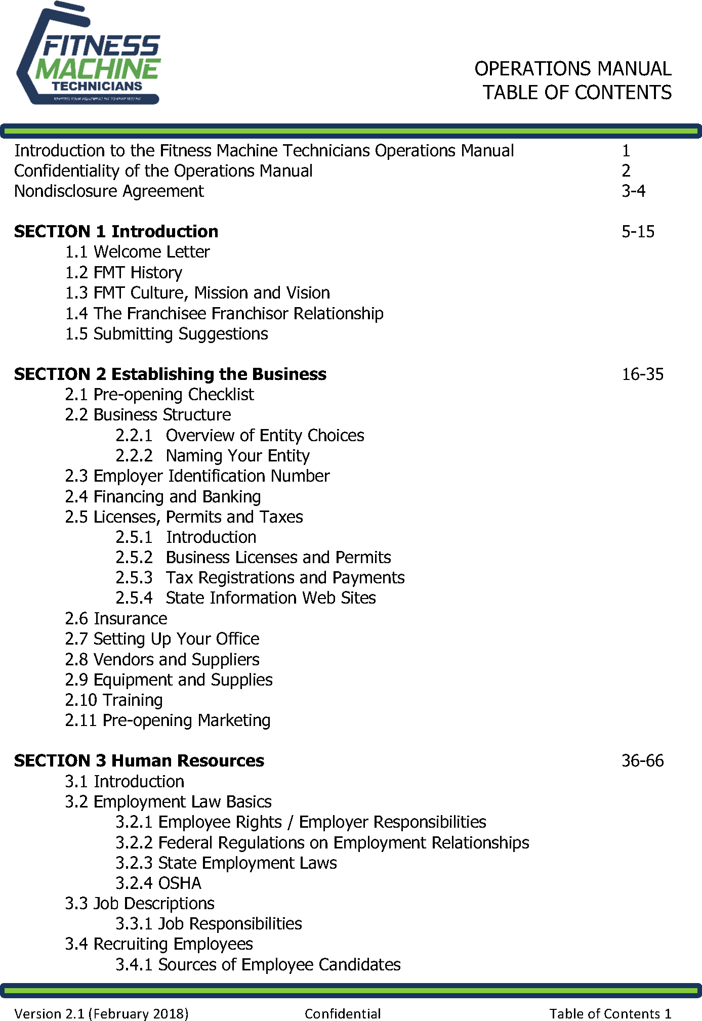

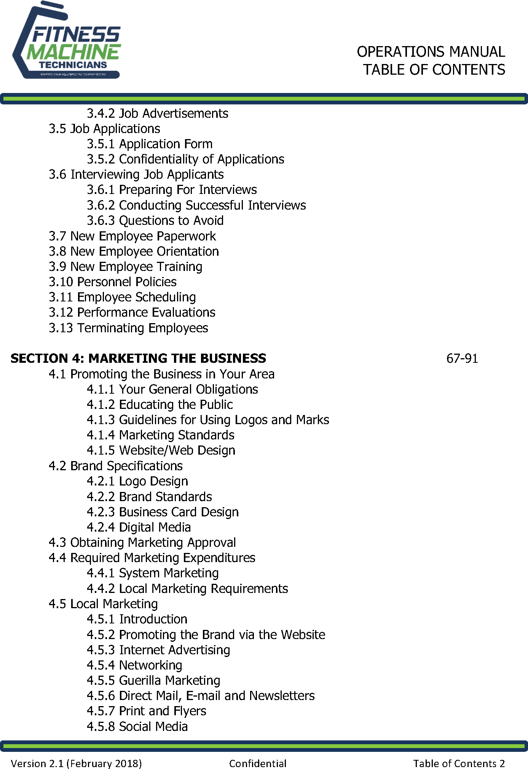

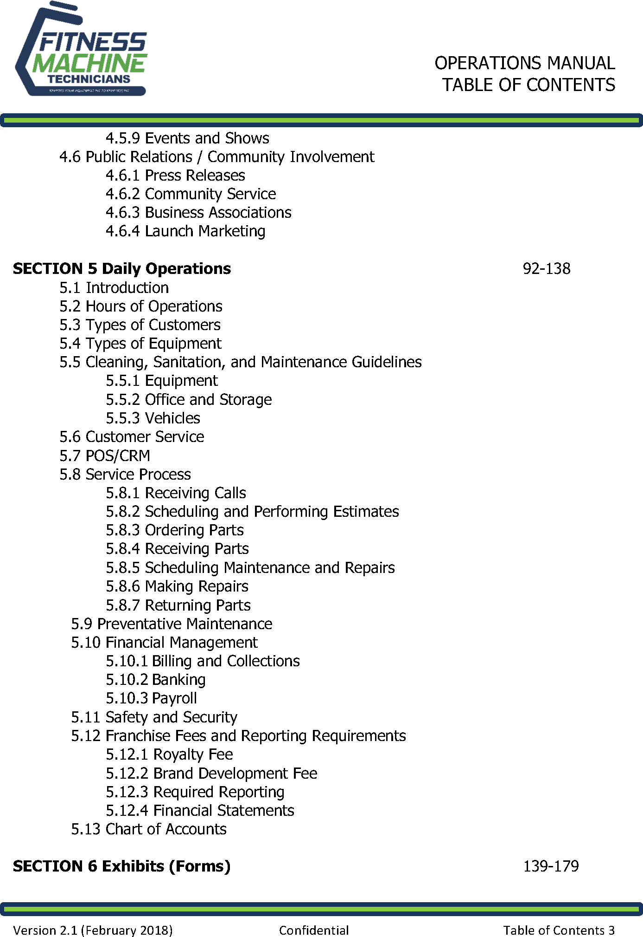

**EXHIBIT D TO THE DISCLOSURE DOCUMENT LIST OF FRANCHISEES AS OF DECEMBER 31, 2024**

* means a Franchisee that has been granted a franchise containing more than one territory that's principal place of business may be located in another state.

|  |  |  |  |  |  |  |
| --- | --- | --- | --- | --- | --- | --- |
| **NAME** | **ADDRESS** | **CITY** | **STATE** | **ZIP CODE** | **PHONE** | **STATES SERVED** |
| Dionne & Nolan Spooner | 28883 N 131st Dr | Peoria | AZ | 85383 | 701-721-  8978 | AZ |
| Jevic Bosele | 8069 W CHERRY HILLS DRIVE | Peoria | AZ | 85345 | 480-843-  7410 | AZ |
| Alex Wang* | 20086 Winton St. | Corona | CA | 92881 | 626-552-  2849 | CA |
| Toutoule & Carly Ntoya* | 1246 N Summit Ave. | Pasadena | CA | 91103 | 818-693-  1914 | CA |
| Bart & Joy Stevans* | 8967 Chantal Way | Sacramento | CA | 95829 | 916-688-  8701 | CA, ID |
| Steve Chapman* | 731 Oleander Pl. | Vista | CA | 92081 | 760-453-  5725 | CA |
| D'Shone Swiney | 20464 Cherry Gate Lane | Yorba Linda | CA | 92886 | 626.261.0836 | CA |
| Nick Peterson* | 405 2nd St (Mailing address: PO Box 256) | Frederick | CO | 80530 | 720-737-  8855 | CO, KS, MO |
| Gary Hamilton | 101 Madeline avenue, 31 | Waterbury | CT | 06708 | 347-788-  2858 | CT |
| Gabe Forest* | 144 S. Dupont Highway | New Castle | DE | 19720 | 302-394-  6991 | DE, NJ, PA |
| Jim Dudley | 17223 Hidden Estates Cl | Fort Myers | FL | 33908 | 765-366-  6349 | FL |
| Chuck Hood | 7251 Salisbury Road | Jacksonville | FL | 32256 | 904-607-  9121 | FL |
| Matt Ferratusco* | 10202 Mallard Landings Way | Orlando | FL | 32832 | 407-234-  2495 | FL |
| Fidel Rodriguez* | 2007 Little Torch Street | West Palm Beach | FL | 33407 | 786-597-  8420 | FL |
| Sarah Newton | 1645 Waylon Ridge Drive | Zellwood | FL | 32798 | 817-629-  9332 | FL |
| Samir Husidic | 2009 1st Avenue East | Newton | IA | 50208 | 319-404-  1530 | IA |
| Tom McGuire | 523 S Chestnut | Arlington Heights | IL | 60005 | 773-491-  7090 | IL |
| Jon Smail | 2009 Coolidge Avenue | Johnsburg | IL | 60051 | 815-690-  4475 | IL |
| Monte McKee | 2519 N. Peckham St. | Wichita | KS | 67228 | 316-210-  2180 | KS |
| Nathan Butler | 1709 Kensington Place Lane | Louisville | KY | 40205 | 502-496-  2475 | KY |
| Ike Okonkwo | 98 Russell Road | West Newton | MA | 02465 | 617-331-  7168 | MA |

|  |  |  |  |  |  |  |
| --- | --- | --- | --- | --- | --- | --- |
| **NAME** | **ADDRESS** | **CITY** | **STATE** | **ZIP CODE** | **PHONE** | **STATES SERVED** |
| Rick Maffezzoli* | 8637 Westford Rd | Lutherville | MD | 21093 | 410-404-  8501 | MD, DC |
| Tom Fryzel | 414 Southlawn Drive | Auburn | MI | 48611 | 989 948-  4593 | MI |
| Julie Jenney* | 2916 Masefield Drive | Bloomfield Hills | MI | 48304 | 248-229-  3638 | MI |
| Brian Dillon* | 9041 Chesshire Ln N | Maple Grove | MN | 55369 | 651-343-  0157 | MN |
| James McKinley | 640 Summerhaven Lane, SE | Bolivia | NC | 28422 | 631-774-  1719 | NC |
| David Caison* | 244 Pinch Gut Rd | Camden | NC | 27921 | 757-515-  1247 | VA |
| Todd Armstrong* | [18803 Silver Quay Drive](https://maps.google.com/?q=18803%2BSilver%2BQuay%2BDrive%2BCornelius%2C%2BNC%C2%A0%2B28031&entry=gmail&source=g) | Cornelius | NC | 28031 | 704-507-  3006 | NC |
| David Musyimi | 245 William Livingston Court | Princeton | NJ | 08540 | 732-781-  5115 | NJ |
| Tom Gellhousen | 2719 Floral Road NW | Albuquerque | NM | 87104 | 505-450-  2003 | NM |
| Alejandro & Elaine Velazquez* | 133 Mosso Niente Place | Henderson | NV | 89011 | 650-281-  7369 | NV, UT |
| David Block* | 46 Fairfield Drive | Dix Hills | NY | 11746 | 631-282-  8180 | NY |
| Fred Burghardt | 28 Waycross Road | Fairport | NY | 14450 | 585-747-  5076 | NY |
| Colm O'Mara* | 205 E 95th St Apt 26C | New York | NY | 10128 | 917-612-  8313 | NY, NJ |
| Kevin Bracy* | 2838 Kettering Ct | Avon | OH | 44011 | 440.915.2780 | OH, KY |
| Eugene "Tom" Lutes | 5064 Shady Knolls Ave NW | Massillon | OH | 44646 | 330-949-  8112 | OH |
| Jennifer Houghton | 13800 Fairhill Road, #201 | Shaker Heights | OH | 44120 | 330-931-  2648 | OH |
| Jesse Rorvig | 22531 SW Park Street | Sherwood | OR | 97140 | 971-420-  3122 | OR |
| Colin Winchester* | 6062 Chimney Bluff Road | Lancaster | SC | 29720 | 704-299-  8601 | NC, SC |
| Dudley Jacobs* | P.O. Box 1629 | Brentwood | TN | 37204 | 615-620-  6809 | GA, FL,  TN, IN, PA, MO |
| Ryan Strother | 209 Bald Eagle Dr. NW | Cleveland | TN | 37312 | 423-619-  6633 | TN |
| Drew Martin* | [11305 Deep Canyon Trl](https://maps.google.com/?q=11305%2BDeep%2BCanyon%2BTrl%2BFrisco%2C%2BTX%2B75033%2B469&entry=gmail&source=g) | Frisco | TX | 75033 | [469-486-](https://maps.google.com/?q=11305%2BDeep%2BCanyon%2BTrl%2BFrisco%2C%2BTX%2B75033%2B469&entry=gmail&source=g)  [3728](https://maps.google.com/?q=11305%2BDeep%2BCanyon%2BTrl%2BFrisco%2C%2BTX%2B75033%2B469&entry=gmail&source=g) | TX |
| Rebecca White | 12423 Tyler Springs Lane | Humble | TX | 77346 | 225-773-  1123 | TX |
| Amy Wilson* | 10 Inwood Knolls | San Antonio | TX | 78248 | 210-882-  6134 | TX |

|  |  |  |  |  |  |  |
| --- | --- | --- | --- | --- | --- | --- |
| **NAME** | **ADDRESS** | **CITY** | **STATE** | **ZIP CODE** | **PHONE** | **STATES SERVED** |
| Rene Garcia* | 11407 Rashell Way | Pearland | TX | 77584 | 832-830-  1931 | TX |
| Chad Black* | 2186 West Pumpkin Patch Lane | Lehi | UT | 84043 | 801-885-  0140 | UT |
| Glenn Deetman | 212 Pear Blossom Rd | Stafford | VA | 22554 | 703-909-  6910 | VA |
| Michael & Dawn Lee* | 17302 Meadow Ln | Mt. Vernon | WA | 98274 | 425-330-  5613 | WA |
| Don Keeley* | N319 Fieldside Lane | Appleton | WI | 54915 | 920.358.3041 | WI |

**FRANCHISE AGREEMENTS SIGNED BUT NOT YET OPEN**

### AS OF December 31, 2024

|  |  |  |  |
| --- | --- | --- | --- |
| **Name** | **Contact** | **Location** | **Phone #** |
| **None** |  |  |  |
|  |  |  |  |
|  |  |  |  |

**EXHIBIT E TO THE DISCLOSURE DOCUMENT LIST OF FRANCHISEES**

**WHO HAVE LEFT THE SYSTEM**

|  |  |  |  |  |  |  |  |
| --- | --- | --- | --- | --- | --- | --- | --- |
| **FRANCHISEE** | **ADDRESS** | **CITY** | **STATE** | **ZIP CODE** | **PHONE** | **# OF TERRITORIES** | **DISPOSITION** |
| **GEORGIA** |  |  |  |  |  |  |  |
| Rob Scott | 3738 Tynemoore Trace, SE | Smyrna | GA | 30080 | 404-664-  7045 | 4 | Transfer |
|  |  |  |  |  |  |  |  |
| **INDIANA** |  |  |  |  |  |  |  |
| Chris Bangma | 13051 E FG Ave | Augusta | MI | 49012 | 661-803-  5360 | 1 | Transfer |
|  |  |  |  |  |  |  |  |
| **KANSAS** |  |  |  |  |  |  |  |
| Brian Wertenberger | 520 W. Washington St. | Gardner | KS | 66030 | 913-244-  3978 | 1 | Transfer |
|  |  |  |  |  |  |  |  |
| **MASSACHUSETTS** |  |  |  |  |  |  |  |
| Rich Kracunas | 544 Jerusalem Road | Cohasset | MA | 02025 | 617-461-  6099 | 2 | Transfer |
|  |  |  |  |  |  |  |  |
| **MICHIGAN** |  |  |  |  |  |  |  |
| Chris Bangma | 13051 E FG Ave | Augusta | MI | 49012 | 661-803-  5360 | 1 | Transfer |
|  |  |  |  |  |  |  |  |
| **MISSOURI** |  |  |  |  |  |  |  |
| Brian Wertenberger | 520 W. Washington St. | Gardner | KS | 66030 | 913-244-  3978 | 1 | Transfer |
|  |  |  |  |  |  |  |  |
| **NORTH CAROLINA** |  |  |  |  |  |  |  |
| Colin Winchester | 6062 Chimney Bluff Road | Lancaster | SC | 29720 | 704-299-  8601 | 1 | Transfer |
|  |  |  |  |  |  |  |  |
| **NEVADA** |  |  |  |  |  |  |  |
| Dave Phelps | 9928 Kalahari Ct | Las Vegas | NV | 89149 | 702-375-  8431 | 2 | Transfer |
|  |  |  |  |  |  |  |  |
| **SOUTH CAROLINA** |  |  |  |  |  |  |  |
| Colin Winchester | 6062 Chimney Bluff Road | Lancaster | SC | 29720 | 704-299-  8601 | 2 | Transfer |
|  |  |  |  |  |  |  |  |
| **PENNSYLVANIA** |  |  |  |  |  |  |  |
| Bruce Sturgeon | 32 Sunset Drive | Ottsville | PA | 18942 | 215-609-  6076 | 4 | Transfer |
|  |  |  |  |  |  |  |  |
| **UTAH** |  |  |  |  |  |  |  |

|  |  |  |  |  |  |  |  |
| --- | --- | --- | --- | --- | --- | --- | --- |
| **FRANCHISEE** | **ADDRESS** | **CITY** | **STATE** | **ZIP CODE** | **PHONE** | **# OF TERRITORIES** | **DISPOSITION** |
| Dave Phelps | 9928 Kalahari Ct | Las Vegas | NV | 89149 | 702-375-  8431 | 1 | Transfer |

**EXHIBIT F TO THE DISCLOSURE DOCUMENT FINANCIAL STATEMENTS**

**THESE FINANCIAL STATEMENTS ARE PREPARED WITHOUT AN AUDIT. PROSPECTIVE FRANCHISEES OR SELLERS OF FRANCHISES SHOULD BE ADVISED THAT NO CERTIFIED PUBLIC ACCOUNTANT HAS AUDITED THESE FIGURES OR EXPRESSED HIS/HER OPNION WITH REGARD TO THE CONTENT OR FORM.**

|  |
| --- |
| **Main Line Brands, LLC** |
| Consolidated Balance Sheet |
| *($ in 000's)* |

**31-Mar-25**

|  |  |
| --- | --- |
| Current Assets: |  |
| Cash & Cash Equivalents | 1,859.9 |
| Restricted Cash | 216.9 |
| Accounts Receivable, Net | 1,361.2 |
| Financed Franchise Fees | 638.0 |
| Vendor Receivable | 127.8 |
| Prepaid Product Goods | 554.7 |
| Prepaid Insurance | 51.7 |
| Prepaid Expenses - Other | 141.0 |
| **Total Current Assets** | **4,951.1** |

|  |  |
| --- | --- |
| Long-Term Assets: | |
| Right-of-use Asset | 936.5 |
| Fixed Assets, Net | 231.1 |
| Net Intangibles | 24,771.3 |
| **Total Long-Term Assets** | **25,938.9** |

**Total Assets 30,890.0**

|  |  |
| --- | --- |
| Current Liabilities: | |
| Accounts Payable | 321.8 |
| Accrued Expenses (Incl. Bonuses) | 129.0 |
| Right-of-use Liability | 145.2 |
| Other Current Liabilities | (3.6) |
| Credit Card Expenses | 192.5 |
| **Total Current Liabilities:** | **784.9** |

|  |
| --- |
| Long-Term Liabilities: |
| Right-of-use Liability 877.9 |
| **Total Long-Term Liabilities 877.9** |

**Total Liabilities 1,662.9**

|  |  |
| --- | --- |
| Shareholders Equity: | |
| Additional Paid In Capital | 24,681.1 |
| Retained Earnings | 4,441.3 |
| Net Income | 104.6 |
| **Shareholders Equity:** | **29,227.1** |

**Total Liabilities & Shareholder's Equity 30,890.0**

|  |
| --- |
| **Main Line Brands, LLC** |
| Consolidated Income Statement |
| *($ in 000's except for territories and unit count)* |

**31-Mar-25**

|  |  |
| --- | --- |
| Revenue: |  |
| Franchise Fees | 296.0 |
| Royalty Fees | 1,722.4 |
| Transfers / Renewals / Refunds / Repurchase | 8.0 |
| Product Sales | 198.8 |
| Technology Fees | 180.7 |
| Company Owned Territory | 429.0 |
| Other | 33.7 |
| **Consolidated Revenue** | **2,868.6** |
| Cost of Goods Sold | 277.6 |
| **Consolidated Gross Profit** | **2,591.0** |
| SG&A |  |
| Administrative & Professional Fees | 51.8 |
| Advertising & Marketing | 55.1 |
| Benefits & Payroll | 821.4 |
| Facility Expenses | 37.1 |
| IT & Software Expenses | 294.7 |
| Rent Expense | 59.6 |
| Travel & Entertainment | 57.4 |
| Franchise Sales | 182.7 |
| Conference Expense | 0.4 |
| Other SG&A | 151.6 |
| Consolidated SG&A | 1,711.9 |
| Depreciation & Amortization | 737.1 |
| Management Fees | 37.5 |
| (Interest Income) | (14.1) |
| Other (Income) / Expenses | 14.1 |
| Total Other (Income) / Expenses | 774.5 |
| **Net Income** | **104.6** |
| Plus: Depreciation & Amortization | 737.1 |
| **Reported EBITDA** | **841.6** |
| Adjustments | 307.0 |
| **Adjusted EBITDA** | **1,148.6** |

**THIS PAGE IS LEFT BLANK INTENTIONALLY**

FMT May 2, 2025

4894-8263-1254 v.19

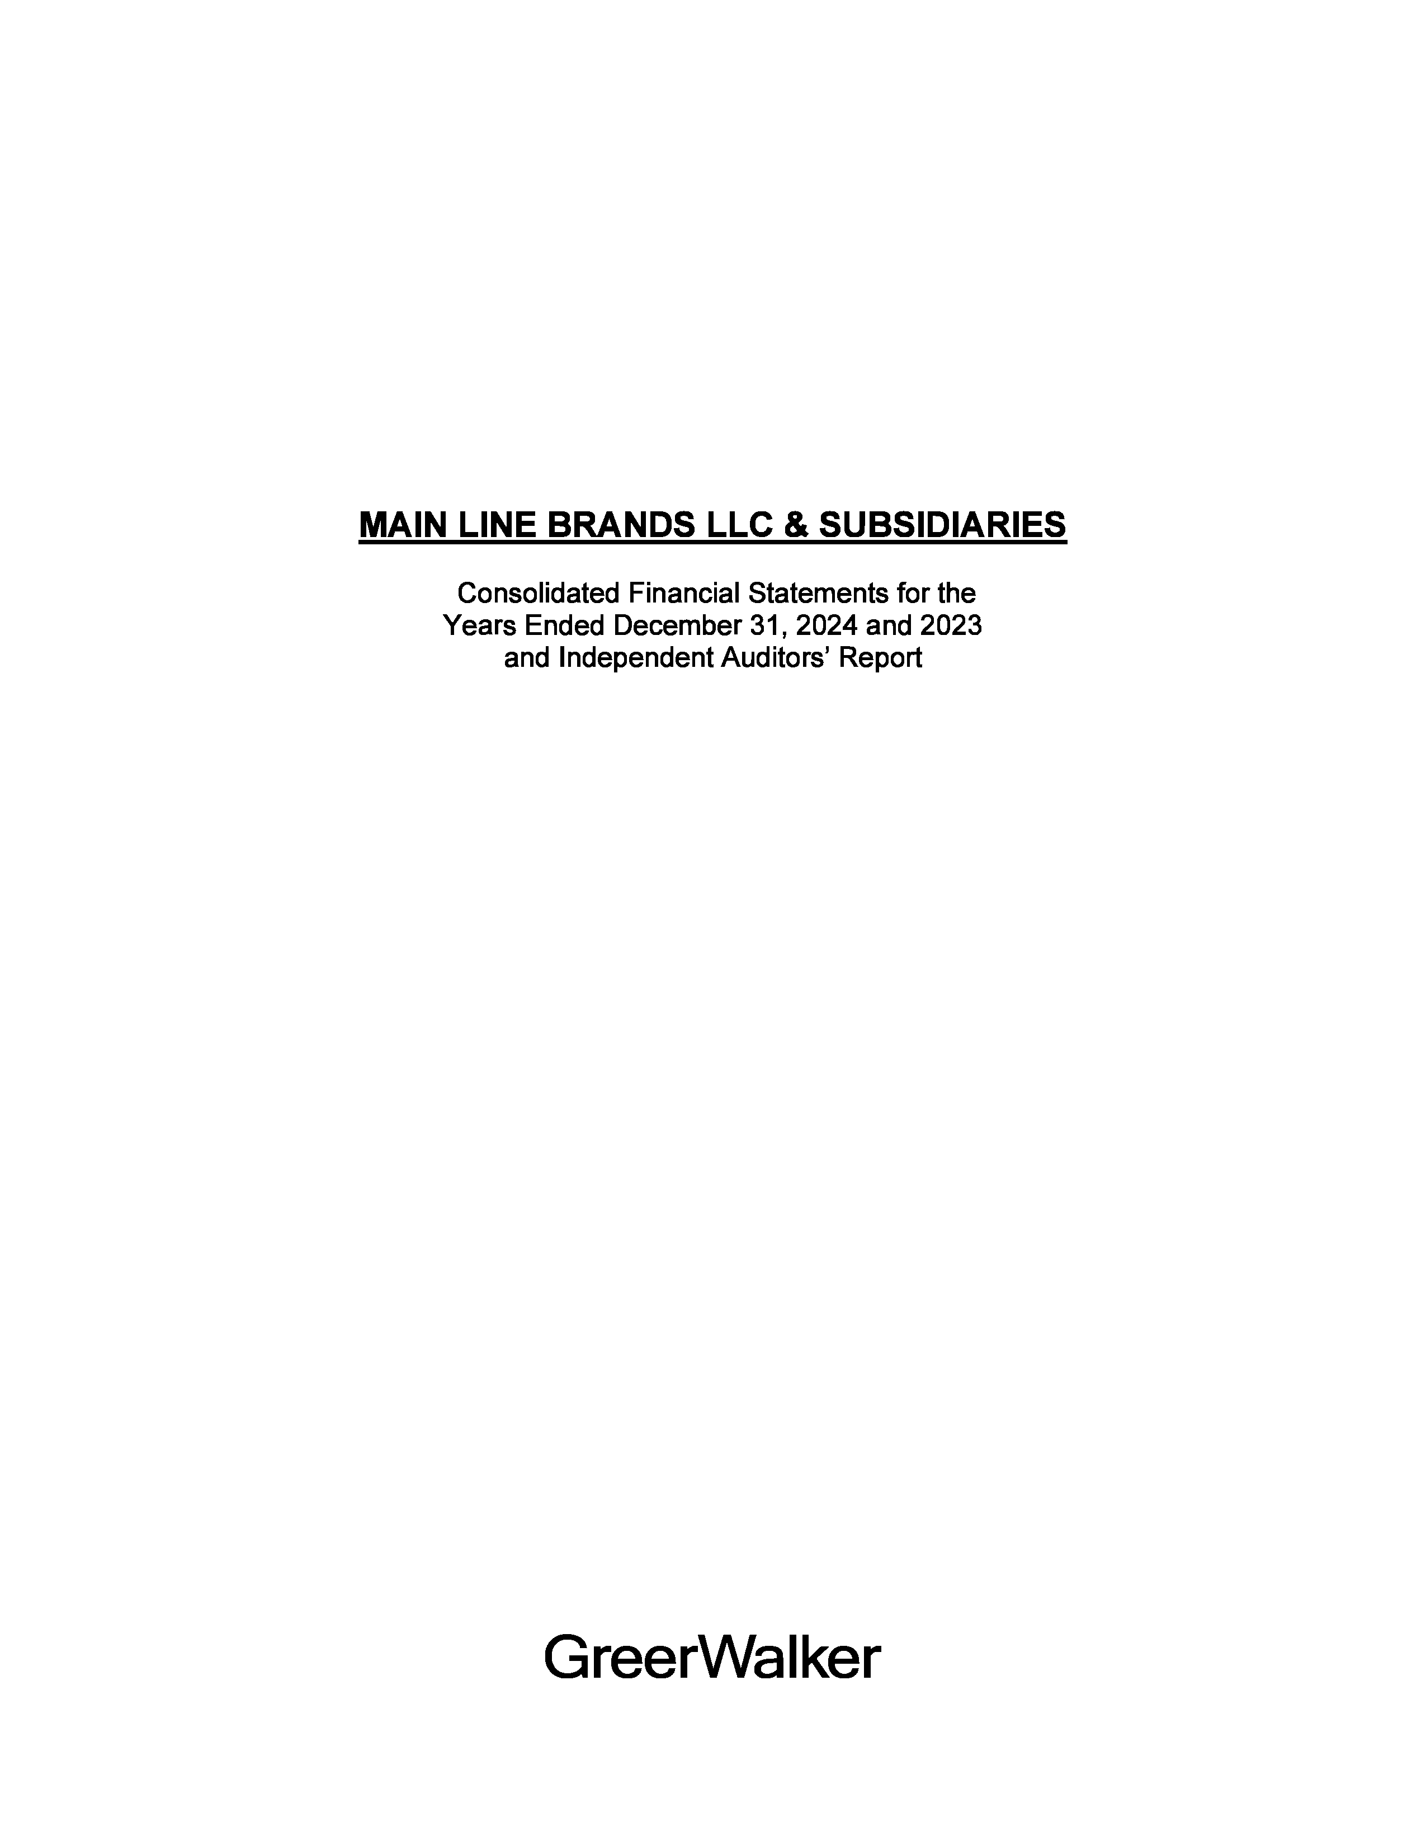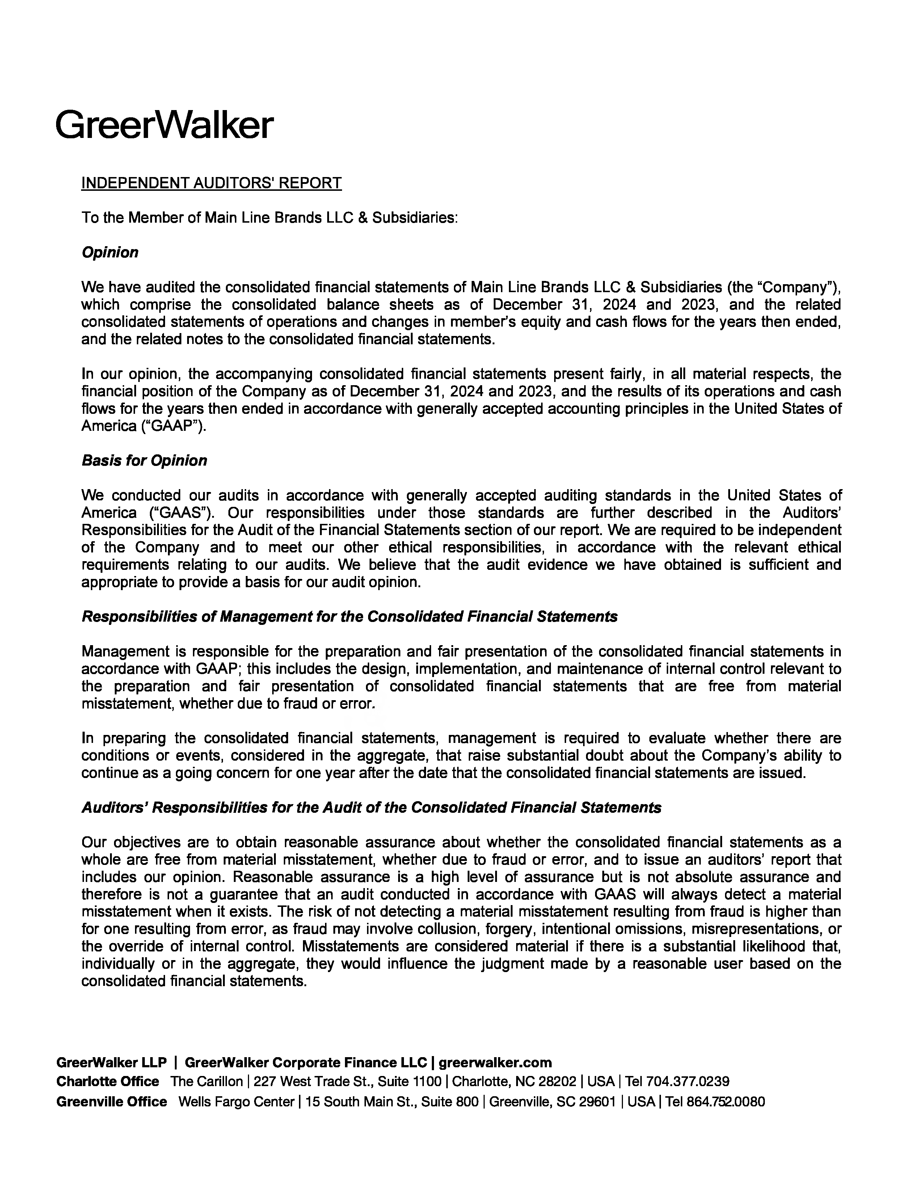

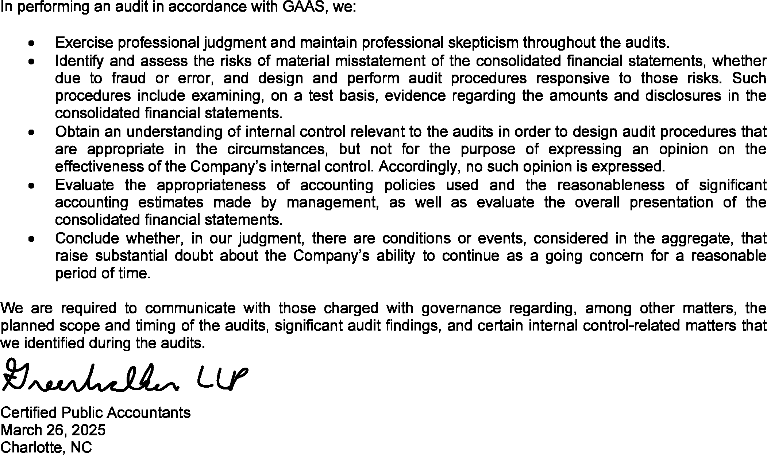

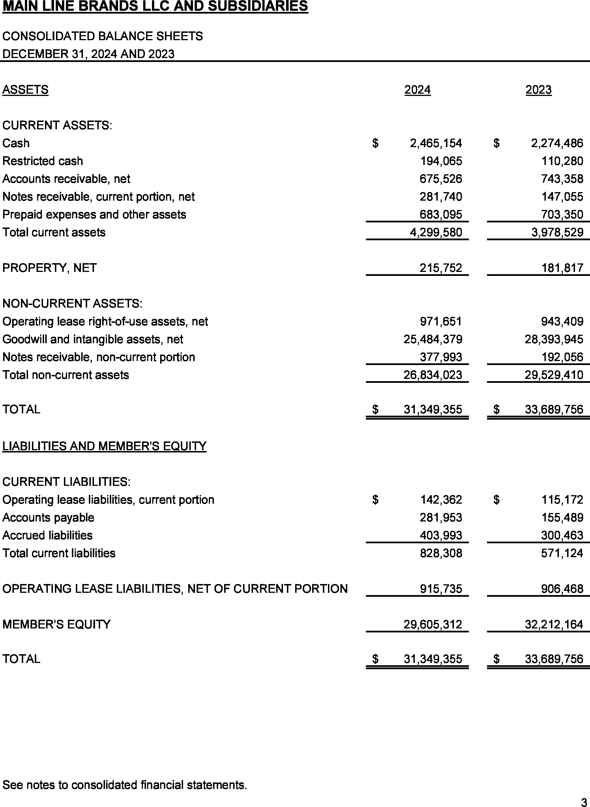

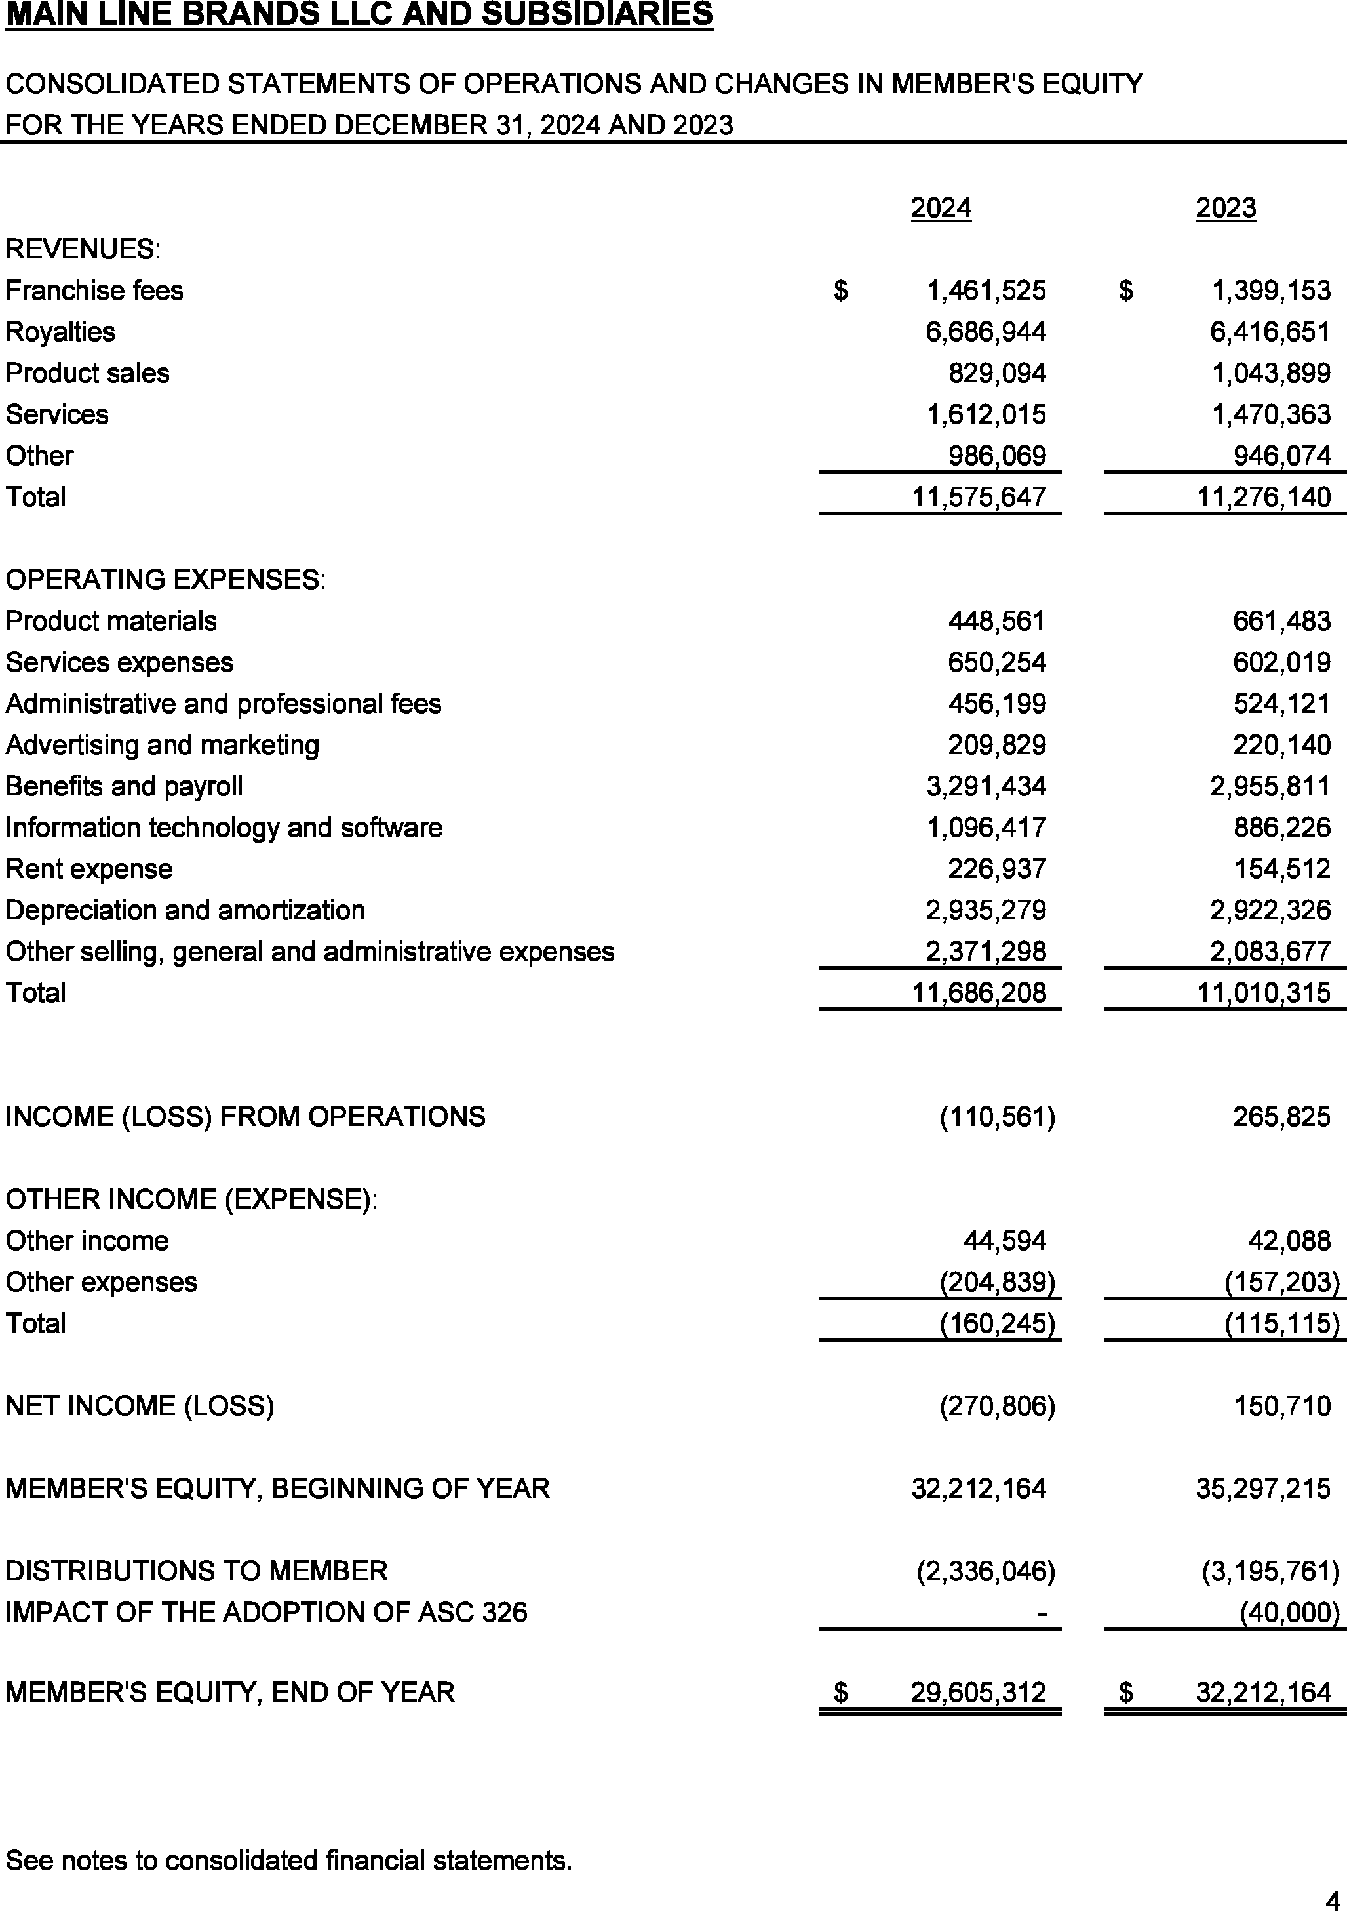

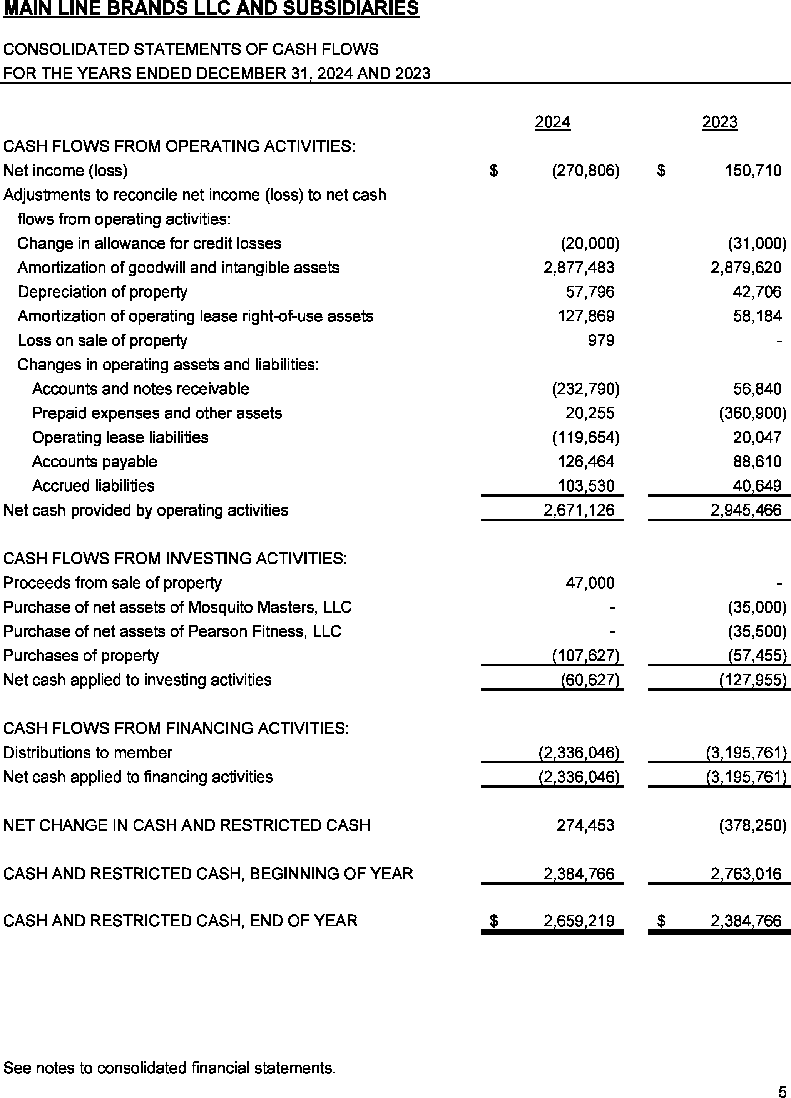

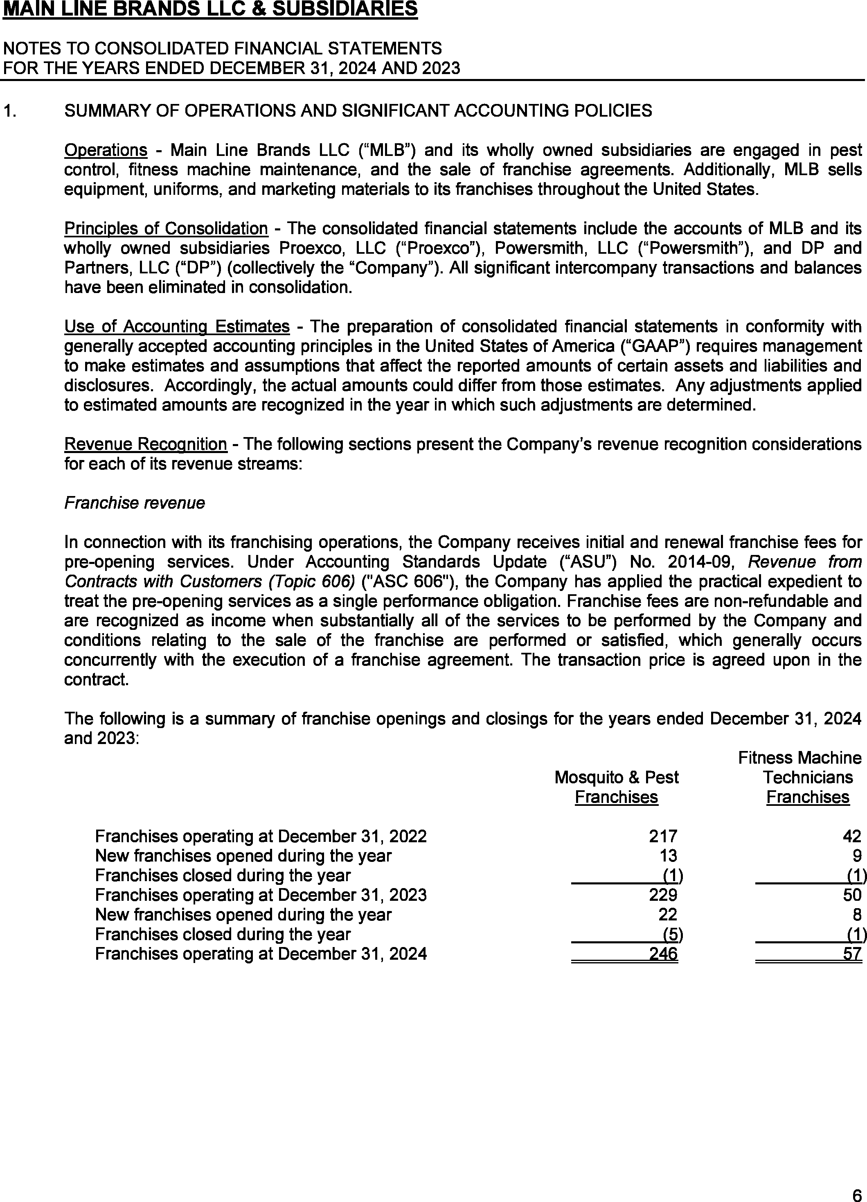

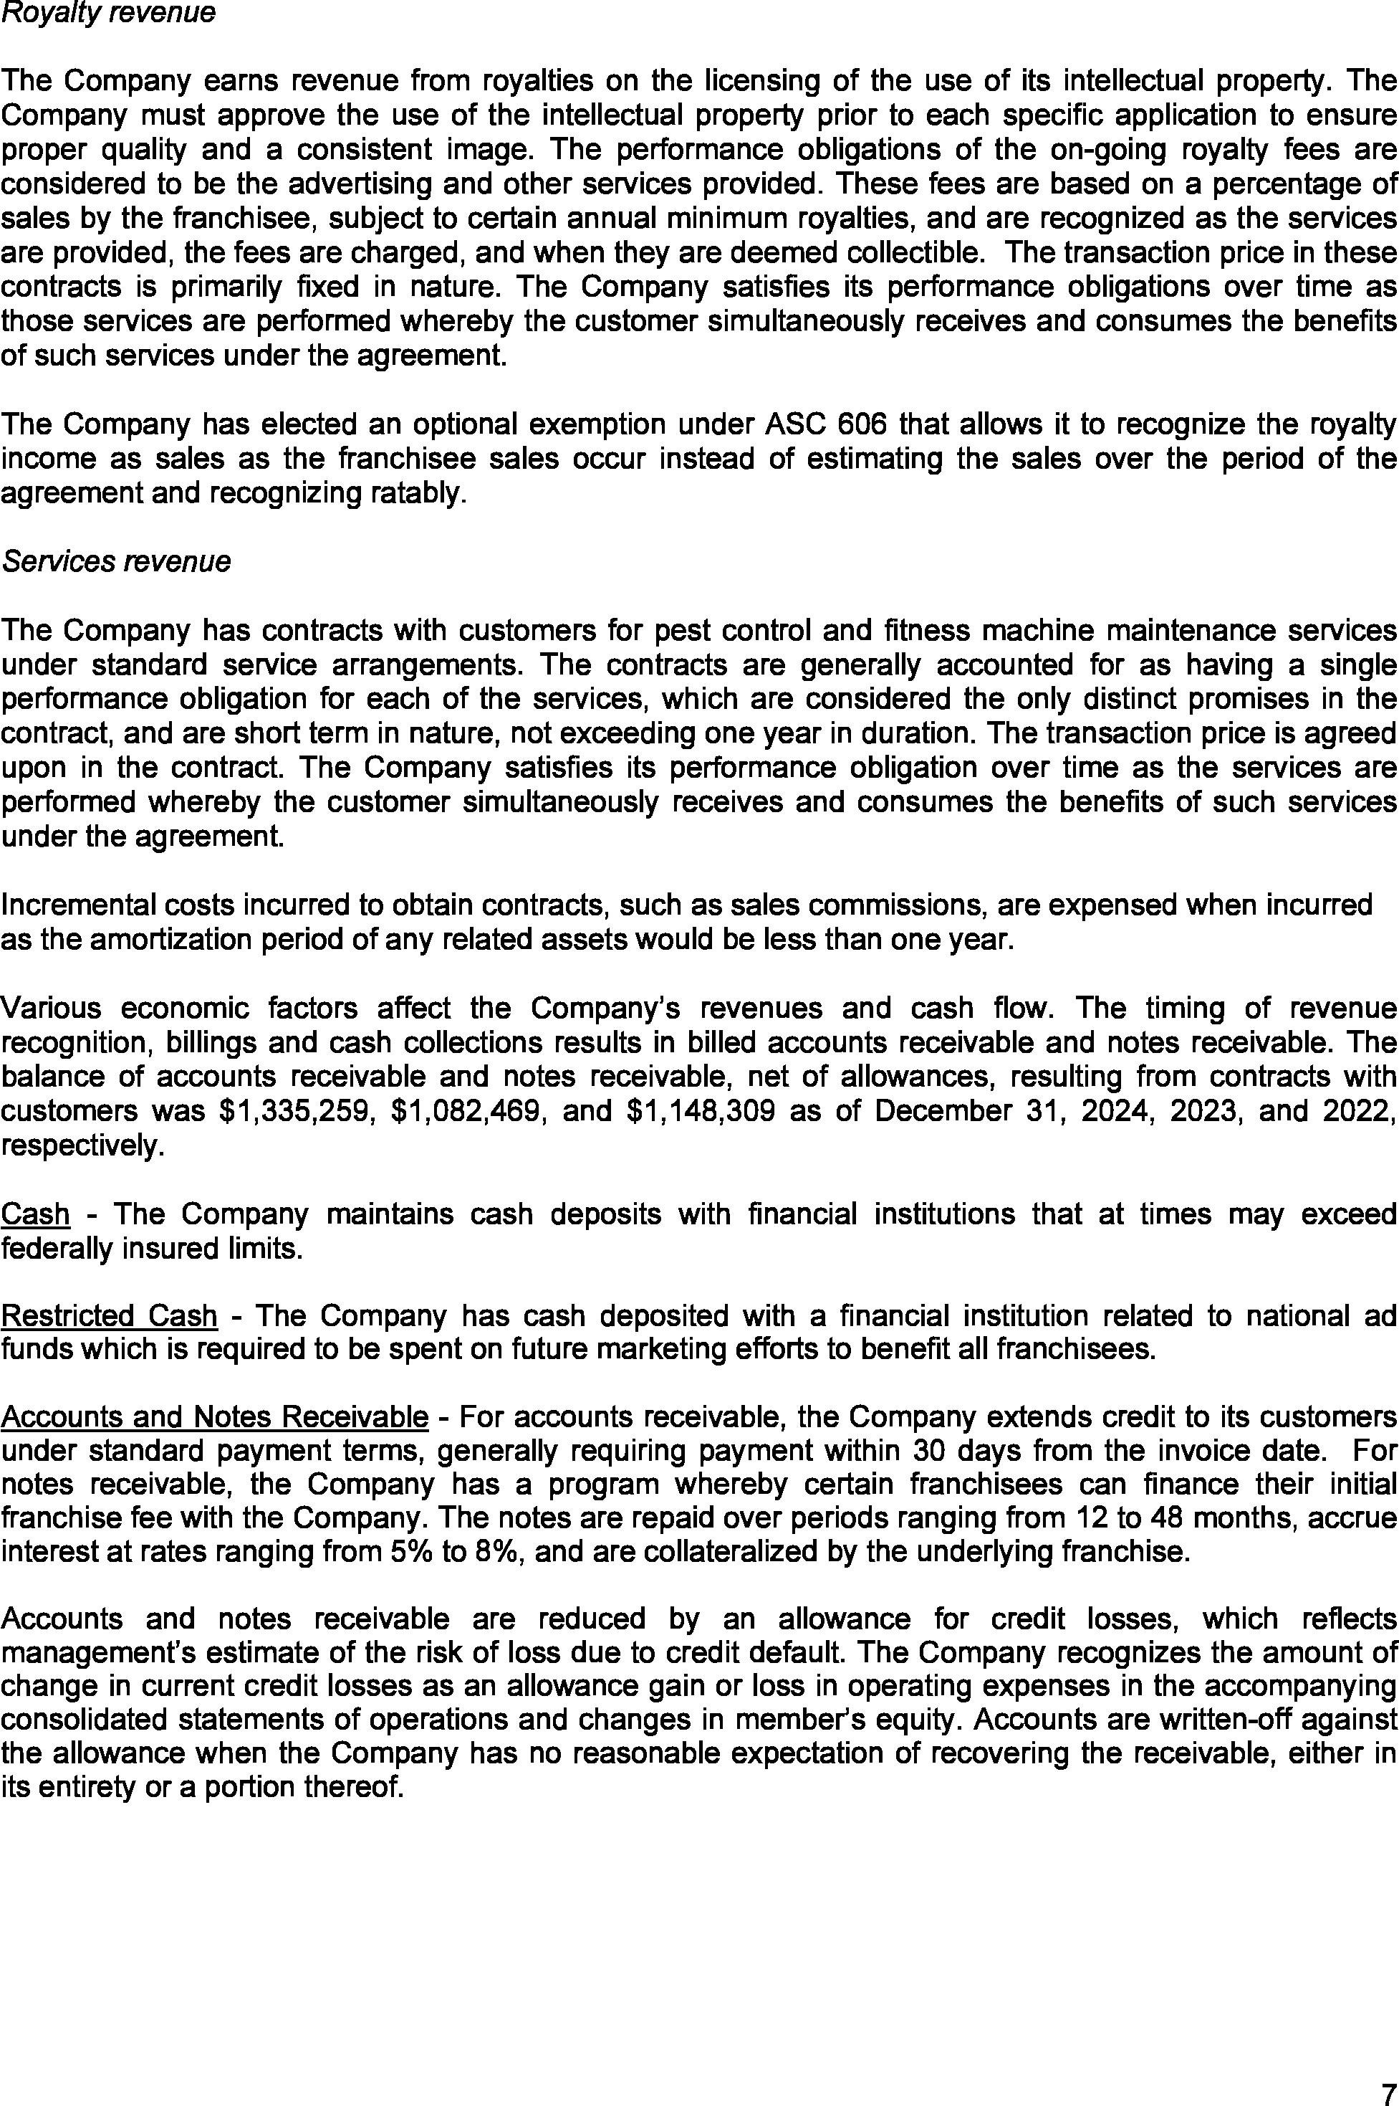

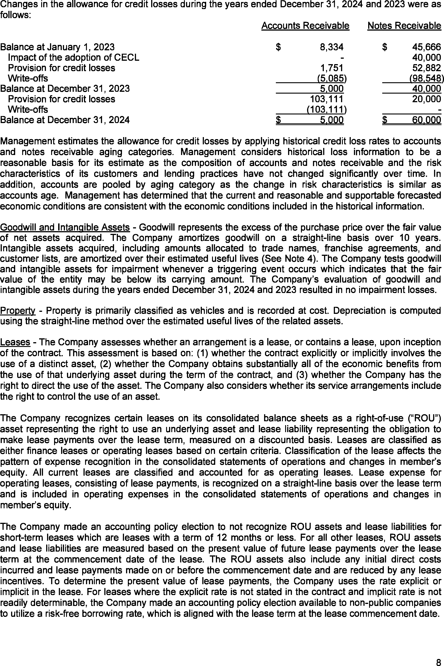

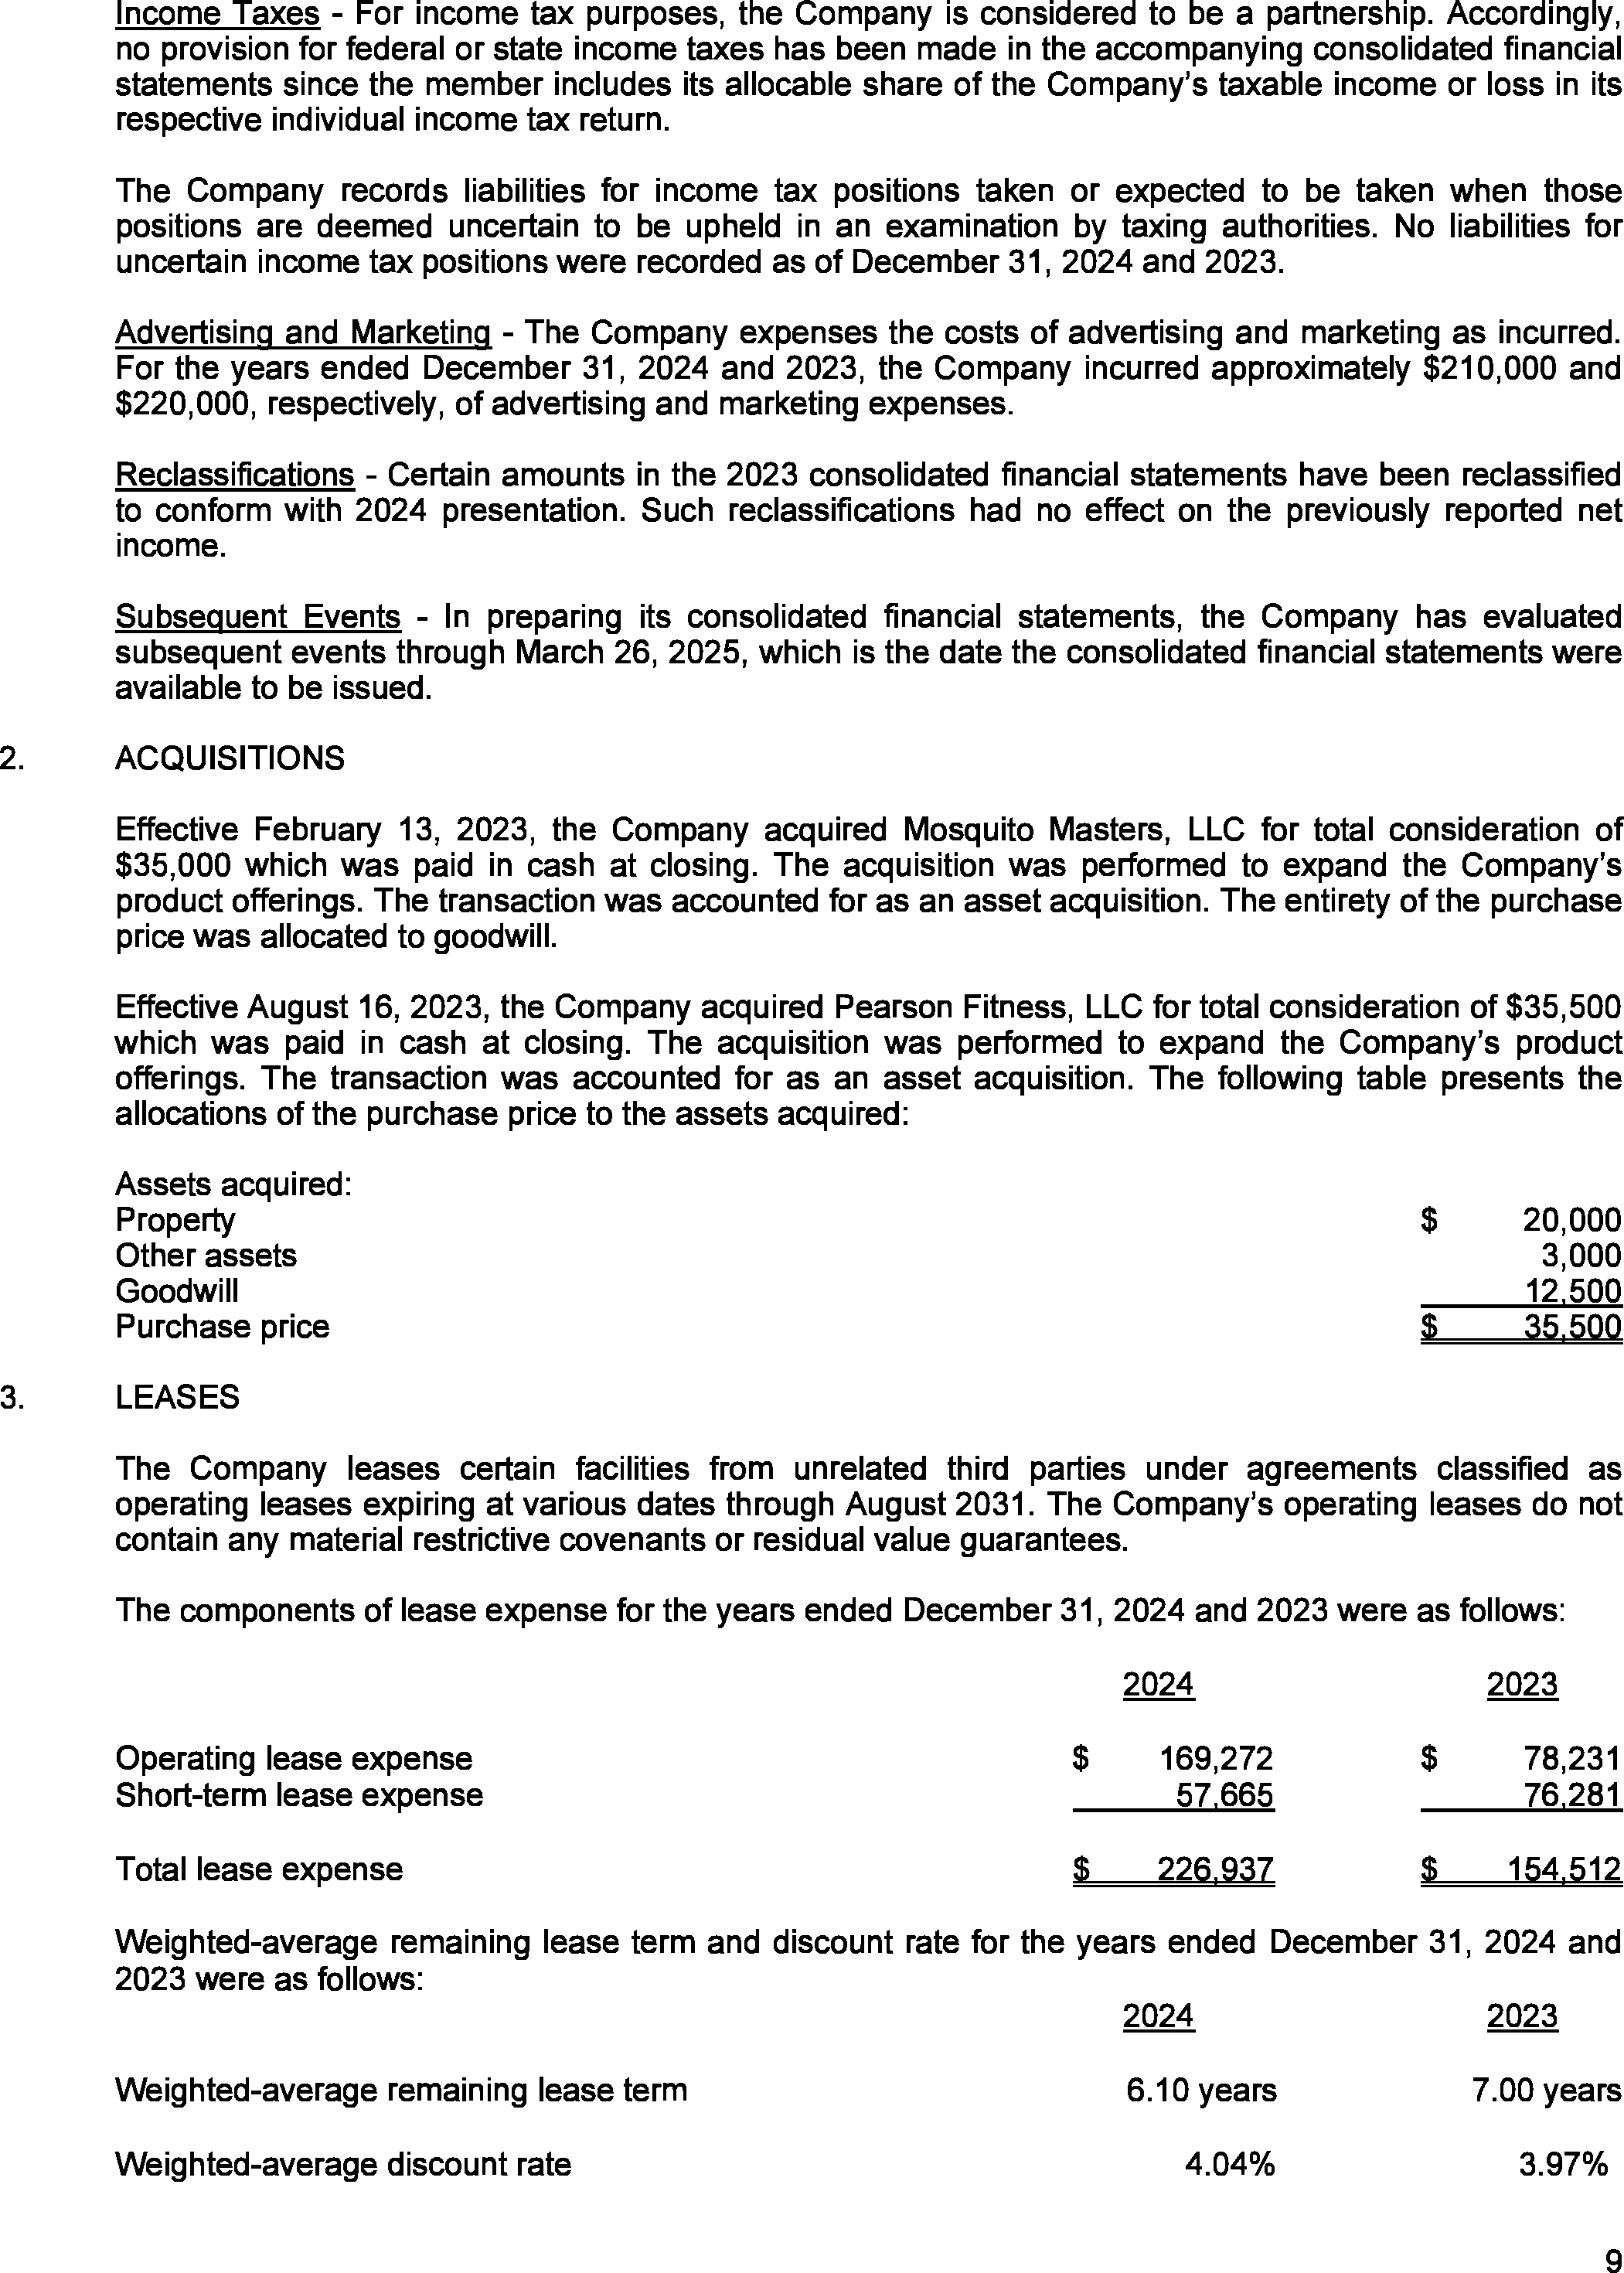

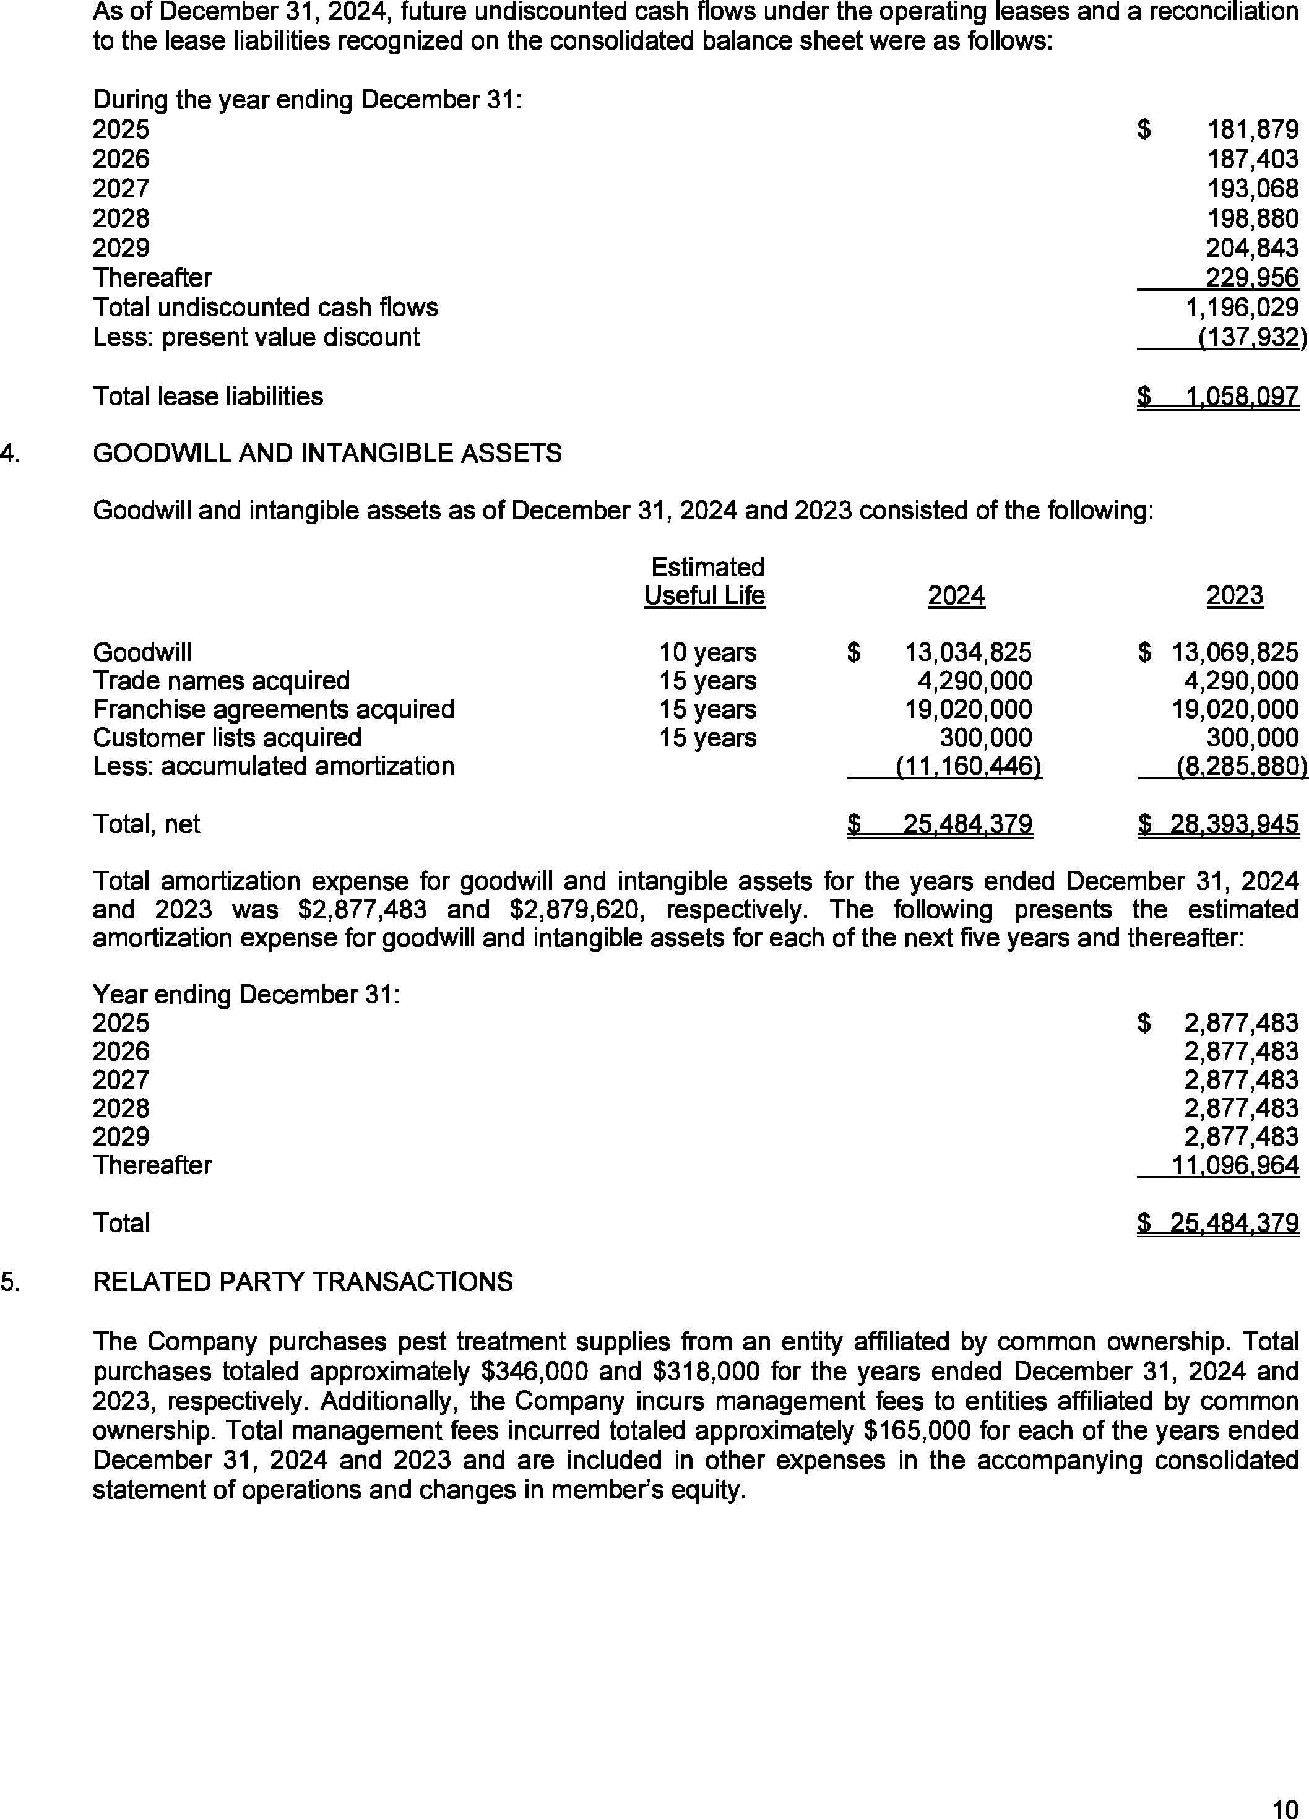

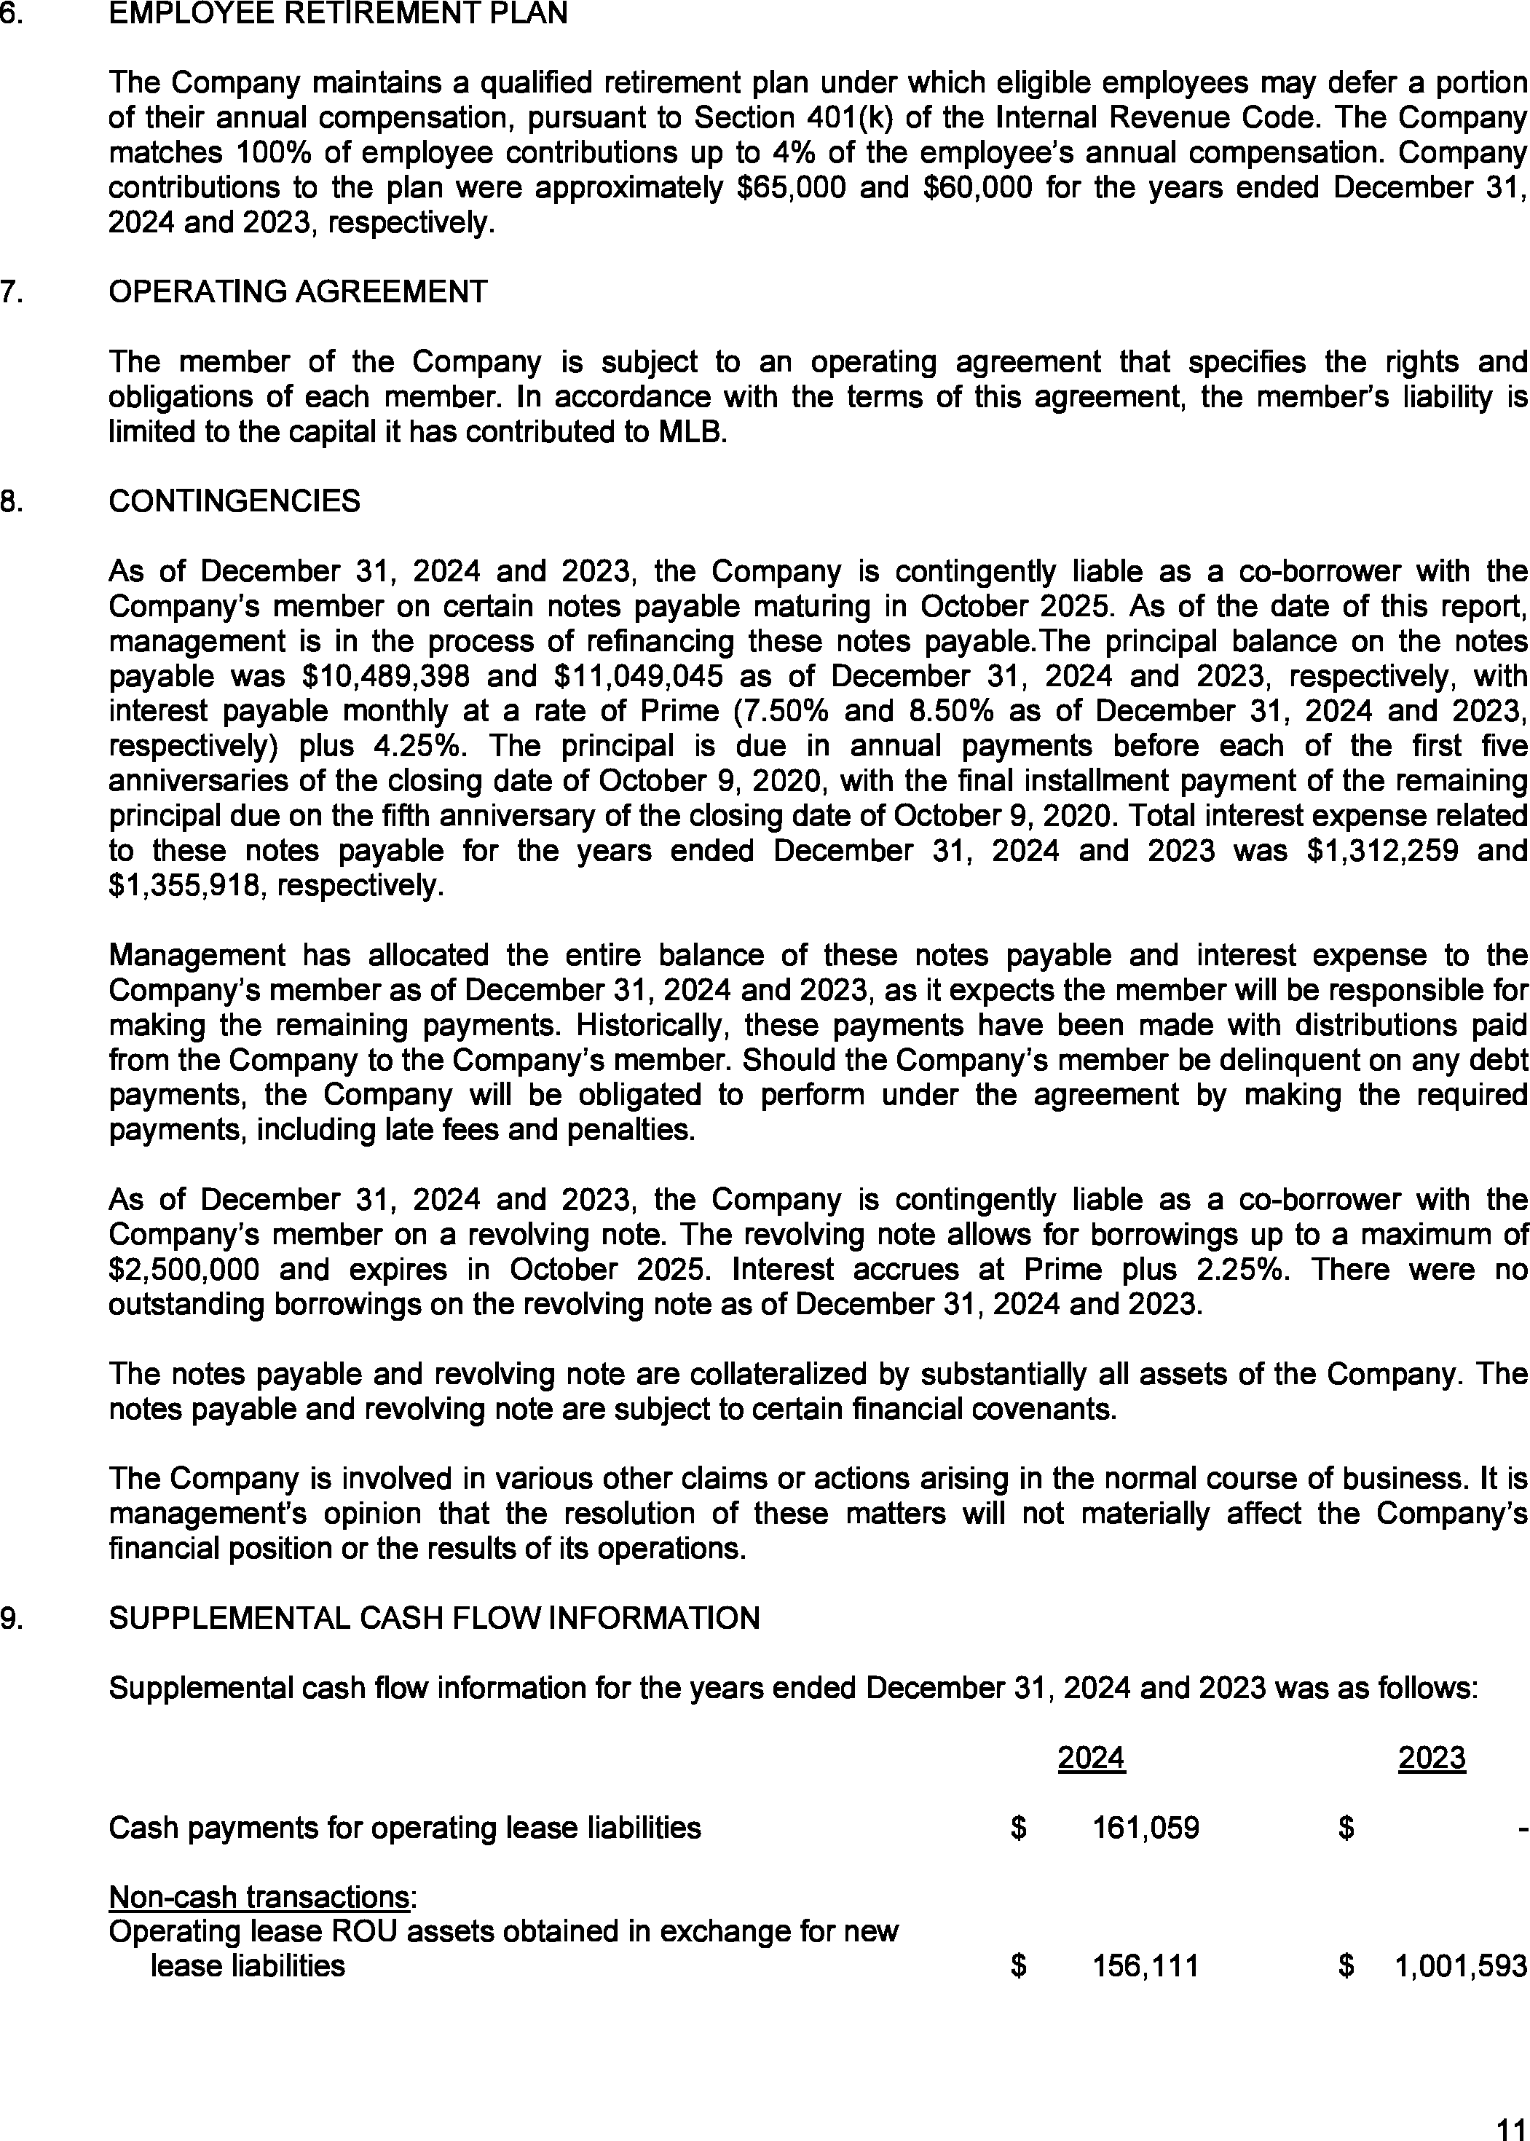



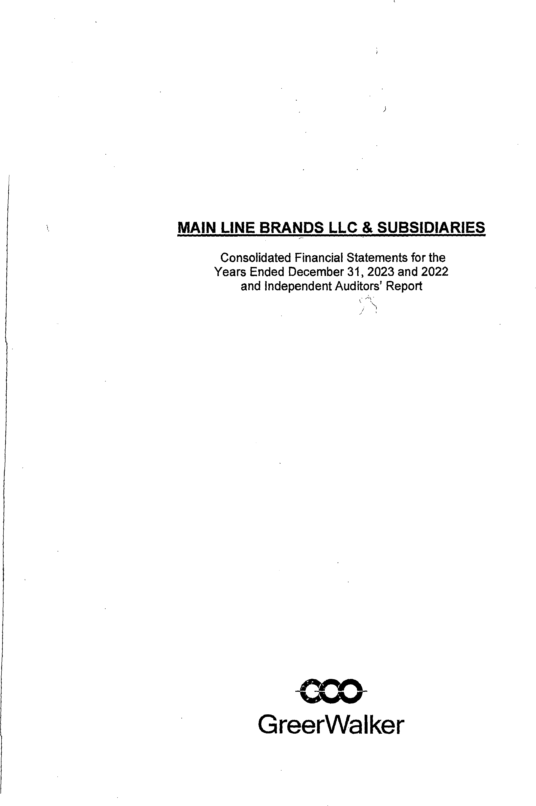

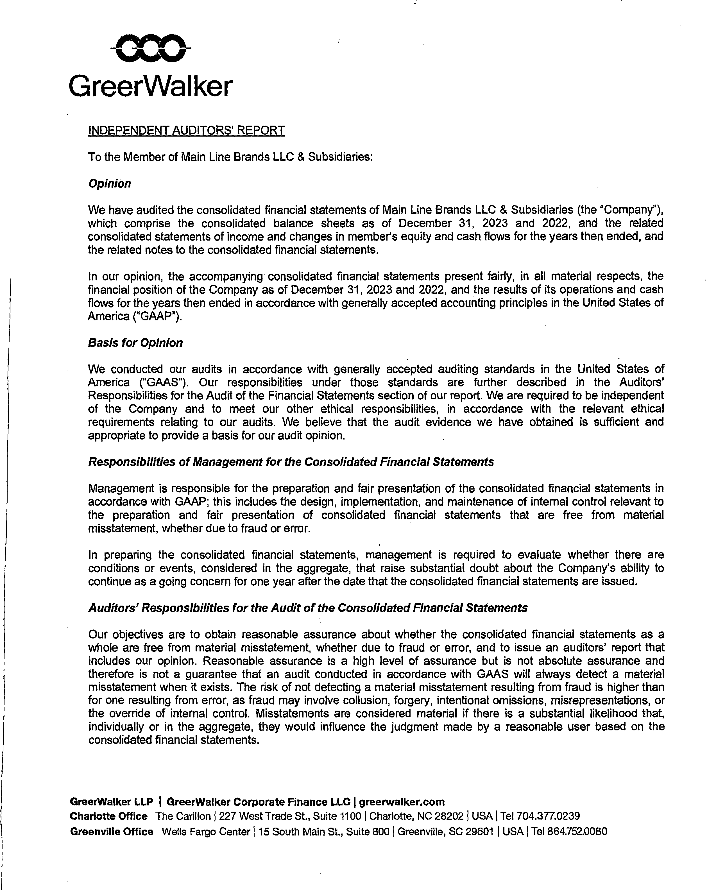

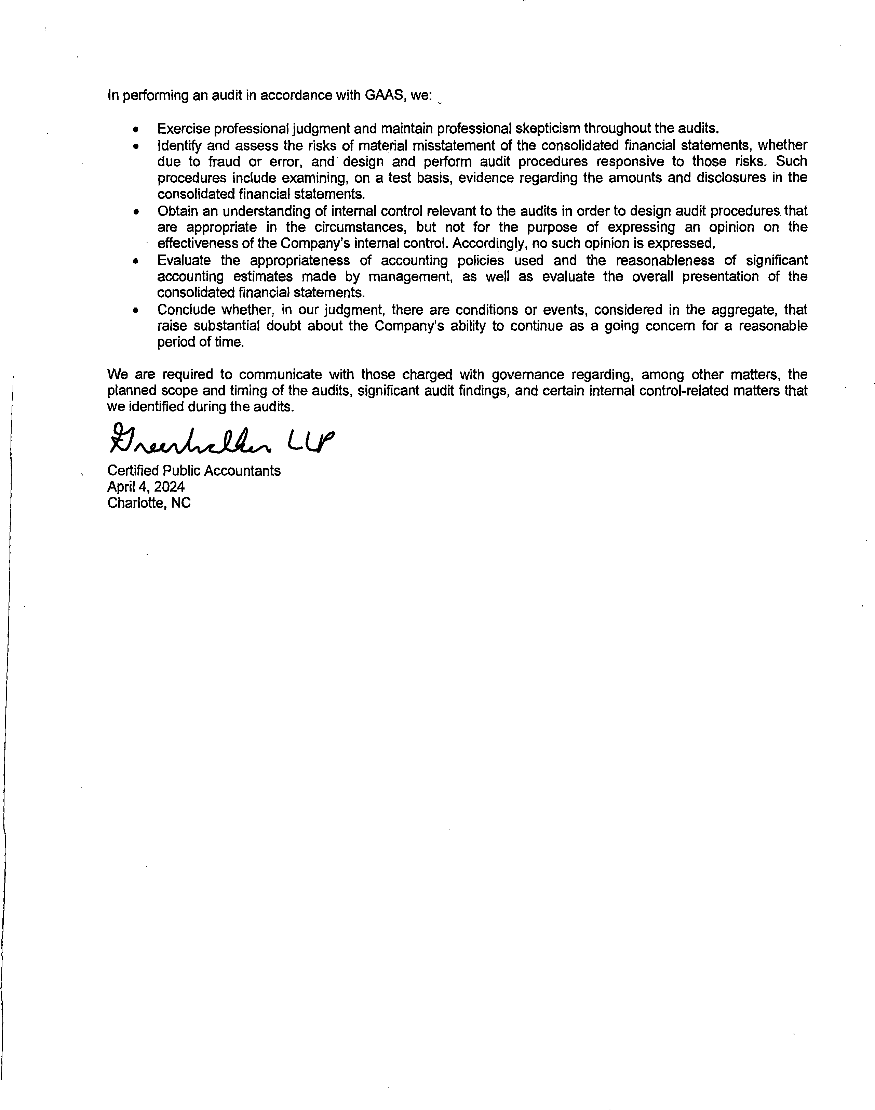

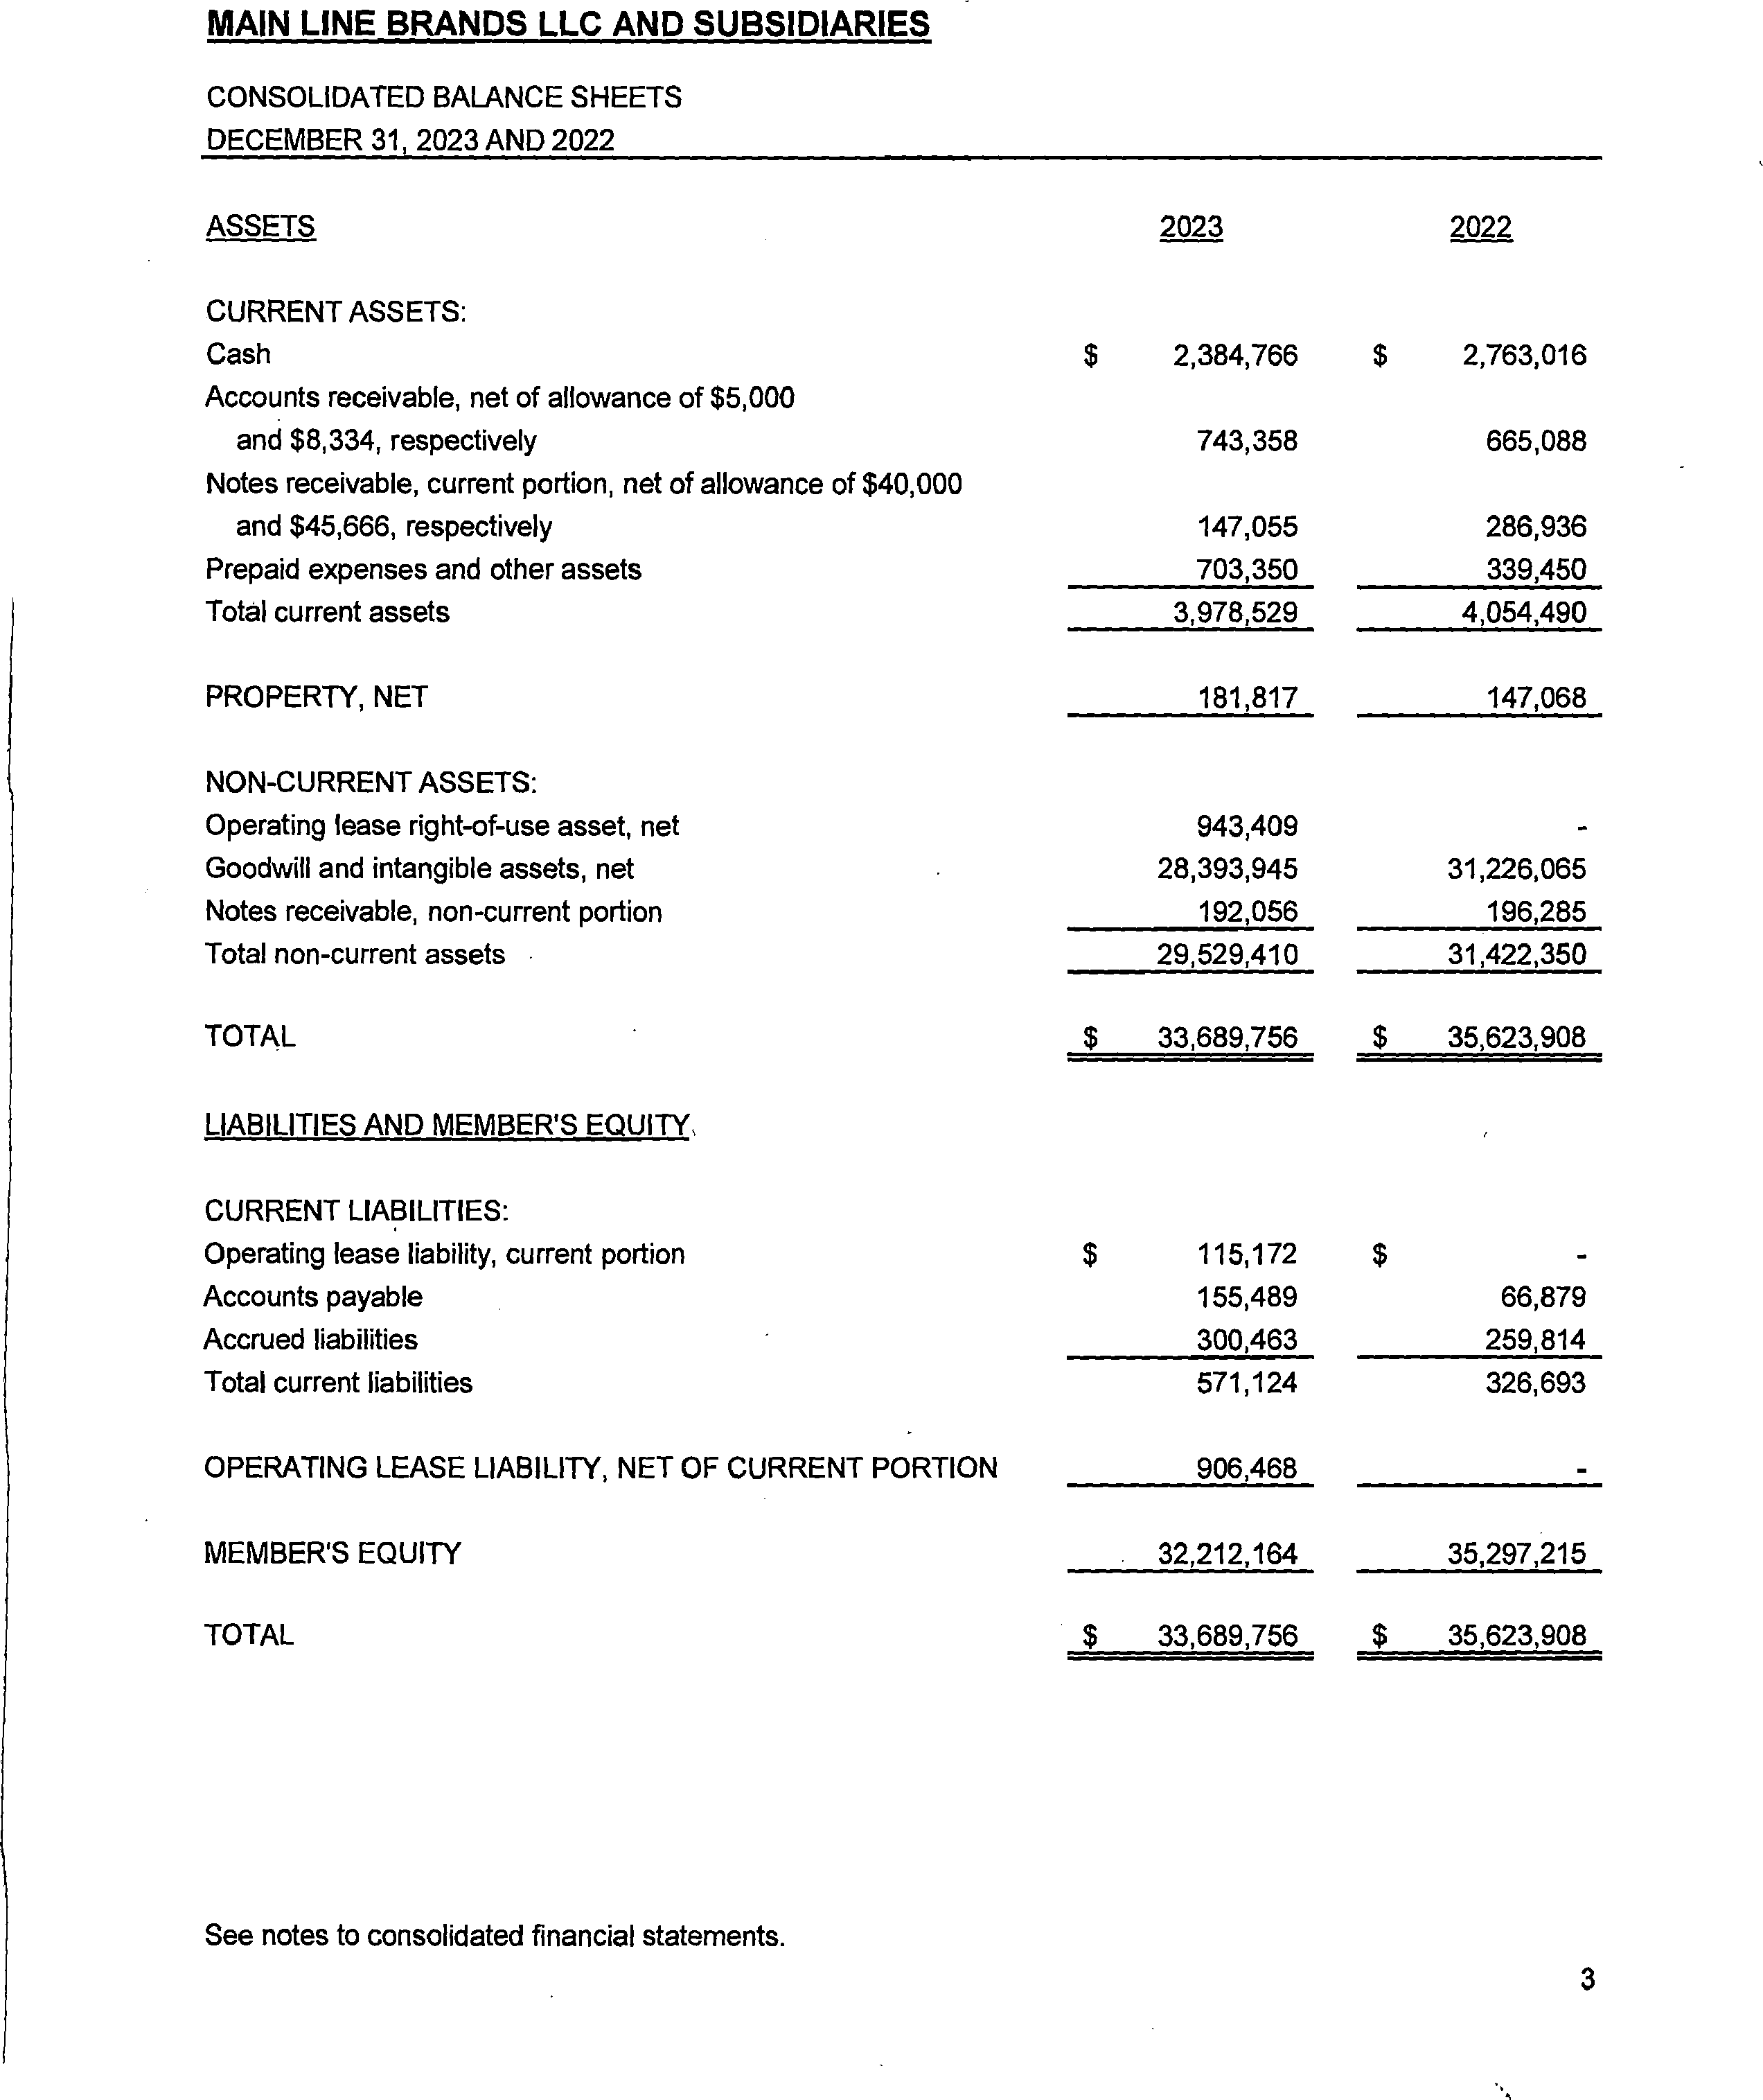

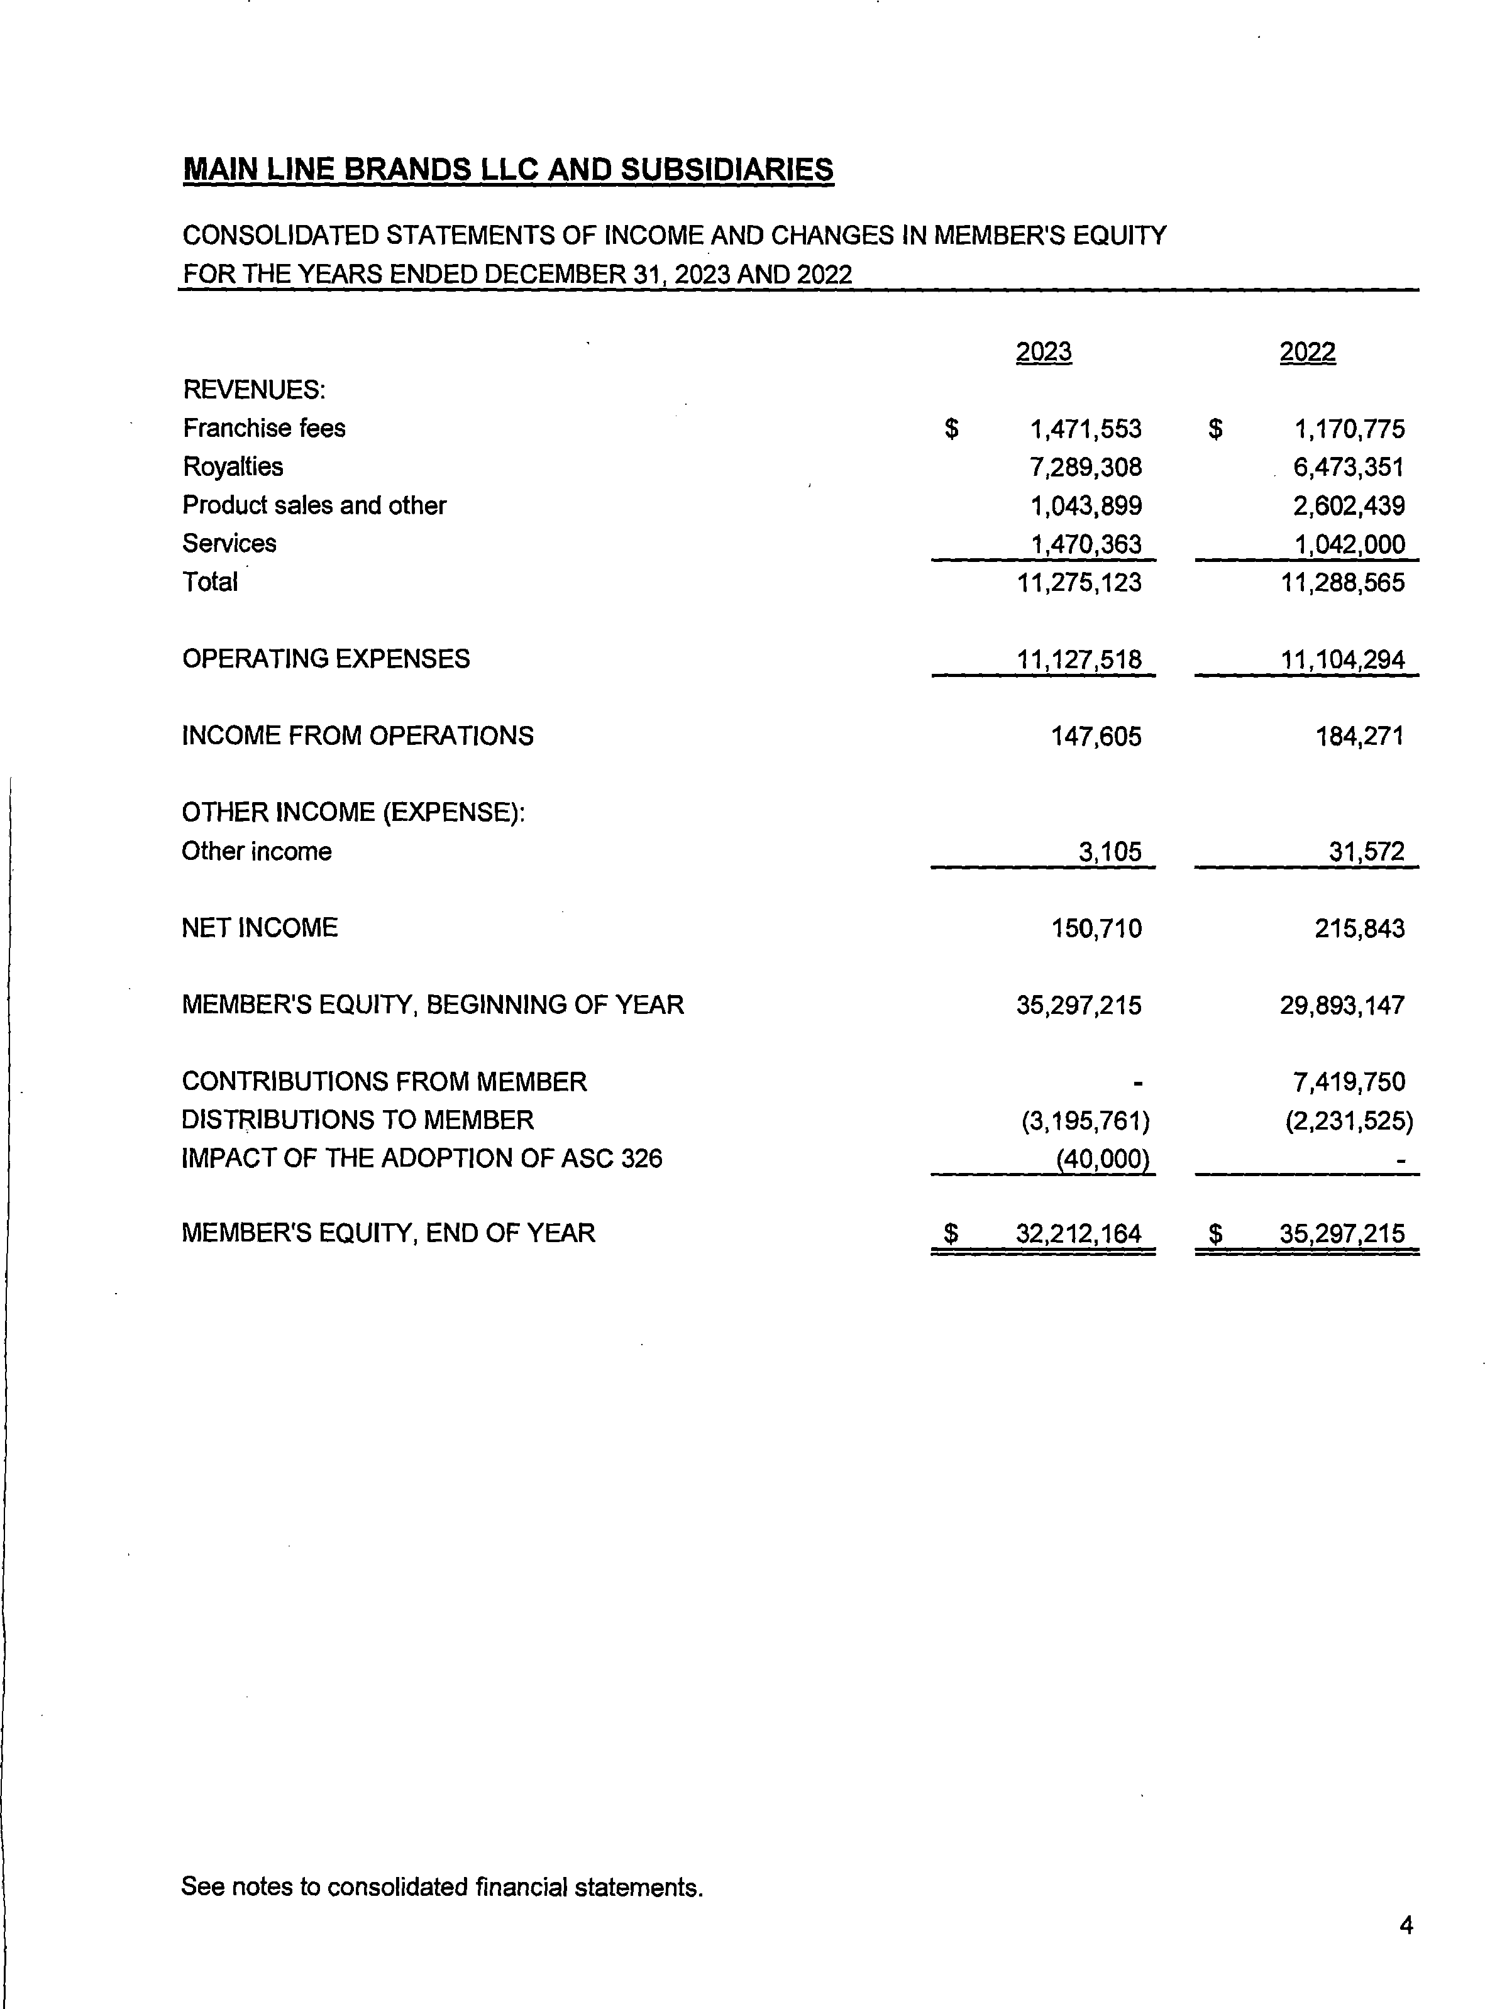

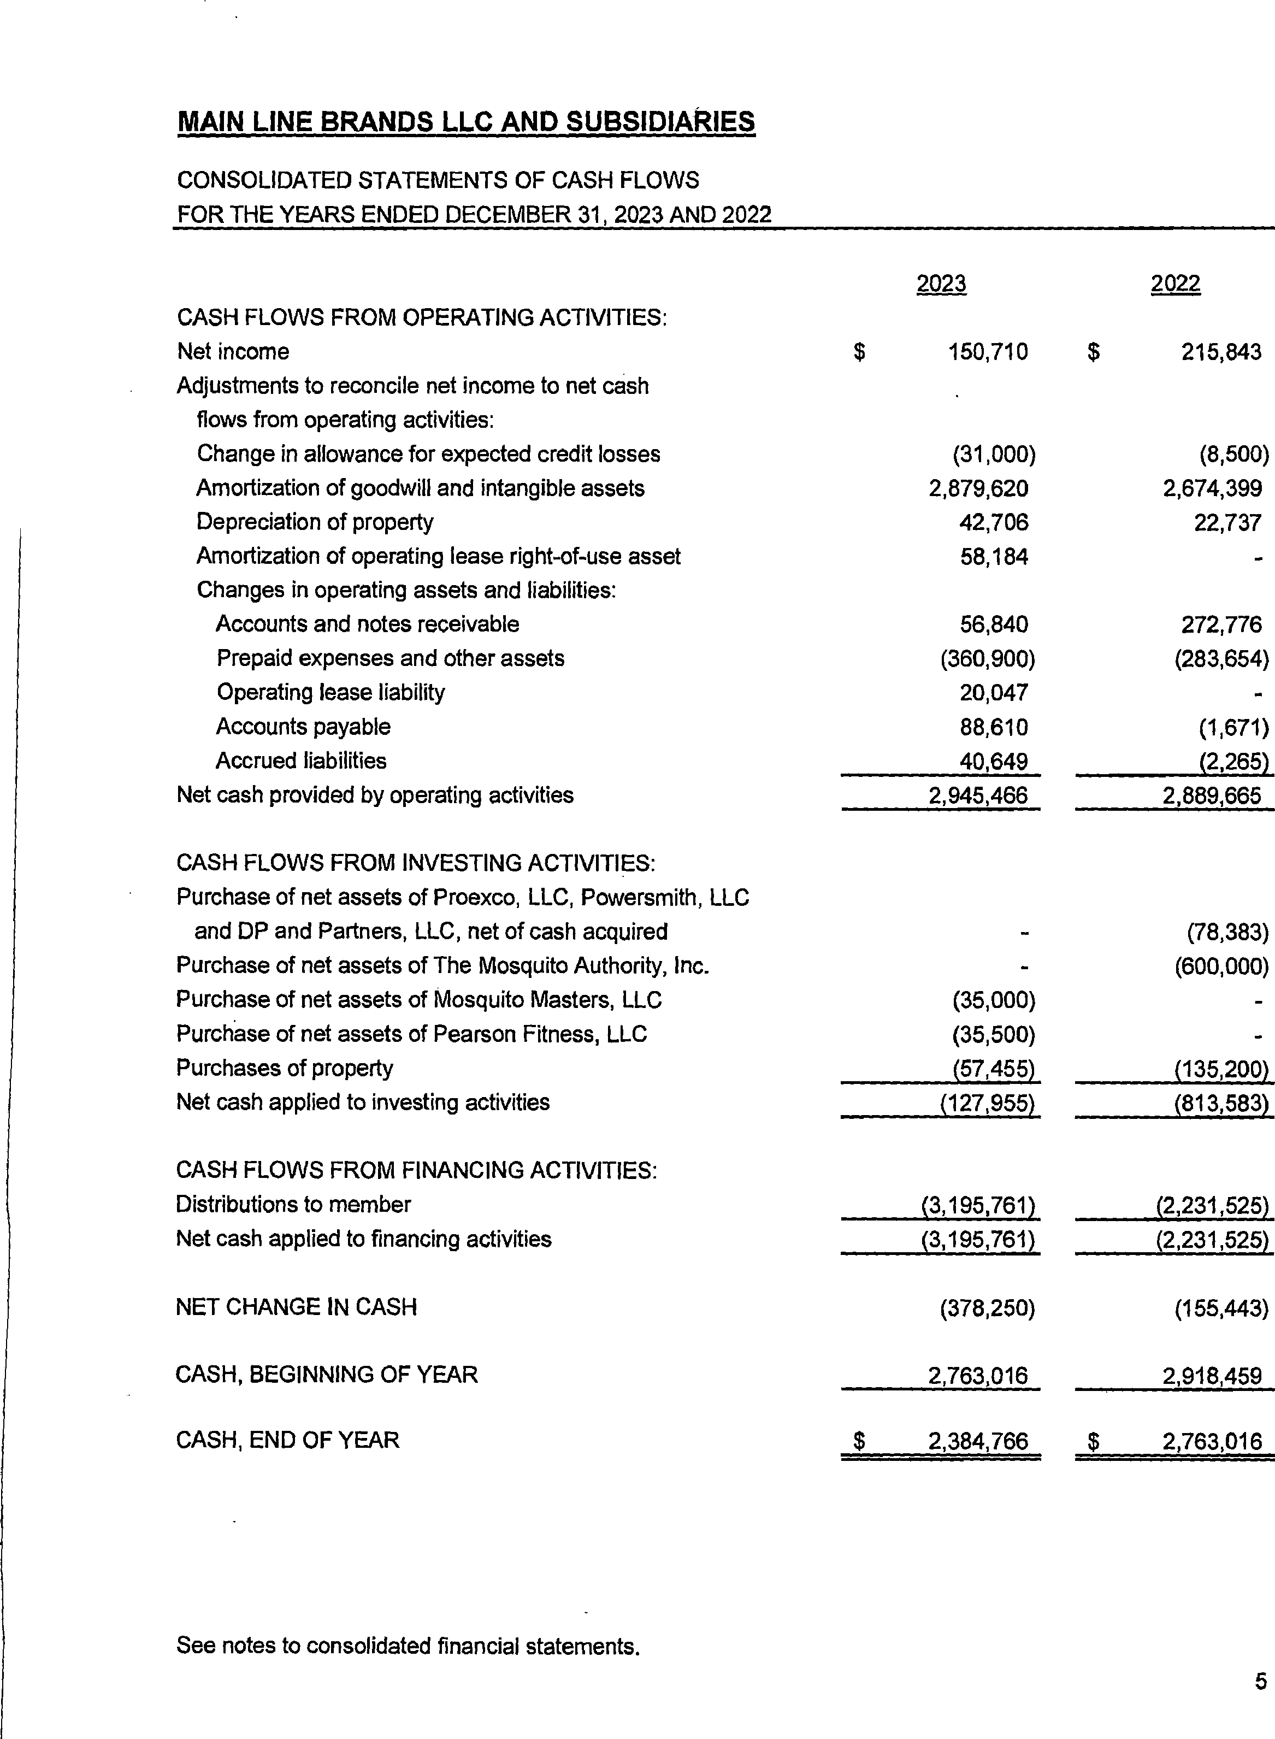

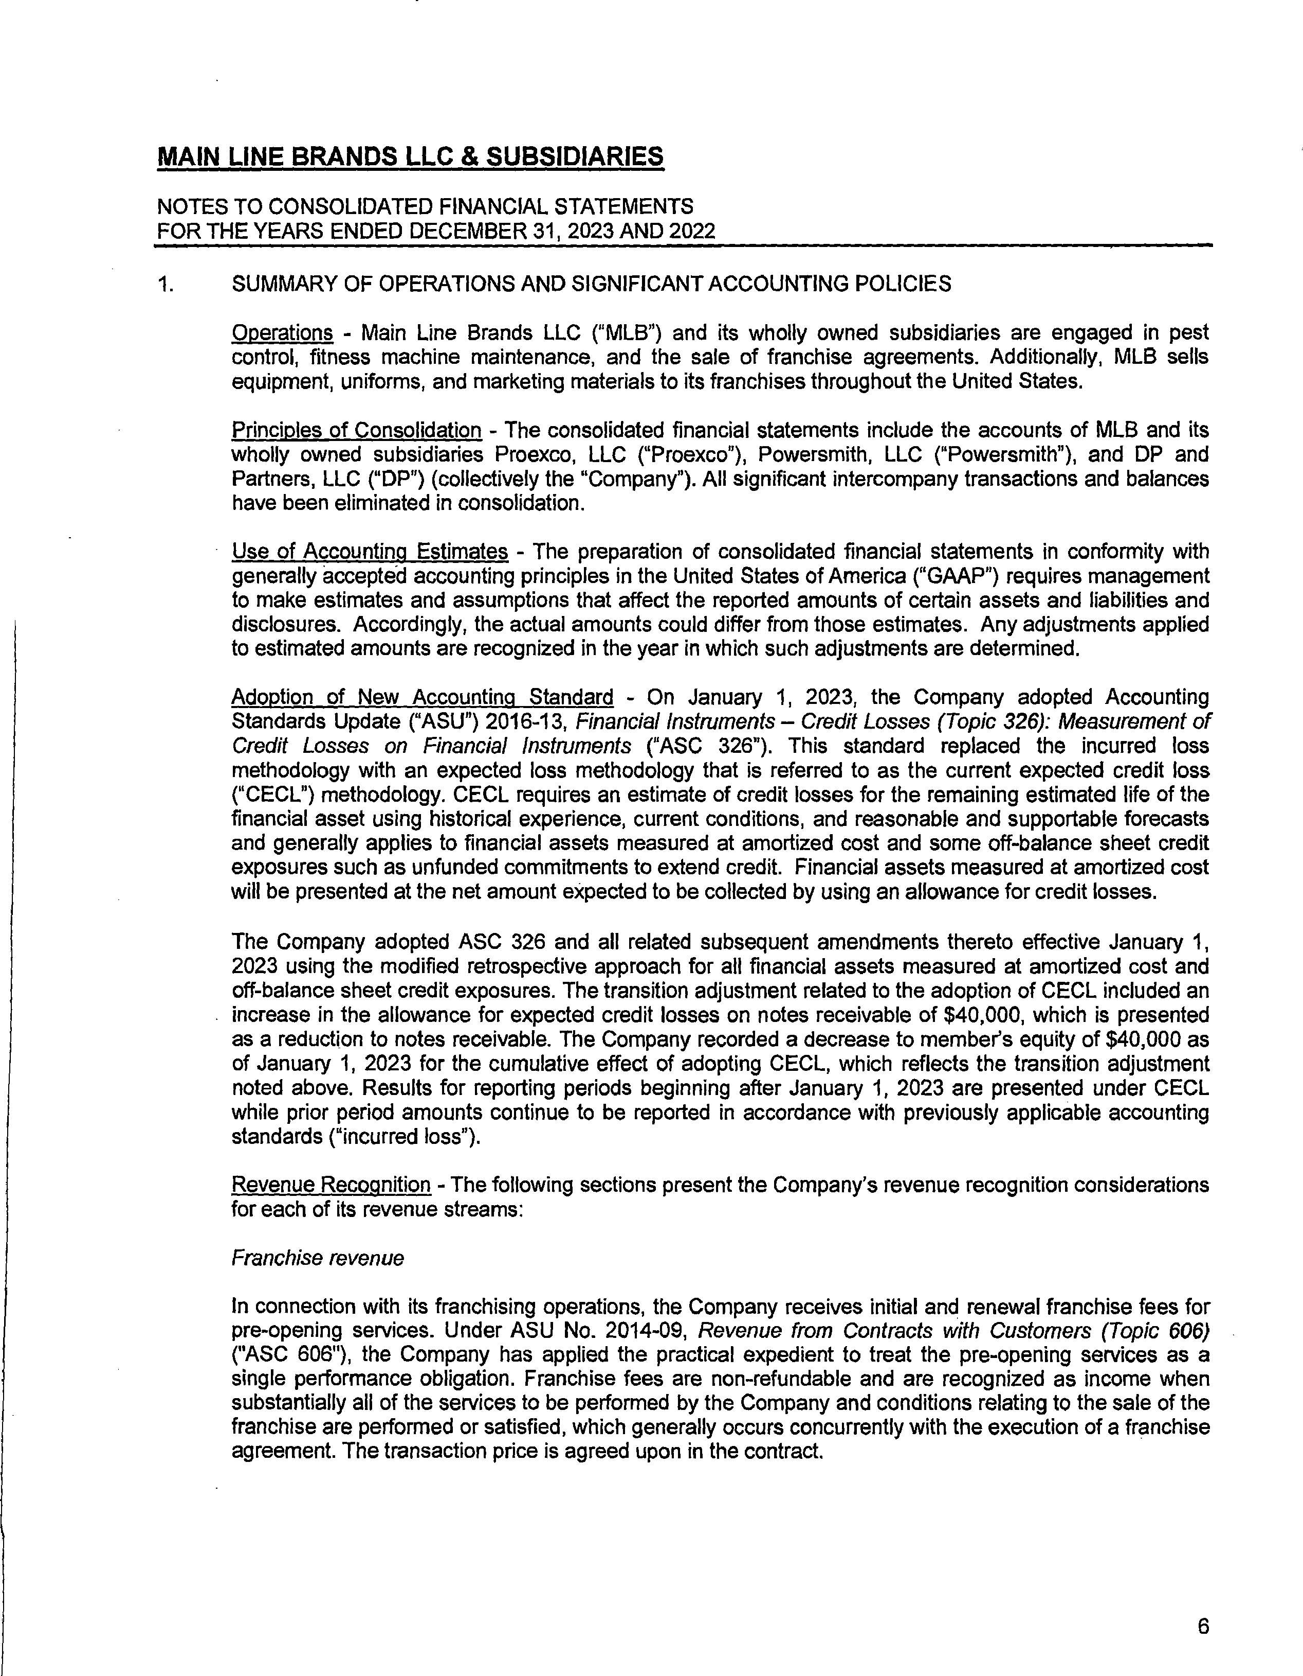

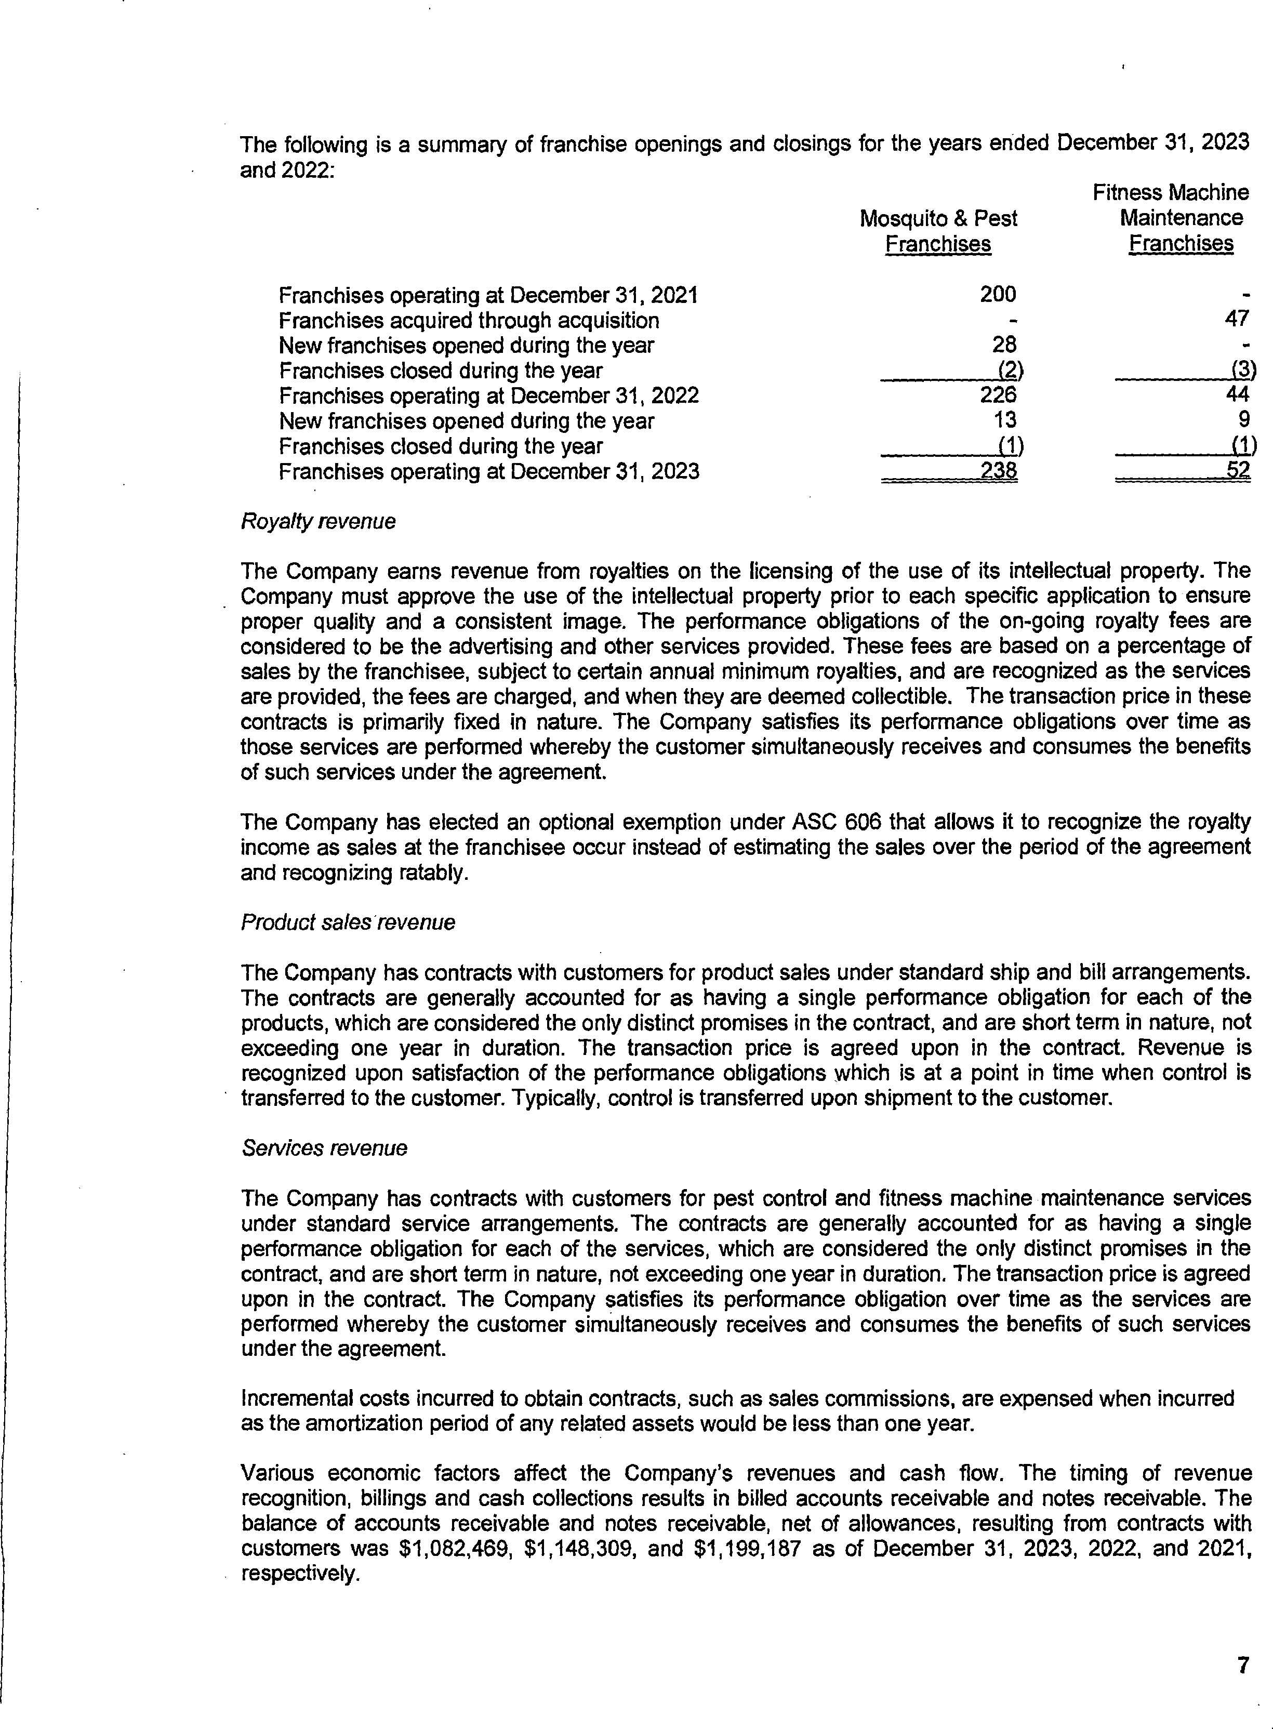

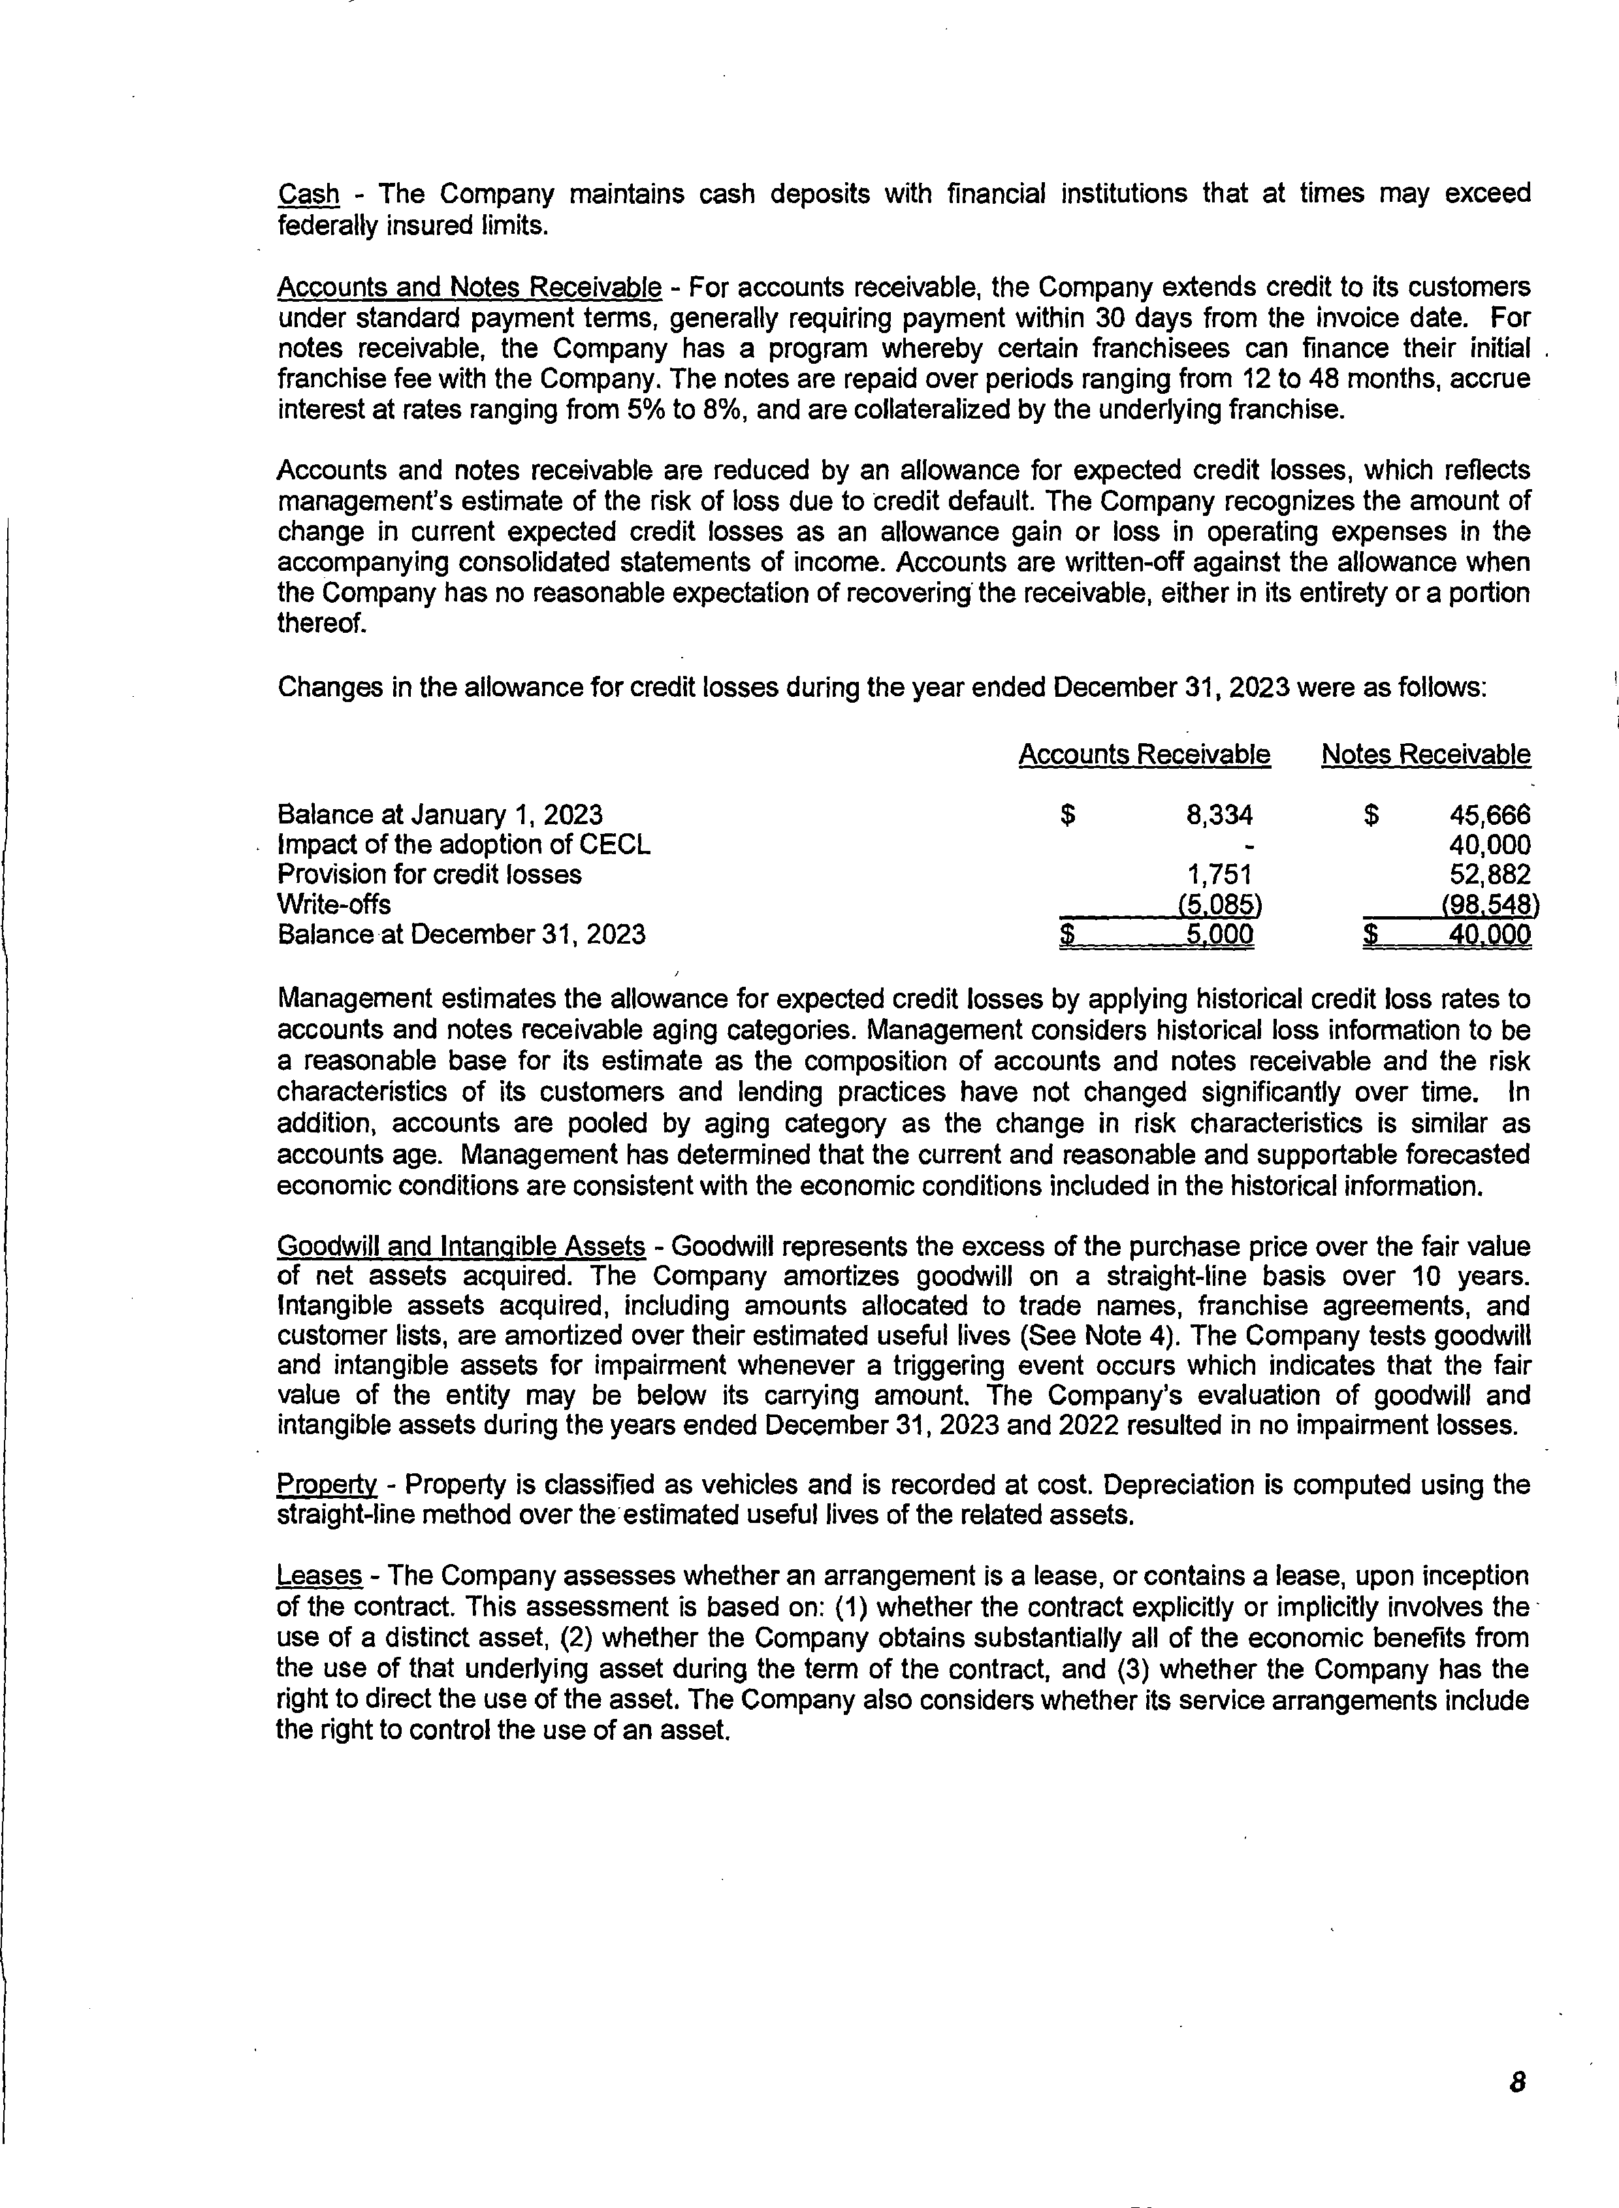

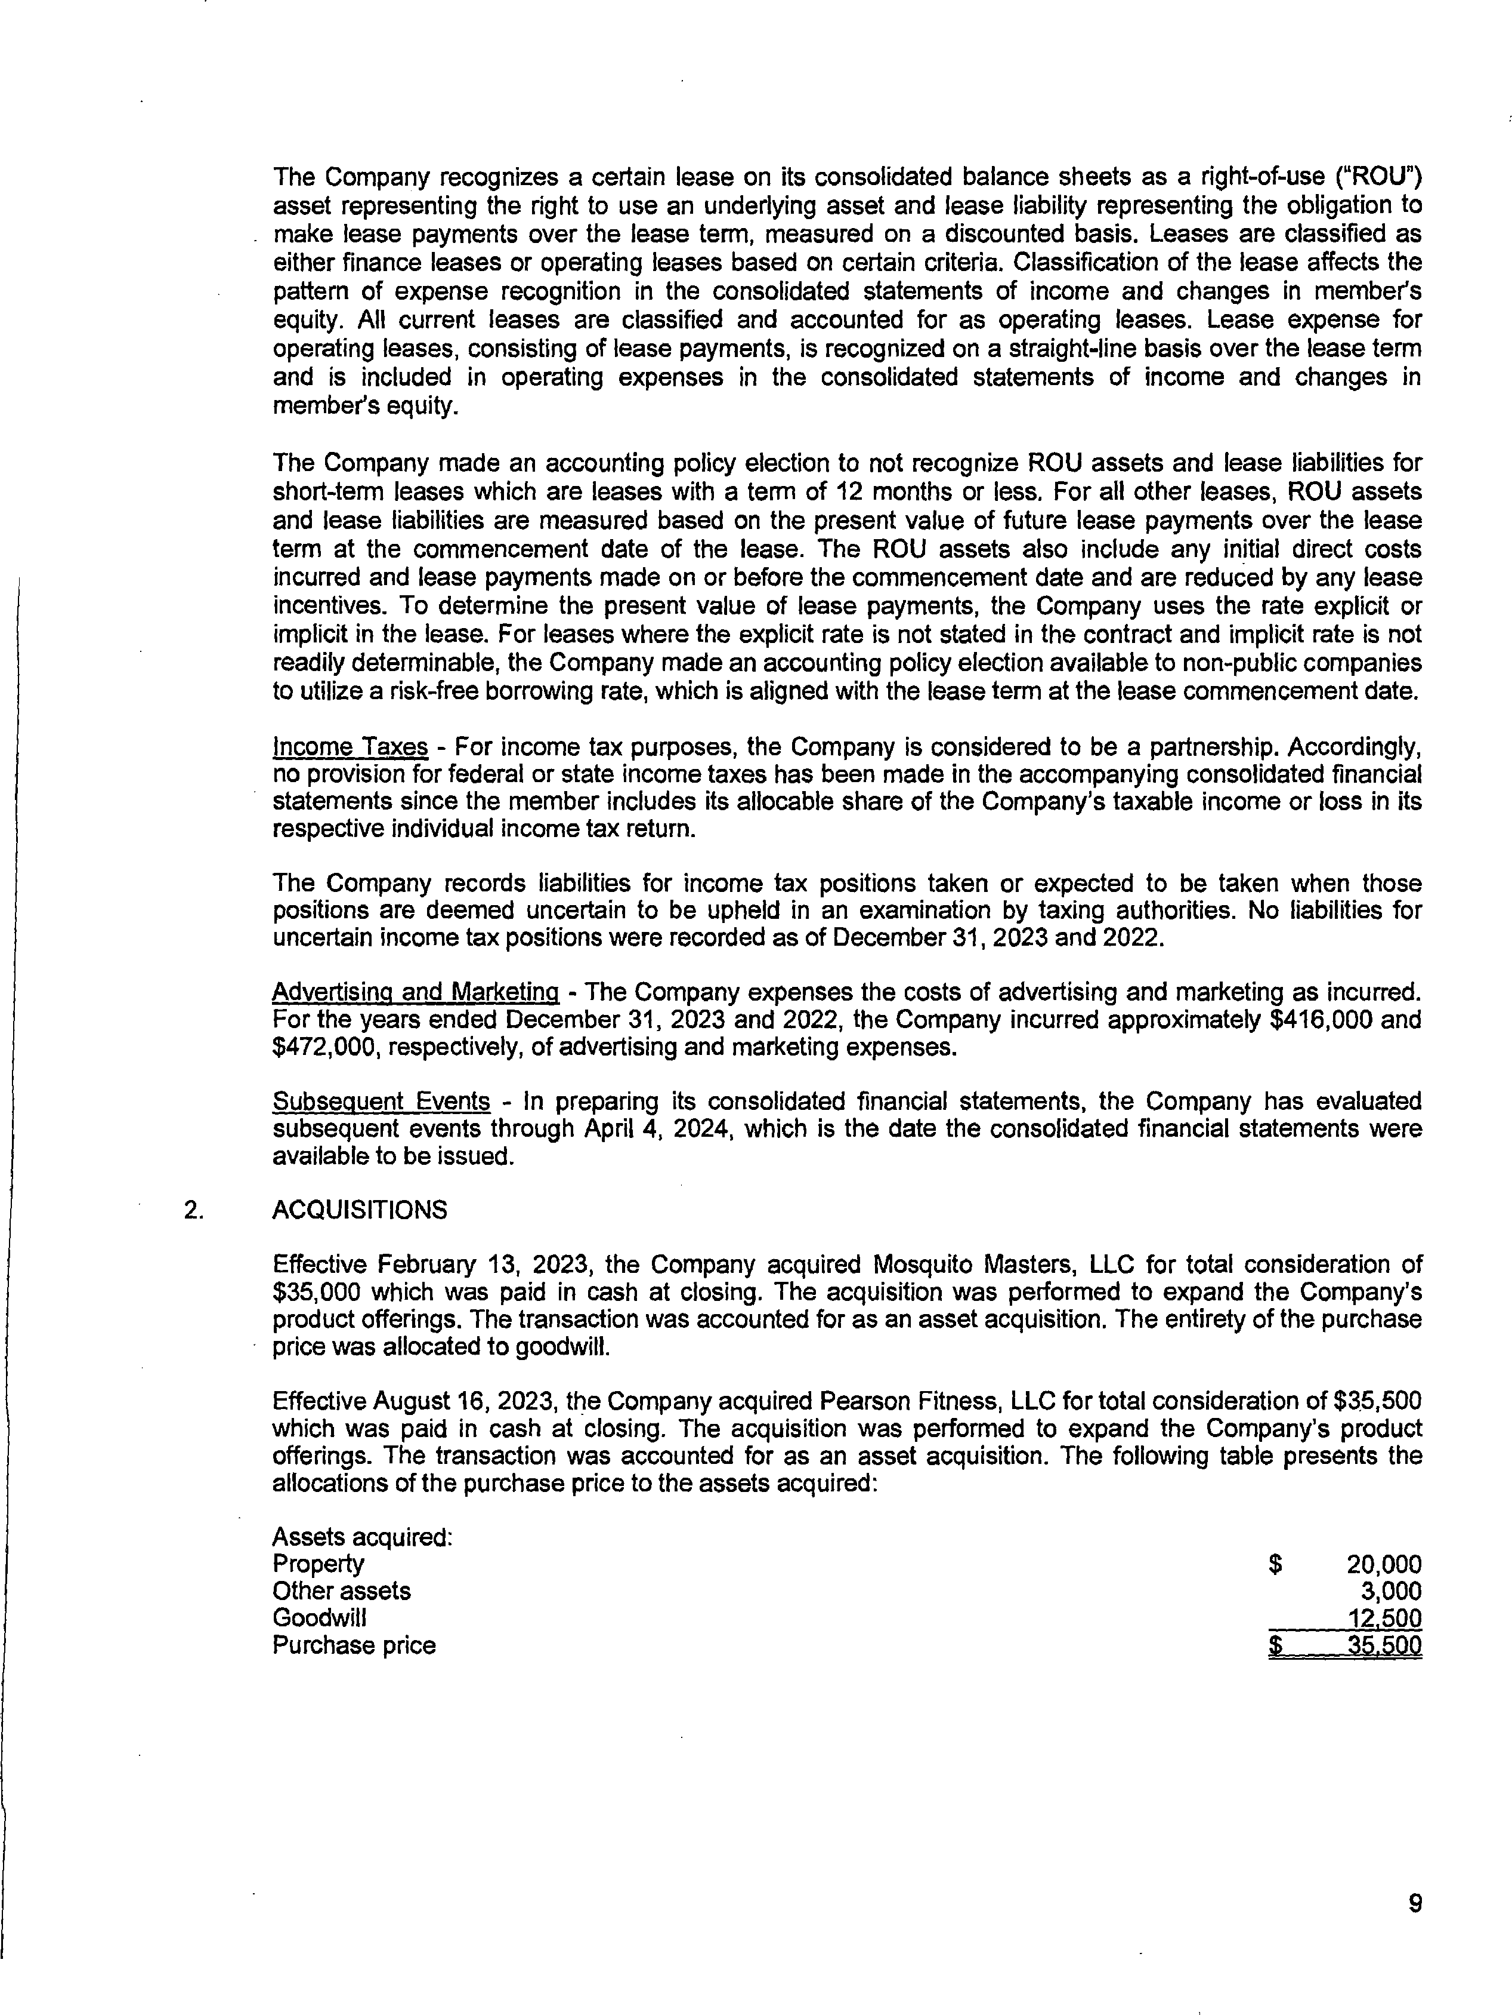

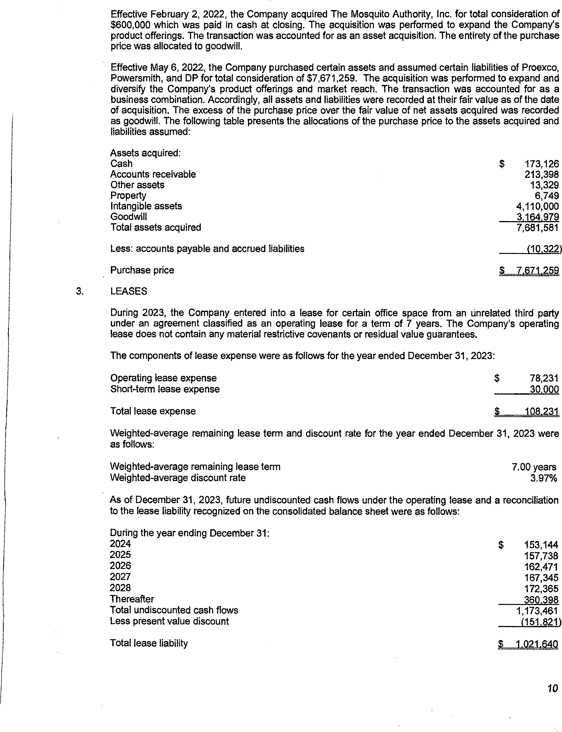

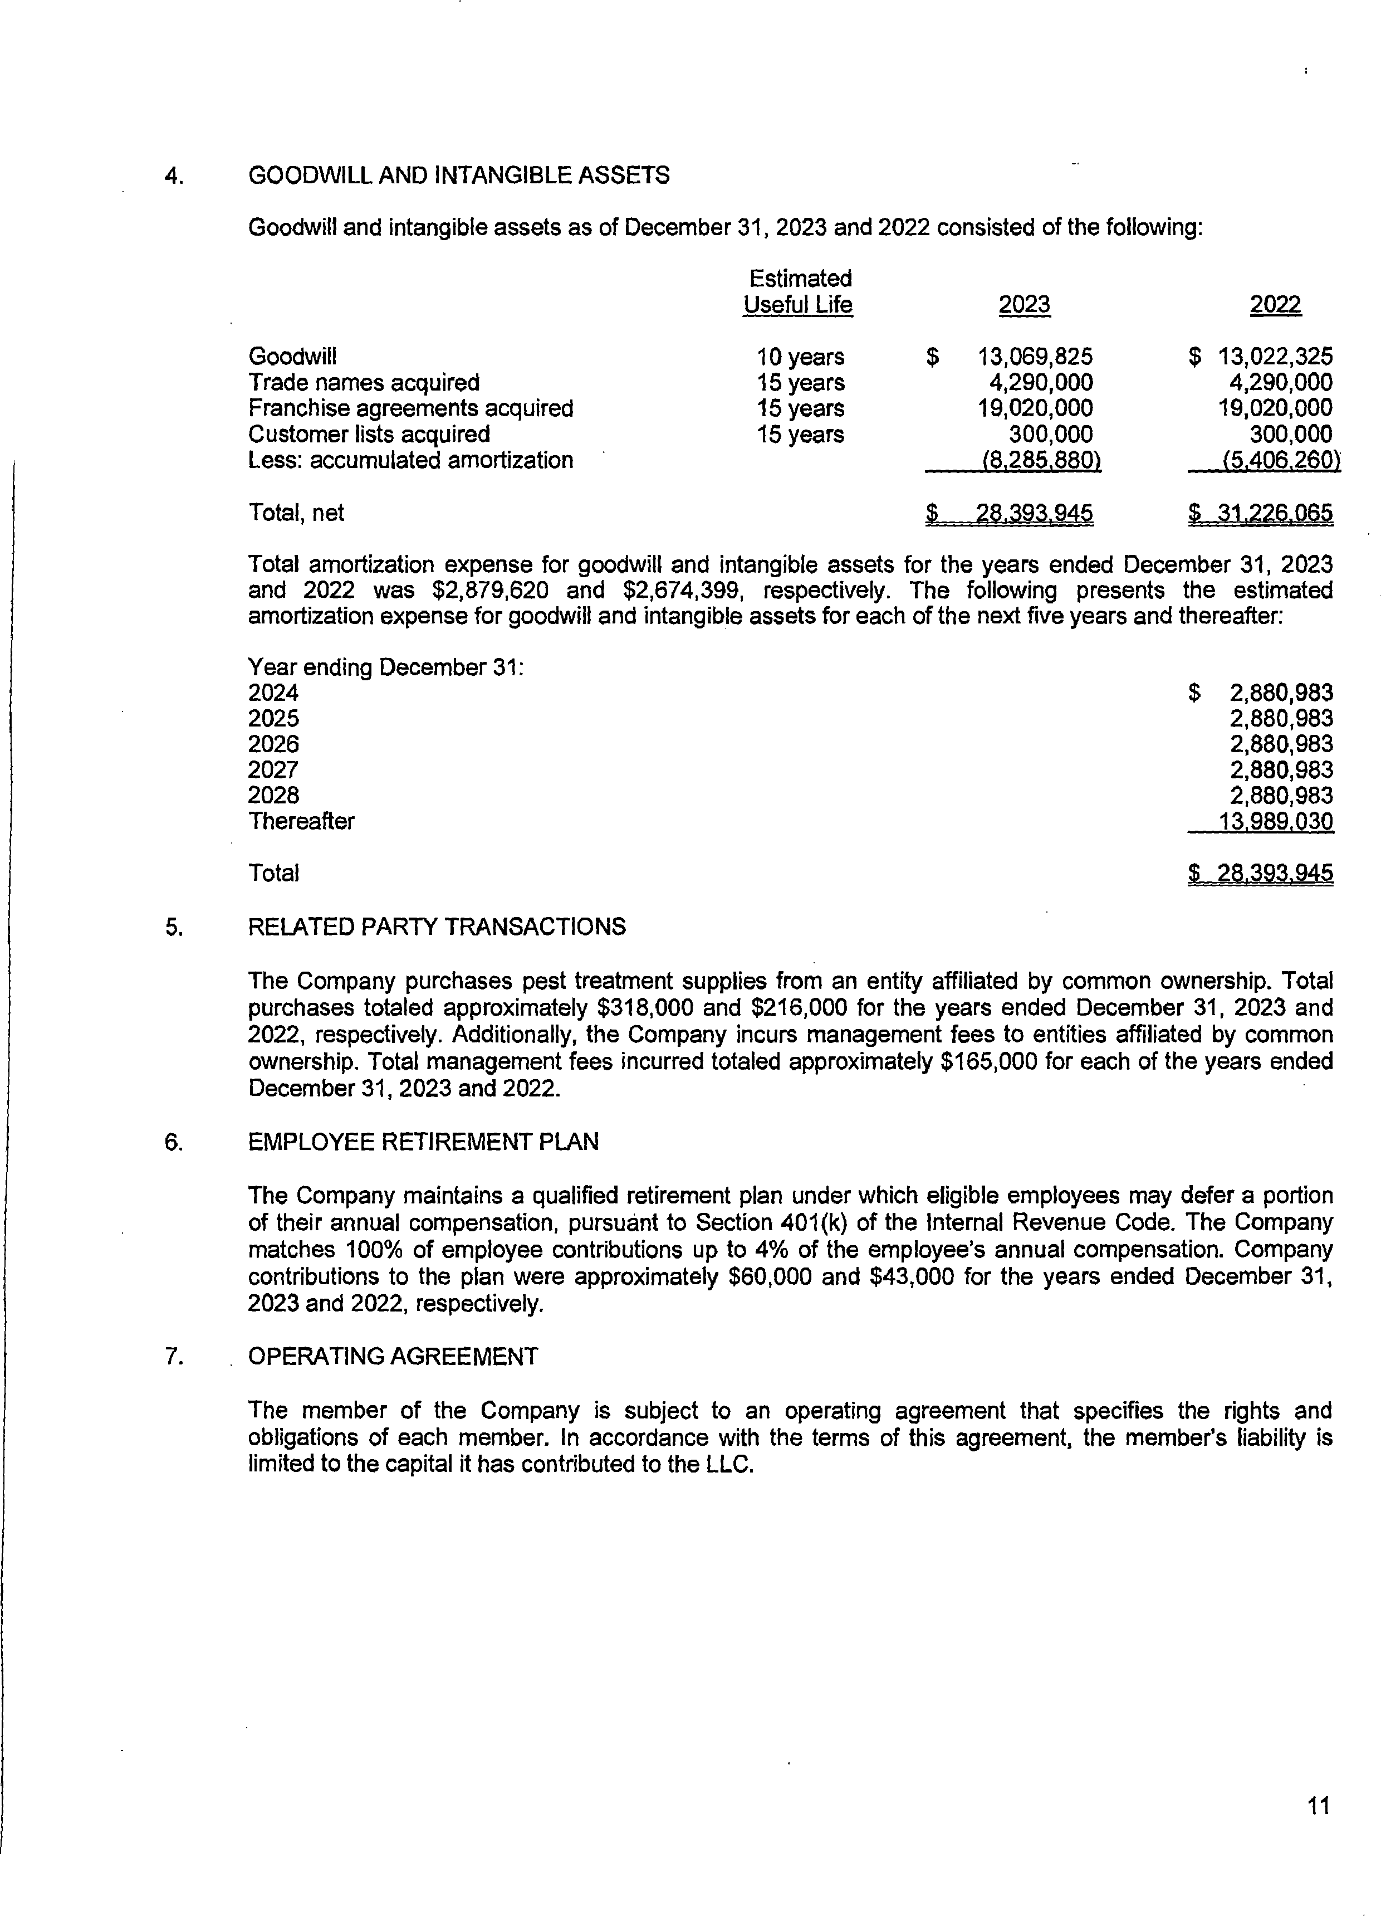

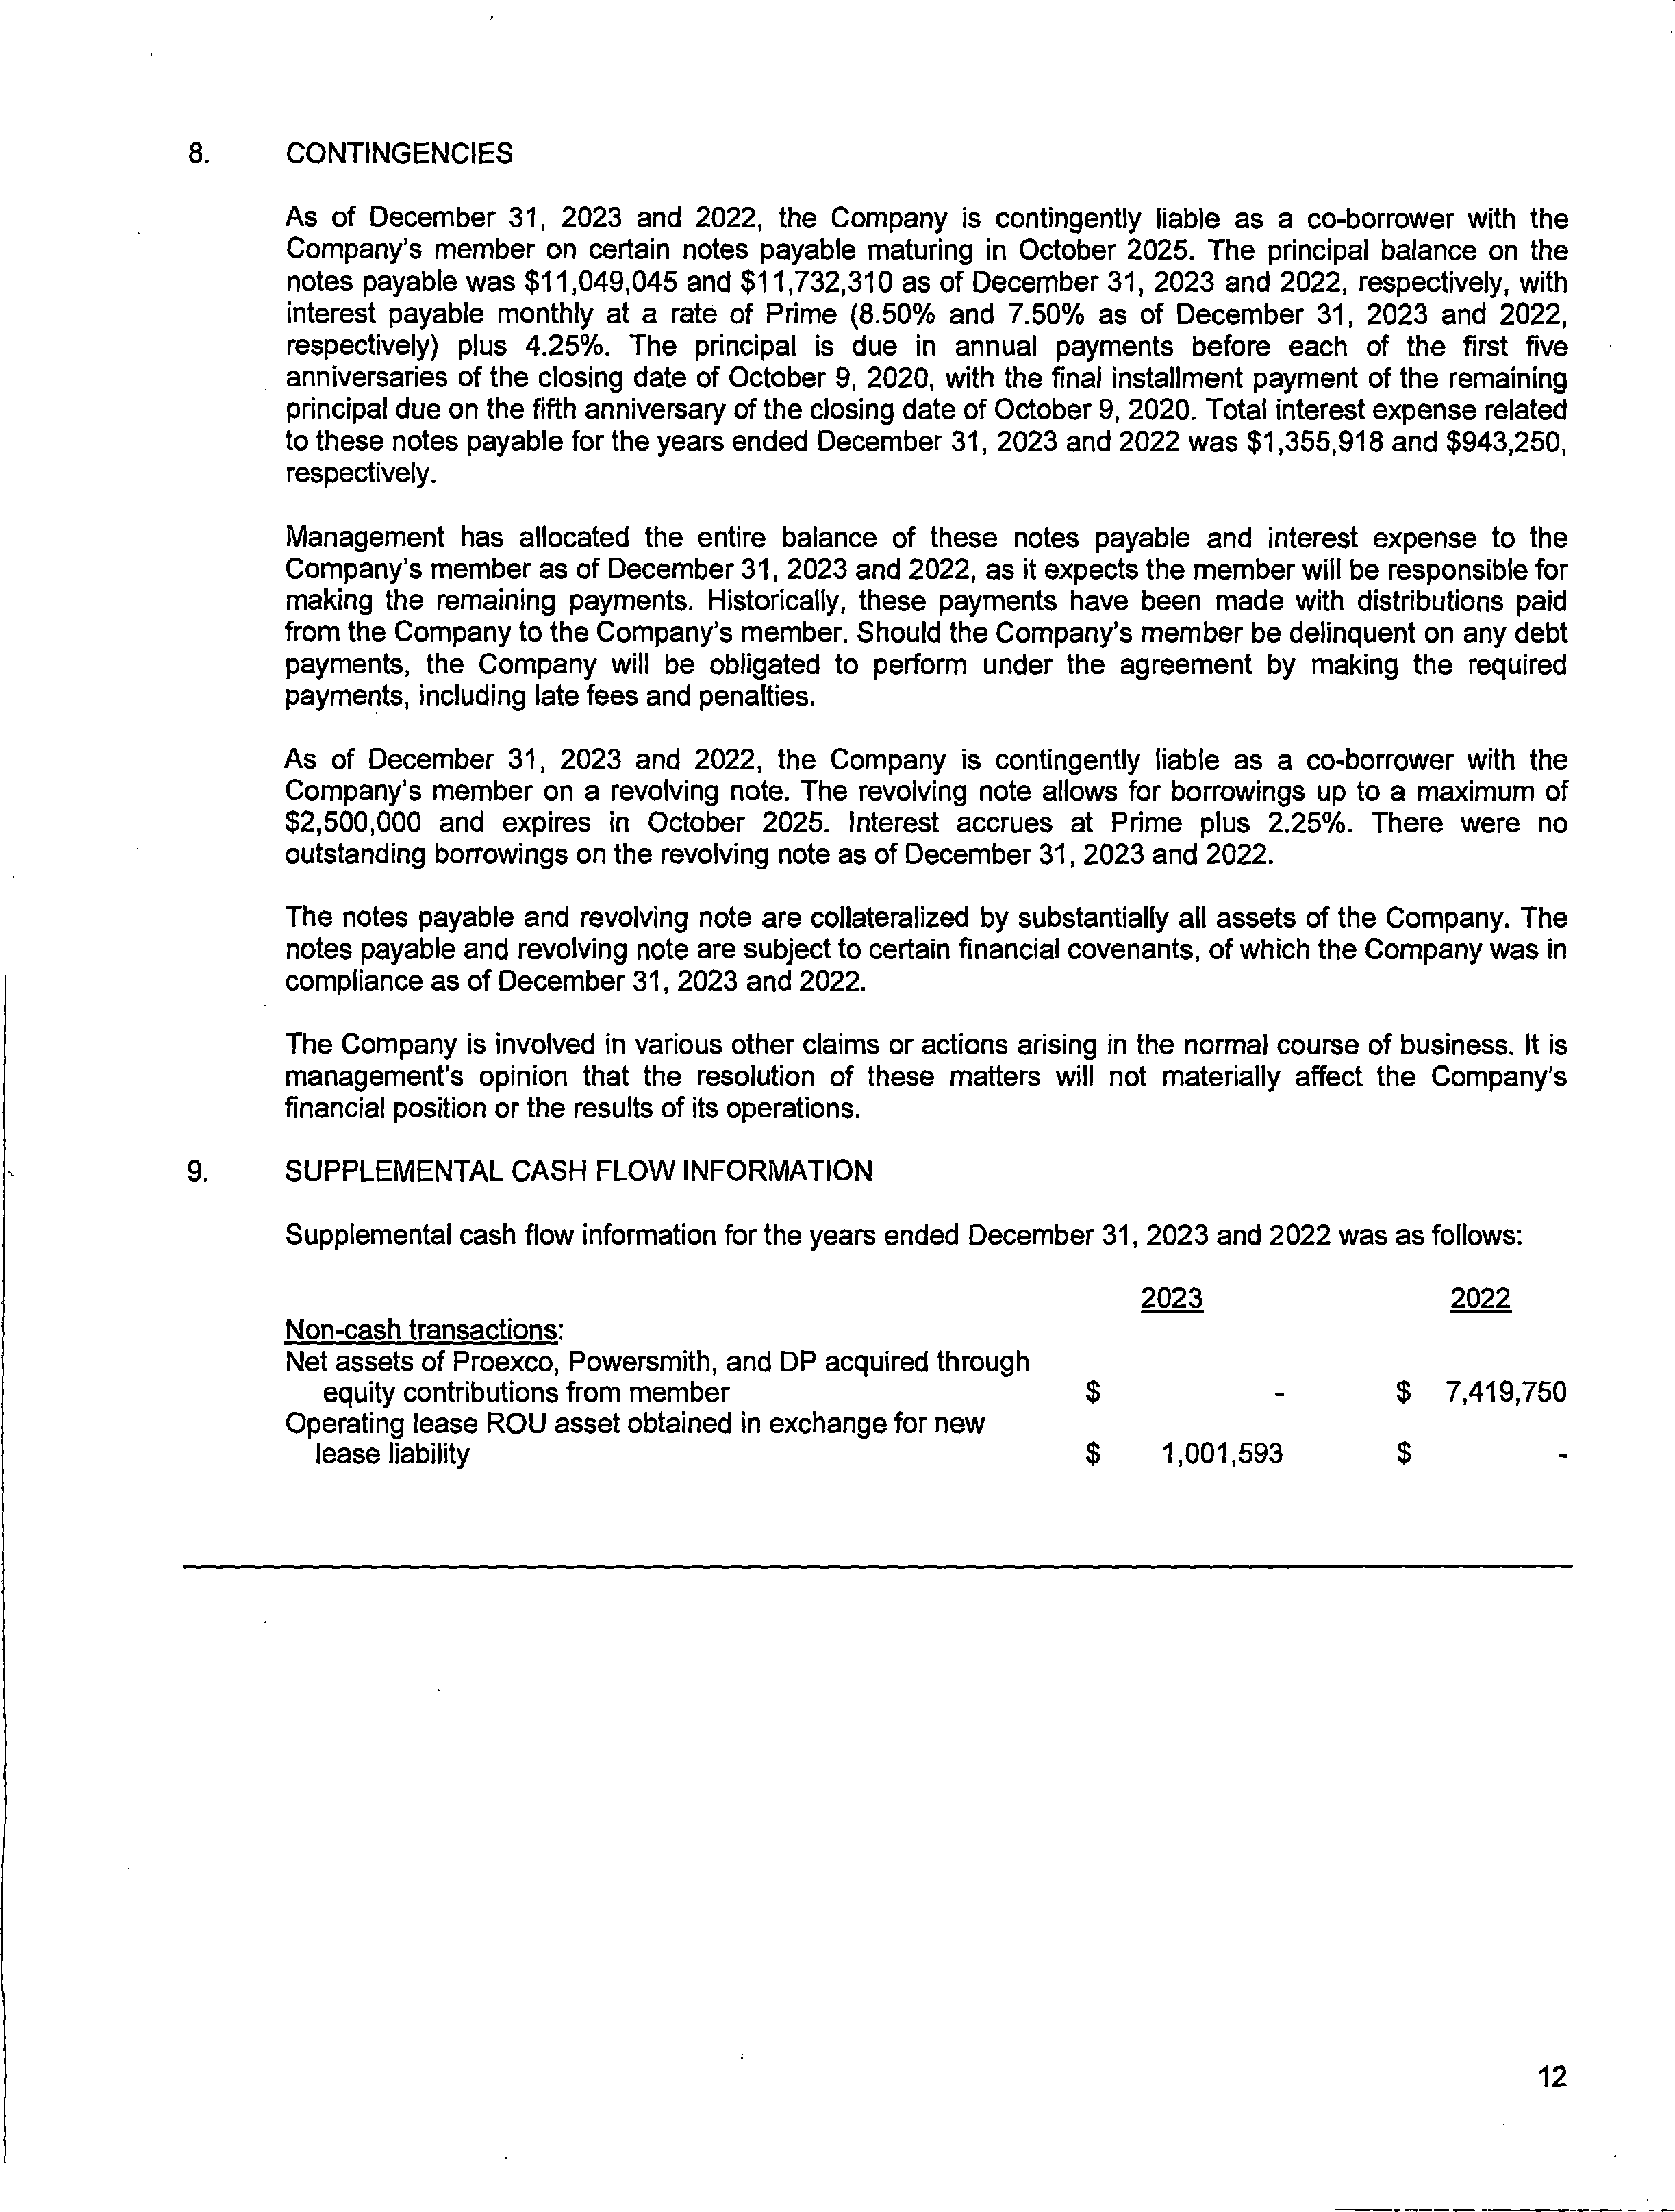

**EXHIBIT G TO THE DISCLOSURE DOCUMENT FORM OF GENERAL RELEASE**

THIS AGREEMENT (“Agreement”) is made and entered into this day by and between Main Line Brands LLC, a Delaware limited liability company located at 2359 Perimeter Pointe Parkway, Suite 250, Charlotte, North Carolina 28208 (the “Franchisor”), and , a with a principal address at (hereinafter referred to as “Releasor”), wherein the parties hereto, in exchange for good and valuable consideration, the sufficiency and receipt of which is hereby acknowledged, and in reliance upon the representations, warranties, and comments herein are set forth, do agree as follows:

### Release by Releasor:

Releasor does for itself, its successors and assigns, hereby release and forever discharge generally the Franchisor and any affiliate, wholly owned or controlled corporation, subsidiary, successor or assign thereof and any shareholder, officer, director, employee, or agent of any of them, from any and all claims, demands, damages, injuries, agreements and contracts, indebtedness, accounts of every kind or nature, whether presently known or unknown, suspected or unsuspected, disclosed or undisclosed, actual or potential, which Releasor may now have, or may hereafter claim to have or to have acquired against them of whatever source or origin, arising out of or related to any and all transactions of any kind or character at any time prior to and including the date hereof, including generally any and all claims at law or in equity, those arising under the common law or state or federal statutes, rules or regulations such as, by way of example only, franchising, securities and anti-trust statutes, rules or regulations, in any way arising out of or connected with the Agreement, and further promises never from this day forward, directly or indirectly, to institute, prosecute, commence, join in, or generally attempt to assert or maintain any action thereon against the Franchisor, any affiliate, successor, assign, parent corporation, subsidiary, director, officer, shareholder, employee, agent, executor, administrator, estate, trustee or heir, in any court or tribunal of the United States of America, any state thereof, or any other jurisdiction for any matter or claim arising before execution of this Agreement, excluding only such claims as the You [Transferor] may have under the Maryland Franchise Registration and Disclosure Law (Md. Code Bus. Reg. §§ 14-201 through 14-233), and the rules adopted thereunder. In the event Releasor breaches any of the promises covenants, or undertakings made herein by any act or omission, Releasor shall pay, by way of indemnification, all costs and expenses of the Franchisor caused by the act or omission, including reasonable attorneys’ fees.

1. Releasor hereto represents and warrants that no portion of any claim, right, demand, obligation, debt, guarantee, or cause of action released hereby has been assigned or transferred by Releasor party to any other party, firm or entity in any manner including, but not limited to, assignment or transfer by subrogation or by operation of law. In the event that any claim, demand or suit shall be made or institute against any released party because of any such purported assignment, transfer or subrogation, the assigning or transferring party agrees to indemnify and hold such released party free and harmless from and against any such claim, demand or suit, including reasonable costs and attorneys’ fees incurred in connection therewith. It is further agreed that this indemnification and hold harmless agreement shall not require payment to such claimant as a condition precedent to recovery under this paragraph.
2. Each party acknowledges and warrants that his, her or its execution of this Agreement is free and voluntary.
3. Pennsylvania law shall govern the validity and interpretation of this Agreement, as well as the performance due thereunder. This Agreement is binding upon and inures to the benefit of the respective assigns, successors, heirs and legal representatives of the parties hereto.
4. In the event that any action is filed to interpret any provision of this Agreement, or to enforce any of the terms thereof, the prevailing party shall be entitled to its reasonable attorneys’ fees and costs incurred therein, and said action must be filed in the Commonwealth of Pennsylvania.
5. This Agreement may be signed in counterparts, each of which shall be binding against the party executing it and considered as the original.

Notwithstanding the foregoing, this release does not apply with respect to claims arising under the Washington Franchise Investment Protection Act, RCW 19.100, and the rules adopted thereunder.

IN WITNESS WHEREOF, the parties hereto, intending to be legally bound hereby, have executed this agreement effective as of the date first above.

Witness: RELEASOR:

(Name)

Witness: MAIN LINE BRANDS LLC:

By: Name: Title:

**EXHIBIT H TO THE DISCLOSURE DOCUMENT STATE SPECIFIC ADDENDA**

**FOR FRANCHISEES IN FRANCHISE REGISTRATION STATES**

Required NASAA Statement. The following only applies in *California, Hawaii, Illinois, Indiana, Maryland, Michigan, Minnesota, New York, North Dakota, Rhode Island, South Dakota, Virginia, Washington and Wisconsin*: No statement, questionnaire, or acknowledgment signed or agreed to by a franchisee in connection with the commencement of the franchise relationship shall have the effect of (i) waiving any claims under any applicable state franchise law, including fraud in the inducement, or (ii) disclaiming reliance on any statement made by any franchisor, franchise seller, or other person acting on behalf of the franchisor. This provision supersedes any other term of any document executed in connection with the franchise.

**CALIFORNIA**

**ADDENDUM TO THE FRANCHISE DISCLOSURE DOCUMENT REQUIRED BY THE STATE OF CALIFORNIA**

### The registration of this franchise offering by the California Department of Financial Protection and Innovation does not constitute approval, recommendation, or endorsement by the commissioner.

1. Item 3 of the Disclosure Document is supplemented by the following language:

Neither we nor any person or franchise broker identified in Item 2 of the Disclosure Document is subject to any currently effective order of any national securities association or national securities exchange, as defined in the Securities Exchange Act of 1934, 15 U.S.C.A.78a et seq., suspending or expelling such persons from membership in that association or exchange.

1. Item 5 of the Disclosure Document and all relevant sections of the Franchise Agreement are amended such that:

All fees paid to the franchisor by the franchisee, including payments for goods and services received from the franchisor before the business opens, shall be deferred until the franchisee has commenced doing business.

1. Item 6 of the Disclosure Document is supplemented to reflect that 10% per annum is the highest interest rate allowed in California.
2. Item 17 of the Disclosure Document is supplemented by the following language:

California Business and Professions Code Sections 20000 through 20043 provide rights to the franchisee concerning termination, transfer or nonrenewal of a franchise. If the Franchise Agreement contains a provision that is inconsistent with the law, the law will control.

The Franchise Agreement provides for termination upon bankruptcy. This provision may not be enforceable under federal bankruptcy law (11 U.S.C.A. Sec. 101 et seq.).

The Franchise Agreement contains a covenant not to compete which extends beyond the termination of the agreement. This provision may not be enforceable under California law.

The Franchise Agreement requires application of the laws of North Carolina. This provision may not be enforceable under California law.

The Franchise Agreement requires submission of dispute to courts located in North Carolina. This provision may not be enforceable under California law.

The Franchise Agreement requires you to waive your right to a trial by jury. This provision may not be enforceable under California law.

The California Corporations Code, Section 31125 requires us to give you a disclosure document, approved by the Department of Corporations, prior to a solicitation of a proposed material modification of an existing franchise.

The Franchise Agreement contains a liquidated damages clause. Under California Civil Code Section 1671, certain liquidated damage clauses are unenforceable.

You must sign a general release if you transfer your franchise. California Corporations Code

§31512 voids a waiver of your rights under the Franchise Investment Law (California Corporations Code §§31000 through 31516). Business and Professions Code §20010 voids a waiver of your rights under the Franchise Relations Act (Business and Professions Code §§20000 through 20043).

1. THE CALIFORNIA FRANCHISE INVESTMENT LAW REQUIRES THAT A COPY OF ALL PROPOSED AGREEMENTS RELATING TO THE SALE OF THE FRANCHISE BE DELIVERED TOGETHER WITH A COPY OF THE DISCLOSURE DOCUMENT AT LEAST 14 DAYS BEFORE SIGNING THE AGREEMENT.
2. OUR WEBSITE HAS NOT BEEN REVIEWED OR APPROVED BY THE CALIFORNIA DEPARTMENT OF FINANCIAL PROTECTION AND INNOVATION. ANY COMPLAINTS CONCERNING THE CONTENT OF THIS WEBSITE MAY BE DIRECTED TO THE CALIFORNIA DEPARTMENT OF FINANCIAL PROTECTION AND INNOVATION AT

[www.dfpi.ca.gov.](http://www.dfpi.ca.gov/)

1. THE CALIFORNIA FRANCHISE INVESTMENT LAW REQUIRES THAT A COPY OF EACH PROPOSED AGREEMENT RELATING TO THE GRANT OF THE FRANCHISE BE DELIVERED TOGETHER WITH THE DISCLOSURE DOCUMENT AT LEAST 14 DAYS PRIOR TO EXECUTION OF THE AGREEMENT.
2. You will not receive an exclusive territory. You may face competition from other franchisees, from outlets that we own, or from other channels of distribution or competitive brands that we control.
3. Any provision of a franchise agreement, franchise disclosure document, acknowledgement, questionnaire, or other writing, including any exhibit thereto, Any provision of a franchise agreement, franchise disclosure document, disclaiming or denying any of the following shall be deemed contrary to public policy and shall be void and unenforceable:
   1. Representations made by the franchisor or its personnel or agents to a prospective franchisee.
   2. Reliance by a franchisee on any representations made by the franchisor or its personnel or agents.
   3. Reliance by a franchisee on the franchise disclosure document, including any exhibit thereto.
   4. Violations of any provision of this division.

**HAWAII**

**THESE FRANCHISES WILL BE/HAVE BEEN FILED UNDER THE FRANCHISE INVESTMENT LAW OF THE STATE OF HAWAII. FILING DOES NOT CONSTITUTE APPROVAL, RECOMMENDATION OR ENDORSEMENT BY THE DIRECTOR OF REGULATORY AGENCIES OR A FINDING BY THE DIRECTOR OF REGULATORY AGENCIES THAT THE INFORMATION PROVIDED HEREIN IS TRUE, COMPLETE AND NOT MISLEADING.**

**THE FRANCHISE INVESTMENT LAW MAKES IT UNLAWFUL TO OFFER OR SELL ANY FRANCHISE IN THIS STATE WITHOUT FIRST PROVIDING TO THE PROSPECTIVE FRANCHISEE, OR SUBFRANCHISOR, AT LEAST SEVEN DAYS PRIOR TO THE EXECUTION BY THE PROSPECTIVE FRANCHISEE OF ANY BINDING FRANCHISE OR OTHER AGREEMENT, OR AT LEAST SEVEN DAYS PRIOR TO THE PAYMENT OF ANY CONSIDERATION BY THE FRANCHISEE, OR SUBFRANCHISOR, WHICHEVER OCCURS FIRST, A COPY OF THE OFFERING CIRCULAR, TOGETHER WITH A COPY OF ALL PROPOSED AGREEMENTS RELATING TO THE SALE OF THE FRANCHISE.**

**THIS OFFERING CIRCULAR CONTAINS A SUMMARY ONLY OF CERTAIN MATERIAL PROVISIONS OF THE FRANCHISE AGREEMENT. THE CONTRACT OR AGREEMENT SHOULD BE REFERRED TO FOR A STATEMENT OF ALL RIGHTS, CONDITIONS, RESTRICTIONS AND OBLIGATIONS OF BOTH THE FRANCHISOR AND THE FRANCHISEE.**

**ILLINOIS**

1. Item 5 of the FDD and all relevant sections of the Franchise Agreement are amended such that:

All fees paid to the franchisor by the franchisee, shall be deferred until franchisor has satisfied its pre-opening obligations and the franchisee has commenced doing business. The Illinois Attorney General’s Office imposed this deferral requirement due to Franchisor’s financial condition.

1. Illinois law governs the Franchise Agreement(s).

In conformance with Section 4 of the Illinois Franchise Disclosure Act, any provision in a franchise agreement that designates jurisdiction and venue in a forum outside of the State of Illinois is void. However, a franchise agreement may provide for arbitration to take place outside of Illinois.

Your rights upon Termination and Non-Renewal are set forth in sections 19 and 20 of the Illinois Franchise Disclosure Act.

In conformance with section 41 of the Illinois Franchise Disclosure Act, any condition, stipulation or provision purporting to bind any person acquiring any franchise to waive compliance with the Illinois Franchise Disclosure Act or any other law of Illinois is void.

1. A National Account is a customer who conducts business in more than one location. The Franchisor has the exclusive right to negotiate and enter into agreements to provide services to national accounts. You

may be offered the opportunity to service a national account. If you decline or are unable to service the account, the Franchisor, an affiliate or another franchise may provide the service with no compensation to you (even if the service is provided within your exclusive territory).

1. The franchisor estimates the time between signing the Franchise Agreement and opening to be 30 to 60 days. The franchisor will offer a training program at headquarters within 60 days after you sign the Franchise Agreement. Your Franchised Business must be opened for business within 90 days after signing the Franchise Agreement, or the franchisor may elect to terminate your Franchise Agreement.
2. No statement, questionnaire or acknowledgement signed or agreed to by a franchisee in connection with the commencement of the franchise relationship shall have the effect of: (i) waiving any claims under any applicable state franchise law, including fraud in the inducement, or (ii) disclaiming reliance on behalf of the Franchisor. This provision supersedes any other term of any document executed in connection with the franchise.
3. By reading this disclosure document, you are **not** agreeing to, acknowledging, or making any representations whatsoever to the Franchisor and its affiliates.

**MARYLAND**

No statement, questionnaire, or acknowledgment signed or agreed to by a franchisee in connection with the commencement of the franchise relationship shall have the effect of (i) waiving any claims under any applicable state franchise law, including fraud in the inducement, or (ii) disclaiming reliance on any statement made by any franchisor, franchise seller, or other person acting on behalf of the franchisor. This provision supersedes any other term of any document executed in connection with the franchise.

### Item 5 of the Franchise Disclosure Document and all relevant sections of the Franchise Agreement are amended such that:

All fees paid to the franchisor by the franchisee, including payments for goods and services received from the franchisor before the business opens, shall be deferred until all of the franchisor’s pre-opening obligations to the franchisee have been satisfied.

### Item 17 of the Franchise Disclosure Document is amended as follows:

Pursuant to COMAR 02.02.08.16L, the general release required as a condition of renewal, sale, and/or assignment/transfer shall not apply to any liability under the Maryland Franchise Registration and Disclosure Law.

Any claims arising under the Maryland Franchise Registration and Disclosure Law must be brought within 3 years after the grant of the franchise.

The provision in the franchise agreement which provides for termination upon bankruptcy of the franchisee may not be enforceable under federal bankruptcy law (11 U.S.C. Section 101 et seq.).

### The Franchise Agreement is amended as follows:

A Franchisee is permitted to bring a lawsuit in Maryland for claims arising under the Maryland Franchise Registration and Disclosure Law.

Pursuant to COMAR 02.02.08.16L, the general release required as a condition of renewal, sale, and/or assignment/transfer shall not apply to any liability under the Maryland Franchise Registration and Disclosure Law.

Any claims arising under the Maryland Franchise Registration and Disclosure Law must be brought within 3 years after the grant of the franchise.

### The Franchise Agreement, Exhibit B to the Franchise Agreement and Exhibit G to the Franchise Disclosure Document are each amended to add the following:

All representations requiring prospective franchisees to assent to a release, estoppel or waiver of liability are not intended to nor shall they act as a release, estoppel or waiver of any liability incurred under the Maryland Franchise Registration and Disclosure Law.

**MINNESOTA**

With respect to franchises governed by Minnesota law, the franchisor will comply with Minnesota Statutes, Section 80C.14 Subds. 3,4 and 5, which require, (except in certain specified cases) that a franchisee be given 90 days’ notice of termination (with 60 days to cure) and 180 days; notice for non-renewal of the franchise agreement; and that consent to the transfer of the franchise will not be unreasonably withheld.

The following language amends the Governing Law, Jurisdiction and Venue, and Choice of Forum sections of the Franchise Disclosure Document and agreement(s): “Minnesota Statutes, Section 80C.21 and Minnesota Rule 2860.4400(j) prohibit the franchisor from requiring litigation to be conducted outside Minnesota, requiring waiver of a jury trial, or requiring the franchisee to consent to liquidated damages, termination penalties or judgment notes. In addition, nothing in the Franchise Disclosure Document or agreement(s) can abrogate or reduce any of franchisee’s rights as provided for in Minnesota Statutes, Chapter 80C, or franchisee’s rights to any procedure, forum, or remedies provided for by the laws of the jurisdiction. Further, Franchisee cannot consent to Franchisor obtaining injunctive relief. Franchisor may seek injunctive relief.

Items 5 and 7 of the Franchise Disclosure Document and Section 2 of the Franchise Agreement are modified such that:

“All initial fees and payments owed by Franchisee to Franchisor or its affiliates shall be deferred until the Franchisee has commenced doing business.”

Pursuant to Minn. Stat. § 604.113, Item 6 of the Franchise Agreement and Section 8 of the Franchise Agreement are modified such that the Insufficient Funds Fee is $30.00 per occurrence.

Item 13 of the Franchise Disclosure Document and the applicable sections of the franchise agreement(s) are modified to state that the franchisor will protect the franchisee’s right to use the trademarks, service marks, trade names, logotypes or other commercial symbols or indemnify the franchisee from any loss, costs or expenses arising out of any claim, suit or demand regarding the use of the name. Minnesota considers it unfair to not protect the franchisee’s right to use the trademarks. See Minnesota Statutes, Section 80C.12, Subd. 1(g).

The Limitations of Claims section is amended to comply with Minnesota Statutes, Section 80C.17. Subd. 5.

In accordance with Minnesota Rule 2860.4400(D), we cannot require you to assent to a general release.

NSF checks are governed by Minnesota Statute 604.113, which puts a cap of $30 on service charges.

No statement, questionnaire, or acknowledgment signed or agreed to by a franchisee in connection with the commencement of the franchise relationship shall have the effect of (i) waiving any claims under any applicable state franchise law, including fraud in the inducement, or (ii) disclaiming reliance on any statement made by any franchisor, franchise seller, or other person acting on behalf of the franchisor. This provision supersedes any other term of any document executed in connection with the franchise.

**NEW YORK**

1. The following information is added to the cover page of the Franchise Disclosure Document:

**INFORMATION COMPARING FRANCHISORS IS AVAILABLE. CALL THE STATE ADMINISTRATORS LISTED IN EXHIBIT A OR YOUR PUBLIC LIBRARY FOR RESOURCES OR INFORMATION. REGISTRATION OF THIS FRANCHISE BY NEW YORK STATE DOES NOT MEAN THAT NEW YORK STATE RECOMMENDS IT OR HAS VERIFIED THE INFORMATION IN THIS FRANCHISE DISCLOSURE DOCUMENT. IF YOU LEARN ANYTHING IN THIS FRANCHISE DISCLOSURE DOCUMENT IS UNTRUE, CONTACT THE FEDERAL TRADE COMMISSION AND THE APPROPRIATE STATE OR PROVINCIAL AUTHORITY. THE FRANCHISOR MAY, IF IT CHOOSES, NEGOTIATE WITH YOU ABOUT ITEMS COVERED IN THE FRANCHISE DISCLOSURE DOCUMENT. HOWEVER, THE FRANCHISOR CANNOT USE THE NEGOTIATING PROCESS TO PREVAIL UPON A PROSPECTIVE FRANCHISEE TO ACCEPT TERMS THAT ARE LESS FAVORABLE THAN THOSE SET FORTH IN THIS FRANCHISE DISCLOSURE DOCUMENT.**

1. The following is to be added at the end of Item 3:

Except as provided above, the following applies to the franchisor, its predecessor, a person identified in Item 2, or an affiliate offering franchises under the franchisor’s principal trademark:

* 1. No such party has an administrative, criminal, or civil action pending against that person alleging: a felony, a violation of a franchise, antitrust, or securities law, fraud, embezzlement, fraudulent conversion, misappropriation of property, unfair or deceptive practices, or comparable civil or misdemeanor allegations.
  2. No such party has pending actions other than routine litigation incidental to the business that is significant in the context of the number of franchisees and the size, nature, or financial condition of the franchise system or its business operations. C. No such party has been convicted of a felony or pleaded nolo contendere to a felony charge or, within the ten years immediately preceding the application for registration, has been convicted of or pleaded nolo contendere to a misdemeanor charge or has been the subject of a civil action alleging: violation of a franchise, antifraud, or securities law; fraud; embezzlement; fraudulent conversion or misappropriation of property; or unfair or deceptive practices or comparable allegations.
  3. No such party has been convicted of a felony or pleaded nolo contendere to a felony charge or, within the ten years immediately preceding the application for registration, has been convicted of or pleaded nolo contendere to a misdemeanor charge or has been the subject of a civil action alleging: violation of a franchise, antifraud, or securities law; fraud; embezzlement; fraudulent conversion or misappropriation of property; or unfair or deceptive practices or comparable allegations.
  4. No such party is subject to a currently effective injunctive or restrictive order or decree relating to the franchise or under a Federal, State, or Canadian franchise, securities, antitrust, trade regulation, or trade

practice law resulting from a concluded or pending action or proceeding brought by a public agency; or is subject to any currently effective order of any national securities association or national securities exchange, as defined in the Securities and Exchange Act of 1934, suspending or expelling such person from membership in such association or exchange; or is subject to a currently effective injunctive or restrictive order relating to any other business activity as a result of an action brought by a public agency or department, including, without limitation, actions affecting a license as a real estate broker or sales agent.

1. The following is added to the end of the “Summary” sections of Item 17(c), titled “Requirements for a franchisee to renew or extend,” and Item 17(m), entitled “Conditions for franchisor approval of transfer”:

However, to the extent required by applicable law, all rights you enjoy and any causes of action arising in your favor from the provisions of Article 33 of the General Business Law of the State of New York and the regulations issued thereunder shall remain in force; this proviso intends that the nonwaiver provisions of General Business Law Sections 687(4) and 687(5) be satisfied.

1. The following language replaces the “Summary” section of Item 17(d), titled “Termination by a franchisee”: “You may terminate the agreement on any grounds available by law.”
2. The following is added to the end of the “Summary” sections of Item 17(v), titled “Choice of forum,” and Item 17(w), titled “Choice of law”:

The foregoing choice of law should not be considered a waiver of any right conferred upon the franchisor or the franchisee by Article 33 of the General Business Law of the State of New York.

1. Franchise Questionnaires and Acknowledgements--No statement, questionnaire, or acknowledgment signed or agreed to by a franchisee in connection with the commencement of the franchise relationship shall have the effect of (i) waiving any claims under any applicable state franchise law, including fraud in the inducement, or (ii) disclaiming reliance on any statement made by any franchisor, franchise seller, or other person acting on behalf of the franchisor. This provision supersedes any other term of any document executed in connection with the franchise.
2. Receipts--Any sale made must be in compliance with § 683(8) of the Franchise Sale Act (N.Y. Gen. Bus. L. § 680 et seq.), which describes the time period a Franchise Disclosure Document (offering prospectus) must be provided to a prospective franchisee before a sale may be made. New York law requires a franchisor to provide the Franchise Disclosure Document at the earliest of the first personal meeting, ten (10) business days before the execution of the franchise or other agreement, or the payment of any consideration that relates to the franchise relationship.

**NORTH DAKOTA**

1. Items 6 and 17(i) of this disclosure document are amended to reflect that all liquidated damages provisions in the Franchise Agreement are deleted in their entirety.
2. Item 17(r) of this disclosure document is amended to reflect that covenants not to compete such as those contained in the Franchise Agreement are generally considered unenforceable in the State of North Dakota.
3. Item 17(v) of this disclosure document is amended to reflect that the jury trial waiver provisions in the Franchise Agreement are deleted in their entirety.
4. Item 17(w) of this disclosure document is amended to reflect that the choice of law provisions in the Franchise Agreement may not be enforceable in the State of North Dakota.
5. Notwithstanding the Franchise Agreement requiring the franchisee to consent to a waiver of exemplary and punitive damages, this provision is deleted in its entirely.
6. Notwithstanding the Franchise Agreement requiring the franchisee to consent to a limitation of claims within one year, the provision is changed to read the statute of limitations under North Dakota Law will apply.
7. Notwithstanding the Franchise Agreement stipulating that the franchisee shall pay all costs and expenses incurred by the franchisor in enforcing the Franchise Agreement, the provision is changed to read that the prevailing party in any enforcement action is entitled to recover all costs and expenses including attorney's fees.
8. No statement, questionnaire, or acknowledgment signed or agreed to by a franchisee in connection with the commencement of the franchise relationship shall have the effect of (i) waiving any claims under any applicable state franchise law, including fraud in the inducement, or (ii) disclaiming reliance on any statement made by any franchisor, franchise seller, or other person acting on behalf of the franchisor. This provision supersedes any other term of any document executed in connection with the franchise.

**RHODE ISLAND**

In recognition of the requirements of the Rhode Island Franchise Investment Act, the Franchise Disclosure Document of Main Line Brands LLC (“we,” “us,” or “our”) for use in the State of Rhode Island shall be amended to include the following:

* 1. Items 17v. and 17w., under the provisions entitled “Choice of law” and “Choice of forum,” shall be supplemented with the following language:

However, you may sue us in Rhode Island for claims arising under the Rhode Island Franchise Investment Act.

* 1. Item 17 shall be supplemented by the addition of the following language at the end of Item

17:

Section 19-28.1-14 of the Rhode Island Franchise Investment Act provides that “A provision in a franchise agreement restricting jurisdiction or venue to a forum outside this state or requiring the application of the laws of another state is void with respect to a claim otherwise enforceable under this Act.”

* 1. Each provision of this Addendum to the Disclosure Document shall be effective only to the extent, with respect to such provision, that the jurisdictional requirements of the Rhode Island Franchise Investment Act are met independently without reference to this Addendum to the Disclosure Document.

**VIRGINIA**

In recognition of the restrictions contained in Section 13.1-564 of the Virginia Retail Franchising Act, the Franchise Disclosure Document for Main Line Brands LLC for use in the Commonwealth of Virginia shall be amended as follows:

1. Additional Disclosure. The following statements are added to Item 17.h:

Pursuant to Section 13.1-564 of the Virginia Retail Franchising Act, it is unlawful for a franchisor to cancel a franchise without reasonable cause. If any grounds for default or termination stated in the franchise agreement does not constitute “reasonable cause,” as that term may be defined in the Virginia Retail Franchising Act or the laws of Virginia, that provision may not be enforceable.

1. The following Risk Factor is added to the Special Risks to Consider About This Franchise page:
   1. **Intangible Assets**. Intangible Assets represents a substantial portion of the franchisor’s total assets.

**WASHINGTON**

**FRANCHISE DISCLOSURE DOCUMENT FOR THE STATE OF WASHINGTON**

The provisions of this Addendum form an integral part of, are incorporated into, and modify the Franchise DisclosureDocument, the franchiseagreement, and all related agreements regardless of anything to the contrary contained therein. This Addendum applies if: (a) the offer to sell a franchise is accepted in Washington; (b) the purchaser of the franchise is a resident of Washington; and/or (c) the franchised business that is the subject of the sale is to be located or operated, wholly or partly, in Washington.

* + 1. **Conflict of Laws.** In the event of a conflict of laws, the provisions of the Washington Franchise Investment Protection Act, chapter 19.100 RCW will prevail.
    2. **Franchisee Bill of Rights.** RCW 19.100.180 may supersede provisions in the franchise agreement or related agreements concerning your relationship with the franchisor, including in the areas of termination and renewal of your franchise. There may also be court decisions that supersede the franchise agreement or related agreements concerning your relationship with the franchisor. Franchise agreement provisions, including those summarized in Item 17 of the Franchise Disclosure Document, aresubject to state law.
    3. **Site of Arbitration, Mediation, and/or Litigation.** In any arbitration or mediation involving a franchise purchased in Washington, the arbitration or mediation site will be either in the state of Washington, or in a place mutually agreed upon at the time of the arbitration or mediation, or as determined by the arbitrator or mediator at the time of arbitration or mediation. In addition, if litigation is not precluded by the franchise agreement, a franchiseemay bring an action or proceeding arising out of or in connection with thesaleof franchises, or a violation of the Washington Franchise Investment Protection Act, in Washington.
    4. **General Release.** A release or waiver of rights in the franchise agreement or related agreements

purporting to bind the franchisee to waive compliance with any provision under the Washington Franchise Investment Protection Act or any rules or orders thereunder is void except when executed pursuant to a negotiated settlement after the agreement is in effect and where the parties are represented by independent counsel, in accordance with RCW 19.100.220(2). In addition, any such release or waiver executed in connection with a renewal or transfer of a franchise is likewise void except as provided for in RCW 19.100.220(2).

* + 1. **Statute of Limitations and Waiver of Jury Trial.** Provisions contained in the franchise agreement or related agreements that unreasonably restrict or limit the statute of limitations period for claims under the Washington Franchise Investment Protection Act, or rights or remedies under the Act such as a right to a jury trial, may not be enforceable.
    2. **Transfer Fees.** Transfer fees are collectableonly to the extent that they reflect the franchisor’s reasonable estimated or actual costs in effecting a transfer.
    3. **Termination by Franchisee.** The franchisee may terminate the franchise agreement under any grounds permitted under state law.
    4. **Certain Buy-Back Provisions.** Provisions in franchise agreements or related agreements that permit the franchisor to repurchase the franchisee’s business for any reason during the term of the franchise agreement without the franchisee’s consent are unlawful pursuant to RCW 19.100.180(2)(j), unless the franchise is terminatedfor good cause.
    5. **Fair and Reasonable Pricing.** Any provision in the franchise agreement or related agreements that requires thefranchisee to purchase or rent any product or servicefor more than a fair and reasonable price is unlawful under RCW 19.100.180(2)(d).
    6. **Waiver of Exemplary & Punitive Damages.** RCW 19.100.190 permits franchisees to seek treble damages under certain circumstances. Accordingly, provisions contained in the franchise agreement or elsewhererequiringfranchisees to waive exemplary, punitive, or similardamagesarevoid, exceptwhenexecutedpursuanttoanegotiatedsettlementafter the agreement is in effect and where the parties are represented by independent counsel, in accordance with RCW 19.100.220(2).
    7. **Franchisor’s Business Judgement.** Provisions in the franchise agreement or related agreements stating that the franchisor may exercise its discretion on the basis of its reasonablebusinessjudgment may be limited or superseded by RCW 19.100.180(1), which requires the parties to deal with each other in good faith.
    8. **Indemnification.** Anyprovisioninthefranchiseagreement orrelatedagreementsrequiring the franchisee to indemnify, reimburse, defend, or hold harmless the franchisor or other parties is hereby modified such that the franchisee has no obligation to indemnify, reimburse,defend,or holdharmless thefranchisororanyotherindemnified party for losses or liabilities to the extent that they are caused by the indemnified party’s negligence, willful misconduct, strict liability, or fraud.
    9. **Attorneys’ Fees.** If the franchise agreement or related agreements require a franchisee to reimburse the franchisor for court costs or expenses, including attorneys’ fees, such provision applies only if the franchisor is the prevailing party in any judicial or arbitration proceeding.
    10. **Noncompetition Covenants.** Pursuant to RCW 49.62.020, a noncompetition covenant is void

and unenforceable against an employee, including an employee of a franchisee, unless theemployee’s earnings from the party seeking enforcement, when annualized, exceed $100,000 per year (an amount that will be adjusted annually for inflation). In addition, a noncompetition covenant is void and unenforceable against an independent contractor of a franchisee under RCW 49.62.030 unless the independent contractor’s earnings from the party seeking enforcement, when annualized, exceed $250,000 per year (an amount that will be adjusted annually for inflation). As a result, any provision contained in the franchise agreement or elsewhere that conflicts with these limitations is void and unenforceable in Washington.

* + 1. **Nonsolicitation Agreements.** RCW 49.62.060 prohibits a franchisor from restricting, restraining, or prohibiting a franchisee from (i) soliciting or hiring any employee of a franchisee of the same franchisor or (ii) soliciting or hiring any employee of the franchisor. As a result, any such provisions contained in the franchise agreement or elsewhere are void and unenforceable in Washington.
    2. **Questionnaires and Acknowledgments.** No statement, questionnaire, or acknowledgment signed or agreed to by a franchisee in connection with the commencement of the franchise relationship shall have the effect of (i) waiving any claims under any applicable state franchise law, including fraud in the inducement, or (ii) disclaiming reliance on any statement made by any franchisor, franchise seller, or other person acting on behalf of the franchisor. This provision supersedes any other term of any document executed in connection with the franchise.
    3. **Prohibitions on Communicating with Regulators.** Any provision in the franchise agreement or related agreements that prohibits the franchisee from communicating with or complaining to regulators is inconsistent with the express instructions in the Franchise Disclosure Document and is unlawful under RCW 19.100.180(2)(h).
    4. **Advisory Regarding Franchise Brokers.** Under the Washington Franchise Investment Protection Act, a “franchise broker” is defined as a person that engages in the business of the offer or sale of franchises. A franchise broker represents the franchisor and is paid a fee for referring prospects to the franchisor and/or selling the franchise. If a franchisee is working with a franchise broker, franchisees are advised to carefully evaluate any information provided by the franchise brokerabout a franchise.
    5. In lieu of an impound of initial franchise fees, under the Franchise Agreement, the Franchisor will not require or accept the payment of any initial franchise fees or other pre-opening amounts until the franchisee has (a) received all pre-opening and initial training obligations that it is entitled to under the franchise agreement or offering circular, and (b) is open for business.

**STATE EFFECTIVE DATES**

The following States require that a Franchise Disclosure Document be registered with the State or be exempt from registration: California, Hawaii, Illinois, Indiana, Maryland, Michigan, Minnesota, New York, North Dakota, Rhode Island, South Dakota, Virginia, Washington and Wisconsin.

The Franchise Disclosure Document is registered, on file or exempt from registration in the following States having Franchise Registration and Disclosure Laws with the following effective dates:

|  |  |
| --- | --- |
| **State** | **Effective Date** |
| California | Pending |
| Hawaii | Pending |
| Illinois | May 2, 2025 |
| Indiana | May 2, 2025 |
| Maryland | Pending |
| Michigan | Pending |
| Minnesota | Pending |
| New York | May 2, 2025 |
| North Dakota | Pending |
| Rhode Island | Pending |
| South Dakota | Pending |
| Virginia | Pending |
| Washington | Pending |
| Wisconsin | Pending |

**EXHIBIT I**

***RECEIPT OF FRANCHISE DISCLOSURE DOCUMENT OF MAIN LINE BRANDS LLC***

This Franchise Disclosure Document summarizes certain provisions of the Franchise Agreement and other information in plain language. Read this Franchise Disclosure Document and all exhibits carefully.

If Main Line Brands LLC offers you a franchise, it must provide this disclosure document to you 14 calendar days before you sign a binding agreement with, or make any payment to, the franchisor or an affiliate in connection with the proposed franchise sale. New York requires that Main Line Brands LLC give you this disclosure document at the earlier of the first personal meeting or 10 business days before the execution of the franchise or other agreement or make any consideration that relates to the franchise relationship. Connecticut and Michigan require that Main Line Brands LLC give you this disclosure document at least 10 business days before the execution of any binding franchise or other agreement or the payment of any consideration, whichever occurs first. Iowa and Maine require that Main Line Brands LLC give you the disclosure document at the earlier of the first personal meeting or 14 days before you sign a binding agreement with, or make a payment to, us in connection with the proposed franchise sale.

If Main Line Brands LLC does not deliver this Disclosure Document on time or if it contains a false or misleading statement, or a material omission, a violation of federal and state law may have occurred and should be reported to the Federal Trade Commission, Washington, DC 20580 and to your state authority listed on Exhibit A.

The name and principal business address and telephone number of each franchise seller offering the franchise is:

|  |  |  |
| --- | --- | --- |
| Jason Pritchard  2359 Perimeter Pointe Parkway, Suite 250, Charlotte, North Carolina 28208 1-800-709-1190 |  |  |

Issuance Date: May 2, 2025

I received a Disclosure Document dated May 2, 2025, that included the following Exhibits:

EXHIBIT A: List of State Franchise Administrators and Agents for Service of Process EXHIBIT B: Franchise Agreement with Attachments

EXHIBIT C: Brand Standards Manuals Table of Contents EXHIBIT D: List of Franchisees

EXHIBIT E: List of Franchisees Who Have Left the System EXHIBIT F: Financial Statements of Main Line Brands LLC EXHIBIT G: Form of General Release

EXHIBIT H: State Specific Addenda EXHIBIT I: Receipt

Date Received: DATE: (If other than date signed)

Print Name: Print Address: City, State:

(Signature of recipient)

***Please return signed receipt to Main Line Brands LLC,***

2359 Perimeter Pointe Parkway, Suite 250 Charlotte, North Carolina 28208

**EXHIBIT I**

***RECEIPT OF FRANCHISE DISCLOSURE DOCUMENT OF MAIN LINE BRANDS LLC***

This Franchise Disclosure Document summarizes certain provisions of the Franchise Agreement and other information in plain language. Read this Franchise Disclosure Document and all exhibits carefully.

If Main Line Brands LLC offers you a franchise, it must provide this disclosure document to you 14 calendar days before you sign a binding agreement with, or make any payment to, the franchisor or an affiliate in connection with the proposed franchise sale. New York requires that Main Line Brands LLC give you this disclosure document at the earlier of the first personal meeting or 10 business days before the execution of the franchise or other agreement or make any consideration that relates to the franchise relationship. Connecticut and Michigan require that Main Line Brands LLC give you this disclosure document at least 10 business days before the execution of any binding franchise or other agreement or the payment of any consideration, whichever occurs first. Iowa and Maine require that Main Line Brands LLC give you the disclosure document at the earlier of the first personal meeting or 14 days before you sign a binding agreement with, or make a payment to, us in connection with the proposed franchise sale.

If Main Line Brands LLC does not deliver this Disclosure Document on time or if it contains a false or misleading statement, or a material omission, a violation of federal and state law may have occurred and should be reported to the Federal Trade Commission, Washington, DC 20580 and to your state authority listed on Exhibit A.

The name and principal business address and telephone number of each franchise seller offering the franchise is:

|  |  |  |
| --- | --- | --- |
| Jason Pritchard  2359 Perimeter Pointe Parkway, Suite 250, Charlotte, North Carolina 28208 1-800-709-1190 |  |  |

Issuance Date: May 2, 2025

I received a Disclosure Document dated May 2, 2025, that included the following Exhibits:

EXHIBIT A: List of State Franchise Administrators and Agents for Service of Process EXHIBIT B: Franchise Agreement with Attachments

EXHIBIT C: Brand Standards Manuals Table of Contents EXHIBIT D: List of Franchisees

EXHIBIT E: List of Franchisees Who Have Left the System EXHIBIT F: Financial Statements of Main Line Brands LLC EXHIBIT G: Form of General Release

EXHIBIT H: State Specific Addenda EXHIBIT I: Receipt

Date Received: DATE: (If other than date signed)

Print Name: Print Address: City, State:

(Signature of recipient)

***KEEP FOR YOUR RECORDS***